ENVS 350: Final Exam

Name: __________________________
Please confine your answers to the space provide and make sure to write legibly. Remember to show all work. There are a total of 235 points available on this exam.
If you choose to type your answers in using a laptop, then do the following:
- Download the exam at http://homework.uoregon.edu/pub/es350f10.doc
- When you first open the exam, save it on your desktop with yourlastname as the filename
- Read the instructions for each section!
- Type your answers in the space below the questions
- Save your exam often in case the battery runs out, or something
- When finished – email the exam to uohomework@gmail.com
- You may want to do the calculation and matching questions on paper so make sure you turn the paper exam in as well.

Section I: Each question worth 10 points: Answer 7 out of 9: (70 points available)

1. Explain the overall concept of the “vehicle to grid” connection.

2. Discuss why flow batteries are a good example of scalable energy storage.

3. Describe how a flywheel acts as an energy storage system. How do you optimize the amount of energy you can store per unit mass?

- Explain why all electric vehicles are basically performance limited by current battery technology.

5. Explain the importance of levelized cost in any analysis of the feasibility of anr proposed electricity generating technologies (note this question is not asking you to explain what determines Levelized costs)

6. Explain the main physical differences between the bird killing wind farms of the 1980's and early 1990's and today's modern wind farm

7. What are the principal differences between the supply chain associated with Wind Energy and that associated with Solar PV technology

8. Briefly explain why the emerging energy footprint of China is so threatening

9. Give two arguments against tidal energy and why we should avoid investing in that technology

Section II: Calculation/Matching – Do all Questions (50 pts available)
10. Match the numbers in the left column to what they pertain to in the right column (this is worth 20 points)
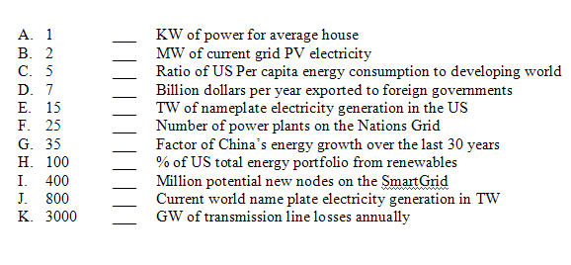

- Currently there are approximately 30 GW of wind nameplate capacity installed in the US. In 2010 we will add 10 GW of extra name plate capacity and these capacity additions will grow at the rate of 20% per year (i.e. 12 GW will be added in 2011). Also assume that total nameplate US electricity production will grow at 3% per year. Based on these trajectories, in approximately what year will wind energy reach 50% of our total electrical portfolio (solve this problem using the concept of exponential doubling times) (15 points)

12. To maintain the American Testosterone level, an 18 year old male requires 200 HorsePower. 1 HP is equivalent to 0.75 KW. Assuming an energy density of 150 watt hours per kg for Li-Ion battery back, how many KG of Li-Ion batteries would be needed for this 18 year old to implement 200 HP for 15 minutes. (15 points)

Section III: Each question worth 15 points: Answer 5 out of 6: (75 points available)
13. Explain why “Peak Power” is difficulty for you local utility to deal with and what some of their options are dealing with this.

14. Explain the concept of the Energy PayBack Time (EPBT) and how it is calculated. How should EPBT be factored into future energy policy? Which technologies have the lowest EPBT and why is this the case?

15. Defend or rebuke the following statement: “Conservation is our best and cheapest energy source”

16. According to the “Bothun Index”, why does Wind Energy technology have such a large relative advantage compared to other renewable technologies.

17. Explain why energy storage is a critical component of renewable energy technologies.

- Explain how OTEC works in basic terms and why it holds such promise as a future source of electricity generation for the world.

Last three questions worth 20 points each: Answer 2 out of 3 (40 points total)
19. Compare and contrast the different suggested/available devices for wave energy. If you were to advise the adoption of a particular wave power technology, which one would it be and why?

20. Give an explanation of why it seems to be that Americans have the attitude that its their manifest destiny to organize and maintain a highly consumptive society.

21. Explain how this course has increased your overall awareness and understanding of the current state of the world and its trajectory.

