ENVS 350: Final Exam

Name: Jake Kurzweil
Please confine your answers to the space provide and make sure to write legibly. Remember to show all work. There are a total of 250 points available on this exam.
If you choose to type your answers in using a laptop, then do the following:
- Download the exam at http://homework.uoregon.edu/pub/es350f11.doc
- When you first open the exam, save it on your desktop with yourlastname as the filename
- Read the instructions for each section in terms of how many questions to answer!
- Type your answers in the space below the questions
- Save your exam often in case the battery runs out, or something
- When finished – email the exam to uohomework@gmail.com
- You may want to do the calculation and matching questions on paper (section II) so make sure you turn the paper exam in as well.
Section I: Each question worth 10 points: Answer 7 out of 9: (70 points available)

1. Explain the overall concept of the “vehicle to grid” connection.

2. Discuss why flow batteries are a good example of scalable energy storage.

3. When defining total electricity production the US, there are often two items listed: Nameplate Capacity and Net Generation. What do each of these terms refer to?

- Describe three possible reservoirs (natural or otherwise) that are available for Carbone sequestration.

5. Explain why “Peak Power” is difficulty for you local utility to deal with and what some of their options are dealing with this.

6. Explain the main physical differences between the bird killing wind farms of the 1980's and early 1990's and today's modern wind farm

7. Explain why the world is currently in a situation of “Plateau Oil” and not actually “Peak Oil”

8. Briefly explain why the emerging energy footprint of China is so threatening

9. Give two arguments against tidal energy and why we should avoid investing in that technology

Section II: Calculation/Matching – Do all Questions (65 pts available)
10. Match the numbers in the left column to the right column (2 points per correct match)
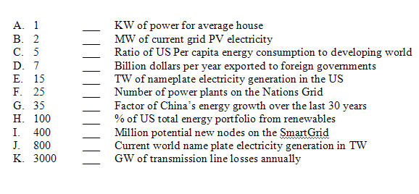
11. To maintain the American Testosterone level, an 18 year old male requires 200 HorsePower. 1 HP is equivalent to 0.8 KW. Assuming an energy density of 200 watt hours per kg for Li-Ion battery back, how many KG of Li-Ion batteries would be needed for this 18 year old to implement 200 HP for 15 minutes. (15 points)

12. Resource X has an initial consumption rate of 100 units per year and consumption is growing at a rate of 5% per year. In what year will we be consuming 1000 units per year? If the rate of growth is 10%, in what year will we be consuming 1000 units per year? (solve this problem on paper and not EXCEL using the concept of exponential doubling times) (15 points)

13. Describe how a feed-in tariff works and why it drives significant renewable deployment. Use the German PV example to illustrate your explanation. (15 points)

Section III: Each question worth 15 points: Answer 5 out of 6: (75 points available)
14. Which aspects of the current marketing of Electric Vehicles to consumers do you think are the most misleading?

15. Explain the concept of the Energy PayBack Time (EPBT) and how it is calculated. How should EPBT be factored into future energy policy? Which technologies have the lowest EPBT and why is this the case?

16. Defend or rebuke the following statement: “Conservation is our best and cheapest energy source”

17. According to the “Bothun Index”, why does Wind Energy technology have such a large relative advantage compared to other renewable technologies.

18. Explain why the development of the SmartGrid is a critical component for the deployment of renewable energy technologies.

19. Explain how OTEC works in basic terms and why it holds such promise as a future source of electricity generation for the world.

Last three questions worth 20 points each: Answer 2 out of 3 (40 points total)
20. Provide what you think should be the single biggest argument that can be made against continued investment if using natural gas as our primary choice of energy source?

21. Give an explanation of why it seems to be that Americans have the attitude that its their manifest destiny to organize and maintain a highly consumptive society.

22. Explain how this course has increased your overall awareness and understanding of the current state of the world and its trajectory.

