Final Technical Report

Proposal Title: Do Galaxy Disks Ever End

Principle Investigator: Dr. Greg Bothun, Department of Physics, University of Oregon

Background:

NASA has recently launched two satellite observatories whose capabilities are directly related to current faculty research that is underway at the Pine Mountain Observatory. These missions are
1) The Spitzer Space Telescope (SST) – which is an imaging telescope that operates in the infrared (spectral range of 3-100 microns) and 2) The Galaxy Explorer (GALLEX) which images in the ultraviolet (1000-2500 angstroms). The SST is sensitive to the presence of dust and molecular emission; GALEX is sensitive to the presence of hot stars. The Pine Mountain observatory is currently engaged in a U-band (3500-4500 angstroms) imaging survey both for follow-up observations of SST and GALEX sources as well as identifying new candidates for GALEX imaging. The astrophysical question of interest is related to the baryon extent of galaxies. Conventional modeling shows that star formation can only occur in relatively dense regions of galaxies which harbor giant, cold, molecular clouds. This leads to the expectation that galaxies are density bounded (i.e. would have hard edges). However, SST has discovered sources of emission that are well beyond the nominal edges of galaxies and GALEX has provided truly remarkable surprises. Specifically, the emergence of extended UV disks in spiral galaxies (often those with known extended H I distributions) has been regarded as one of the more interesting and surprising results from the GALEX mission to date.

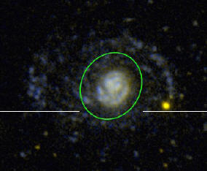

The above image shows the case of NGC 4569 (see Gil De Paz etal 2007) in which the (green) ellipse denotes the nominal optical extent of the disk. The excess NUV emission at radii larger than the green ellipse defines is quite obvious. It is this initial discovery of these extended UV (hereafter XUV) features around normal galaxies that stimulated our interest in using PMO to discover possible new candidates for follow-up imaging with the GALEX satellite. Using the initial research money granted by the OSGC, we were able to successfully acquire observing time during cycle 4 of the GALEX emission. However, various technical issues associated with the data pipeline processing of our images, delayed the release of that data by approximately one year. Indeed, it was only on about 1 Aug 2009 when the data was released to us. The delay in providing this final report is a direct consequence of this.

Despite the delay, the observations produced some outstanding results and confirmed the XUV phenomena in a couple of different kinds of galaxies. These results have major implications on the size evolution of galaxies, their appearance and structure at high redshift, and leave open the question of why there is so much material available for star formation at very large distances from the center of the galaxy. This should just not be the case as such material is easily disrupted by galaxy-galaxy gravitational/tidal encounters which are relatively frequent in the nearby Universe. The degree to which the XUV phenomena is present, suggests there is some pool of material which is continually in falling towards galaxies which would clearly indicate that galaxy formation is still occurring.
From our initial analysis of the GALEX data, the two major results of our research are shown and summarized below:

NGC 5172:

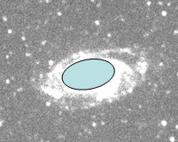
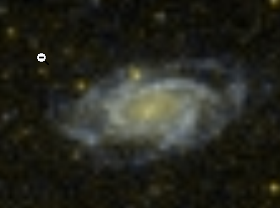
This is a relatively normal galaxy; the preliminary Near UV image is shown to the right. Further data processing will bring out much more fainter details. The solid (blue) ellipse shows the extent of this galaxy as defined by its optical light. Clearly, once again, XUV structure is present as the galaxy is nearly twice as big at these wavelengths. Recall, the UV wavelengths imply hot stars, and hot stars are recently formed stars. So NGC 5172 again provides a strong example of the curious case of star formation that is occurring, at a fairly vigorous rate, at regions far removed from the center of the galaxy. These regions have low density and everything we have learned over the last 20 years of star formation occurring exclusively in cold, dense, molecular clouds, is overturned by the presence of these XUV structures. Consistent with this is the image to the left which shows the preliminary color composite difference between the Far UV image and the Near UV image. In this image one sees essentially two blue oval rings. The inner one corresponds to the optical size of the galaxy as shown previously. The outer one, which is clearly seen in this color difference image, is a nearly continuous ring of hot stars, again implying the presence of significant amounts of star formation in the outer regions. This galaxy is therefore clearly growing with time and this has major implications with respect to the size evolution of galaxies and the inferences we make about galaxies when we observe them at high redshift (i.e. when they were young). In principle, these XUV structures are suggesting that galaxies can’t be as big as we think they are, when we observe them at high redshift.

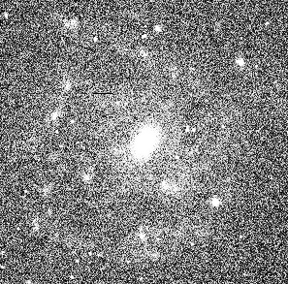
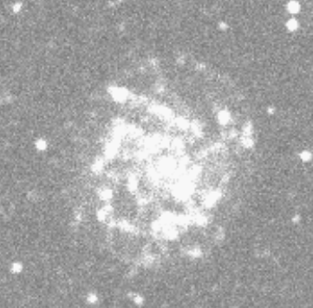
UGC 9024: This result is a truly startling one. UGC 9024 is a class example of what is known as a Low Surface Brightness galaxy. These are galaxies that, in the optical part of the spectrum, have very little contrast with respect to the sky background and, in essence, effectively compete with the noise of the sky background. For many years such galaxies were not thought to exist as the implied low surface mass density seemed to be physically implausible. However, the PI and his colleagues have established, over many years of research, that such galaxies do exist, that they are among the most massive galaxies known, and that their absence from surveys (because they are so hard to detect) makes such surveys quite statistically invalid. The concept of galaxy signal competing with background noise is clearly seen in this optical image (taken at Pine Mountain) of UGC 9024. Here the center of the galaxy is easily seen but its overall disk structure or spiral arms are effectively drowned out by the noise of the night sky. Such galaxies are therefore easily missed by imaging surveys of the sky. Careful sky subtraction and data reduction techniques need to be applied in order to detect such objects. The overall ability to detect these enigmatic LSB objects then depends on the level of the sky background as well as your detector noise. In principle, objects of even lower surface brightness can be detected with satellite observations at UV wavelengths (specifically around 2000 angstroms) as the level of the cosmological sky background is known to be at its lowest point. Thus when we imaged UGC 9024 at these wavelengths, we expected to simply see the low surface brightness features become slightly more visible and enhanced. However, the NUV image from GALEX shown to the left is amazing! There is no hint at the LSB nature of this galaxy and the ration of NUV emission to optical emission is unprecedented and strongly implies that this galaxy is actually forming right now and hasn’t had time to become more luminous in the optical part of the spectrum. This is potentially a major new discovery that strongly impacts our ides about galaxy formation and evolution. Moreover, if this galaxy were at higher redshift then, when imaged from an optical ground based filter system, the rest-frame UV light from the galaxy would enter the ground based filter system and we would have no idea that this object is intrinsically a LSB object. The dramatic difference in the NUV structure and the optical structure of UGC 9024 is remarkable and this new observation has now motivated a Cycle 7 GALEX proposal in addition to a Cycle 19 proposal to use the new Camera on the Hubble Space Telescope to image a suite of optically LSB galaxies to help determine I this UGC 9024 result is a fluke, or representation of a major new shift in our understanding of these kinds of galaxies and of galaxy formation and evolution in general.

