Contents
Introduction 2
Advantages of Wind Energy, Driving Factors, and Associated Challenges 4
Basic Advantages 4
Driving Factors 4
Federal Subsidies 4
State Incentives 5
Challenges associated with wind energy 6
Transmission 6
Variability and Correlation 7
Reliability and Capacity 8
BPA’s Wind Integration Policy Solutions 11
BPA and Hydroelectric Power 11
Power Marketing and Balancing 12
Balancing Policy Progression 14
Balancing and Persistent Deviation 14
Intra-Hour Scheduling 15
Netting Errors 16
Regression Analysis of Wind Data in BPA BA 17
Preliminary Analysis 17
Energy Capacity Factor 17
Initial Study of Variance 18
Maximum Generation Errors 19
Regression Analysis of Generation Errors 21
I am still working on my analysis of variance in the errors, and will finish this section by early next week, unfortunately, we are just getting to this sort of analysis in my regression and variance class. 21
Potential Solutions 21
Balancing Area Consolidation 22
Dynamic Transfer 23
Customer Supplied Balancing 23
Energy Storage 24
Smart Grid Technology 25
Conclusion 26

Introduction
States in the West and Pacific Northwest are currently re-defining their energy profiles. Statewide resolutions to fight climate change through the reduction of Carbon Dioxide emissions have turned into aggressive renewable energy campaigns. Oregon’s Renewable Portfolio Standard (RPS) is “25% Renewables by 2025.” California and Washington have similar RPS’s, “33% by 2030 and 15% by 2020” respectively. Idaho does yet have any official state goals for renewable energy but did receive grants from the Federal Government to help promote energy efficiency around the state. Wind energy is a key component of the states vision for how to accomplish these goals.
Because we have no current storage capacity for wind, we must use the power as it is produced. Generation must equal load at all times. The West is divided into “balancing areas” (BAs) in order to delegate responsibility for maintaining reliability and balance between load and generation to specific agencies or utilities for each area. These entities must deal with many of the challenges associated with wind energy integration. The Bonneville Power Administration (BPA), is the balancing authority (BAA) for one of the major balancing areas in the Pacific Northwest, as illustrated in Figure 1 below. BPA is therefore responsible for the backup power associated with the constantly varying wind power in the BPA service area.
Since July of 2005, the installed nameplate capacity of wind generation in the BPA Balancing Area (BPA BA) has increased more than tenfold, from 265 MW installed nameplate capacity recorded on June 28, 2005 up to 2780 MW on January 15, 2010. Wind energy is already playing a major part in accomplishing the renewable goals of the Pacific NW, but there are many challenges associated with its implementation. BPA has to maintain policy that helps with the growing penetration levels of wind generation.
This research focuses on the challenges associated with wind integration in the BPA BA, as well as an overview of current policy solutions. Detailed analysis on the overall wind generation in the BPA BA is done in an attempt to solidify the understanding of the challenges in the area, and to address the effectiveness of the current policy solutions. This study also includes a summary of the future policy solutions that are under discussion in the industry for some insight as to the future of renewable energy in the Pacific NW and California.

Figure 1: Western Balancing Areas

Advantages of Wind Energy, Driving Factors, and Associated Challenges

Basic Advantages
Aside from energy conservation, wind power is currently the most cost-effective form of renewable energy available. It has a high investment cost but low variable costs and maintenance costs, and there are currently federal subsidies to help drive investment in wind power. Significant international investment has come to the Pacific Northwest for wind development. Payoff timescales are short compared to other renewable energy sources. The amount of energy returned compared to the amount of energy invested in wind turbines in a full life-cycle assessment including manufacturing all parts, installation, run time, and decommission, the Energy Return on Investment (EROI) rating, is higher than other conventional forms of energy production.
Wind energy lowers air pollution and GHG emissions, reduces water use in the electricity sector, reduces streambed acidification from acid rain and mining, and it reduces metals emitted into the air from fossil fuel use. The development of renewable energy production methods also enhances US energy security, and it could help with the stabilization of energy rates with reduced dependence on fossil fuels. On a more local level, wind energy production can bring enhanced revenue for rural landowners and increase industry and jobs in rural areas that have good wind resources.

Driving Factors

Federal Subsidies
To ensure progress in the direction of renewable energy standards, the federal government has provided financial motivation. There are two main federal government subsidies that help to motivate the implementation of new renewable energy projects: Federal Renewable Energy Production Tax Credits (PTCs) or the Federal Business Investment Tax Credits (ITCs). These credits should help to buffer the costs associated with the implementation of wind energy.
The PTC in place for wind energy generation pertains to any facility online by December 31, 2012 and is generally applied for the first ten years of a plant’s operation. This credit is per production, 2.1cents per kilowatt-hour ($21 per megawatt-hour). These PTCs will continue until at least 2022, making wind power profitable at lower rates than conventional energy production methods. This gives private wind companies an initial foothold in the market while they establish themselves and while implementation challenges are overcome.
ITCs are an option that companies can choose in place of the PTCs, which are a one-time credit based on investment in new projects. The ITC for wind has a maximum payoff of $200/kilowatt of capacity installed as long as the turbines have a minimum efficiency standard of 26%. One time credits such as these do not have lasting effects on the power markets. Both of these types of federal incentives have helped to drastically boost the renewable energy portfolio of the Pacific Northwest and the United States as a whole.

State Incentives
Some state governments have also created market incentives for new renewable energy investments. California has recently chosen to take statewide legislative action to help reduce greenhouse gas emissions with the Assembly Bill 32 and is in the process of creating an emissions trading market, in which low emission power sources such as wind get valuable emissions credits. This incentive is applicable to out-of-state energy producers such as the wind power producers of Oregon and Washington. Oregon and Washington have agreed to help California with the emissions trading market, but if conventional energy is cheaper even without the credits, the market may have “leakage” where consumers choose to buy conventional power from elsewhere rather than opting for more expensive renewable energy even with the emissions credit incentives.
California is also allowing the purchase of tradable wholesale Renewable Energy Certificates (RECs) to help reach the required renewable energy standards. These certificates also allow for businesses and individuals to voluntarily choose to purchase certified e-Green energy for an extra cost for personal reasons or in order to make a business more sustainable to reach green markets. Though this market is voluntary, it is a publicly driven motivation for additional renewable energy, making certified renewable energy more valuable in the wholesale energy markets. The REC market is growing rapidly, with an over 66% increase in REC sales from 2007 to 2008.
One effect of the strong incentives in California is that 80% of the wind energy produced in the BPA BA ends up in California. This means that it can be difficult for all of the states to accomplish their renewable energy goals when they are competing for renewable energy credits in segregated markets with state-segregated policy incentives. Navigating the market effects of renewable resource integration is just one piece of the integration puzzle.

Challenges associated with wind energy

Transmission
Though there are many benefits to wind energy, and many investors are choosing to move forward with wind projects, there are also many challenges associated with the implementation of new energy sources. On the most basic level, new power sources require new transmission. Transmission system flexibility and surplus capacity has declined over the last 20 years. “Since 1982, growth in peak demand for electricity… has exceeded transmission growth by almost 25% every year. Yet spending on research and development – the first step toward innovation and renewal – is among the lowest of all industries.” The current electrical grid has been hailed as the greatest engineering feat of the twentieth century but efficiency losses are staggering, and reliability is getting more difficult to maintain as the transmission system gets bogged down by too many producers and as demand continues to rise. Many BAs routinely deal with congestion in portions of their grids.
Part of what makes transmission difficult with wind energy is that wind is a variable power source. With no current storage methods for large scale energy production, the current system runs by marketing the energy on various timescales and using the energy as it is produced. With a resource that fluctuates as much as wind does, this can be difficult.

Variability and Correlation
This brings to light the main obstacle associated with wind integration: maintaining reliability in the face of variability. Wind power production has a cubic relationship with wind velocity, for example, if the wind velocity increases by only 25%, the power production almost doubles (1.25^3=1.95). This means that slight changes in the weather cause significant effects on power production of individual plants. These ramping effects can potentially be magnified by the fact that much of the wind production in the NW comes from the same geographical area, centered around the Columbia River gorge and is thus influenced by the same weather patterns. (See Figure 2) Balancing out these extreme ramping events to maintain power flow can be very difficult, especially if predictions about how much power the wind will produce at any given time are erroneous.

Figure 2: Map of Current and Proposed Wind Generation Sites in the BPA BA
Analysts at BPA accounted for the correlated location of the Pacific Northwest wind fleet in their 2009 rate process. Each new facility that is included in the BPA rate process for the following years that was not yet online when the rate case was analyzed was included based on its proximity to other existing facilities, classified by “lead and lag time” for how generation trends are likely to relate to other facilities that are already online. As stated in the study,
“A west-to-east wind pattern prevails generally in the locations of many future wind projects in BPA’s BAA, and future wind project generation is assumed to be predicted generally by using leading (earlier in time) generation values from an existing project that is west of the future project or lagging (later in time) values from an existing project that is east of the future project. Data reflecting common delays between existing projects and future project locations was obtained from a wind forecasting company in Seattle (3TEIR). .. observations based on existing wind facilities indicated that different wind facilities seldom ramp up or down at exactly the same time. As a result…the data is adjusted to reflect a 10-20 minute lead or lag based on BPA’s observations and knowledge of the area in question…”
It was important for BPA to account for the potential correlation in analyzing how much reserve capacity is needed to enable wind variation to be balanced using the federal hydro system or other generating resources because this correlation is likely to intensify the effects of weather events on wind generation output. (See analysis section)

Reliability and Capacity
Another reliability obstacle arises when the wind does not blow. The potential correlation between wind producers in the BPA BAA is especially noticeable under this circumstance. A 56 week study done by BPA showed that on average, 22.8% of the time the overall wind generation in the BPA balancing area was below 3% of installed capacity. This included a few longer periods of very low production such as the one pictured in Figure 3 from January of 2009 where there were more than 11 ½ continuous days with less than 50 MW (3% of capacity) of wind generation.

Figure 3: An Example of Variability and Low Capacity
Events such as these demonstrate the separation between energy sources that have generation capacity (the ability to control the generation and produce the amount that meets load) compared to energy production capability (the potential for energy production). This sets wind apart from other traditional energy generation sources because it does not have generation that can be relied upon to satisfy loads. This lack of reliability calls into question how much wind penetration the system will be able to handle.
Over short timescales such as those used in the current industry for energy marketing, this lack of reliability translates into the “peaking capacity.” “Peaking capacity” is the generation capacity that can be called upon to reach loads that are above baseline at any given time, and is an important part of energy production. Unfortunately, wind has a peaking capacity of zero, because it cannot be called upon for higher generation when needed. This zero peaking capacity (otherwise known as non-dispatchability) could become more of a problem as the Pacific NW approaches its renewable energy goals and if average load grows with population and changes in climate.
Overall, this lack of consistent generation generally translates into the “energy capacity factor” which is the average generation over a specified period of time divided by the total installed capacity (maximum potential generation installed) expressed as a percentage. In general, wind energy tends to have about a 30% overall energy capacity factor for long time periods. On shorter time scales, however, the energy capacity factor can be essentially zero or it can be higher. In the current wind industry, this factor is measured over long time frames to estimate overall generation trends for a certain facility, location, or turbine model, but does not translate very well into the direct action of marketing wind power in the system that is currently used, because of the short timescales that are considered while using the power it as it is produced. This figure would be more relevant if the wind energy was being stored rather than used instantaneously.
Wind has become a major part of the energy portfolio of our region in just a few short years. It is a very cost effective option that is developing very rapidly. Unfortunately, obstacles such as variability, correlation, low energy capacity factor, zero peak generation capacity, and the market affects of long-term production credits will require innovative solutions on the policy side of energy implementation. Embracing the future energy profile of the Pacific NW region will be a difficult but rewarding process.

BPA’s Wind Integration Policy Solutions

Figure 4: Map of FCRPS

BPA and Hydroelectric Power
BPA is a federal agency run as a profit-neutral organization. Any cost incurred during BPAs processes is reflected in the cost of the services they provide. The products and services provided by BPA include power sales, transmission services and balancing, fishery protection and restoration, energy conservation, and research and development. BPA markets power from the Federal Columbia River Power System (FCRPS) which is a total of 31 hydroelectric dams as shown in the service area map in Figure 4. Only 10 of the dams, however, are equipped with the capability to provide balancing services using Automatic Generation Control (AGC) a computerized operation system that can control production on very short timescales by adjusting the dam operations. Hydroelectric dams, because they can be controlled on shorter time scales than nuclear or coal power plants, could be considered ideal backup power sources for “balancing” intermittent production from resources such as wind and solar.

Power Marketing and Balancing
Power is bought and sold as a commodity in a complex system of markets. There are many independent power producers in the region, including a rapidly growing number of wind producers who have taken advantage of the PTCs and ITCs. These independent producers, who are businesses running for a profit, have to use the balancing and transmission services that BPA offers to deliver the power that they sell. Because they are not in control of how much power is produced, they must predict and schedule what they believe they are going to produce, create contracts to sell the amounts that they schedule, and then transmit the power as it is produced with BPA to fill in any gaps between the schedule and actual generation using its own generation resources. Balancing happens on a fleet-wide level, after all of the wind producers have submitted their schedules for each hour. This means that the fleet level data that is available accurately represents the balancing services that BPA is providing, and the overall net schedule deviations that must be corrected.
Backing up the wind production as it is produced is a combination of processes. When wind power is not generated according to the predicted schedules, extra capacity reserves are needed for controlling the power both by reducing generation and by ramping up generation. Incremental reserve capacity (INC) is the ability to ramp up generation to correct for under-generation in relation to schedules or to adjust for increased load. Decremental reserve capacity (DEC) is the ability to reduce generation in times of wind over-generation or decreasing loads. The varying schedules associated with wind power production require BPA to carry increased INC and DEC reserve capacity. A hydro scheduler at BPA controls which dams hold certain percentages of this capacity for adjustment, when committing power production units to certain amounts of load while obeying fish and stream flow regulations, as well as trying to optimize efficiency in the balancing system.
Under BPA’s operating systems, wind balancing and load reserve requirements are made up of three basic components: Regulation (instantaneous corrections to maintain reliability), following (calculated as change over 0-10 minute intervals), and imbalance reserve (unit commitments which generally occur on hourly intervals or sometimes within hour to adjust for larger changes in schedule). Over a longer time horizon, BPA also offers a “storage and shaping” service where variable wind energy is taken into the hydro-system and released as hourly scheduled energy a set time later.
Wind balancing services use mostly regulation and following reserves because they occur within the hour of delivery. These reserves are classified by how rapidly they can respond for each of these processes. Regulation and a portion of following is done with spinning reserves (on-line generation capable of responding instantaneously) usually employed by Automatic Generation Control (AGC). Non-spinning reserves (reserves that can be brought on line within 10 minutes) and spinning reserves are both used to for following services, to follow larger load trends throughout the day such as the traditional daily load curve (the general shape of aggregate energy use within a day, higher in day and lower at night).
Generation adjustments and reserve capacity on the part of the BA have associated costs. Efficiency can be lost when power output is adjusted. In an ideal situation, for example, the dams would store water during off-peak hours in the middle of the night when power prices are low, and then let it through at optimum capacity when the load and price are high during the day. In order to have increased DEC capability during off-peak hours and to maintain minimum generation values during LHL with wind penetration, hydro generation must be shifted to light load hours (LHL). Similarly, during peak hours (HLH) when hydro generation would normally be maximized, in order to have INC capacity hydro generation must be reduced from optimum levels and shifted to LHL generation, this is classified as “energy shift”.
“The impact of the energy shift calculation is twofold. First there is an economic cost to shifting generation out of the HLH period and into the LLH period, and there is a change in plant efficiency due to the change in HLH and LLH generation values…The economic impact results from reduced high value HLH power sales for increased LLH sales of lesser value.” This is an example of the costs associated with wind implementation in the BPA BAA.
Understanding these costs has motivated BPA to introduce policy solutions to help recover and allocate costs appropriately. Maintaining reliability, however, is the main goal of these changes in operations, and so BPA also has it in their best interest to motivate wind schedulers to minimize deviations from schedules in order to limit the reserve requirements, risk, and costs of balancing wind. Analysis in a later section of this paper explores whether each of the policies that have already been enacted have actually helped to reduce the balancing services that BPA is providing.

Balancing Policy Progression

Balancing and Persistent Deviation
One policy solution that BPA has implemented to direct the costs associated with balancing back to the producers rather than passing them on to the average consumer is balancing charges and persistent deviation charges. The balancing charge is a flat fee per installed nameplate wind capacity that was implemented October 1, 2008. These charges are generally reassessed every other year in the “Generations Input Study” part of BPA’s rates. Wind penetration was incurring enough costs to BPA however, that a special rate case was done during 2009 with new fees assessed to try to limit large deviations from the schedule. Charges for deviation from schedule existed previously but were re-defined and the new version was implemented starting October 1, 2009.
The charges for “persistent deviations” from schedule may be assessed when (a) a producer deviates from the schedule in the same direction (over generation or under-generation) for four hours of more than 15% or at least 20 MW in for each of the four hours, or (b) a “pattern of over delivery or under delivery [occurs] at certain times of the day”. In meetings during April 2010 BPA reminded parties of the provision for assessing penalties for patterns of schedule error, and described the number of times they had been enforcing the (a) type persistent deviations. Analysis in a later section of this paper examines the effects of the balancing rate and persistent deviation penalties on fleet level schedule error.
On October 1st of 2009, another BPA policy, Dispatcher Standing Order 216 (DSO 216) was enacted to help maintain reliability standards and to avoid BPA risk of running out of DEC or INC reserves. Under DSO 216, the dispatcher has protocols for informing the wind producers when 85% of the reserves are used up, then again when 90% are used up and when 100% are used. The wind producer may be asked to lower production (usually by turning the blades of the turbines away from the wind slightly) to get within their portion of the reserve requirements of the schedule in times of over-generation or to change the schedule to get within that margin of actual production in times of under-generation. The dispatcher will have the power to disconnect wind plants if system reliability is at risk and the wind producer fails to comply with curtailment orders. A plant which fails to comply 3 times within a 24 month period will be required to install technology that automatically adjusts their generation down to an upper limit provided by BPA during times of over-generation. Curtailing schedules as a result of limited incremental reserves is very similar. No schedule curtailments or generation limitations will occur in the final 15 minutes or 10 minutes of the hour respectively or in the initial 10 minutes of the new hour in order to allow wind producers to adjust schedules or generation accordingly during the ramping period between hours without action from BPA.
This policy is pushing risk and cost of balancing back onto wind producers and forcing them to take efficiency losses or sales losses when reserve capacity is unable to meet their needs. Forced reduction of renewable energy generation does not seem like a very good solution in the long run, but more reserve capacity is needed in order to allow for higher levels of wind penetration and the associated levels of balancing services. If wind producers had near-perfect schedules where for each hour they produced very close to the amount they scheduled, this policy in particular would almost never be called into action. Persistent deviation charges also can be avoided with improved schedule accuracy. Unfortunately, the hour long time scales that BPA normally schedules on can be very difficult for wind producers to schedule accurately because of the variability of wind.

Intra-Hour Scheduling
Wind schedulers have to submit a forecast for each delivery hour, by 30 minutes before the hour. The wind can change rapidly and create large schedule errors, meaning that the hour long timescales are not conducive to the minimization of scheduling errors. Objections to the scheduling fee and persistent deviation penalties seem relevant when considering this obstacle. “A system that allowed 10 minute schedule-changes could solve 80% of the issues BPA faces, if technical and institutional complexities can be addressed.” Adjusting hydro operations to shorter schedules would be a very effective long term solution.
Phase I of the intra-hour scheduling program went into effect at 09:00 on December 1, 2009 to help address the challenge of scheduling a variable resource on such long timescales. The requirements for a wind producer to re-submit a schedule within the hour are (a) the transmission customer must be rescheduling because of visible or expected excess generation in relation to the previously submitted schedule for the hour, and (b) the customer must be a generator within the BPA BA who is buying transmission to a load outside of the BPA BA. These schedules are ramped in at during 25-35 minutes after the hour and the new schedule is for the remainder of the hour. Analysis in a later section will examine if this intra-hour scheduling has helped to reduce the net error of the wind generators for which BPA is providing balancing services.

Netting Errors
Wind producer’s errors can also often cancel each other out (one might over-generate relative to their schedule while another under-generates, leaving a smaller net error). Under current policy both producers are charged for their persistent schedule deviations which seems unfair to wind producers if BPA is only balancing on a fleet level. The strictness of the policy is meant to motivate producers to improve their scheduling accuracy at a plant level scale. Starting soon, however, wind producers will be able to net schedule deviations against each other before DSO 216 is implemented.
This ability for errors to net out to zero is especially affective in uncorrelated wind sites. In exploring the statistical properties of wind, more wind development in geographically independent and diverse sites should also lower the variability of the wind generation. Wind generation sites and future projects that are balanced by the BPA BA are mostly centered around the Columbia River Gorge area. They do not appear to be very geographically independent, and as mentioned in a prior section of this paper, BPA’s analysts did assume some correlation while calculating reserve requirements for future facilities. An analysis of the growth of wind capacity and it’s correlation with the variance of the wind generation and the scheduling errors will also be included in order to confirm or reject the idea that the wind in the BPA BA is correlated, and also to make conjectures about potential policy solutions to correlated wind fleets.
These policy solutions should be helping to curb BPA’s costs and risks associated with balancing growing levels of wind penetration. They should also motivate wind producers to improve their scheduling accuracy. If these policies have been effective for overcoming the challenges of wind integration, data analysis should demonstrate improvements in schedules as a result of the scheduling and persistent deviation charges and DSO 216 as well as the new intra-hour scheduling. The growth of the fleet should also contribute to lower relative errors and variance unless plant locations are too highly correlated.

Regression Analysis of Wind Data in BPA BA
Fleet level wind data for the balancing services that BPA provides is available on the BPA website. This data is in MW on 5 minute intervals starting at 00:00 on May 9, 2008 through March 31 of 2010. The variable that is under investigation in this analysis is the actual generation in relation to basepoint forecast (schedule) to evaluate the error in fleet-wide scheduling that BPA is providing balancing services for. The actual wind generation minus basepoint (schedule) is used to calculate tabular generation error values in MW. The goal of the policies that have been introduced at BPA as of yet is to overcome the challenges of variability and low capacity factor, as well as to decrease the costs associated with increased reserve capacity and energy shift.
Analysis of the fleet level wind data should demonstrate some of these challenges as well as a decrease in scheduling error that could have been caused by a variety of system changes such as greater installed capacity (with less correlation), policy solutions, or just an improvement in forecasting in the field.

Preliminary Analysis
A preliminary analysis to watch some of the indicators of the challenges in the BPA BAA was done using the fleet-level data.

Energy Capacity Factor
Using month long data sets for actual wind generation and the values for average installed nameplate capacity, the overall capacity factor for each month was calculated. The trapezoid approximation for area under a curve was used to approximate wind generation with the 5 minute tabular values for a total production in MWH. The overall generation capacity was calculated using the average installed nameplate capacity for each month multiplied by the total hours in that month. Energy capacity factor is the quotient of these two numbers. The results are as follows:
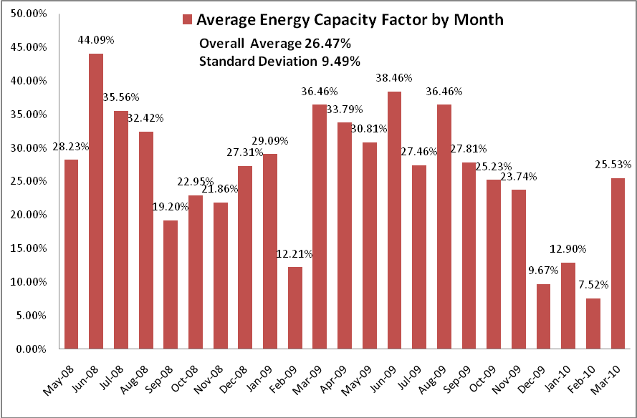
As shown in the graph, there were a few months with high energy capacity factors and a few with very low energy capacity factors. This demonstrates the challenge of low generation capacity in our area, and to some extent the correlation in our fleet. If the plants were in more geographically diverse areas, the standard deviation should be lower for a more steady overall generation capacity.

Initial Study of Variance
With increased scheduling accuracy as a result of any of the indicators discussed, an observable decrease in the variance of the fleet-level error should be present. As a preliminary study, the variance of the generation error was calculated for each of the months included in this study. To include the growth of the fleet over time, this was analyzed in terms of the error as percent of the installed nameplate capacity. This did not use the average capacity values as above, but rather the actual installed nameplate capacity in the BPA BAA at every time in the time period under analysis.
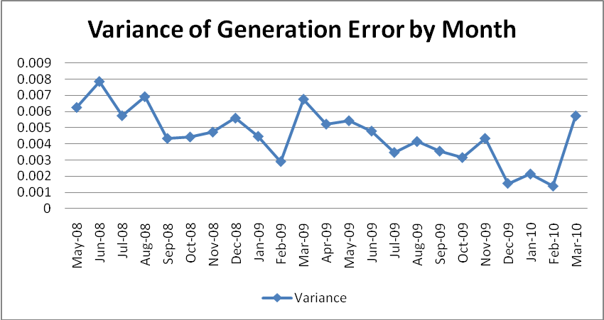
There appears to be a decline in the variance but January and February of 2010 were both very low generation months, which would limit the variance in those months. Closer analysis in the next section will try to deduce if this is an actual decline in variance and therefore overall errors and which indicator this is most likely to be linked to.

Maximum Generation Errors
The maximum generation errors show an example of the maximum balancing services that BPA was obligated to provide during each time period. These values are particularly relevant in terms of reliability standards, because BPA does have limited reserve capacity, and maintaining reliability is the main priority for a BA. This maximum balancing service has grown slightly over time but has become relatively stable in recent months. The last four months shown are when the DSO 216 is in effect, essentially capping the balancing service that BPA is willing to provide. The installed nameplate capacity in the BPA BAA doubled in this time period, but maximum balancing services in either direction (INC or DEC) were not allowed to grow at the same rate as the nameplate capacity through regulation policy.
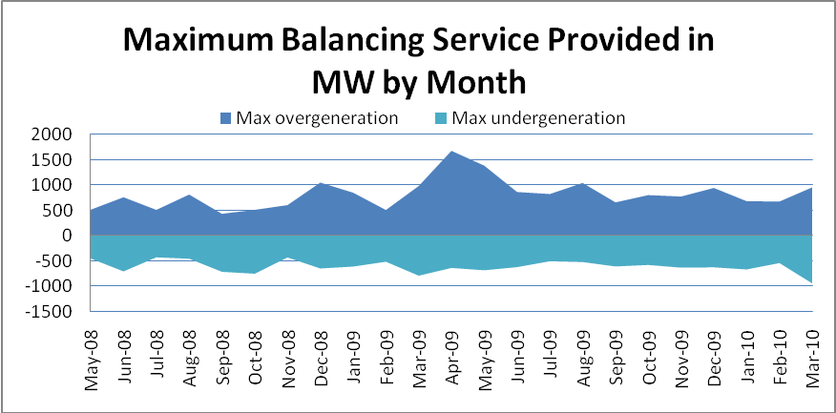
The next graph shows this same amount but as a percent of the installed nameplate wind capacity at the time. April of 2009 was a particularly bad month but overall the maximum generation error as a percent of capacity appears to have stabilized somewhat, with the implementation of persistent deviation charges and DSO 216 in October and December of 2009, respectively.

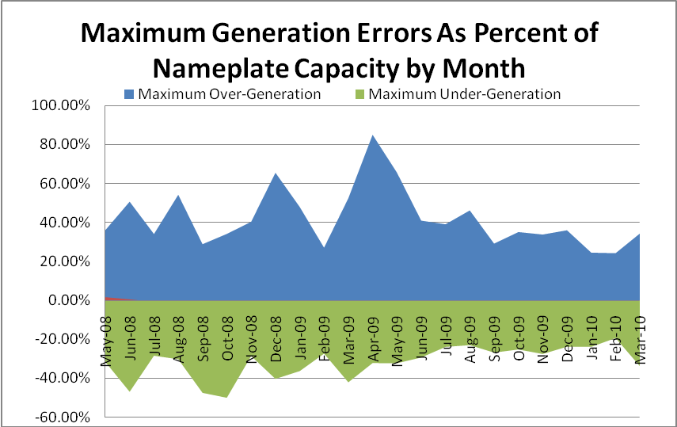

Regression Analysis of Generation Errors
These deviations from schedule will be analyzed in relation to the following indicators:
Installed Nameplate Capacity:
The installed nameplate capacity of wind over time could have a correlation with the net errors in the system. If the wind sites are geographically diverse enough, the net errors should decrease as more capacity is added, but if the wind sites are correlated as the analysts at BPA believe, this trend may not be visible in the data, and the decline in variance in the error will not show a strong correlation with the growth of installed capacity.
Load Hours:
Peak load hours (PLH), heavy load hours (HLH) and light load hours (LLH) as defined by the North American Energy Reliability Council (NERC) could demonstrate a tendency to err in one direction or another because of market trends. Energy prices are generally higher during peak load hours and heavy load hours and lower in light load hours. This means that especially before persistent deviation charges were introduced, over-generating while market prices are high could be a lower risk option on wind generators parts because of the way fees are assessed. Persistent deviation charges should have worked to correct for this sort of trend in the scheduling error, and as a result BPA would incur less costs associated with energy shift.
Policy Dates:
If these policies are effective, the aforementioned dates in which new policies were enacted will have some effect on the errors. This analysis is done by using a variable that represents time periods of various policies and fees.

I am still working on my analysis of variance in the errors, and will finish this section by early next week, unfortunately, we are just getting to this sort of analysis in my regression and variance class.

Potential Solutions
Wind scheduling fees, persistent deviation charges, curtailments, and intra-hour scheduling are not the only solutions to the challenges of balancing a variable generation source. There are many other potential policy solutions that are currently being explored by BPA and the wind producers that buy transmission and balancing services from BPA, as well as by power customers in California that purchase much of the wind produced in the BPA BAA.

Balancing Area Consolidation
Many of the market obstacles associated with the current state of wind in the NW as well as the balancing challenges could be minimized with either the actual or some automated form of BA consolidation. In the recent ColumbiaGrid Balancing Area Consolidation Feasibility Study; the consolidation of NW BAs is discussed as a potential solution for these problems. Larger BAs allow for more netting of errors and less correlated wind fleets and therefore a lower variance with the total wind generation than with the sum of the individual variances (See Figure 5, below). Load variability would also be smoothed by BA consolidation which would help to lower required reserve capacities. It could also provide access to more regulation and load following resources.
BA consolidation could help the NW to reach their energy goals together by allowing for higher levels of wind penetration in geographically diverse regions. It could solve the problem of correlated wind fleets. Rather that separate states competing for renewable power, resources would be pooled and wind and other renewable resources could be developed with lower associated costs and diminished challenges.

Figure 5: Variariability of Separate Data Sets Versus the Variability of their Sum. Source: R. Daio, R.T. Guttromson, S. Malhara, Y.v. Makarov, N.A. Samaan, C.R. Sastry, “ColubiaGrid Balancing Area Consolidation Feasibility Study.”
This consolidation could be an actual physical consolidation of transmission services under one larger BA similar to the independent system operators (ISOs) that manage larger BAs in other parts of the US, as proposed in the ColumbiaGrid study, or it could be a virtual consolidation using advanced technology to make better instantaneous transfers and communication between the current BAs. This would require more investment in new technology and transmission, but would help to alleviate individual BAs current disputes with wind producers. This solution would help to make meeting our regional renewable energy goals very possible.

Dynamic Transfer
Dynamic Transfers are a technological solution that is a step in the direction of BA consolidation, but with relatively minor system operations changes. They are a way for BAs to quickly transfer excess generation to areas outside of the BAA, or for a BA to control a generation source that is in a different BAA. This can be useful for intermittent producers seeking balancing services outside of their BA or from other sources that are not managed by the BA. Dynamic transfers could also allow for a BA to access extra reserve capacity from other BAAs to help with balancing services.
The California independent system operator (CAISO), who is the BA for most of California, recently presented a Straw proposal to encourage more direct transfers. Because California is very aggressive about reaching their RPS, this change would allow them to buy excess wind generation from BPA as it is produced, therefore alleviating BPA of some of the challenges associated with wind energy, and the costs associated with excess generation during HLHs that is getting exported to CAISO in the end anyway.
In the proposal, CAISO included special allowances for official intermittent resources (such as wind generators) that would allow them to actively change their schedule during the hour of sales if the ISO has the capacity to use the excess electricity while maintaining reliability standards. This type of solution provides some of the benefits of BA consolidation in terms of uncorrelated load requirements, reserve requirements, and generation errors having the capability to net with other errors in different BAAs. It also helps California to more quickly approach their RPS by importing renewable energy from out of state. This could potentially allow for more renewable energy generation to develop in Oregon and Washington, but it is unclear how much of that energy would stay in the NW, meaning regional goals could fall behind California reaching its RPS.

Customer Supplied Balancing
A different approach to solving balancing and reserve issues is customer supplied balancing. To avoid costs associated with balancing and persistent deviation charges, many wind producers are searching for alternative balancing services. This could be accomplished through the aggregation of variable resources with more conventional methods that would be used for balancing purposes, for example, natural gas plants, or through the purchasing of power from other producers. This would give them the capability to send generation that was exactly as scheduled to BPA for transmission, and relieve BPA of the duty of balancing wind deviations from schedule, or to directly transfer blocks of power with firmer contracts to California loads.
Because it is essentially making even smaller BAs rather than larger BAs, this policy seems to be an alternate track to the BA consolidation route. CAISO commented that this would only be an effective form of energy management if the aggregated sources were geographically nearby each other, so as not to increase transmission requirements. On the surface this appears to alleviate the problems, but it also diminishes some of the benefits of large scale wind production. Producers would no longer have errors that could net against each other; and other forms of energy that may be less renewable would have to be used to back up the wind rather than taking advantage of the ideal backup that is available with the hydroelectric resources in our area.

Energy Storage
All of the challenges associated with wind energy could be solved with the capability to store the wind energy as it is produced rather than having to use it exactly as it is produced. BPA is exploring pumped storage methods as a way of storing wind energy using the FCRPS. Pumped storage is a way to use excess generation to pump and store water resources in the reserves associated with the FCRPS. This would be an excellent way to increase reserves and reduce loss from energy shift. Pumped storage in the BPA BAA could allow for higher levels of wind penetration in the future by providing an extra resource to help with energy management. Other storage techniques that Pacific NW National laboratories are exploring include compressed air storage, batteries and flywheels.
These are all storage techniques that continue to use our current energy carrier, electricity. Another option is the idea of converting the energy to hydrogen through electrolysis (the splitting of water molecules). This would allow for lots of storage capacity and the resulting hydrogen could be used as fuel for hydrogen cars, or converted back into electricity at controlled rates. Another way of using hydrogen storage is to create hydrogen buffer zones, using a system of wind generation, electrolysis, and shorter term storage that compresses the hydrogen as more is produced (because it is a gas) and then converts it back to electricity at a controlled rate. Wind powered electrolysis would eliminate the problems of wind variability through converting wind into a controllable resource, a fuel, and could therefore allow for large increases in wind energy production.

Smart Grid Technology
“If the [current electrical] grid were just 5% more efficient, the energy savings would equate to permanently eliminating the fuel and greenhouse gas emission from 53 million cars.” If renewable energy is our goal, improvements on the grid would clearly be an important piece of moving forward with energy policy. Some of the current challenges of managing the market and load curves with an intermittent resource could be curbed with the adoption of new smart grid technology, through a more interactive grid system.
Smart grid technology includes a more controlled role on the consumption end of electricity generation, through Advanced Metering Infrastructure. This is done with devices such as smart appliances, which would respond to signals from the grid for when to use electricity. Advanced metering helps to better predict and even control loads. One goal of this new technology is to smooth out the daily load trends by using electricity at times when market prices are low (such as the middle of the night) but while there is still potential generation from intermittent producers. This would help to limit the reserve requirements associated with load shaping and following, thus leaving more available reserve capacity for wind in our area. It would also help to limit costs associated with energy transfer from HLH to LLH generation.
Another component of the smart grid is better visualization technology for grid operators. Improved modeling systems for monitoring generation and loads would help to make the grid more efficient through better situational awareness of the grid at all times. Better predictions of loads would help with excess generation in areas where fossil fuel is used to meet peak demands. The Western Electricity Coordinating Council (WECC) which includes BPA just received $53 million in funding from the DOE to try new smart grid technology to help with grid congestion and better transfer capabilities. The Pacific Northwest Smart Grid demonstration project also received $89 million from the DOE to help quantify costs associated with smart grid implementation and to evaluate the benefits it will provide.
Regardless of the other policy solutions that are enacted to help with the integration of renewable resources, a smarter grid will be necessary as more variable generation sources come online. Without smart grid technology, smarter consumers will also help with transmission challenges through energy conservation in all its forms.

Conclusion
Wind energy is already a major source of renewable energy generation in the Pacific NW and California. The challenges that we face with the integration of variable power production will require policy solutions, and careful analysis as to whether those policy solutions are working.
Scheduling and persistent deviation fees, intra-hour scheduling, and the forced curtailment of wind in order to maintain reliability has effectively reduced scheduling errors to the limits of reserve capabilities for Bonneville Power Association, but other policies will be required to accommodate higher levels of wind penetration in our area. Reaching the renewable portfolio standards of Oregon, Washington, and California together will require careful planning and large, cooperatively based policy solutions.

United States, Department of Energy (DOE). Energy Efficiency and Renewable Energy. States With Renewable Portfolio Standards. http://apps1.eere.energy.gov/states/maps/renewable_portfolio_states. cfm#chart (Accessed January 23, 2009)
United States, Department of Energy. “Obama Administration Delivers Nearly $72 Million for Energy Efficiency and Conservation Projects in 7 States and Territories,” press-statement, October 1, 2009. http://www.energy.gov/8099.htm (Accessed November 3, 2009)
United States of America. Department of Energy. Bonneville Power Administration (BPA). BPA Balancing Authority Installed Nameplate Wind Generation Capacity By Plant, Current. Bonneville Power Administration, 15 Jan. 2010. http://www.transmission.bpa.gov/business/operations/wind/ (Accessed January 23, 2010)
United States, Federal Energy Regulatory Commission (FERC). “Map of WECC Balancing Areas,” http://www.ferc.gov/market-oversight/mkt-electric/wecc-balancing-authorities.pdf (accessed December 30, 2009).
Northwest Power and Conservation Council. 6th Northwest Power Plan: Plan Overview. http://www.nwcouncil.org/energy/powerplan/6/final/PlanOverview_021010.pdf , 3-4, (accessed May 1, 2009).
United States, Department of Energy (DOE). Energy Efficiency and Renewable Energy. 20% Wind Energy by 2030: Increasing Wind Energy's Contribution to U.S. Electricity Supply, July 2008. http://www1.eere.energy.gov/windandhydro/pdfs/41869.pdf. (accessed November 1, 2009)
Cleveland, Cutler J., and Peter K. Endres. "Energy Return on Investment (EROI) for Wind Energy." Encyclopedia of Earth. June 7, 2007. http://www.eoearth.org/article/Energy_return_on_investment_ %28EROI%29_for_wind_energy (accessed April 12, 2010)
DOE, 20% Wind Energy by 2030, 13.
United States, Department of Energy. Energy Efficiency and Renewable Energy. Federal Incentives/Policies for Renewables and Efficiency. http://www.dsireusa.org/incentives/ incentive.cfm?Incentive_Code=US13F&re=1&ee=1 (accessed January 23, 2010)
California Environmental Protection Agency. Air Resources Board. California’s Cap and Trade Rulemaking Process and the Western Climate Initiative. http://www.arb.ca.gov/cc/factsheets/ capandtrade.pdf (accessed April 20, 2010)
United States, Department of Energy, Energy Efficiency and Renewable Energy. “Green Power Markets: Renewable Energy Certificates.” November 2009. http://apps3.eere.energy.gov/greenpower/ markets/certificates.shtml?page=2&companyid=288 (accessed May 3, 2010)
Manzeir, Elliot. United States, Department of Energy, Bonneville Power Administration. “Balancing Act for Wind.” ppt. Presentation. www.bpa.gov/corporate/WindPower/docs/presentation-BalancingActforWind.ppt (accessed May 1, 2010).
United States, Department of Energy. The Smart Grid: An Introduction. Comp. Litos Strategic Communications. United States Department of Energy. http://www.oe.energy.gov/ DocumentsandMedia/DOE_SG_Book_Single_Pages(1).pdf (accessed November 20, 2009), 6.
DOE, The Smart Grid: An Introduction. 5.
United States, DOE. Bonneville Power Administration. 2010 BPA Rate Case, Wholesale Power Rate Final Proposal: Generation Inputs Study. July 2009. Print.
United States, DOE. Bonneville Power Administration, Transmission. “Map of BPA Wind, Current and Proposed Projects.” http://www.transmission.bpa.gov/planproj/wind/documents/map-BPA_wind_ interconnections.pdf (accessed January 30, 2010)
BPA, 2010 BPA Rate Case. 12
United States, Department of Energy. Bonneville Power Administration. “ Frequency of “Very Low” Total Wind Generation in the BPA Balancing Authority Area, 12/31/07 to 1/25/09.” http://www. transmission.bpa.gov/Business/Operations/Wind/WindGen_VeryLow_Jan08Jan09x.xls (accessed March 3, 2010)
DOE, 20% Wind by 2030, 87.
United States, DOE, BPA website definitions page. http://www.bpa.gov/corporate/pubs/definitions/c. cfm
BPA website, definitions page.
Jones, Mark. Bonneville Power Administration. Pumped Storage Evaluation. Presentation ppt. October 29, 2009. http://www.nwhydro.org/events_committees/Docs/2009_NHA_NWHA_ Regional_Meeting/1Mark%20Jones-BPA%20PresentationNHA-NWHA%2010-29.pdf (accessed April 12, 2010)
Jones, Mark. Pumped Storage Evaluation.
United States, Department of Energy. Bonneville Power Administration. Power Benefits of the Lower Snake River Dams. January, 2009. http://www.bpa.gov/corporate/pubs/fact_sheets/09fs/Fact_Sheet_-_Power_ benefits_of_the_lower_Snake_River_dams.pdf (accessed March 31, 2010) 2.
BPA, 2010 Rate Case, 6.
BPA, 2020 Rate Case, 33.
BPA, 2010 Rate Case. 7,19.
BPA, 2010 Rate Case, 43.
United States, Department of Energy. Bonneville Power Administration Transmission Services. 2010 Transmission and Ancillary Services Rate Schedule, Effective October 2009. http://www.transmission. bpa.gov/Business/Rates/documents/2010_Rate_Schedules_10_01_09.pdf (accessed May 1, 2010) 105.
BPA Transmission Services. “DSO 216 Phase II Summary”, October 2009. http://www.transmission. bpa.gov/operations/wind_operations/docs/DSO216_Phase_II_Summary_10-13-09.pdf (accessed May 1, 2009) 1-3.
BPA, “Balancing Act For Wind.”
BPA Transmission Services. “Business Practice: Intra-hour Scheduling Pilot Program (Phase I)” October 16, 2009. http://www.transmission.bpa.gov/includes/get.cfm?ID=1594 (accessed May 1, 2009)
BPA, “Balancing Act For Wind” ppt. Presentation.
M. Milligan, B. Kirby, R. Gramlich, and M. Goggin. United States, Department of Energy. National Renewable Energy Laboratories. “Impact of Electric Industry Structure on High Wind Penetration Potential.” July 2009. http://www.osti.gov/bridge
M. Milligan, B. Kirby, R. Gramlich, and M. Goggin. “Impact of Electric Industry Structure on High Wind Penetration Potential.”
R. Daio, R.T. Guttromson, S. Malhara, Y.v. Makarov, N.A. Samaan, C.R. Sastry, “ColubiaGrid Balancing Area Consolidation Feasibility Study.” (Presented …April 2010)
United States, Department of Energy, Bonneville Power Administration. Wind Integration Team Work Plan Initiative, June 2009. http://www.bpa.gov/corporate/WindPower/docs/WIT_Work_Plan_-_June_16.pdf (accessed April 31, 2010) 4.
Independent System Operator California (CAISO). Dynamic Transfer Straw Proposal. March 10, 2010. 16
CAISO, Dynamic Transfer Straw Proposal.17
Elliot’s Presentation to senate
United States, Department of Energy. Energy Efficiency and Renewable Energy. Hydrogen Production Overview. United States Department of Energy, Aug. 2004. http://www1.eere.energy.gov/ hydrogenandfuelcells/ (accessed October 31, 2009)
DOE, SmartGrid, an Introduction,7.
DOE, SmartGrid, an Introduction,11.
DOE, SmartGrid, and Introduction, 12-14.
Statement of Elliot Mainzer, Executive V.P. of Corporate Strategy, Bonneville Power Administration, DOE. (Presented before the Committee on Energy and Natural Resources United States Senate Hearing on The Role of Grid Scale Energy Storage in Meeting our Energy and Climate Goals.) December 10, 2009.http://www.congressional.energy.gov/documents/12-10-09_Final_Testimony_%28Mainzer%29_ %28BPA%29.pdf 7.

