A Study of Host Galaxy Bias and Dust in Supernova Galactic Environments

Results of Prior NSF Support: LSB Galaxies

The PI has held two significant NSF Grants in the recent past. The less relevant one is related to Curriculum Development and the development of electronic tools and simulations-http://www.mtsu.edu/itconf/proceedings/09/itf.pdf.

The more relevant project involved a long term study of the properties of Low Surface Brightness (LSB) galaxies. The existence of LSB galaxies and their likely large space density (at all galactic mass scales) clearly shows the severity of observational selection effects as applied to galaxy detection. This severity has been strongly confirmed by the analysis of the SDSS which has returned many more examples of LSB galaxies (see Kniazev et al. 2004; Bomans and Rosenbaum 2007) indicating that, in the words of Bomans and Rosenbaum, “there are two branches of galaxy evolution”.

LSB galaxies represent a legitimate sector of the galaxy population and research on these enigmatic objects has now become part of mainstream extragalactic astronomy. This was not the case prior to the NSF funded research so in that sense the impact of this work on the community was relatively large. Over the period 1995-2004 this research has resulted in at least 25 peer reviewed publications as well as a few popular articles. This research was also the direct basis for at least 6 Ph.D. students: S. McGaugh, K. O’Neil, D. Sprayberry, T. Pickering, W. de Blok and J. Helmboldt.

LSB galaxies are relatively unevolved systems at all levels of galactic mass. Their overall gas contents are higher than other systems, their mean ages appear to be younger, their metal abundances are low, their current star formation rates per unit mass are considerably lower, and their dust and molecular gas contents are deficient. Yet, these systems have managed to produce the same number of stars over a Hubble time as more normal spirals of the same mass. The nature of star formation in LSB galaxies therefore remains elusive as it’s unclear whether star formation is stimulated by a sparse population of molecular clouds in these systems or is it occurring in the more plentiful diffuse atomic H I medium. LSB galaxies have very interesting dynamical properties. Rotation curves that are fit with standard dark matter halos invariably result in baryonic mass fractions of LSB disks that are 5-10 times lower than galaxies of higher surface brightness. This potentially makes them physically different objects than disk galaxies that define the Hubble sequence. On the other hand, LSB disks occupy the same locus of points on the Tully-Fisher diagram as normal galaxies which is manifestly impossible if their baryonic mass fractions are systematically lower because this results in systematically lower dynamical mass-to-baryonic light ratios. LSBs should therefore define a different TF relation. A possible resolution to this dilemma invokes Modified Newtonian Dynamics (MOND) as an explanation for their rotation curves. MOND curiously fits all the LSB rotations curve data extremely well. A family of very large LSB disks (e.g. Malin 1 like) has been discovered and characterized. These objects are extremely enigmatic structures and seem to violate most of the standard rules for star formation and evolution of disk galaxies. Some of them are the most massive galaxies ever discovered and the most recent aspect of this project (e.g. O’Neill et al. 2004) has now tripled the numbers of these objects.

In sum, the NSF funded study of the properties of LSB galaxies has been a highly productive area of investigation and has helped upon up a new window of inquiry in extragalactic astronomy. The field has been the basis of several PhD theses. The overall research in this field has elevated LSB galaxies from idiosyncratic individual objects to a major component of the extragalactic background. No theory of galaxy evolution can therefore be complete unless it includes these objects. The same set of strong biases that apply to galaxy selection may well apply to the selection of extragalactic supernova and so this current proposal represents a nice complement to the expertise gained under the previous proposal.

Background and Motivation

The physical nature of supernova Ia (SN Ia) progenitors remains unknown and has become presently the largest obstacle in utilizing these objects for high precision cosmology. These bright stellar explosions, used as cosmological distance markers, have the potential to uncover the nature of dark energy, and measure the equation of state of the Universe (the w parameter – see Bothun et al. 2008) as they can be detected at significant cosmological distances. The objects are “calibrate-able” meaning that through empirical choice of parameters, SNe Ia can be standardized to one intrinsic brightness. In order for SNe Ia to be accurate distance probes two conditions must be met:

- The explosion physics must be similar at all redshifts.
- SN light curve properties have no dependence on their galactic environment.

Neither of these conditions has been reliably established for the SNe Ia population on a scale that encompasses an accurate representative sample all possible host galaxies at all redshifts. Indeed, extant data indicate that a substantial dispersion exists in the derived peak brightness of the explosions that no amount of calibration or light-curve template fitting seems to eradicate. This dispersion may originate from a) fundamental differences in the progenitor populations, b) important (but unknown) differences in the micro physics of the actual detonation, c) a dependence on the host galaxy properties/environment (e.g. reddening due to dust) that have not been properly corrected for. Importantly, Sullivan et al (2010) demonstrate that SNe from galaxies representative of the distant sample require a different calibration in absolute brightness in order to reduce the systematic error when used in cosmological analyses – essentially, SNe Ia evolve! Since host galaxy properties clearly evolve, then any dependence of SNe Ia light curves on host galaxy characteristics will cause this evolution. An evolving standard candle cannot be properly calibrated without making several assumptions about the SN progenitor and environment conditions.

Clearly the current use of SNe (Ia) as cosmological probes (e.g. Tonry et al. 2003; Strolger et al. 2004; Kowalski et al. 2008; Wood-Vasey et al. 2007) motivates a more intense scrutiny of the properties of nearby SNe and their environments. Any attempt to use the properties of nearby SN as a calibration template for the properties of distant SN requires some kind of test or certification that the physics of SN formation has not evolved over cosmic time and that the galactic environment, which produce SN has also not strongly evolved. In particular, assessing the true variance in the properties of SN hosts and the SN producing environments within those hosts is essential in understanding the probability of selecting a similar environment in any survey of distant galaxies

In addition as the discovery of SNe Ia increases, the taxonomy of the subtypes grows. This is troubling because of the nontrivial fraction of “over luminous” SNe Ia discovered in nearby galaxies that resemble “normal” SNe Ia. SN cosmology has now reached the point where the precision demanded is smaller than the observed luminosity dispersion of these objects, potentially requiring more corrections as a function of host galaxy properties. Clearly, SNe and their host galaxy properties need to be explored, using all extant data, in order to confirm the validity of these objects as standard candles. Understanding nearby SN properties as a function of galaxy environment was the subject of a PhD thesis “Host Stellar Population Properties and the Observational Selection Function of Type Ia Supernovae” by Elsa Johnson (Johnson 2010). The data from this study was rather extensive and the findings point to the need for further analysis of the whole nearby SN sample. Such a project is rather large scale and is well suited for postdoctoral work as well as graduate/undergraduate research.

Johnson (2010) explored the connection between host stellar environment and supernova peak colors through analyzing regions underlying the location where a supernova occurred (typically on a linear scale of 1-2 kpc). That analysis indicated a possible connection between the stellar population and the peak colors of SNe Ia as well as distinctly similar environments for subtype Ia events (fig 1). Whether this correlation is due to the properties of the underlying population as progenitors (although we recognize the problem with stellar drift) or complications due to dust in that small scale environment, is not yet clear. In the same work, the supernova observational selection function was constructed based on over 20 real supernova searches conducted from 1936-2007 in an effort to estimate an accurate rate for nearby (z<0.1) SN Ia events. What emerged was that different rates were determined for two very different types of searches, one that searches only galaxies listed in catalogs (distance-limited) which are predominately bright, nearby galaxies and surveys that randomly point to regions in the sky (magnitude limited), leaving the possibility that the choice of galaxy sample may in fact be imposing a bias on nearby data. As a result Johnson (2010) we are left with a series of important questions that require further research and investigation:

- Does the choice of observed potential host galaxies affect the interpreted SN properties? Are bright galaxies selected from catalogs similar to all galaxies within the same volume?

- Are SN rates from special samples such as large galaxies and multiple SNe hosts consistent with the entire sample of galaxies?

- Are the estimates for dust and extinction in the supernova environment accurate?

- How reliable does the SN calibration have to be in order for observations of distant supernova to produce a reliable measurement of w

In order to more fully explore these questions we plan a full statistical analysis of all galaxies within z <0.1 and compare derived quantities from smaller sub samples to the entire population of galaxies. Along with our statistics, we plan to map the distribution of dust across nearby host galaxies. This is accomplished by combining imaging from Sloan Digital Sky Survey (York et al. 2000) and 2MASS (Skrutskie et al 2006), together with additional imaging using the University of Oregon 1-m telescope located at Pine Mountain Observatory in case of galaxies with angular sizes of one arminute or more. The goal is to look for potential correlations between the SNe and the dust structures within each galaxy and ultimately determine the amount of dust that affects SN brightness.

In recent years, the concept of SNe conforming to a standard candle has become ambiguous in the light of increasing data on actual SNe. In their simplest form, SNe Ia are thought to be standard candles because of universal explosion physics. Specifically, SNe Ia are a special type of stellar explosion consisting of a carbon-oxygen white dwarf star and a companion star that is either another white dwarf or a large, evolved helium burning star. Theory dictates that once the white dwarf accretes enough material from its companion to reach a critical mass of roughly 1.4 times the mass of the sun, it will explode. Because white dwarfs must reach this same critical mass before detonating, it follows that the explosion must consistently reach the same peak brightness. However, Phillips (1993) showed that real dispersion exists in the SN Ia peak brightness. He also noted that the intrinsic brightness appears to be a function of how fast the supernova fades over time. The faster the decay in brightness, the dimmer the supernova and conversely, the longer it takes for the supernova to fade, the more luminous the object. Phillips empirically derived a relationship between the shape of the light curve and the intrinsic peak SN brightness, rendering these objects as “calibrate-able” standard candles. Better fitting methods to the data have since replaced his original technique (e.g., Hamuy et al. 1996; Wang et al. 2006; Guy et al. 2007; Jha et al. 2007; Bailey et al. 2009) taking into consideration factors such as the extinction effects of dust from the host galaxy, reducing the dispersion in the peak magnitude to the present value of 0.12 mag (Folatelli et al. 2010). The cause of the variation is likely due to an entanglement of properties of the supernova such as the metal abundance of the white dwarf, the companion type, the age of the progenitor and the explosion mechanism. Although the variation seems small, to put it into perspective, the difference between an open universe cosmology and a cosmology dominated by dark energy amounts to only 0.2 magnitudes in SNe Ia peak luminosity at z=0.5. Taking this to the next level of supernova cosmology requires an even smaller dispersion as the difference between the w parameter being a cosmological constant and having evolving properties is about 0.05 magnitudes. Any conclusion derived from data with such small tolerances in cosmological distance measurements is highly susceptible to selection biases, in that detection of large z SNe Ia are skewed toward overly luminous objects.

In addition, the potential role of dust extinction remains ambiguous (see Blondin et al. 2009; Chornock et al. 2008). Dust has a dual effect of reddening colors and dimming the luminosity. Dust is handled by either 1) assuming that after several days, the supernova light will decay in a specific way in all filters and any deviation from this due to dust effects (Wang et al. 2006); 2) estimating the amount of dust by examining the host galaxy spectra (Guy et al. 2007). The first technique lies on the unfounded assumption that all SNe Ia must behave the same. The second technique is more robust; however, it fails to consider what happens to the dust properties and content of the local environment once the supernova explodes. That is, the resulting shock wave could easily change the grain size distribution and therefore change the form of the reddening law in the environment of the SN. Amid such variation there are also subtypes of SNe Ia, specifically over and under luminous types that do not work with the usual empirical fitting techniques and therefore, by definition, become anomalous.

As a result of these complications, there should be considerable concerns over the proper identification of the particular SNe Ia subtype, which occurs at cosmological distances.
Such concerns are buoyed by the observation that just 2-5 days past peak brightness the spectra of over luminous SNe Ia resemble that of normal SNe Ia (Foley et al. 2009).
Gathering spectra for a supernova doesn’t always occur immediately after discovery due to telescope scheduling and other difficulties. Studies show that these over luminous types can consist of ~20% of the nearby (Li et al. 2001) and intermediate distance (Foley et al. 2009) sample, an amount significant enough to cause inconsistent results. This is another area where analysis of a larger sample, along with proper identification of selection effects will return a more secure calibration of the SN luminosity scale. In addition, recent years have seen an increase in theoretical activity aimed at explaining over and under luminous supernova. The emergence of a new class of diverse SNe, 2002cx-like events which have both under and over luminous subtype characteristics, have forced a critical view of the Chandrasekhar mass limit progenitor paradigm, which has never been successfully modeled to match intrinsically fainter SNe Ia. Sub Chandrasekhar mass progenitors systems are now being considered because of the lack of successful single degenerate models and number of sufficiently large white dwarfs (in binary systems or not) in the nearby Universe. Progenitor models (Fink et al, 2007; Sim et al. 2010; Woosley and Kasen 2011) have managed to produce sub Chandrasekhar explosions that replicate the light curves through steady accretion onto high mass white dwarfs where slow helium burning can allow for a dynamical helium shell (flash) explosion before the Chandrasekhar mass limit is reached.

The difference between this mechanism and the standard carbon deflagration mechanism is just the material accretion rate onto the white dwarf. It is reasonable to presume that accretion rate a) depends upon the environment and b) can vary by orders of magnitude. In addition, Bildsten et al. (2007), show how accretion of helium onto a carbon/oxygen white dwarf can produce flashes that would result in the appearance of an under luminous SNe Ia. The likely variance in the accretion rate should then naturally produce some sub-Chandrasekhar mass progenitors and the comprehensive study of Stritzinger et al. (2006) seems to confirm this. That work also strongly counters the sentiment of Benjamin et al. (2003) by stating “In order to explain a factor of ten range in the observed bolometric luminosity, more detailed modeling of the explosion mechanism is required.” Hence, there is every reason to believe that sub-luminous SN Ia are going to be included in any selected sample and it thus seems imperative to determine, in the nearby sample, whether or not the presence of sub-luminous SNe Ia correlates with any environmental variable within the host galaxy. Indeed, low accretion rate white dwarf systems might take significantly longer to “flash” than high accretion rate objects. Thus, as a function of time (redshift) the ratio of He-flash SNe Ia (e.g. sub-luminous) to normal (e.g. C deflagration) may well increase. This also means that there must be some parameterization of the light curve shape to the underlying mass of the white dwarf or more accurately the amount of ⁵⁶Ni produced in the explosion, in order to determine the peak brightness while taking into consideration dynamics of the explosion, dust, etc. The accretion rate likely depends on the separation between the white dwarf and its binary companion. If this characteristic separation is a function of galacto-centric radius (more widely separated binaries in regions of lower stellar density at larger radii) then sub-luminous SNe Ia may be preferentially found in galactic outskirts. Analysis from Johnson (2010) shows that under luminous SNe Ia have twice as high of occurrence of originating outside the visible radius of the host galaxy compared to SNe Ia of normal luminosity.

As a result of Johnson (2010) and some of the works previously referenced, it would be naïve to assume that SN and SNe Ia are a homologous family of objects that shows virtually no variance from galaxy to galaxy. Host galaxy properties and statistical selection effects must exit at some level. Currently those levels are assumed to be small but until all of parameter space is analyzed for a large sample of SN host galaxies, we should not be so scientifically confident that such effects do not exist. Performing this analysis is the motivating force behind this proposal.

New Areas of Investigation:

Investigating bias in selection of target host galaxies:

Predominately most supernova searches up until 2007 focused on observing potential host galaxies from bright galaxy catalogs, such as the NGC catalog. These galaxies are chosen as targets because they have large apparent diameters and surface brightnesses. Figure 2 compares the absolute blue magnitude distribution (data extracted from HyperLeda database; Paturel et al. 2003) of galaxies from Third Reference Catalog of Bright Galaxies (RC3 hereafter; de Vaucouleurs et al. 1991) to non-catalog galaxies occupying the same volume. Both distributions are normalized to one another for clarity. RC3 galaxies form approximately 20% of galaxies at distances of z< 0.05, yet have a distinctly different luminosity distribution than non-catalog galaxies. The selection effect is apparent, specifically the average and median RC3 brightness are -19.75 and -20.0 magnitudes, respectively, whereas the non-catalog galaxy sample has an average and median of approximately -18.6 magnitudes. Hypothetically therefore, if SNe Ia have some peak brightness dependence on host galaxy luminosity, then clearly observing hosts only from the RC3 would produce a biased SNe Ia luminosity scale. Correlations between host galaxy and supernova properties have been suggested in order to better calibrate SNe Ia and reduce their dispersion, acknowledging to some degree that SNe Ia depend upon the global properties of the host galaxy. Studies by Sullivan et al. (2010) indicate that distant massive galaxies produce brighter SNe by approximately 0.08 mag. Mannucci et al. (2005) show, rather remarkably, that the type Ia rate in the galaxies bluer than B-K=2.6 is about a factor of 30 larger than in galaxies with B-K>4.1. It is also now accepted that there are at least two distinct types of progenitor that come from either an old or young stellar population (see review in Mannucci 2009), clearly introducing an age dependency into the observed SN Ia properties. Galaxy mean age is dependent on their particular star formation history and that can have high variance. An early foray into this idea that mean stellar age may be important can be found in von Hippel et al. (1997) who suggested that, since progenitors of SN Ia are white dwarfs in binary systems, then there may be a dependence of SN Ia peak luminosity on the white dwarf mass function (WDMF) of the host galaxy and that the WDMF is a function of the mean stellar age of the galaxy. Indeed, it is well established (see Hamuy et al. 1996) that among SNe Ia, those that occur in E/S0 hosts are 0.3 mag fainter than those that occur in spiral hosts. The essential difference between an E/S0 galaxy and a spiral galaxy lies in the mean age of the stellar population and the WDMF models of von Hippel et al. correctly predict this observed difference.

The frequency of SN Ia events can help indicate the nature of the progenitor such that a rate correlated with the host galaxy current star formation rate may indicate a single white dwarf progenitor with a younger binary companion and rates correlated with mass and older populations may indicate that the progenitor comes from an older stellar population that may involve merging white dwarf binaries as the progenitors. Traditionally, supernova rates were expressed in terms of SNus where 1 SNu is equal to one supernova event every 100 years per 10¹⁰ blue solar luminosities of stars, but have since evolved into a two-component rate as a function of stellar mass and star formation rate as first suggested by Scannapieco and Bildsten (2005). From the two-component rate the average progenitor age is estimated by using a delay time distribution, or DTD, (Mannucci et al. 2006). A DTD describes the span of time between formation of the stellar population and the supernova explosion, thus estimating the age of the progenitor population. Moreover, as stressed in (Johnson and Bothun 2011) the currently measured WDMF for the Milky Way is strongly peaked at WD masses of about 0.55 solar masses. Using a Monte Carlo approach, Johnson and Bothun (2011) randomly sampled binary pairs from this WDMF to derive the probability of selection a binary pair with a combined mass above the Chandrasekhar mass limit. Assuming a pairing/merger of once per 100 years revealed that the probability of the combined merger mass being higher than the Chandrasekhar mass limit was approximately 1 in 300 which would imply an extremely low SNe Ia rate if this was the primary progenitor mechanism.

The mass component of the rate appears to obey a power law. Using data from the Lick Observatory Supernova Search (LOSS), a distance-limited search (z~0), Li et al (2010) derived the rates of Ia as function of galaxy type, inclination, mass and size finding that the SNe rate per unit mass or unit luminosity increases for decreasing galaxy size for all galaxy morphological (e.g. spiral, elliptical) types. These results are similar to Hamuy et al. (2000) who showed that, for a sample of 44 SN Ia events, the brightest events occur in the least luminous galaxies, which correspond to the youngest stellar environments (consistent with the expectation of von Hippel et al. 1997). This mass-rate relationship was also found in Sloan Digital Sky Survey data (SDSS; Smith et al. 2011), but there was a dependence on galaxy morphological type as well. This is contrary to the Sullivan et al. findings as they find the brightest events are in more massive galaxies, using metallicity as an indicator for mass. This is a disturbing result and suggests a definite Malmquist like bias in SN selection. Indeed, the most simple selection effect that exists is that preferentially brighter galaxies are detected at high redshift. If SNe Ia peak brightness really depends on this, while that can be corrected for, one needs an independent identifier of “high mass”. Luminosity is not a reliable indicator as stellar populations can evolve rapidly in M/L. Moreover, this would seem to be a strange effect as, while there are statistically more stars in a high mass galaxy, why would that effect SNe Ia peak brightness if the detonation mechanism is purely local? However, the galaxy sample in Sullivan et al are from a higher (z>.2) redshift regime and suffer from more selection effects than Li et al and Hamuy et al samples. The Smith et al. sample was from intermediate redshifts (0.05 < z <0.2) and is probably the most unbiased sample because of its distance and non-catalog hosts. What is clear from all of the findings is that there is some connection between host mass, luminosity, size and potentially metallicity and the relationships vary depending on the observed sample.
These dependencies require further elucidation using larger samples of SN host galaxies.
Over the 3 year period of this study, we would expect on order of 300-500 newly discovered “nearby” host galaxies from which we can better study their SN producing environment, to add to the sample of few dozen well studied cases in Johnson 2010.

As a demonstration of search-dependent results with galaxy sample and the severity of selection effects, consider the following case: For the current cosmology (h=0.7 and Ω_{M}=0.3), the volume out to z = 0.1 is 10⁸ Mpc³. Taking the current galaxy luminosity function and correcting it for the presence of LSB galaxies (e.g. O’Neil and Bothun 2000; O’Neil et al. 2004) indicates that this volume contains approximately 2 million galaxies each capable of a 1 SNu of production (the contrast with the listed number of ½ million galaxies in this volume in Hyperleda is another manifestation of the strong bias against the selection of LSB galaxies). Over a 100-year period then, 2 million SN have occurred within this volume yet we have catalogued, at most, 2000 Ia events. Thus our earth observer detection efficiency averaged over this time period is approximately 0.1%. Detection efficiency this low necessarily carries with it a very large and uncertain selection function. Moreover, the rapid rise in SN detection efficiency by the community of Earth observers in the last few years (where we now typically detect 200-300 SNe per year instead of order 50) makes the selection function highly time dependent. Johnson (2010) modeled this selection function and showed that by applying a SN Ia rate based on blue luminosity to all galaxies with in a volume of z<0.1, that the distributions and interpreted rates from distance (fig. 3) and magnitude-limited (fig. 4) searches produced significantly different results. As figure 4 shows, we are clearly missing several SNe from the observed magnitude limited searches.

As of 2007, more magnitude-limited searches have emerged such as Catalina Real-Time Transient Survey (Drake et al. 2009) and Palomar Transient Survey (Rau et al. 2009) locating SNe and other transient phenomena in the nearby z<0.1 regime, increasing the number of SNe discovered in anonymous galaxies. With the larger data set of SNe from anonymous galaxies, we can build upon the previous selection bias work from Johnson (2010) and confirm if catalog galaxies do indeed form a biased sample with rates different from the more plentiful anonymous galaxies. Currently, our Monte Carlo simulations model the following properties of real SN searches over the last 70 years:

- Galaxy position as a function of Earth year
- Amount of time available to search each night
- Observatory location, field of view, limiting magnitude, filters, exposure time
- Moon position
- Galaxy surface brightness as a function of galaxy radius
- Survey search pattern (galaxy sample or specified region)

We will improve upon the existing statistics by tracking and comparing the numbers of SNe from catalog host galaxies in the magnitude limited searches and those that are not, thereby extracting the observer bias and determining whether galaxies from catalogs are different than all other galaxies in the surrounding region. Our rates will initially depend on blue luminosity, which as before for the first set of simulations, can be taken from the Hyperleda database. The existing simulation framework is adaptable to different rate quantities, such as those that depend on mass, B-K color and size of the galaxy, which we plan to do using K band magnitudes from the 2MASS database (Skrutskie et al 2006). Our simulations also factor in selection bias against events occurring in the center of the galaxy and can be designed to provide statistics on events missed as a function of galaxy position.

Implications of a Target Galaxy Bias

Based on the findings from Li et al and Hamuy et al., there should be more events from non-catalog galaxies, especially if these galaxies are dim and plentiful. Today, more SNe are discovered from non-catalog galaxies at distances of z<0.1 than ever, but it isn’t clear if we are seeing the expected number. Bailey (2007) highlights a growing data management problem of efficiently identifying potential SNe Ia from vast quantities of nightly data in magnitude limited searches, thus several SNe go undetected, especially ones that are dim and are well past their peak light. But in our simulations, we model only the 2-week window near the peak brightness in order to reduce this problem and supernovae within z < 0.1 should peak at a magnitude well above the sky background and detection limit of all magnitude-limited searches. Therefore the number of SNe should be consistent with the number of non-catalog galaxies in z < 0.1 after the selection biases are removed.

Fundamentally, what does bias in the local sample mean in the larger context of galaxy selection and supernova rate at vast cosmological distances? Currently, extant analyses use only small and well-defined samples to derive the rate in which the selection function is supposedly easier to estimate. However, it is by no means clear that such small samples are representative because the distant sample contains more selection biases than any nearby sample. Pain et al. (2002) derive a SN Rate at average z = 0.55 of 0.65 SNu based on 38 SN with z = 0.25 – 0.85. In deriving this rate, they assume zero evolution in the SN rate with redshift even though they end up with a rate at z = 0.55 which is 4 times higher than the z=0 rate! In addition, a study by Dahlen et al. (2004) finds a SN Ia rate at z~1 that is 3-5 times higher than the local rate and recently. These high rates are similar to the rate of 0.7 SNu derived for active and starburst galaxies by Richmond et al. (1998) with all detected SN in that sample coming from outside the dense stellar nucleus.
If the main channel for the production of SNe Ia is white dwarf binary mergers, then based on Hamuy et al. (2000) and von Hippel et al. (1997), most of the distant events having a high SN rate will produce more luminous SN events than the average distribution of SN brightnesses. The simplest selection effect suggests that a subset of brighter and particularly over luminous events will be detected more often than normal SNe Ia, thereby not forming a random sample, resulting in a systematic bias in the data and giving an incorrect cosmology.

Statistical Tests on Galaxy Samples

Metallicity in Galaxies
Bothun et al. (1984) demonstrates the use of the J-K color as an indicator of metallicity for stellar populations within disk galaxies. Combined with a larger baseline color (e.g B-K) that technique can be effectively used to disentangle mean stellar population agre from metallicity. Combining J-K with available optical colors from SDSS, we can create a statistical description of the metallicities and mean ages of all galaxies, catalog galaxies and galaxies hosting SNe events occurring within a volume-limited sample defined by 2MASS and SDSS detection limits. This is a relatively large task and has not yet been done to date. Results of such a combination would be valuable for studies of the evolution of stellar populations in galaxies in its own right. We can also compare the SN colors and luminosities to the J-K color in order to test if a metallicity – SN dependence is significant and metal-poor galaxies have dimmer SNe. For galaxies which are sufficiently will resolved (which is for any host with z < 0.02), B-K, J-K color maps can be made to reveal the local variations (see White and Bothun 2003).

Statistics on Large Galaxies

As first highlighted by Romanishin (1983) there exists a class of very large spiral galaxies which contain 10¹² stars and hence should have a supernova occurrence every 1-
2 years. Canzian (1998) has more formerly produced a list of the 50 largest galaxies, which basically meet these criteria and have red shifts less than 0.04. At the completeness data of our study (October 2011), 14 of these 50 hosts have had detected SNe and 4 of these galaxies (e.g. NGC 772, NGC 1961, NGC 5172, NGC 7753) have had 2 SNe detected within a 3 year period. These multi SN hosts have all been detected since 1998. Both NGC 772 and NGC 7753 have had 2 SNe occur in within the same year, 2003 (2003hl and 2003iq) and 2006 (2006a and 2006ch), respectively. This is an important constraint on our Monte Carlo simulations because it indicates that our detections of nearby supernovae now do include galaxies, which potentially have very high intrinsic SN rates. We can use our models to account for the selection function, and determine whether or not these observed rates are consistent with theoretical rates by or are significantly different than expectation. Moreover, it is precisely these kinds of galaxies that are likely to be the host galaxies of detected distant SN. Therefore, more detailed follow-up on the properties of these very large nearby host galaxies is in order.

Multiple SNe in Hosts

As of November 2011, there have been 264 galaxies that have had multiple events for a total of 611 SNe of various types. Building upon work from Guthrie (1990), we will measure the likelihood of multiple events occurring in galaxies based on a simplified version of our selection function for the last 100 years where we consider the galaxy position relative to the sun, the detector technology (e.g. CCD, photographic plates) and number of observatories at different Earth latitudes as function of time as the observer biases. Our goal is to identify if this phenomenon is primarily a selection effect or if there is some observational property of these host galaxies that differentiate them from other galaxies and thus offering an environment that is more favorable for SNe production.

Dust and Metallicity
In our view, the published work on the issue of dust extinction and SNe Ia Peak luminosities is both incomplete and ambiguous. For instance, a study of archival HST R and I images of 22 z=0.6 SN Ia host galaxies by Farrah et al. (2002,2004) finds that a) projected SN explosion distances from galaxy centers range from 3-30 kpc and b) the variation in the R-I colors is large suggesting that extinction is important and is highly variable from host to host. Note that at z=0.6, B-V essentially shifts to R-I and B-V is very sensitive to variations in dust extinction. Furthermore, they find no evidence that high redshift detected SN Ia events preferentially occur at radii larger than 10 kpc, where extinction might be expected to be low. In contrast to this, Sullivan et al. (2003) show that the Hubble diagram of type Ia SNe as a function of host galaxy morphology reveals no evidence for dust effects in their overall sample but instead the scatter in peak brightness correlates with morphology (and is lowest in early type galaxies). This result is consistent with an attempted direct measure of dust content of 14 z=0.5 Ia hosts by Clements et al. (2005). Using the sub millimeter flux to define dust content, Clements et al. find little evolution in mean dust content from z =0 to z =0.5 but do note that two objects in their sample of 14 appear to have quite large dust contents. In stark contrast, Rowan-Robinson (2002) claims that dust extinction has been so seriously underestimated that the observed distribution of SN Ia peak brightness carries with it no cosmological significance. Reindl et al. (2005) go so far as to state that the observed difference in brightness (e.g. 0.3 mag) between SN Ia in E/S0 hosts compared to spirals is solely a result of differential extinction between the two types of hosts as opposed to the mean age differences suggested by von Hippel et al. (1997). Totani and Kobayashi (1999) show that a simple model in which the optical depth of dust is proportional to gas column density and gas metallicity yields an average B-band extinction at z =0.5 which is 0.15 mag larger than the extinction at z=0. Riello and Patat (2005) present an actual model for extinction in SNe Ia events and conclude that the total dust content of the host as well as the size of its Galactic bulge have a greater effect than the particular spiral arm geometry in that host. Adding to the complexity is the study by Reindl et al. (2005) who claim that the extinction law for SN in distant galaxies is governed by a different extinction curve than that which holds for the Galaxy. As the form of the extinction law depends upon the distribution of grain sizes, this proposition may not be unreasonable as SNe shocks have the potentially for altering the grain size distribution locally (see Contini 2004).
Clearly the issue of the amount of expected/observed reddening in the vicinity of SNe Ia events remains controversial, ambiguous and open ended. Indeed, Figure 1 directly shows that dust extinction may indeed be in issue.

We therefore propose that under this grant we will direct the following projects to better characterize the supernova region and disentangle the effects of dust, age and metallicity.
These projects will be carried out simultaneously at the postdoctoral, graduate student and under graduate student research level.

Dust structure analysis on nearby galaxy SN hosts

The distribution of dust surrounding a SN Ia event remains poorly mapped out. As mentioned before, dust and extinction laws for galaxies are determined from residual fits to template light curves. We plan to study the spatial distribution of dust in several nearby galaxies imaged by Pine Mountain Observatory (NGC 6946, NGC 5005, NGC 3147 and NGC 2403) and compare this to the location of historical SNe in each galaxy, each of which has had at least one event. NGC 6946 is a particularly good candidate as its large angular size (about 15 arcminutes) means that its well resolved into various sub regions. In addition, there have been 8 SN occurrences in that galaxy since 1900 (which in itself is interesting). Using a technique outlined in White and Bothun (2003), the spatial distribution of dust in the galaxy can be estimated by dividing the galaxy in question into grids and then adding random amounts of reddening, a dust structure will emerge. By examining the variation of dust in each galaxy we can determine if reddening changes significantly across the galaxy, especially near SNe and if radial dust approximations are accurate enough to account for the distribution of reddening. In order to increase our data, we will apply this same analysis to images from SDSS.

Demography and Photometry of Multiple SN Hosts

Johnson (2010) provides the SDSS color ratios for several 1-3Kpc galactic regions underlying SNe in an attempt to characterize the SN host stellar populations. Approximately 60 galaxies in this sample have had more than one supernova event (all types) for a total of 142 regions with complete SDSS and 2MASS K band color information. Using this data set in conjunction with 2MASS J and H band colors, one can employ the techniques described in Bothun et al. (1984) and Bothun and Gregg (1990) to effectively decouple the effects of reddening, stellar population age, and stellar population metallicity. With the existing demography from our Monte Carlo simulations, we look for correlations based on the type and position of each SN event as a function of color, local metallicity and the entire host galaxy. The goal is to compare results from using the local region characteristics against the entire galaxy properties in order determine if local stellar populations are more tightly correlated to SNe properties than host galaxy properties.

Imaging of Faint SN Ia Environments

Wang et al. (1997) analyzed a small sample (less than 50 hosts) of galaxies to find SNe that occurred at a distance of more than 7.5 kpc from the respective galactic center. These objects showed 3-4 times smaller scatter in peak brightness than those SNe, which occurred closer to the center. Howell et al. (2000) find that photographically discovered SNe are preferentially discovered at larger galacto-centric distances compared to those that have been discovered with more modern CCD imaging (this probably is a selection effect). They also find that SNe located at large galacto-centric radius are 0.3 magnitudes fainter than near the center (but they integrate all types of host galaxies together to make this determination). Importantly, Howell et al. (2000) calculate the probability that any high redshift sample of selected SNe coming from the same parent population, as is found in the local sample, to be less than 0.1%. Additionally, Ivanov et al. (2000) studied the properties of 62 SNe Ia as a function of radial distance from host galaxy center. They find no radial dependence of the distribution of peak brightness for E/S0 hosts but do find that spiral hosts show a larger range in the peak brightness distribution, supporting the general idea that the mean age of the stellar population is a factor that determines the overall brightness distribution. Clearly, stellar populations at high redshift have younger mean ages than stellar populations at z=0 and so there is cause for calibration concern, especially when many SNe used as calibration templates are from areas far from the visible radius of the galaxy.

The question of different SN Ia characteristics from distinct galactic and dim environments can be best studied by long exposure images of faint outer stellar populations. Johnson (2010) utilizing a sample of a few hundred historical SNe Ia found that approximately 15% of detected SN lie outside the visible radius of the galaxy, defined as 4 scale lengths of disk light. Since 4 scale lengths enclose 99% of the light in an exponential disk, then, only 1% of the stars in the host galaxy are beyond that. Thus the 15% figure is rather unexpected (and is not the result of any selection effect as SN can easily be detected within 1 scale length of a spiral galaxy). Similar to a method used in Zinn et al. (2011) who looked for hypervelocity core-collapse supernovae in dim populations, we will take long exposure images of the some of these hosts using the Pine Mountain 32-inch telescope to determine mean colors and surface brightness of the local stellar population in those large galactocentric radius SN events.

In sum, Johnson (2010) has produced a framework and preliminary analysis designed to reveal any correlations on SN properties and host galaxy properties as well as to better understand an array of possible selection effects associated with SN selection. As this process is quite data and time intensive, Johnson (2010) was only able to rigorously analyze a couple of hundred (out of a potential nearby historical SN sample of 2500 hosts) host galaxies. One result (Figure 1 of this document) seems to strongly suggest that variations in host galaxy dust extinction properties are, in fact, important. Given the visibility of the distant SN cosmology projects and the large scientific resources devoted to detecting significant numbers of high redshift SN we strongly feel that it is both prudent and wise to investigate all dimensions of the possible connections between host galaxy properties and SNe Ia light curves so that we can be more confident that selection effects and host galaxy effects are not producing bias estimates of the inferred luminosity distances to these potential valuable cosmological probes. Work done to date (e.g Johnson 2010 and references cited within this proposal) strongly suggests that we should not be so confident in our calibration. Finally, more data analysis will allow for the derivation of a more robust selection function to more firmly establish the SN rate based on a sample of 2-3000 nearby hosts as opposed to just the few dozen that constitute current samples.

FIGURES
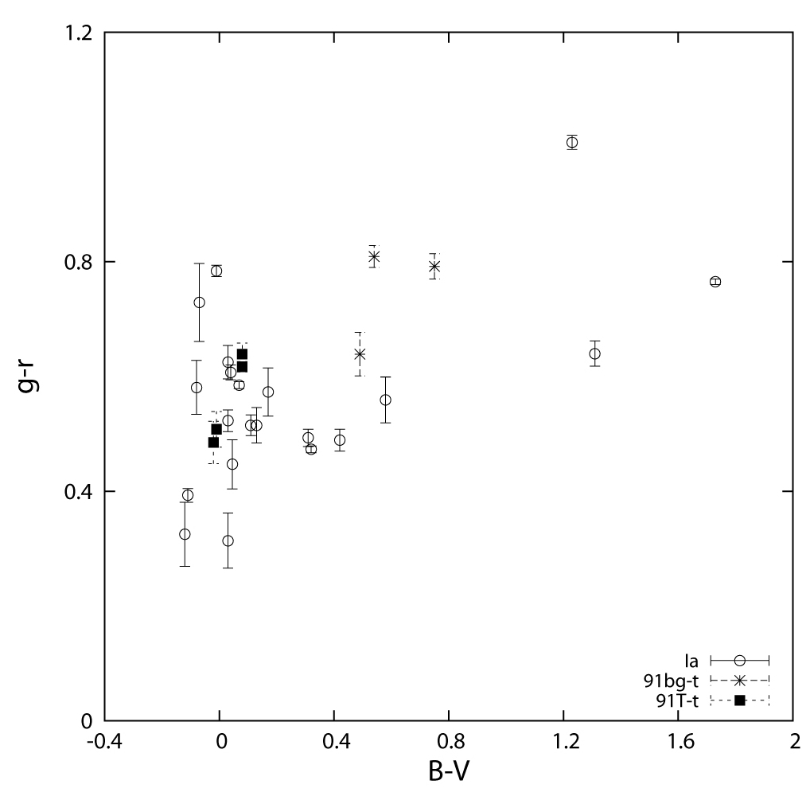

Figure 1: SN Peak B-V colors are plotted against environmental (g-r) underlying colors corresponding to 2-3Kpc in radius about the location of the SN. Observed blue colors are clearly seen in the galaxies with the bluest background colors. .(Johnson 2010).

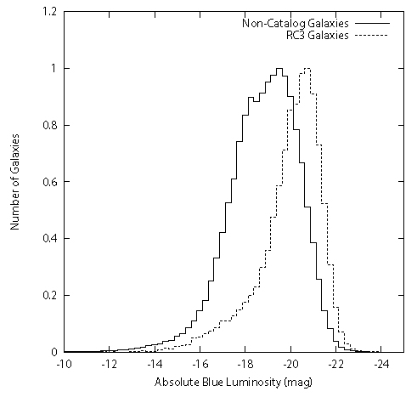
Figure 2: The distribution of absolute blue luminosity of galaxies from the RC3 and all other galaxies within cz <20,000
Figure 2: The distribution of absolute blue luminosity of galaxies from the RC3 and all other galaxies within cz <20,000.

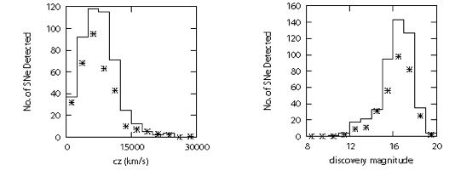
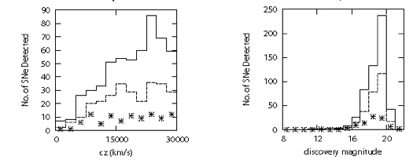
Figure 3: The redshift and discovery magnitude distributions for SN rate = 0.4SNu from distance-limited searches (searches targeting galaxies from the RC3). The asterisks are the real observational data and the solid line is the simulation.
Figure 4: The redshift and discovery magnitude distributions from magnitude-limited searches. The solid and dashed lines correspond to simulations for rates of 0.4SNu and the best fitting rate of 0.2SNu, respectively. The asterisks are the real observational data. Simulations include an extinction of Av = 1.

