Part 1: Each Question in this Section is worth 5 points: (40 points total)

1. A new object is discovered in the Solar System. Its orbital period is approximately how far way from the sun is this object? Good Performance

2. A newly discovered planetary system has a planet with a mass of 2 earth masses. What must the radius of this planet be for it to have the same density as that of the Earth? Mixed Performance

Some of you did not do any reality check and just said the new radius had to be twice the old radius. In that case, the new density would be 2/8 = ¼ of an Earth density.
3. A newly discovered planetary system has a planet with a mass of 20 earth masses and it is located in a similar part of that solar system as Uranus and Neptune in our own solar system. What would the approximate radius of this new planet be (in units or Earth Radii?) Mixed Performance
Remember the density in this part of the solar system is about 1.5 g/cc or about 4 times less than that of the Earth.
- What is the best method of probing the nature of the surface features of Venus? What are the limitations of this method? Answered pretty well
- Radar Topographic Measurements from Orbiting Satellite
- Limitations are a) can’t actually sample surface and b) resolution limited in the size of detected topographic features

5. Briefly explain why the Earth has a dense iron-nickel core and a lighter silicon-oxygen crust. Answered pretty well

Gravitational separation of dense and less dense elements in a molten fluid; iron-nickel sinks to core; silicon-oxygen rises to the top and cools forming the crust. Earth is molten due to the heat of accretion.
- Below are two images of a planetary surface. Which one is younger and explain how you know this. Answered pretty well Right one; Less craters; smoother appearance; no evidence of saturation

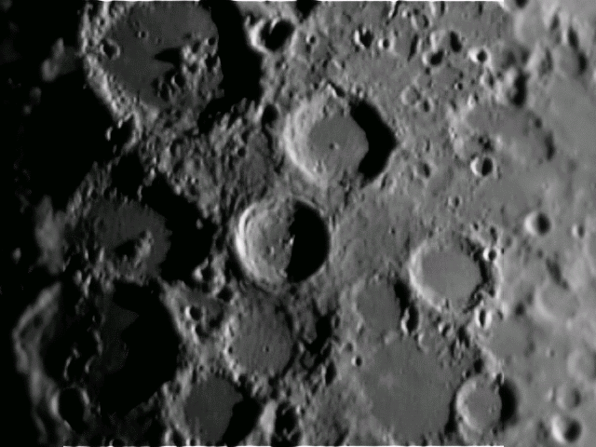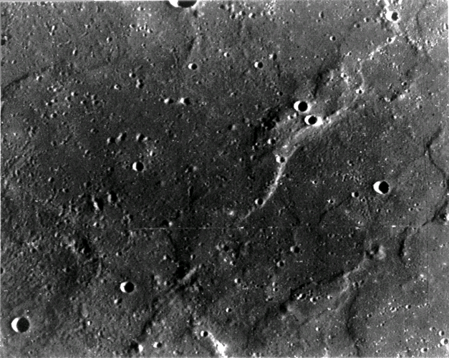
7. What is the principle heat source in the interior of the Earth that drives plate tectonics?

Mixed Performance

The decay of Uranium 238 which has a half-life of 4.5 billion years

8. On what planet is the Caloris Basin and why is this feature of significance in understanding planetary surface features. Answered pretty well

Mercury (not Venus or Saturn) → shows that planetary surfaces can withstand very large impacts and that such impacts can shock the opposite side of the planet causing geological features to emerge

Part II: Medium Answer Questions worth 10 points each (30 points total)

9. Explain why the observed retrograde motion of Mars is a problem in the Aristotelian Cosmology and what Ptolemy had to construct to resolve this problem. Answered pretty well but two key words (in bold below) were usually left out
- All the planets have to move in the same direction since they are stuck to spheres (crystalline) that revolve around the Earth. Therefore no planet can move backwards
- Wait, Mars moves backwards (i.e. exhibits retrograde motion), how can that be?
- Ptolemy builds a system with epicycles that allows Mars to periodically move backwards in its orbit about the earth.

10. Explain what is anomalous about the bulk properties of the moon and why this suggests it must have a special origin. Answered pretty well but some left out the actual density of the moon which is an important part of the overall answer
- If the moon formed by accretion then its density should be identical to the Earth’s
- Observed density is significantly lower, at 3.5 g/cc → similar to the density of Mars or the Earth’s Mantle
- Implies Moon formed in the vicinity of Mars or was somehow ripped out from the Earth’s mantle.
- Also the mass ratio of the moon to the earth is very high.

11. Describe Tycho’s experiment to prove that the Earth orbited the Sun. Why was he unable to prove this assertion from his data? Mixed Performance – many of you simply wrote down the words “stellar parallax” defining how that method works.
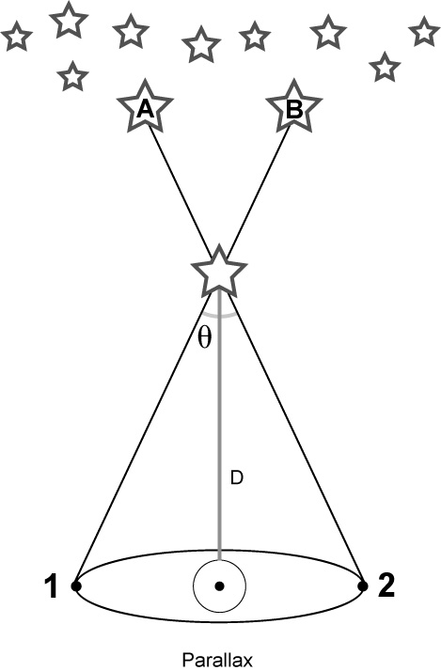
Stellar Parallax:
Observe stars 6 months apart and see if there is any movement of that particular star with respect to the background stars.
Tycho had no telescope and with the naked eye, the real parallax angle is less than the positional accuracy of the measurements. This is because even the nearest stars are unimaginably far away.

Part III: Longer answer Questions: Each question worth 15 points (30 points total)
- Explain why Pluto is no longer considered as a proper planet but instead is part of another, larger population in our Solar system.
Mixed Performance – most answers were incomplete in one way or another.

Elements of a complete answer include:

Its very small compared to the other outer planets

Its orbit is not very regular compared to the other outer planets

Its composition suggests its basically a large comet

With the discovery of the Kuiper Belt, it is now known that the solar system contains lots of relatively large cometisimals – Pluto seems to be merely the most massive example of this large solar system population

The larger objects in the Kuiper belt are now defined to be members of the dwarf icy planet category. There are 4-5 examples of this discovered in the last few years.

- Explain how the observed density gradient in the solar system was produced by its formation process.
Also answered at various levels of incompleteness

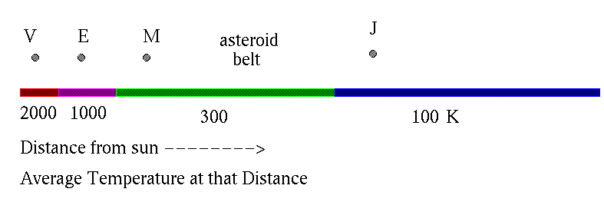
- The sun has to be radiating energy prior to planet formation
- The Only material that can exist as a solid at temperatures of 1000 K are rocks/rocky grains
- 90% of the initial protoplanetary material is ice and 10% is rock (this crucial point was left out in a lot of responses)
- With the sun as a heating source – only small rocky planets can form in the inner solar system but large balls of mostly ice can form in the outer solar system
- Outer icy planets can have a rocky core due to the initial 90% - 10% rock/ice ratio.

