Notes on the homework:

Part I:

Question 1-4 were pretty straightforward. Place an aperture on a star and then place the second aperture on the background (which contains no star in that aperture). The difference in counts between those two apertures is basically the brightness of the star (e.g. its apparent flux on the detector). For example:

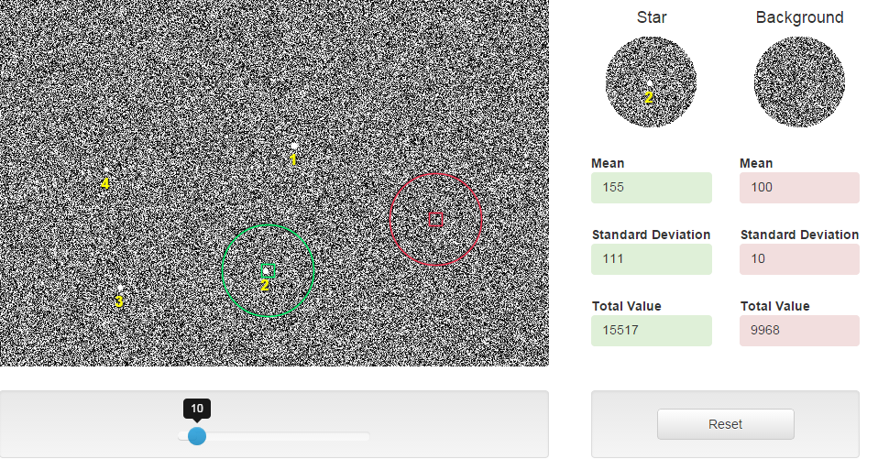

So the net count in this case is 55 in 10 seconds or 5.5 counts per second (which is effectively the received energy flux from Star 2 in this example)

Question 5: The background counts are essentially the same; any small differences are just a manifestation of random noise. This indicates the background is uniform and not systematically biased by the detector.

Question 6-7: A 1 second exposure for star 4 looks like this:

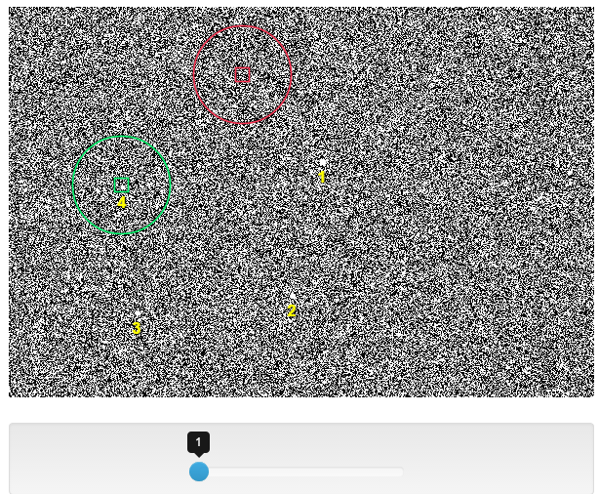

In this short exposure, random noise dominates the image and washes out the signal from the star so that it is barely detectable.

Questions 8-13:

Below are the 4 images for A,B,C and D.

A B

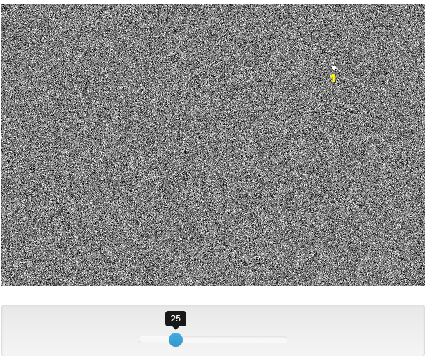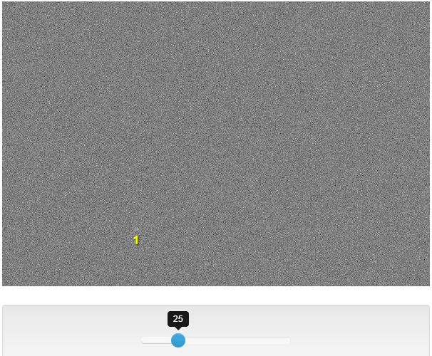

C D

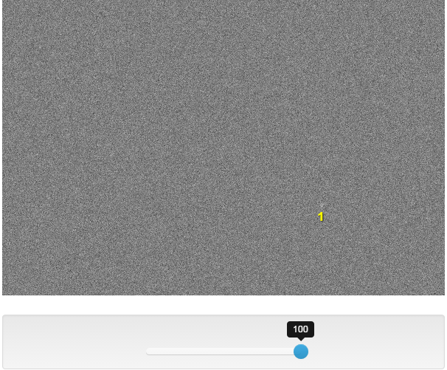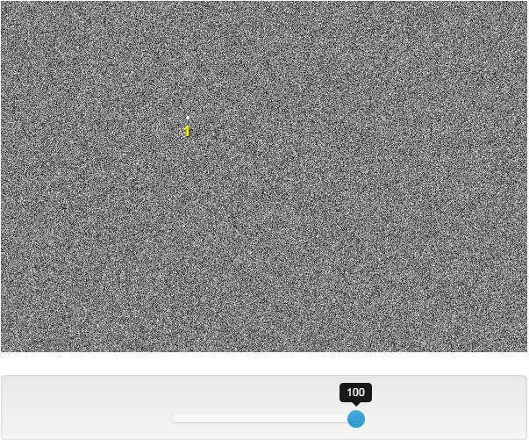

Things to notice between A,B,C and D (and you probably want to zoom this document to 200% to better notice).

- The actual image of the star in D is contained in a very small number of pixels – hardly anyone noticed this.

- The background counts are 10 times higher in image B compared to image A making that same star harder to detect in observing condition B compared to A (e.g. C has moonlight in it).

- Condition C is the case where atmospheric smearing is large, so the image of the star is spread out over many pixels and the signal to noise per pixel is very low (compared to condition D which was taken in space – no atmospheric aberration, hence a very small image on the pixel detector.

So every observation has sources of noise and background issues that determine the kinds of objects you can detect. In the case of high background, high detector noise, you simply can’t detect faint stars. In addition, atmospheric motions when observing from the ground smear out images thus making it again difficult to detect faint stars. This is why the Hubble Space Telescope exists and is able to detect stars that are approximately 100 times fainter than can be detected from the ground.

Part II: (Note this refers to a different simulator but the principles are all the same – this one just shows the optical spectrum colors much better)

Set T = 8000 and the simulator should look like this:

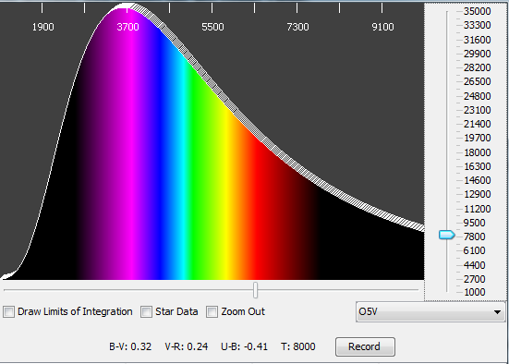

The peak wavelength (where the white curve reaches its highest point) is about 3750 angstroms. Since the wavelength of peak emission is inversely proportional to temperature then if you ½ the temperature (from 4000 to 8000) then the peak emission shifts from 3750 angstroms to about 7500 angstroms (i.e. in the red). This proportionality is Wien’s Law, described in the text:

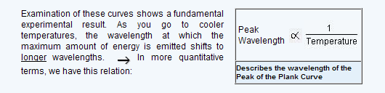

The next set of questions has to do with determining the temperature sensitivity of the B-V index to small changes in temperature around some given temperature. So for a star with B-V = 0.50 the corresponding temperature is about 6550 K

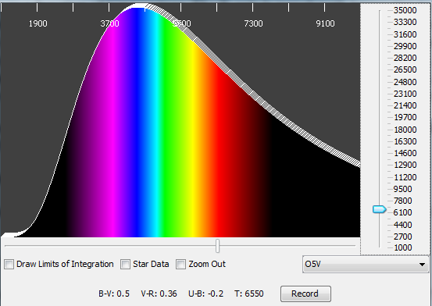

Raising the or lowering the temperature by about 500K will produce a 0.1 change in B-V:

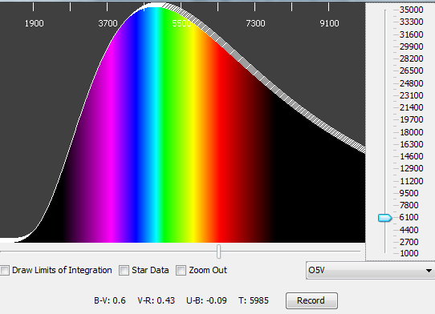

Indeed, a 1% change in B-V is produced by a temperature change of about +/- 40 degrees. Thus in this temperature range if you could accurately measure B-V you could measure stellar atmospheric temperatures to a precision of +/- 40 degrees or so. This accuracy exists in this filter system because both B and V sample the flux near the peak of the flux curve.

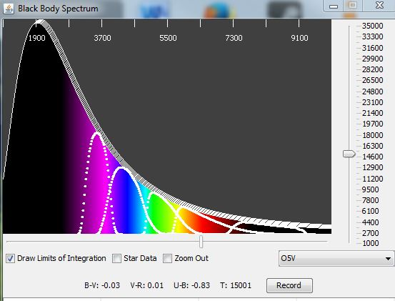
But when you move to hotter stars, B-V is not very sensitive to changes in temperature. Indeed at 15000 degrees B-V =-0.03 and to change it by 10% (e.g. a value of 0.1 in B-V) would require a change of 5000 degrees! This means that you can not use this filter system to accurately measure the temperatures of hot stars. This is because hardly any energy from the star even falls in the B and V bands. This is apparent when you look at the simulation as you can see that the B and V filters are well beyond the peak of energy emission. Few students commented on this but instead inserted some extraneous answer coming from Web surfing. Often time, more correct responses are based on directly what you’re looking at.

You would need to make Ultraviolet observations outside the Earth’s atmosphere using a satellite to get a good estimate of the stellar temperature because clearly most of the flux from the star is at wavelengths less than the atmospheric cutoff (and therefore does not penetrate through the atmosphere to even reach a telescope on the ground) as shown for this case above.

Finally, the basic point is that the relation between energy emitted from a blackbody (a star) and its temperature is NON-LINEAR which means that small changes in temperature will produce large changes in the total energy emitted.

