When you first launch detector you will see this:

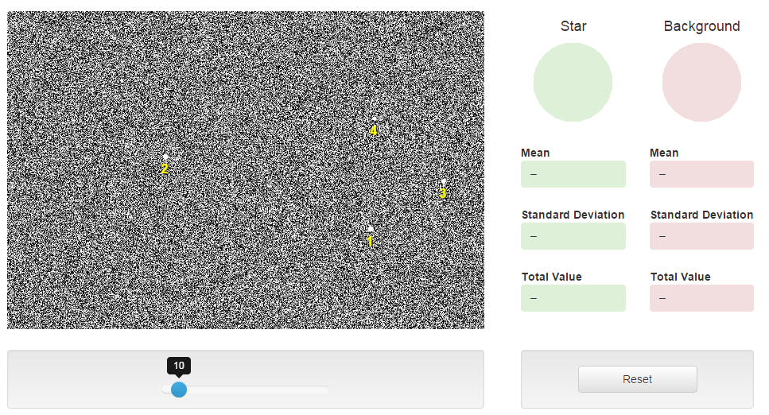

There are four marked stars in the image above with the default exposure time of 10 seconds - sliding the blue dot increases or decreases the exposure time. Important note: The positions of the 4 stars are randomly determined so the layout will not look exactly like it does above on your screen – but all four stars will be there.

To measure the brightness of a star, follow this procedure.

1. When you mouseover the detector image a reticle will appear:

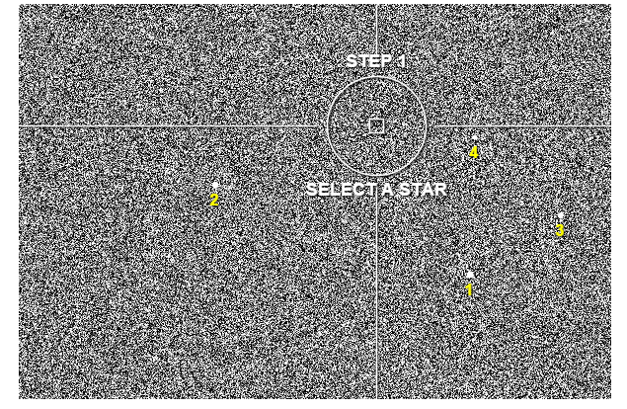

2. Position the center square over one of the stars and click. In the example below it is over star 1. Upon clicking you will populate the green readout boxes with numbers. For the exercise you will only care about the number in the box labelled MEAN, which in this case is 215.

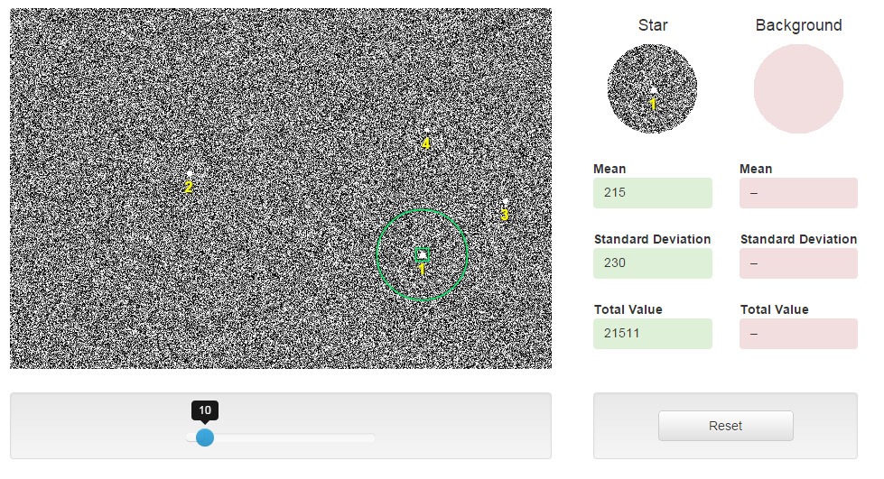

3. Next select the background, which should be some region of the image that contains no stars. Upon clicking the numbers will populate the red boxes. These numbers represent the average number of photons that are recorded in the green and red square apertures – in this case there are 99 counts in the red aperture.

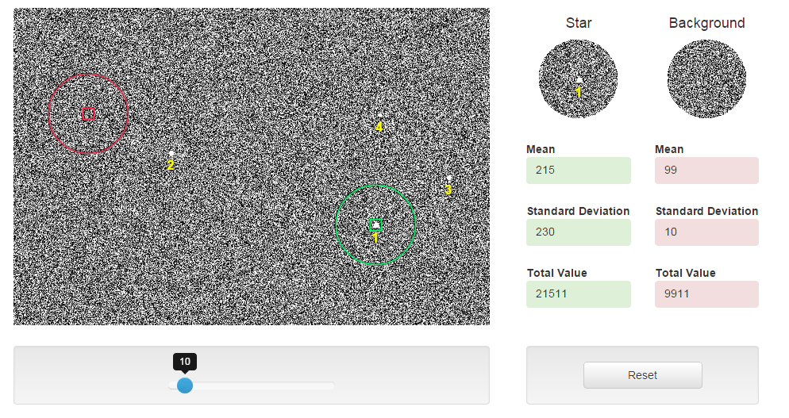

4. Now to the important thing: Whenever we take an image of the sky, there is always background light – the sky is not infinitely dark. So to DETECT a star, it means that the photon count in the star has to be higher than the photon count in the background. That leads to the concept of NET counts.

The green box counts = star + background

The red box counts = background

Green – Red = (star + background) – (background) = star.

Therefore the brightness of this star is 215 – 99 = 116 units for this exposure time of 10 seconds. Obviously the number of photons counted will depend on the exposure time, longer exposure time more photons are collected in BOTH the star and the background. This is why you’re measuring NET counts in this exercise and making inferences from that.

5. Make sure to hit the RESET button after each measurement. Please note: there is a small bug – reset doesn’t clear out the background box so as soon as you select another star, the background box will populate – just ignore that and make a new background measurement.