Astronomy 122 mid Term Exam

Name: __________________________
Please confine your answers to the space provided and make sure to write legibly. Remember to show all work. There are a total of 160 points on this exam. This exam consists of three parts:
- Part 1: 10 Short Questions @3 points each
- Part 2: 8 Medium Answer Questions @5 points each
- Part 3: 9 Longer Answer Questions @10 points each
Part 1: Each Question in this Section is worth 3 points: (30 points total)

- If a 7500 K blackbody has a wavelength of peak emission at 4000 angstroms, what would the wavelength of the peak admission for a blackbody at a temperature of 2500K?

7500/2500 = 3 → 3*4000 = 12,000

Use the blackbody simulator to get a better feel for this inverse relation and review the material in Module 1 Lecture F. Also, as I said in class, if this inverse relation did not hold then cooler objects would be emitting short wavelength high energy photons which doesn’t make any physical sense because then a source at absolute zero would be emitting photons of infinite energy.

- Star A has a B-V color index of 1.0. Star B has a B-V color index of 0.5. Which star is hotter and how do you know this?

B-V is a measure of the ratio of flux through the blue filter to flux through the visual (green) filter. The more flux there is in B relative to V the hotter the star and the lower the B-V index is. Again, observe the change in B-V color in the blackbody simulator.

- Star A has a surface temperature of 4000 degrees (K). Star B has a surface temperature of 8000 degrees (K). Both stars have the same radius. What is the luminosity ratio of Star B to Star A?

This is all covered in Module 2 Lecture A and it was done in class on more than one occasion. It is fundamental to blackbody radiation that the total energy emitted goes as the 4th power of the temperature. Therefore Star B emits 2^4 =16 times more energy than Star A since its twice as hot.

- You make parallax measurements of two stars. Star A is observed to have a parallax of 1/4 of an arc second. Star B is observed to have a parallax of 1/2 of an arc second. What the ratio of distance of Star A to Star B?

Parallax angles (Module 3-A) are measured in units of arc seconds. As the distance increases the angle gets smaller directly proportional to that distance increase.

¼ is twice as small as ½ therefore Star A is twice as far away as Star B

- Star A and Star B have identical intrinsic energy outputs. Star A is at a distance of 2 light years and registers a flux of 2 units on the observer's detector. Star B is located at a distance of 4 light years. What is the flux on the observer's detector from Star B?

B is twice as far away, flux is down by ¼ so its 2/4 =0.5

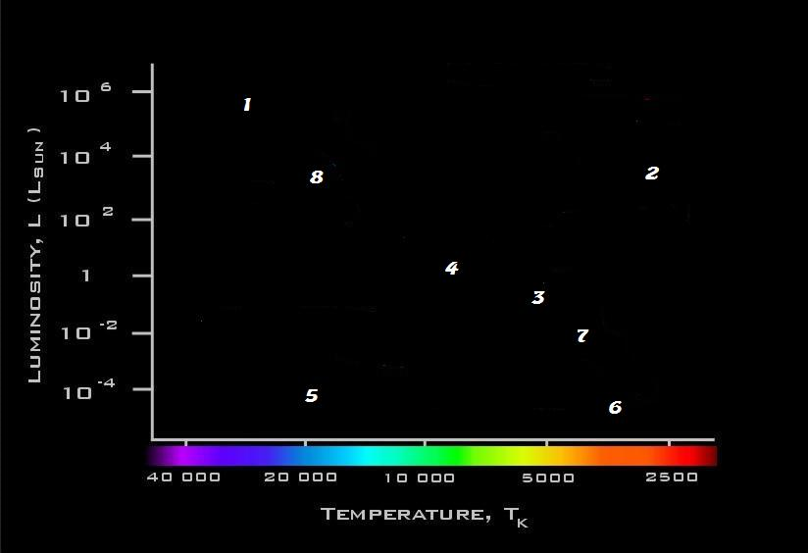

Questions 6 – 10 refer to the above diagram.

- Which star has the highest luminosity? 1 (this is obvious)

- Which star has the longest main sequence lifetime? 6

- Which star is fusing Helium as its primary energy source? 2 (this is a Red Giant)

- Which star has the lowest mass? (6) (but full credit given for 5 as well)

- Which star is most like our sun? (3) but 2 pts for 4 or 7; star 3 has a luminosity of 1 solar luminosity (Y-axis)

Part 2: Each Question in this Section is worth 5 points: (40 points total)

1. Suppose some simplified atom has 3 energy states. The ground state has zero energy, the first excited state has energy = 5 units above the ground state and the second excited state has energy = 7 units above the ground state. If an electron resides in the first excited state, describe what kinds of photon emission or absorption could happen in this case.

Either a photon of 5 units can be emitted or a photon of 2 units can be absorbed.
You observe 4 stars in the sky. Their properties are summarized in the table below:
Star | Flux on Detector  (Arbitrary Units) | Distance  (Light Years) | Observed  Color
A | 2 | 2 | Blue
B | 4 | 4 | Red
C | 5 | 4 | Very Blue/White
D | 16 | 1 | Yellow

- Which of these stars has the coolest surface temperature and how do you know this?

Star B because it is red

- Which of these stars has the highest luminosity?

Move all stars to the same distance to determine the Luminosity.

Simplest to move to 4 LY since B and C are already there. Since all the stars are now at the same distance, then their fluxes are an indicator of their luminosity, but only after you have corrected for the differing distances.

At 4 LY

Flux of star A = 2*(1/2)^2 = 0.5
Flux of star B = 4
Flux of star C = 5
Flux of star D = 16*(1/4)^2 =1

Star C has the highest flux and therefore the highest luminosity (because again all stars are at the same distance)
- What is the ratio of luminosities between Star D and Star A?
From above: 1/.5 = 2
Most of you simply said it was 16/2 = 8 but how can this be the luminosity ratio since Star A and Star D are not at the same distance? The question did not ask “what is the ratio of the observed fluxes”.
Flux = L/D^2 → this concept will be on the final as well

- Explain how astronomers quantitatively measure the "color" of a star
This question was answered remarkably poorly. The simplest answer (again in the blackbody simulator) is that astronomers put filters in front of a digital camera and measure filter flux ratios.

A typical student answer to this question was:
“They measure the temperature of the star” … (well how do they measure the temperature? - via the method stated above!)

- Explain why it is difficult to make accurate distance measurements to nearby stars by using ground based telescopes.
Atmospheric motions smear out the images of the stars so that the error in the positional accuracy is comparable to the actual parallax value. Have to make many measurements and average them.

Most students made no reference to the blurring effects of the atmosphere but merely used the buzz word “atmospheric noise” or “atmospheric blockage” – while you got partial credit for this, its rather far from the correct answer shown above.
.
- List two physical characteristics that are common for all main sequence stars, independent of their mass
All fuse hydrogen in core
All are stable (radius= stable; P=G)

- Briefly explain how stellar masses can be determined.
This is fully covered in Module 3 Lecture D. The only direct way to measure stellar masses is through observations of binary stars. From those observations it becomes possible to construct (empirically) the Mass Luminosity relationship for main sequence stars (e.g. Homework 2 question).

Part 3: Each Question in this Section is worth 10 points: (40 points total)

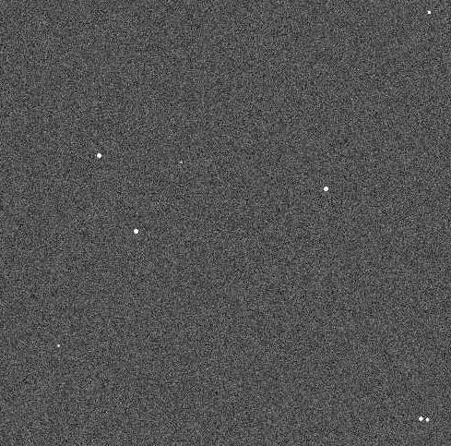

1. The above images show two exposures of the same star field. The exposure on the right is 1 seconds, the exposure on the left is 50 second. Explain why you can more easily detect the stars in the 50 second exposure than in the 1 second exposure.
This question was answered well. Longer exposures serve to suppress or reduce the amount of detector and background noise.

2. Explain what astronomers’ measure in order to determine the spectral type of a Star and why astronomers are interested in determining spectral types.

They measure absorption line strengths relative to one another – for example the ratio of calcium lines to hydrogen lines. The equivalent width method is used to measure the line strengths. Spectral types more accurately measure temperature than does, say, B-V color index.

Most students didn’t come close to providing this kind of answer even though it was the basis for the Homework 3 assignment of determining spectral types!

A typical answer was something like this:

“Astronomers measure the color and luminosity of a star to determine its spectral type. “

NO – spectral types are measured from absorption line spectra (hence the name spectral type) in the same way you did for Homework 3.

- Explain why the fusion of helium requires a higher temperature than the fusion of hydrogen.

The electrostatic repulsion of 4 protons is a lot more than 2 single protons. Need a higher temperature to overcome this.

A lot of student answered use terms like Helium is more “dense” or more “complex” than hydrogen (I don’t know what that means) or that Helium has more electrons than hydrogen – electrons are irrelevant – these are atomic nuclei, protons and neutrons.

- Explain why the main sequence lifetime of a star is strongly dependent on its mass.

The core temperature is determined by the mass. The fusion rate is a very strong function of the core temperature. More massive stars therefore have higher core temperatures which burns up the available material much faster.

At least ½ of the students said that more massive stars obviously have longer lifetimes because they have more mass to burn. This clearly misses out on the crucial point that the luminosity of a star is critically dependent on the core mass and the more massive stars simply burn up their material faster.

- You observe a stellar cluster and make an HR diagram of the stars in it. From that you notice that the most massive star that is still on the main sequence is 2 solar masses. What is the approximate age of this cluster and how is this age determined?

See Module 4 Lecture A

Main sequence lifetime of a 2 solar mass star is about 1/8 that of a 1 solar mass star which we know to be 10 billion years (because it was mentioned in class a lot). Therefore the cluster is about 1 billion years old as all stars more massive than 2 solar masses have evolved off the main sequence.

Overall this question was answered poorly:

Here is an example that got ½ credit – again even though it’s not even close to correct:

“You determine the age by looking at the stars around it. Since they are in a stellar cluster they are the same age. The age of the star is 2 times the age of the Sun.”

Or

“The most massive star still on the main sequence that is 2 solar masses will be 10 billion years old and it is determined by astronomical measurements and observational data”

I told you this exam was graded liberally!

- Explain why low mass stars such as the sun can never produce any elements heavier than Carbon or Oxygen.

They can never achieve the requisite core temperature (about 2 billion K) to initiate Carbon burning because there is insufficient mass available to generate that high of temperature.

This question generated a lot of confused responses that were well beyond the simple issue of insufficient core mass to generate the requisite temperature for Carbon fusion. Many students talked about the star being unstable (its not).
For instance:

“Low mass stars cannot produce elements heavier than Carbon and Oxygen because it could not maintain or be stable with any heavier elements”

Or

“Low mass stars can not handle any heavier amount of photons or electrons”

(yes, many people wrote photon when they meant proton)

- When hydrogen fusion is occurring in a thin shell around the core, explain what will happen to both the region of the star interior to that shell (e.g. the core) and exterior to that shell (e.g. the envelope).

  - as the shell temperature rises the luminosity of the star steadily increases
  - the pressure of the shell causes the envelope to expand and cool
  - the pressure of the shell also causes the core to collapse faster further increasing the rate at which the shell heats and subsequently the luminosity of the star increased
  - this continues until the core stabilizes and begins to fuse Helium

Again student response was mixed here:

“When hydrogen fusion is occurring in a thin shell around the core, the core will push away any electrons that the envelope was unable to block”

“Both the core will heat up and the envelope will collapse causing everything to speed up and heat up. The star will either collapse or expand”

Again, points were awarded for these kinds of responses.

- Explain the post main sequence evolutionary process of a star that leads to much of the mass of the star being lost and to the brief appearance of the planetary nebula phase of stellar evolution.

Similar to the initial post main sequence evolution raised in the previous question. In this case we are beyond the red giant core helium burning stage and now there is a double shell source (H; He – due to the collapsing carbon core)) which applies so much pressure to the outer layers of the star that they are just driven off completely thus exposing the inner hot core. Those outer layers also see a hotter star and become ionized and the ionizing gas glows, thus forming the extended, observed nebula.

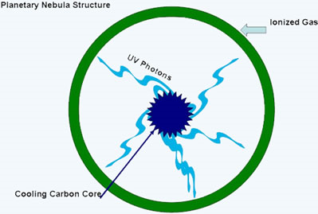

Note that this has nothing to do with Supernova but about 1/3 of the student responses talked about supernova.

- We observe a binary star system in which both stars have the same physical age. However, one of these stars is a 10 solar mass main sequence star while its companion is a 1 solar mass white dwarf. Explain what is odd about this system and provide a plausible explanation for this apparently paradoxical observation (note that such real systems do exist in our Galaxy.

It’s odd because the low mass star is in an advanced evolutionary stage with respect to the high mass star even though both stars have the same physical age.
The 1 solar mass star must have been originally more massive than the 10 solar mass star and simply lost all its mass during the course of post main sequence evolution.

