Campbell Biology in Focus, 2e (Urry)
Chapter 5 Membrane Transport and Cell Signaling

5.1 Multiple-Choice Questions

1) The fluid mosaic model of the membrane proposed that membranes
A) consist of a phospholipid bilayer composed of a variety of fatty acids.
B) consist of protein molecules embedded in a fluid bilayer of phospholipids.
C) consist of a single layer of phospholipids and proteins.
D) consist of a phospholipid bilayer between two layers of hydrophilic proteins.
Answer: B
Topic: Concept 5.1
Skill: Knowledge/Comprehension
Learning Outcome: 5.1

2) Which of the following are localized on the exterior of a phospholipid bilayer?
A) saturated fatty acids
B) unsaturated fatty acids
C) phosphate groups
D) cholesterol
Answer: C
Topic: Concept 5.1
Skill: Knowledge/Comprehension
Learning Outcome: 5.1

3) The primary structural components of the cell membrane are
A) phospholipids and cellulose.
B) phospholipids and proteins.
C) cholesterol and proteins.
D) proteins and cellulose.
E) glycoproteins and cholesterol.
Answer: B
Topic: Concept 5.1
Skill: Knowledge/Comprehension
Learning Outcome: 5.1

4) When biological membranes are frozen and then fractured, they tend to break along the middle of the bilayer. The best explanation for this is that
A) the integral membrane proteins are not strong enough to hold the bilayer together.
B) water that is present in the middle of the bilayer freezes and is easily fractured.
C) the hydrophobic interactions between the fatty acid tails of the two phospholipid monolayers are the weakest interactions in the membrane.
D) the carbon-carbon bonds of the phospholipid tails are easily broken.
Answer: C
Topic: Concept 5.1
Skill: Application/Analysis
Learning Outcome: 5.1
Global L.O.: G2
5) A primary function of cholesterol in the plasma membranes of some animals is to
A) make the membrane more rigid, allowing it to resist pressure from outside the cell.
B) facilitate the removal of hydrogen atoms from saturated phospholipids.
C) facilitate cell-cell interactions by binding to receptors on neighboring cells.
D) enable the membrane to stay fluid more easily when the temperature drops.
Answer: D
Topic: Concept 5.1
Skill: Knowledge/Comprehension
Learning Outcome: 5.1

6) According to the fluid mosaic model of cell membranes, which of the following is a true statement about membrane phospholipids?
A) They can move laterally along the plane of the membrane.
B) They frequently flip-flop from one side of the membrane to the other.
C) They occur in an uninterrupted bilayer, with membrane proteins restricted to the surface of the membrane.
D) They are free to depart from the membrane and dissolve in the surrounding solution.
Answer: A
Topic: Concept 5.1
Skill: Knowledge/Comprehension
Learning Outcome: 5.1

7) Which of the following is one of the ways that the membranes of winter wheat are able to remain fluid when it is extremely cold?
A) by increasing the average length of the fatty acid tails in membrane
B) by decreasing the percentage of cholesterol molecules in the membrane
C) by decreasing the number of hydrophobic proteins in the membrane
D) by increasing the percentage of unsaturated phospholipids in the membrane
Answer: D
Topic: Concept 5.1
Skill: Knowledge/Comprehension
Learning Outcome: 5.1

8) An integral membrane protein would have to be
A) hydrophilic.
B) hydrophobic.
C) amphipathic, with at least one hydrophobic region.
D) exposed to water on only one surface of the membrane.
Answer: C
Topic: Concept 5.1
Skill: Evaluation/Synthesis
Learning Outcome: 5.1
Global L.O.: G2
9) Which of the following tend to lack hydrophobic regions on their surface?
A) transmembrane proteins
B) integral proteins
C) peripheral proteins
D) integrins
E) cholesterol
Answer: C
Topic: Concept 5.1
Skill: Knowledge/Comprehension
Learning Outcome: 5.1

10) How do unsaturated fatty acids help keep any membrane more fluid at lower temperatures?
A) The double bonds form kinks in the fatty acid tails that prevent adjacent lipids from packing tightly together.
B) Unsaturated fatty acids have a higher cholesterol content that prevents adjacent lipids from packing tightly together.
C) Unsaturated fatty acids are more polar than saturated fatty acids.
D) The double bonds result in shorter fatty acid tails and therefore thinner membranes.
Answer: A
Topic: Concept 5.1
Skill: Knowledge/Comprehension
Learning Outcome: 5.1

11) Which of the following is true of integral membrane proteins?
A) They serve only a structural role in membranes.
B) They are loosely bound to the surface of the bilayer.
C) They are usually transmembrane proteins.
D) They are not mobile within the bilayer.
Answer: C
Topic: Concept 5.1
Skill: Knowledge/Comprehension
Learning Outcome: 5.1

12) A primary function of polysaccharides attached to glycoproteins and glycolipids of animal cell membranes is to
A) facilitate diffusion of active transport of molecules into the cell.
B) mediate cell-to-cell recognition.
C) maintain the integrity of a fluid mosaic membrane.
D) maintain membrane fluidity at low temperatures.
Answer: B
Topic: Concept 5.1
Skill: Knowledge/Comprehension
Learning Outcome: 5.1

13) A protein that spans the phospholipid bilayer one or more times is
A) a transmembrane protein.
B) a glycoprotein.
C) a peripheral protein.
D) an extracellular matrix protein.
Answer: A
Topic: Concept 5.1
Skill: Knowledge/Comprehension
Learning Outcome: 5.1
14) The movement of the hydrophobic gas nitrous oxide (N2O) (laughing gas) into a cell is an example of
A) active transport across the lipid bilayer.
B) facilitated diffusion through the lipid bilayer.
C) diffusion through the lipid bilayer.
D) osmosis through the lipid bilayer.
E) cotransport across the lipid bilayer.
Answer: C
Topic: Concept 5.2
Skill: Application/Analysis
Learning Outcome: 5.2

15) The cell membranes of Antarctic ice fish might have which of the following adaptations?
A) a high percentage of very long chain saturated fatty acids
B) no cholesterol
C) a high percentage of unsaturated fatty acids
D) a high percentage of trans fatty acids
Answer: C
Topic: Concept 5.1
Skill: Application/Analysis
Learning Outcome: 5.1
Global L.O.: G2

16) Why are lipids and proteins free to move laterally in membranes?
A) The interior of the membrane is filled with liquid water.
B) Lipids and proteins repulse each other in the membrane.
C) Phospholipids form hydrogen bonds with water at the membrane surface, which moves the lipids as water moves.
D) Weak hydrophobic interactions in the interior of the membrane are easily disrupted.
Answer: D
Topic: Concept 5.1
Skill: Knowledge/Comprehension
Learning Outcome: 5.1

17) Which of the following provides the most likely explanation for why cell membranes are asymmetrical?
A) Proteins only function on the cytoplasmic side of the cell membrane, which results in asymmetry across the membrane.
B) Cell-to-cell communication requires different proteins on the surfaces of interacting cells.
C) The molecular composition of the inner and outer layers of the cell membrane is determined by genes.
D) The two sides of a cell membrane face different environments and carry out different functions.
Answer: D
Topic: Concept 5.1
Skill: Evaluation/Synthesis
Learning Outcome: 5.1
Global L.O.: G2
18) Which of the following is true for the evolution of cell membranes?
A) The fluid mosaic nature of cell membranes provides for the rapid evolution of cell membranes.
B) The evolution of cell membranes is driven primarily by the evolution of phospholipids as a result of natural selection.
C) The evolution of cell membranes is driven primarily by the evolution of glycoproteins and glycolipids as a result of natural selection.
D) The evolution of cell membranes is driven by the evolution of all membrane components as a result of natural selection.
Answer: D
Topic: Concept 5.1
Skill: Evaluation/Synthesis
Learning Outcome: 5.1
Global L.O.: G2

19) What kinds of molecules pass through a cell membrane most easily?
A) large hydrophobic
B) small hydrophobic
C) large polar
D) small ionic
E) large and hydrophilic
Answer: B
Topic: Concept 5.2
Skill: Knowledge/Comprehension
Learning Outcome: 5.2

20) Which of the following is a characteristic feature of a carrier protein in a plasma membrane?
A) It is a peripheral membrane protein.
B) It exhibits a specificity for a particular type of molecule.
C) It requires the expenditure of cellular energy to function.
D) It works against a concentration gradient.
Answer: B
Topic: Concept 5.2
Skill: Knowledge/Comprehension
Learning Outcome: 5.2

21) Which of the following would diffuse through the lipid bilayer of a plasma membrane most rapidly?
A) glucose
B) starch
C) O2
D) Na+
E) an amino acid
Answer: C
Topic: Concept 5.2
Skill: Application/Analysis
Learning Outcome: 5.2
Global L.O.: G2
22) Which of the following would diffuse through the lipid bilayer of a plasma membrane most slowly, if at all?
A) glucose
B) an amino acid
C) O2
D) CO2
E) water
Answer: B
Topic: Concept 5.2
Skill: Application/Analysis
Learning Outcome: 5.2
Global L.O.: G2

23) Which of the following statements about diffusion is correct?
A) It is very rapid over long distances.
B) It requires an expenditure of energy by the cell.
C) It is a passive process in which molecules move from a region of higher concentration to a region of lower concentration.
D) It is an active process in which molecules move from a region of lower concentration to one of higher concentration.
E) It is a passive process in which molecules move from a region of lower concentration to a region of higher concentration.
Answer: C
Topic: Concept 5.2
Skill: Knowledge/Comprehension
Learning Outcome: 5.2

24) Water passes quickly through cell membranes because
A) the bilayer is hydrophilic.
B) it moves through hydrophobic channels.
C) water movement is tied to ATP hydrolysis.
D) it is a small, nonpolar molecule.
E) it moves through aquaporin channel proteins.
Answer: E
Topic: Concept 5.2
Skill: Knowledge/Comprehension
Learning Outcome: 5.2
25) Celery stalks that are immersed in fresh water for several hours become turgid (stiff). Celery stalks left in a 0.15 M salt solution become flaccid (limp). From this we can deduce that
A) the fresh water and the salt solution are both hypertonic to the cells of the celery stalks.
B) the fresh water and the salt solution are both hypotonic to the cells of the celery stalks.
C) the fresh water is hypertonic and the salt solution is hypotonic to the cells of the celery stalks.
D) the fresh water is hypotonic and the salt solution is hypertonic to the cells of the celery stalks.
E) the fresh water is isotonic and the salt solution is hypertonic to the cells of the celery stalks.
Answer: D
Topic: Concept 5.3
Skill: Application/Analysis
Learning Outcome: 5.3
Global L.O.: G2

26) Mammalian blood contains the equivalent of 0.15 M NaCl. Seawater contains the equivalent of 0.45 M NaCl. What will happen if red blood cells are transferred to seawater?
A) Water will leave the cells, causing them to shrivel and collapse.
B) NaCl will be exported from the red blood cells by facilitated diffusion.
C) The blood cells will take up water, swell, and eventually burst.
D) NaCl will passively diffuse into the red blood cells.
Answer: A
Topic: Concept 5.3
Skill: Application/Analysis
Learning Outcome: 5.3
Global L.O.: G2

27) Which of the following statements correctly describes the normal tonicity relationships between typical plant and animal cells and their respective environments?
A) Animal cells are generally in a hypotonic solution, and plant cells are generally in an isotonic solution.
B) Animal cells are generally in an isotonic solution, and plant cells are generally in a hypotonic solution.
C) Animal cells are generally in an isotonic solution, and plant cells are generally in a hypertonic solution.
D) Animal cell are generally in a hypertonic solution, and plant cells are generally in an isotonic solution.
E) Animal cells are generally in a hypertonic solution, the plant cells are generally in a hypotonic solution.
Answer: B
Topic: Concept 5.3
Skill: Knowledge/Comprehension
Learning Outcome: 5.3
28) Submerging a plant cell in distilled water will result in
A) plasmolysis of the cell.
B) lysis of the cell membrane.
C) bursting of the cell.
D) the cell becoming turgid.
E) the cell becoming flaccid.
Answer: D
Topic: Concept 5.3
Skill: Application/Analysis
Learning Outcome: 5.3

29) Submerging a red blood cell in distilled water will result in
A) plasmolysis of the cell.
B) lysis of the cell.
C) the cell becoming turgid.
D) the cell becoming flacid.
Answer: B
Topic: Concept 5.3
Skill: Application/Analysis
Learning Outcome: 5.3

30) Submerging a red blood cell in a hypertonic solution will result in
A) plasmolysis of the cell.
B) lysis of the cell.
C) the cell becoming turgid.
D) the cell wall shriveling.
Answer: D
Topic: Concept 5.3
Skill: Application/Analysis
Learning Outcome: 5.3

31) Glucose diffuses slowly through artificial phospholipid bilayers. The cells lining the small intestine, however, rapidly move large quantities of glucose from the glucose-rich food into their glucose-poor cytoplasm. Based on this information, which transport mechanism is most likely responsible for glucose transport in the intestinal cells?
A) simple diffusion
B) phagocytosis
C) active transport pumps
D) facilitated diffusion
Answer: D
Topic: Concept 5.3
Skill: Application/Analysis
Learning Outcome: 5.3
Global L.O.: G2
32) Which of the following membrane activities requires energy from ATP hydrolysis?
A) facilitated diffusion of chloride ions across the membrane through a chloride channel
B) movement of water into a cell through aquaporins
C) movement of sodium ions from a lower concentration in a mammalian cell to a higher concentration in the extracellular fluid
D) movement of glucose molecules into a bacterial cell from a medium containing a higher concentration of glucose than inside the cell
E) movement of carbon dioxide out of a paramecium
Answer: C
Topic: Concept 5.4
Skill: Application/Analysis
Learning Outcome: 5.4

33) Which of the following is most likely true of a protein that cotransports glucose and sodium ions into the intestinal cells of an animal?
A) Sodium and glucose bind to the same site on the cotransporter.
B) Transport of glucose against its concentration gradient provides energy for uptake of sodium ions against the electrochemical gradient.
C) Sodium ions can be transported whether or not glucose is present outside the cell, but glucose transport requires cotransport of sodium ions.
D) Transport of sodium ions down their electrochemical gradient facilitates the transport of glucose against its concentration gradient.
E) Following transport of sodium ions into the cell, the cotransporter can also transport potassium ions out of the cell.
Answer: D
Topic: Concept 5.4
Skill: Application/Analysis
Learning Outcome: 5.4
Global L.O.: G2

34) The phosphate transport system in bacteria imports phosphate into the cell even when the concentration of phosphate outside the cell is much lower than the cytoplasmic phosphate concentration. Phosphate import depends on a pH gradient across the membrane–more acidic outside the cell than inside the cell. Phosphate transport is an example of
A) passive diffusion.
B) facilitated diffusion.
C) active transport.
D) cotransport.
E) receptor-mediated endocytosis.
Answer: D
Topic: Concept 5.4
Skill: Knowledge/Comprehension
Learning Outcome: 5.4
35) What is the voltage across a membrane called?
A) water potential
B) chemical gradient
C) membrane potential
D) osmotic potential
E) electrochemical gradient
Answer: C
Topic: Concept 5.4
Skill: Knowledge/Comprehension
Learning Outcome: 5.4

36) The sodium-potassium pump is called an electrogenic pump because it
A) pumps electrons across the plasma membrane.
B) pumps hydrogen ions out of the cell.
C) contributes to the membrane potential.
D) ionizes sodium and potassium atoms.
Answer: C
Topic: Concept 5.4
Skill: Knowledge/Comprehension
Learning Outcome: 5.4

37) Transport of potassium ions into an animal cell by the sodium-potassium pump requires
A) low intracellular concentrations of sodium.
B) high intracellular concentrations of sodium.
C) high intracellular concentrations of potassium.
D) low intracellular concentrations of potassium.
E) energy from ATP.
Answer: E
Topic: Concept 5.4
Skill: Knowledge/Comprehension
Learning Outcome: 5.4

38) The sodium-potassium pump generates the following concentration gradients across the plasma membrane:
A) high [Na+] and [K+] inside the cell and low [Na+] and [K+] outside.
B) low [Na+] and [K+] inside the cell and high [Na+] and [K+] outside.
C) low [Na+] and high [K+] inside the cell and high [Na+] and low [K+] outside.
D) high [Na+] and low [K+] inside the cell and low [Na+] and high [K+] outside.
Answer: C
Topic: Concept 5.4
Skill: Knowledge/Comprehension
Learning Outcome: 5.4
39) Proteins that allow the diffusion of ions across membranes in the direction of their concentration gradients are most likely
A) channel proteins.
B) carrier proteins.
C) aquaporins.
D) active transport pumps.
Answer: A
Topic: Concept 5.4
Skill: Knowledge/Comprehension
Learning Outcome: 5.4

40) Which of the following would increase the electrochemical gradient across a membrane?
A) a chloride channel
B) a sucrose-proton cotransporter
C) a proton pump
D) a potassium channel
Answer: C
Topic: Concept 5.4
Skill: Application/Analysis
Learning Outcome: 5.4
Global L.O.: G2

41) Proton pumps are used in various ways by members of every domain of organisms: Bacteria, Archaea, and Eukarya. What does this most probably mean?
A) Proton pumps must have evolved before any living organisms were present on Earth.
B) Proton pumps are an essential feature of all cell membranes.
C) Proton gradients across a membrane were used by cells that were the common ancestor of all three domains of life.
D) Cells of each domain evolved proton pumps independently when oceans became more acidic.
Answer: C
Topic: Concept 5.4
Skill: Evaluation/Synthesis
Learning Outcome: 5.4
Global L.O.: G2

42) A bacterium engulfed by a white blood cell through phagocytosis will be digested by enzymes contained in
A) peroxisomes.
B) lysosomes.
C) Golgi vesicles.
D) vacuoles.
E) secretory vesicles.
Answer: B
Topic: Concept 5.4
Skill: Knowledge/Comprehension
Learning Outcome: 5.4
43) Familial hypercholesterolemia is characterized by extremely high levels of cholesterol in the blood, which results from
A) defective cell membranes that cannot incorporate cholesterol.
B) poor attachment of cholesterol to the extracellular matrix of cells.
C) inhibition of the cholesterol active transport system in red blood cells.
D) nonfunctional or missing LDL receptors on cell membranes.
Answer: D
Topic: Concept 5.5
Skill: Knowledge/Comprehension
Learning Outcome: 5.5

44) The difference between pinocytosis and receptor-mediated endocytosis is that
A) pinocytosis brings only water molecules into the cell, whereas receptor-mediated endocytosis brings in other molecules as well.
B) pinocytosis increases the surface area of the plasma membrane, whereas receptor-mediated endocytosis decreases the plasma membrane surface area.
C) pinocytosis is nonselective in the molecules it brings into the cell, whereas receptor-mediated endocytosis is highly selective.
D) pinocytosis requires cellular energy, but receptor-mediated endocytosis does not.
E) pinocytosis can concentrate substances from the extracellular fluid, but receptor-mediated endocytosis cannot.
Answer: C
Topic: Concept 5.5
Skill: Knowledge/Comprehension
Learning Outcome: 5.5

45) In receptor-mediated endocytosis, receptor molecules are initially localized on the outer surface of the plasma membrane. Where do the receptors end up following endocytosis?
A) on the inside surface of the plasma membrane
B) on the inside surface of a vesicle
C) on the outer surface of a vesicle
D) on the outer surface of the nucleus
E) on the inside surface of the Golgi apparatus
Answer: B
Topic: Concept 5.5
Skill: Knowledge/Comprehension
Learning Outcome: 5.5

46) Which of the following is the first event that occurs following the binding of a ligand by a membrane receptor protein?
A) An intracellular enzyme is activated by phosphorylation.
B) An intracellular G protein is activated.
C) The membrane receptor protein undergoes a conformational change.
D) The membrane receptor protein enters the cytoplasm.
Answer: C
Topic: Concept 5.6
Skill: Knowledge/Comprehension
Learning Outcome: 5.6
47) Which of the following is true of steroid receptors?
A) The receptor molecules are themselves lipids or glycolipids.
B) The receptor molecules are transmembrane proteins with the ligand binding domain on the outside of the cell.
C) The receptor molecules are transmembrane proteins with the ligand binding domain on the inside of the cell.
D) The receptor molecules are peripheral proteins embedded in the interior layer of the plasma membrane.
E) The receptor molecules may be soluble proteins in the cytoplasm.
Answer: E
Topic: Concept 5.6
Skill: Knowledge/Comprehension
Learning Outcome: 5.6

48) Which of the following is the most likely fate of animal cells that lack receptors for local paracrine signal molecules?
A) They would be unable to grow and divide in response to growth factors from nearby cells.
B) They would be unable to respond to hormone signals delivered through the bloodstream.
C) They would bind locally secreted growth factors, but intracellular signal pathways would be blocked.
D) They would grow and divide normally.
Answer: A
Topic: Concept 5.6
Skill: Application/Analysis
Learning Outcome: 5.6
Global L.O.: G2

49) The secretion of a signal molecule by a cell into the local environment, followed by a response by a number of cells in the immediate vicinity, is an example of
A) hormonal signaling.
B) synaptic signaling.
C) endocrine signaling.
D) paracrine signaling.
E) extracellular matrix signaling.
Answer: D
Topic: Concept 5.6
Skill: Knowledge/Comprehension
Learning Outcome: 5.6

50) Which of the following characteristics is unique to plant hormones?
A) Plant hormones may be bound by intracellular steroid receptors.
B) Plant hormones may be delivered to target cells through a vascular system.
C) Plant hormones may be delivered to target cells through the air.
D) The target cells for plant hormones may be located large distances from the cells that produce and secrete the hormones.
Answer: C
Topic: Concept 5.6
Skill: Knowledge/Comprehension
Learning Outcome: 5.6
51) When a neuron responds to a particular neurotransmitter by opening gated ion channels, the neurotransmitter is serving as which part of the signal pathway?
A) receptor
B) relay molecule
C) signal molecule
D) transducer
E) molecule protein
Answer: C
Topic: Concept 5.6
Skill: Application/Analysis
Learning Outcome: 5.6

52) The mechanism by which testosterone alters cell function is by
A) binding to a receptor protein that enters the nucleus and activates specific genes.
B) serving as a transmembrane signal receptor that activates cell-signaling pathways.
C) acting as a steroid signal receptor that activates ion channel proteins.
D) serving as a second messenger that activates cell-signaling pathways.
Answer: A
Topic: Concept 5.6
Skill: Application/Analysis
Learning Outcome: 5.6

53) The primary function of transcription factors is
A) to regulate the conversion of ATP into cAMP.
B) to regulate DNA synthesis.
C) to regulate gene expression.
D) to transmit signals from an activated receptor to intracellular G proteins.
Answer: C
Topic: Concept 5.6
Skill: Knowledge/Comprehension
Learning Outcome: 5.6

54) In general, a signal transmitted via a phosphorylation cascade
A) is initiated by a phosphorylase enzyme.
B) is propagated by a steroid receptor.
C) results in a conformational change in each phosphorylated protein.
D) is turned off by a kinase enzyme.
Answer: C
Topic: Concept 5.6
Skill: Knowledge/Comprehension
Learning Outcome: 5.6

55) Approximately what proportion of human genes are thought to encode protein kinases?
A) 0.01%
B) 0.5%
C) 2%
D) 10%
Answer: C
Topic: Concept 5.6
Skill: Knowledge/Comprehension
Learning Outcome: 5.6
56) Immediately following binding of a growth factor, an activated receptor would most likely stimulate
A) activation of a protein kinase.
B) activation of adenylyl cyclase.
C) activation of a calcium-binding protein.
D) activation of a protein phosphatase.
Answer: A
Topic: Concept 5.6
Skill: Application/Analysis
Learning Outcome: 5.6
Global L.O.: G2

57) Following activation of a receptor, which sequence below represents the correct order in which components will be involved in a signaling pathway that utilizes the second messenger cAMP?
A) G protein → cAMP → adenyl cyclase → protein kinase
B) G protein → adenyl cyclase → cAMP → protein kinase
C) adenyl cyclase → cAMP → G protein → protein kinase
D) cAMP → adenyl cyclase → protein kinase → G protein
E) protein kinase → G protein → adenyl cyclase → cAMP
Answer: B
Topic: Concept 5.6
Skill: Application/Analysis
Learning Outcome: 5.6
Global L.O.: G2

58) Which of the following correctly describes the relationship between an enzyme and its function?
A) kinase: addition of a tyrosine
B) phosphatase: removal of a phosphate group
C) glycogen phosphorylase: synthesis of glycogen
D) adenylyl cyclase: conversion of cAMP to AMP
Answer: B
Topic: Concept 5.6
Skill: Application/Analysis
Learning Outcome: 5.6

59) Which of the following enzymes adds a phosphate group to target proteins?
A) kinase
B) phosphatase
C) glycogen phosphorylase
D) adenylyl cyclase
Answer: A
Topic: Concept 5.6
Skill: Application/Analysis
Learning Outcome: 5.6
60) The primary function of phosphatases in signal transduction is to
A) transfer a phosphate group from a kinase to the next relay molecule in a series.
B) inactivate protein kinases to turn off signal transduction.
C) amplify signal transduction so it activates multiple relay molecules.
D) amplify the second messenger cAMP.
Answer: B
Topic: Concept 5.6
Skill: Application/Analysis
Learning Outcome: 5.6
Global L.O.: G2

61) The primary function of kinases in signal transduction is to
A) inactivate relay molecule to turn off signal transduction.
B) regulate gene expression by serving as a transcription factor.
C) inactivate second messengers such as cAMP.
D) activate protein kinases or other relay molecules in a series.
Answer: D
Topic: Concept 5.6
Skill: Application/Analysis
Learning Outcome: 5.6
Global L.O.: G2

62) In which of the following ways could signal transduction most probably be explored in research to treat cancer?
A) removal of serine/threonine phosphate acceptors from transduction pathways in colon pre-cancerous growths
B) increase in calcium ion uptake into the cytoplasm in order to modulate the effects of environmental carcinogens
C) alteration of protein kinases in cell cycle regulation in order to slow cancer growth
D) stimulation of cAMP production in cancer cells
Answer: C
Topic: Concept 5.6
Skill: Evaluation/Synthesis
Learning Outcome: 5.6
Global L.O.: G2

63) A drug designed to inhibit the response of cells to testosterone would almost certainly result in which of the following?
A) lower cytoplasmic levels of cAMP
B) an increase in receptor tyrosine kinase activity
C) a decrease in transcriptional activity of certain genes
D) a decrease in G protein activity
Answer: C
Topic: Concept 5.6
Skill: Application/Analysis
Learning Outcome: 5.6
Global L.O.: G2
64) At puberty, an adolescent female body changes in both structure and function of several organ systems, primarily under the influence of changing concentrations of estrogens and other steroid hormones. How can one hormone, such as estrogen, mediate so many effects?
A) Estrogen is produced in high concentrations by a large number of different cell types.
B) Estrogen binds to common receptors inside several cell types, and each cell responds in the same way to its binding.
C) Estrogen does not affect cells that lack estrogen receptors in the cell membrane.
D) Estrogen binds to specific receptors inside many kinds of cells, each of which has different responses to its binding.
Answer: D
Topic: Concept 5.6
Skill: Evaluation/Synthesis
Learning Outcome: 5.6
Global L.O.: G2

65) In research on aging (both cellular aging and organismal aging), it has been found that aged cells do not progress through the cell cycle as they had previously. Which of the following would provide evidence that this is related to cell signaling?
A) decreased ATP production in aged cells
B) decreased hormone production in aged cells
C) decreased affinity of growth factor receptors for their respective ligands
D) decreased numbers of cytoplasmic ribosomes
Answer: C
Topic: Concept 5.6
Skill: Evaluation/Synthesis
Learning Outcome: 5.6
Global L.O.: G2

66) Sutherland discovered that the signaling molecule epinephrine
A) increases concentrations of cyclic AMP in the cytoplasm.
B) causes lower blood glucose by binding to liver cells.
C) binds to a cytosolic receptor inside muscle cells.
D) interacts directly with glycogen phosphorylase.
Answer: A
Topic: Concept 5.6
Skill: Knowledge/Comprehension
Learning Outcome: 5.6

67) Which of the following is the greatest advantage of having multiple steps in a transduction pathway?
A) Many of the steps can be used in multiple pathways.
B) Having multiple steps in a pathway requires the least amount of ATP.
C) Having multiple steps provides for greater possible amplification of a signal.
D) Each step can be activated by several G proteins simultaneously.
Answer: C
Topic: Concept 5.6
Skill: Knowledge/Comprehension
Learning Outcome: 5.6
68) The primary function of G proteins in signal transduction is
A) transducing the signal from an activated receptor to the next protein in the pathway.
B) binding extracellular signal molecules to activate the pathway.
C) converting ATP to cATP to amplify the signal.
D) phosphorylating relay molecules in the pathway.
Answer: A
Topic: Concept 5.6
Skill: Knowledge/Comprehension
Learning Outcome: 5.6

5.2 Art Questions

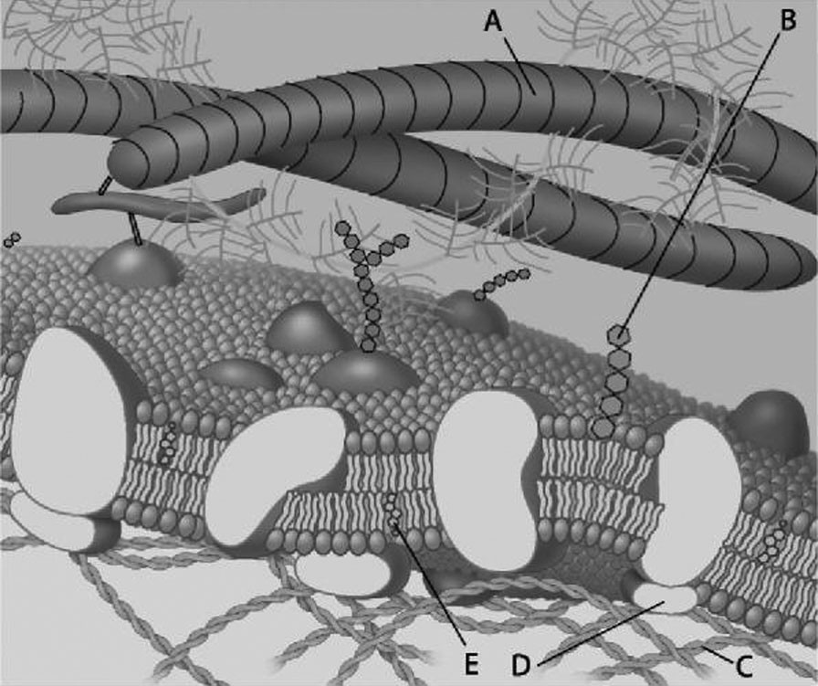
Figure 5.1

For the following questions, match the labeled component of the cell membrane in Figure 5.1 with its description.

1) Which component in the figure is a peripheral protein?
A) A
B) B
C) C
D) D
E) E
Answer: D
Topic: Concept 5.1
Skill: Knowledge/Comprehension
Learning Outcome: 5.1
2) Which component in the figure is cholesterol?
A) A
B) B
C) C
D) D
E) E
Answer: E
Topic: Concept 5.1
Skill: Knowledge/Comprehension
Learning Outcome: 5.1

3) Which component in the figure is a fiber of the extracellular matrix?
A) A
B) B
C) C
D) D
E) E
Answer: A
Topic: Concept 5.1
Skill: Knowledge/Comprehension
Learning Outcome: 5.1

4) Which component in the figure is a microfilament of the cytoskeleton?
A) A
B) B
C) C
D) D
E) E
Answer: C
Topic: Concept 5.1
Skill: Knowledge/Comprehension
Learning Outcome: 5.1

5) Which component in the figure is a glycolipid?
A) A
B) B
C) C
D) D
E) E
Answer: B
Topic: Concept 5.1
Skill: Knowledge/Comprehension
Learning Outcome: 5.1
6) Which component in the figure helps membranes resist changes in fluidity at high and low temperatures?
A) A
B) B
C) C
D) D
E) E
Answer: E
Topic: Concept 5.1
Skill: Knowledge/Comprehension
Learning Outcome: 5.1

7) Which component in the figure plays an important role in cell-cell recognition?
A) A
B) B
C) C
D) D
E) E
Answer: B
Topic: Concept 5.1
Skill: Knowledge/Comprehension
Learning Outcome: 5.1

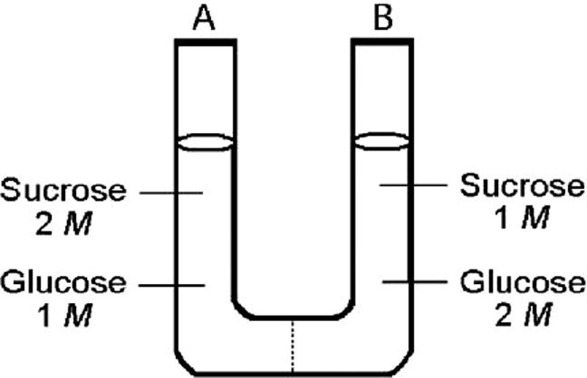
Figure 5.2

The solutions in the two arms of this U-tube (Figure 5.2) are separated by a membrane that is permeable to water and glucose but not to sucrose. Side A is half-filled with a solution of 2 M sucrose and 1 M glucose. Side B is half-filled with 1 M sucrose and 2 M glucose. Initially, the liquid levels are equal. Refer to the figure to answer the following question(s).

8) Initially, in terms of tonicity in the figure, the solution in side A with respect to that in side B is
A) hypotonic.
B) hypertonic.
C) isotonic.
D) saturated.
Answer: C
Topic: Concept 5.3
Skill: Application/Analysis
Learning Outcome: 5.3
9) After the system depicted in the figure reaches equilibrium, what changes are observed?
A) The concentrations of glucose and sucrose are unchanged.
B) The water level is higher in side A than in side B.
C) The water level is unchanged.
D) The water level is higher in side B than in side A.
Answer: C
Topic: Concept 5.3
Skill: Application/Analysis
Learning Outcome: 5.3
Global L.O.: G2

10) After the system depicted in the figure reaches equilibrium, what changes are observed with respect to the concentrations of sugars?
A) The concentration of sucrose is equal in sides A and B and the concentrations of glucose are unchanged.
B) The concentrations of glucose and sucrose are equal in sides A and B.
C) The concentration of glucose is equal in sides A and B and the concentrations of sucrose are unchanged.
D) The water levels change, but the concentrations of glucose and sucrose in sides A and B are unchanged.
Answer: B
Topic: Concept 5.3
Skill: Application/Analysis
Learning Outcome: 5.3
Global L.O.: G2
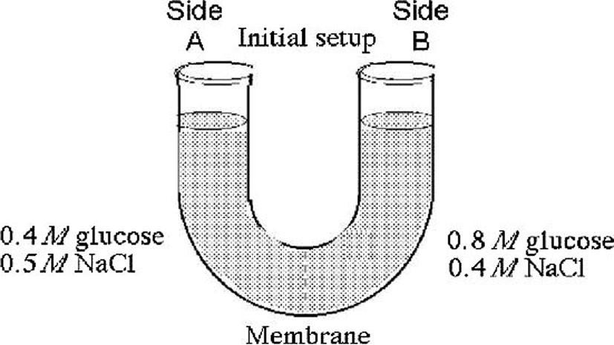
Figure 5.3

The solutions in the arms of a U-tube (Figure 5.3) are separated at the bottom of the tube by a selectively permeable membrane. The membrane is permeable to sodium chloride but not to glucose. Side A is filled with a solution of 0.4 M glucose and 0.5 M sodium chloride (NaCl), and side B is filled with a solution containing 0.8 M glucose and 0.4 M sodium chloride. Initially, the volume in both arms is the same. Refer to the figure to answer the following questions.

11) At the beginning of the experiment, side A in the figure
A) is hypertonic to side B.
B) is hypotonic to side B.
C) is isotonic to side B.
D) is hypertonic to side B with respect to glucose.
E) is hypotonic to side B with respect to sodium chloride.
Answer: B
Topic: Concept 5.3
Skill: Application/Analysis
Learning Outcome: 5.3

12) If you examine side A in the figure after three days, you should find
A) a decrease in the concentration of NaCl and glucose and an increase in the water level.
B) a decrease in the concentration of NaCl, an increase in water level, and no change in the concentration of glucose.
C) no net change in the system.
D) a decrease in the concentration of NaCl and a decrease in the water level.
E) no change in the concentration of NaCl and glucose and an increase in the water level.
Answer: D
Topic: Concept 5.3
Skill: Application/Analysis
Learning Outcome: 5.3
Global L.O.: G2
13) If you examine side A in the figure after three days, the concentrations of glucose and NaCl should be
A) 0.4 M glucose, 0.45 M NaCl.
B) 0.6 M glucose, 0.5 M NaCl.
C) 0.6 M glucose, 0.45 M NaCl.
D) 0.8 M glucose, 0.4 M NaCl.
E) 0.8 M glucose, 0.5 M NaCl.
Answer: C
Topic: Concept 5.3
Skill: Application/Analysis
Learning Outcome: 5.3
Global L.O.: G2

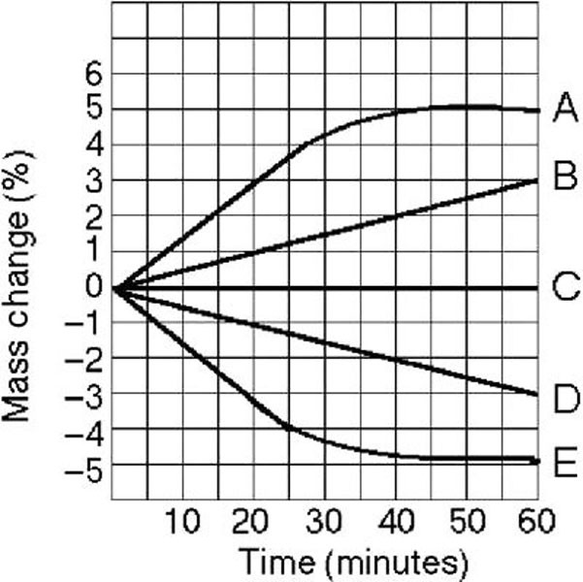
Figure 5.4

Five dialysis bags, constructed from a semipermeable membrane that is impermeable to sucrose, were filled with various concentrations of sucrose and then placed in separate beakers containing an initial concentration of 0.6 M sucrose solution. At 10-minute intervals, the bags were massed (weighed) and the percent change in mass of each bag was graphed. Refer to Figure 5.4 to answer the following question(s).

14) Which line in the graph represents the bag that contained a solution isotonic to the 0.6 M solution at the beginning of the experiment?
A) A
B) B
C) C
D) D
E) E
Answer: C
Topic: Concept 5.3
Skill: Application/Analysis
Learning Outcome: 5.3
Global L.O.: G3
15) Which line in the graph represents the bag with the highest initial concentration of sucrose?
A) A
B) B
C) C
D) D
E) E
Answer: A
Topic: Concept 5.3
Skill: Application/Analysis
Learning Outcome: 5.3
Global L.O.: G3

16) Which line or lines in the graph in the figure represent(s) bags that contain a solution that is hypertonic at 50 minutes?
A) A and B
B) B
C) C
D) D
E) D and E
Answer: B
Topic: Concept 5.3
Skill: Application/Analysis
Learning Outcome: 5.3
Global L.O.: G3
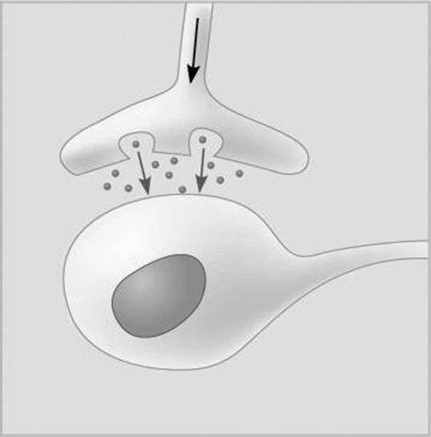
Figure 5.5

17) Which of the following types of signaling is represented in Figure 5.5?
A) autocrine
B) paracrine
C) hormonal
D) synaptic
Answer: D
Topic: Concept 5.6
Skill: Knowledge/Comprehension
Learning Outcome: 5.6

18) In Figure 5.5, the dots in the space between the two structures represent which of the following?
A) receptor molecules
B) signal transducers
C) neurotransmitters
D) hormones
Answer: C
Topic: Concept 5.6
Skill: Knowledge/Comprehension
Learning Outcome: 5.6
5.3 Scenario Questions

1) Cystic fibrosis is a genetic disease in humans in which the CFTR protein, which functions as a chloride ion channel, is missing or nonfunctional in cell membranes. The CFTR protein belongs to what category of membrane proteins?
A) gap junctions
B) carrier proteins
C) electrogenic ion pumps
D) cotransporters
E) hydrophilic channels
Answer: E
Topic: Concept 5.2
Skill: Knowledge/Comprehension
Learning Outcome: 5.2

2) A patient has had a serious accident and lost a lot of blood. In an attempt to replenish body fluids, distilled water — equal to the volume of blood lost — is transferred directly into one of his veins. What will be the most probable result of this transfusion?
A) It will have no unfavorable effect as long as the water is free of viruses and bacteria.
B) The patient's red blood cells will shrivel up because the blood fluid has become hypotonic compared to the cells.
C) The patient's red blood cells will swell because the blood fluid has become hypotonic compared to the cells.
D) The patient's red blood cells will shrivel up because the blood fluid has become hypertonic compared to the cells.
Answer: C
Topic: Concept 5.3
Skill: Evaluation/Synthesis
Learning Outcome: 5.3
Global L.O.: G2

3) You are working on a team that is designing a new drug. In order for this drug to work, it must enter the cytoplasm of specific target cells. Which of the following would be a factor that determines whether the molecule selectively enters the target cells?
A) blood or tissue type of the patient
B) lack of charge on the drug molecule
C) similarity of the drug molecule to other molecules transported by the target cells
D) lipid composition of the target cells' plasma membrane
Answer: C
Topic: Concept 5.3
Skill: Application/Analysis
Learning Outcome: 5.3
Global L.O.: G2
4) A major group of G protein-coupled receptors contains seven transmembrane α helices. The amino end of the protein lies at the exterior of the plasma membrane. Loops of amino acids connect the helices either at the exterior face or on the cytosol face of the membrane. The loop on the cytosol side between helices 5 and 6 is usually substantially longer than the others.

The coupled G protein most likely interacts with this receptor
A) at the NH3 end.
B) at the COO- end.
C) along the exterior face of the membrane.
D) at the loop between helices 5 and 6.
Answer: D
Topic: Concept 5.6
Skill: Evaluation/Synthesis
Learning Outcome: 5.6
Global L.O.: G2

5) If an animal cell suddenly lost the ability to produce GTP, what might happen to its signaling system?
A) It would use ATP instead of GTP to activate G proteins on the cytoplasmic side of the plasma membrane.
B) It would use protein kinases in place of G proteins.
C) It would be able to carry out reception and transduction but would not be able to respond to a signal.
D) It would not be able to activate G proteins on the cytoplasmic side of the plasma membrane.
Answer: D
Topic: Concept 5.6
Skill: Application/Analysis
Learning Outcome: 5.6
Global L.O.: G2

5.4 End-of-Chapter Questions

1) In what way do the membranes of a eukaryotic cell vary?
A) Phospholipids are found only in certain membranes.
B) Certain proteins are unique to each kind of membrane.
C) Only certain membranes of the cell are selectively permeable.
D) Only certain membranes are constructed from amphipathic molecules.
Answer: B
Topic: End-of-Chapter Questions
Skill: Knowledge/Comprehension

2) Which of the following factors would tend to increase membrane fluidity?
A) a greater proportion of unsaturated phospholipids
B) a greater proportion of saturated phospholipids
C) a lower temperature
D) a relatively high protein content in the membrane
Answer: A
Topic: End-of-Chapter Questions
Skill: Knowledge/Comprehension
3) Phosphorylation cascades involving a series of protein kinases are useful for cellular signal transduction because
A) they are species specific.
B) they always lead to the same cellular response.
C) they amplify the original signal manyfold.
D) they counter the harmful effects of phosphatases.
Answer: C
Topic: End-of-Chapter Questions
Skill: Knowledge/Comprehension

4) Lipid-soluble signaling molecules, such as aldosterone, cross the membranes of all cells but affect only target cells because
A) only target cells retain the appropriate DNA segments.
B) intracellular receptors are present only in target cells.
C) only target cells have enzymes that break down aldosterone.
D) only in target cells is aldosterone able to initiate a phosphorylation cascade that turns genes on.
Answer: B
Topic: End-of-Chapter Questions
Skill: Knowledge/Comprehension

5) Which of the following processes includes all the others?
A) osmosis
B) diffusion of a solute across a membrane
C) passive transport
D) transport of an ion down its electrochemical gradient
Answer: C
Topic: End-of-Chapter Questions
Skill: Application/Analysis
6) Based on the figure below, which of these experimental treatments would increase the rate of sucrose transport into a plant cell?

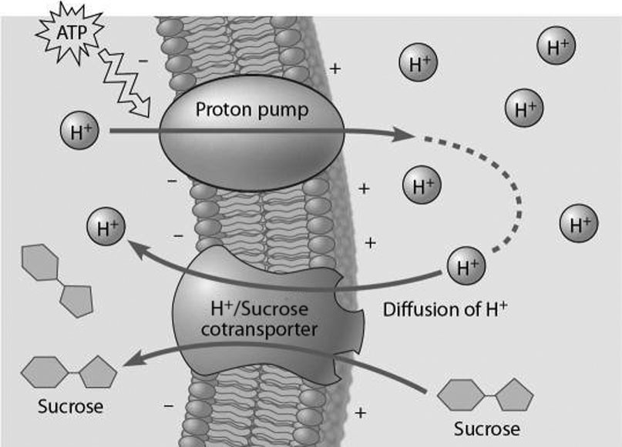

A) decreasing extracellular sucrose concentration
B) decreasing extracellular pH
C) decreasing cytoplasmic pH
D) adding a substance that makes the membrane more permeable to hydrogen ions
Answer: B
Topic: End-of-Chapter Questions
Skill: Application/Analysis

