Some Notes on Physics 155 Homework 2:

One generic problem with submissions this time is that many people did not put much effort into researching and answering questions 2 and 3. There is quite a lot of available research material to fully answer these two questions.

The vast majority of you did, in fact, solve the circuits completely correct, despite some of you insisting that problem 1 can’t be solved. Problem 1 contains no “missing information” since you can easily diagnose what the missing values have to be by thinking about the circuit.

Solution to Circuits:

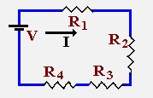
In a series circuit, the current is always constant at each resistor. So the value of I is the same at all the R’s: Apply ohm’s law to each resistor:

V₁ = R₁I₁
V₂= R₂I₂

This is also equivalent to (V₁+V₂) = I*(R₁+R₂) because I is a constant.

We know that R₄=10 and the total resistance is 30. That means that

R₁ + R₂ + R₃ = 20

We also know that

V₁ + V₂ + V₃ = 20 (as given in the problem)

So V =IR over that part of the circuit means 20 = I*20 so I = 1; everywhere

There are many ways to figure out that I must be 1 and that is the key to solving this circuit since the current can’t vary in a series circuit.

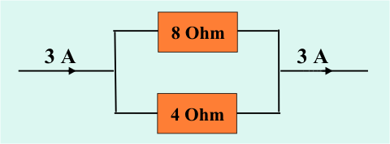

This is a strictly parallel circuit so you apply the parallel law:

1/R = 1/8 +1/4 = 3/8 → R = 8/3; Current is split by the ratio of 2 to 1; Twice as much current flows through the lower resistor (bottom) → 2 amps below, 1 amp above

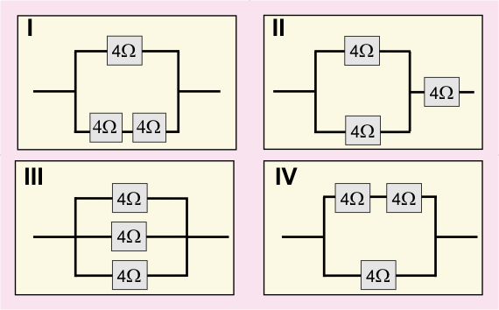

- This circuit is identical to what you just solved above; the total equivalent resistance in the bottom part of the parallel circuit is 8 Ohms
- This is parallel + serial. For the parallel part:
1/R = 1/4+1/4 =1/2 therefore R = 2
The serial part is just 4 so total R = 2+4 = 6
- All parallel: 1/R = 1/4+1/4+1/4 =3/4 so R=4/3

2. This question was not answered particularly completely and many answers left out the most important physics. By introducing extra nuclei you’re allowing the capacity for significantly more electrons to be liberated to create a current. Below is an example of a pretty complete answer and the second sentence and last few sentences were concepts left out of most of your answers.

Doping increases overall efficiency because it substantially reduces resistance, therefore increasing conductivity by adding impurities. The beauty of this process is that it only requires very small amounts of impurities to make a drastic change in the electric property. The way doping works is that the atoms used to dope the semiconductor acts as a donor that donates electrons to the conduction band and leaves behind positive charges. One challenge of this process is the difficulty in controlling the levels of impurities. This is why high precision clean rooms are required to minimize the impurities and maximize the overall effective yield of each wafer. The requirement for clean rooms also limits the production scale of these devices.

3. There are many points about the evolution of lithography that should have been addressed in your responses. One of the key concepts which helps maintain Moore’s law is the evolution of lithography which allows smaller and smaller circuits to be laid out. This is why the evolution from optical lithography to UV to X-ray lithography is important and was left out of many answers.

Here is an example of mostly complete answer to this question.

Well, lithography was originally a method for printing using a stone. What is more essential to this class is a newly developed form called photolithography. It is a micro fabrication technique used to make integrated circuits within a microchip and very small electromechanicial systems. The processes in which you etch the patterns on circuits/semiconductors have undergone various techniques to get the results fine-tuned and to lead to smaller fabrication structures.

The basic principle still remains today. You take a prefabricated design that as been tested, called a photo mask, as the master to produce the final pattern. In other words, the photo mask is the stone in lithography. However, today there is a process called electron beam lithography. This process requires no photo mask to produce the final result. Instead, the design is all done on a computer. The process is done by controlling an electron beam as the “resist-coated” material is scanned across it. It has its upsides as well as downsides. It is typically much slower than photolithography; likewise, it is capable of much higher resolution patterning.

Nanoimprint lithography is a process that cost relatively low within the industry, but also gives good resolution. This process used mechanical deformation of imprint resist. In order to achieve the imprint you must cure the resist. A variety of techniques have been used by some include using heat or a UV light. The key benefit is the simplicity it gives and low cost as it is normally the greatest cost going into producing a microchip. Another way to achieve this is by using X-rays. The process uses X-rays to transfer the patterns. The use light sensitive resists on the substrate. To refine the final result, the substrate undergoes a series of chemical treatments that bring up engraves under the photoresist. UV and X-ray light have much smaller wavelengths than optical (e.g. photo) light which means that smaller and smaller scale patterns can be etched into circuit boards.

Today you can also use a magnetic field to produce the patterns. This is known as magnetolithography. In the more extreme cases, ultraviolet lithography is used. You can get precise patterns. It the wavelength is 13.5nm which his 4 times smaller than photo light so you can achieve a 2D increase in resolution of 16. This is a big deal.

As you see, over the past 20 years various techniques had been used to improve the overall performance of the process. Typically, the costs have been going down as older methods are replaced from newer ones with more accuracy and higher resolution. The smaller and smaller we can get these patterns on chips will help out Moore’s law and open new possibilities for further advancements within the industry. Shaving off a few nanometers makes a huge difference.

