Exam performance was strongly bimodal – in such a distribution the average score is not meaningful but the median score is 116 ( For this exam the median was. Many people did quite well as most of the questions were straightforward and all of this was covered in class and is in the lecture note material.

Exams are available outside my lab door – 417 Willamette Hall.

Part I: True or False: Circle your answer. 2 pts each

1 | Ohm’s Law depends on the temperature of the resistor | T F
2 | A simple circuit with V=12 volts and R=8 ohms would have I=2 amps | T F
3 | The photoelectric effect proves that light is not a particle | T F
4 | The physical velocity of electrons in a conductor is ½ the speed of light | T F
5 | The Pony Express is an example of a switched information network | T F
6 | IBM was a successful catalyst in launching the early Internet | T F
7 | Gordon Moore states his now famous law in the mid-1960s | T F
8 | A LAN is a large area network connecting different institutions | T F
9 | TCP/IP was the first protocol used with Internet addressing | T F
10 | Electrons as information have more bandwidth than photons | T F

Part II: Multiple Choice: Choose the Best Answer (4 pts) Partial Credit given for some responses
11 |  | How many bits would it take to represent 50 equally likely outcomes?
 | A | 50
 | B | 5
 | C | 6 2^6 = 64 so needed to represent 50 (2^5 = 32 and is insufficient)
 | D | 500
 | E | None of the above
12 |  | In a wire with resistance = 10 ohms and Voltage source = 120 volts, the total power would be
 | A | 12 Watts
 | B | 120 Watts
 | C | 1440 Watts (P=V*I; I = V/R = 12; 12*120 = 1440)
 | D | 12 Kilowatts
 | E | None of the above

13 |  | Which term describes the first process of getting a laser started
 | A | heating
 | B | pumping
 | C | priming
 | D | exciting
 | E | Ignition
14 |  | A 6.2 Volt Zener laser has an operating power of 1 Watt. What is the current?
 | A | 6.2 amps
 | B | 1.61 amps Power = V*I = 1 Watt; therefore I =P/V
 | C | 161 millamps
 | D | 2.6 millamps
 | E | Square root if 6.2 amps
15 |  | A signal chain with 5 components each with 4% loss has an overall efficiency of about
 | A | 90%
 | B | 80%
 | C | 50%
 | D | 20%
 | E | 4%
16 |  | A semiconductor generally has how many valence electrons?
 | A | 1
 | B | 2
 | C | 3
 | D | 4 (Silicon)
 | E | 6
17 |  | The purpose of doping a semiconductor would be
 | A | To make is less susceptible to temperature variations
 | B | To increase the number of nuclei in the crystal
 | C | To create a new depletion zone
 | D | To introduce more free electrons (e.g. phosphorous has extra valence electron easily liberated in a Silicon crystal)
 | E. | All of the Above
18. |  | In a semiconductor material “holes” reflect
 | A | Locally missing electrons
 | B | Sites of extra impurity nuclei
 | C | Physical defects in the material
 | D | Small depletion zones that form near the edges of any junction
 | E | Regions of induced negative charge |  | Where was the Sun in Ptolemy's model of the universe?
19. |  | The output of an AND gate with three inputs A,B and C will be yes when
 | A | A=1 B= 0 C=1
 | B | A=1 B= 1 C=0
 | C | A=1 B=1 C=1
 | D | A=0 B=0 C=0
 | E | A=0 B=1 C=1
20. |  | The depletion zone in the PN junction is caused by |  | None of the above;
 | A | Migration of impurity ions across the barrier
 | B | The accumulation of positive charge neat the barrier
 | C | The diffusion of charge carriers
 | D | Changes in the electron drift velocity
 | E | The warmer temperatures on the P side compared to the N side

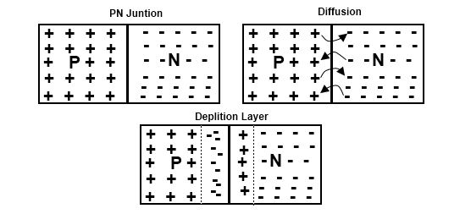

Part III: Short Answer Questions: Answer 10 out of 12 (10 points each) – Once again, only answer 10 OUT OF THE 12 questions.
21. A digital camera has 20 megapixels and each pixel has a depth of 32 bits. In units of megabytes, calculate how much storage is needed for on image (show all work).
32x20/8 = 80

22. Explain how doping with a small amount of impurity improves the overall performance of a semiconductor.

Not answered very well despite it being a homework problem. Introduce substances with weakly bound valence electrons so that more FREE electrons become available to the device.

23. Explain the basic physical reason why we encode electronic information in only 2 bits (e.g. binary).

Very simple: Electricity is either ON or OFF. Lots of other reasons were given instead of this basic one.

24. What functions does a transistor provide within an Integrated Circuit?

Not answered well

To amplify and switch the amount of current that goes different places in an integrated circuit which serves to control the overall flow of information through the various logic gates.

25. Explain the primary function of the subnet mask.
Lots of different answers given here but a subnet mask is part of internet routing – it is not part of the photolithography process.
To identify where a particular machine resides on a local area network that has more than 255 nodes on it.

We won't got into this in detail, but the generic concept of the subnet mask in IP routing basically tells the router how big their LAN is and what address space defines that LAN. Any address not in that space is then another network.

26. Explain why the current is everywhere the same in a serial circuit and not in a parallel circuit.

Because there is only ONE path for the current to flow – there are now BRANCHING points that reroute partial current through other channels.

27. Provide a brief description of the concepts of network latency and packet loss.

The physical time it takes each packet to arrive at the receiver and/or the time it takes to ACK back is called latency
Most all answers left out the important ACK part.

Because TCP/IP requires that all packets arrive in order (thus TCP/IP is not very smart), any single lost packet means that then entire contents of the receive buffer must be retransmitted. Sufficient loss can cause some TCP/IP based application to completely fail.

28. Explain the origin of shot noise in an electrical circuit.

Arises from fluctuations of the number of electrons (or fluctuations in the current) of the injected current in a semiconductor

29. Explain how the photoelectric effect show that light can behave like a particle

Answered poorly

The energy of a photon is E=hf (f = frequency)l if that energy is above the threshold energy that bind a valence electron to a nuclei that electron will be removed from the nucleus and become free. This is energy transfer from one particle to another.

This concept will be on the FINAL.

30. Explain how improvements in photolithography help to maintain Moore’s law.

Answered well – lower wavelength lithography (UV, X-ray) can produce smaller and smaller masks for a circuit board.

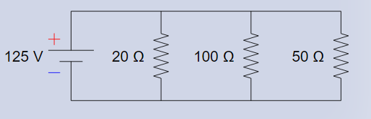
31.
What is the total current flowing through the above circuit? (show all your work)

1/20 +1/100 +50/100 = 1/R
5/100+1/100+2/100 = 8/100 → R = 12.5 I=V/R = 125/12.5 =10

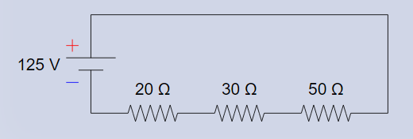

32. What is the current flow through each of the resistors? (Show your work)

R =20+30+50 = 100 : I =125/100 =1.25

