The Energy Challenge Scale: Background and Framework
G. Bothun, Department of Physics – Preface to Congressional Report (submitted March 2008)

It is nearly impossible to overstate the imperative and the magnitude of the challenge we, as a nation, collectively face. Developing cost effective renewable energy sources to meet future energy demand in an environmentally responsible manner is clearly the only sensible pathway that can be taking toward achieving both energy independence and overall sustainability. However, the incredible scale of our consumption presents a grand challenge in meeting this important goal. According to the Energy Information Administration report Annual Energy Outlook 2006, renewables currently make up only 6% (and most of that is hydroelectric power developed in the period 1935-1965) of our U.S. energy supply and domestic energy demand is projected to grow by 34% over the next quarter century.
Vision and Goals

By the year 2030, scientific and technological breakthroughs, enabled by significant increases in computational resources, will produce a 50 fold increase in our present use of nature’s ambient energy (sun, wind, and biomass) for the production of electricity and transportation fuels. These new sources of generation will be connected via a large, distributed, smart electrical grid which will delivery reliable electric power anytime, anywhere.

It is within this context that aspirational national goals are being set by the Administration, the Congress, and by the Department of Energy. These goals include generating sufficient biofuels to reduce gasoline usage by 20% in ten years, generating 20% of the total U.S. electrical supply from wind energy by 2030, and deploying market competitive photovoltaic systems by 2015. More specifically, there is a need to bring on approximately 100,000 new Megawatts of power generation in the form of renewables (wind, solar, biomass, geothermal) as quickly as possible. Currently less than 10000 MW of generating capacity exists in these forms. It is clear from the discussions at the workshop that meeting these ambitious goals will depend heavily on robust computational capabilities including petascale computing systems, scalable modeling and simulation codes, capacious data storage and informatics, and high speed communication networks.

The 100,000 Mega Watt Scale:

To better frame the problem, it is important to impart a more visceral description to the energy generation and fuels problem and to characterize this whole challenge as a gigantic systems optimization problem. We begin with the notion of bringing 100,000 new MW of power on line and the possibilities for achieving that under various scenarios and technologies:
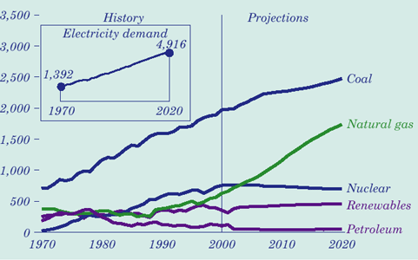
Business as Usual Scenario:

Currently, almost all new power plant construction utilizes natural gas as the feedstock. The current projected EIA electricity profile clearly shows a continuing increase in NG fired electricity after the year 2000. Indeed, in the year 2000, 23,500 MW of new electric capacity was added to the US grid and 22,300 of that (95%) was in the form of NG fired plants. Our nominal future electricity pathway therefore ignores renewables altogether and assumes continue available NG as our fuel stock for future electricity generation. Unfortunately, the domestically available supply of NG can not meet this projected demand and hence we will not achieve energy independence by following this pathway. At present, annual US NG Consumption is 20-22 Trillion Cubic Feet (TCF) and domestic production is 19.5 TCF .

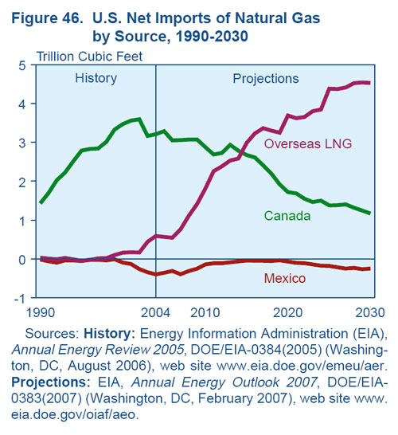
.Imported NG from Canada makes up the difference but those imports are expected to decline to be replaced (hypothetically) by imports of LNG from overseas suppliers. Currently the US is estimated to have 204 TCF of NG remaining or about 9 years worth of supply at current consumption. Clearly, as indicated in the above graph, NG fired electricity is expected to double from its present value around the year 2015 and in no way are there sufficient reserves in the US and Canada to support this trajectory. Venezuela currently does not export NG and is estimated to have a reserve of 150 TCF and therefore they become a logical trade partner if this path of electricity generation is followed. More worrisome, however, is the simple fact that Russia (30.5%) and Iran (14.8%) combined have almost half of the accessible NG reserves on the planet and thus, if this path of electricity generation is followed, the US will have an inevitable tie to those entities. Moreover, the US has insufficient LNG importation facilities (only 5 presently exist) and while have to expand that network to approximately 50 total facilities by the year 2020 to handle the expected 7 TCF of imported LNG required to sustain our NG electricity generation pathway. Finally, while NG is cleaner burning than coal for many pollutants, NG fired electricity still emits ½ of the Carbon per generated MW as Coal fired power plants. Thus increased electricity generation with NG power plants will continue to increase the US’s net emission of greenhouse gases (GHGs). Therefore, the NG fired electricity pathway will continue our “business as usual” trajectory and runs directly counter to our desire and motivation to build of an infrastructure of renewable and distributed energy generation.

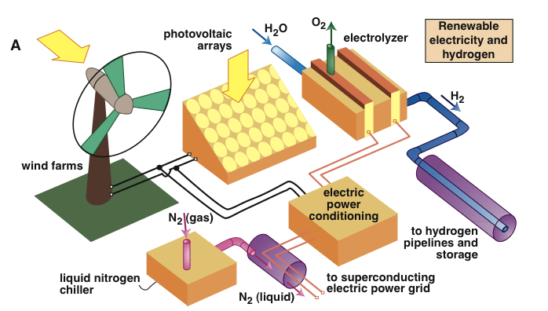
Moving away from the business as usual trajectory and towards a less carbon intense means of producing electricity will require a mixture of different technologies as its clear that, aside from possible, ocean thermal electric conversion, that there is no signal alternative and renewable energy generation technology that scales to meet our increasing consumption. One can therefore envision our new energy economy as a series of interconnected components, and new technologies managed by an emerging smart electrical grid, that all work together within a large network similarly to the one illustrated here. The optimization of each of the components illustrated is mandatory to reach our desired goals in terms of electricity generation coming from renewables. The four components illustrate here, Wind power, PV power, Hydrogen as an energy carrier, and the new electrical power grid represent the main points of focus in this workshop.

Wind Energy Potential:

In 2005 and 2006 approximately 2500 new MW per year of wind energy was added. In 2007 3100 MW of wind energy is projected to be added. Most of this wind energy comes from newly created wind farms that utilize 1.5 to 1.8 MW turbines as the standard unit device. Future wind farms will likely utilize higher output turbines.
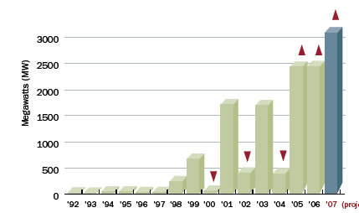

Of course, given the intermittent nature of the feedstock (wind), these capacity additions are modulated by the wind reliability factor at the wind farm. Industry data suggests that a typical wind farm efficiency or duty cycle is approximately 1/3 meaning that over the last 3 years the US has created 2700 MW of reliable wind power electricity generation. This implies that, to achieve an additional 100,000 MW of reliable electricity generation would require 300,000 MW of capacity wind additions. At the current rate of wind farm expansion (3000 Megawatts per year) 100 years would be required. However, the great economy of scale of wind power lies in the ability to increase unit Turbine size on essentially the same footprint scale on the land. This economy of scale is visualized below:

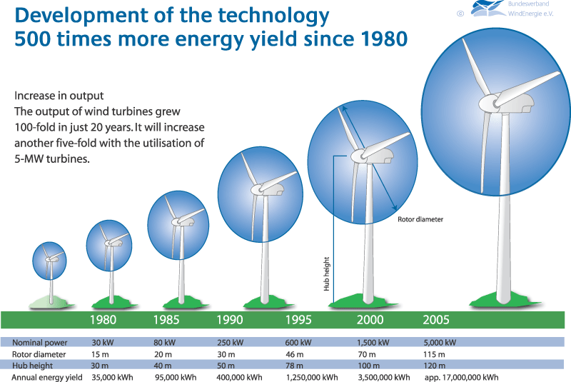

Presently the largest functioning wind turbine has a capacity of 6MW with a rotor diameter of about 135 meters. Utilizing those in future wind farms therefore decreases the 100 year timescale by a factor of 4. However, with advanced computer modeling and new materials, it is hypothesized that horizontal wind turbines can achieve capacities as large 20 MW with a rotor diameter of approximately 225 m. If such devices can be constructed and placed (on essentially the same footprint at the current 1.5 MW units) then we require only 5000 of these devices to reach our 100,000 MW goal. However, given that a wind turbine will easily experience 100 million flex cycles over its lifetime as well as the fluid dynamics problem that differential flow and vertical turbulence is exacerbated once the scale becomes larger, there is a significant amount of computational modeling that needs to occur. Nonetheless, the construction of 5000 20 MW wind turbines constitutes a significantly different energy pathway than the construction of 2000 new NG fired electricity plants that will require importation of the fuel source. In addition, wind farms are not a source of GHG emission.

Solar Energy Potential:

Presently solar energy electricity generation is embodied by 4 different kinds of devices:

- Photovoltaic (PV) arrays: uses the photoelectric effect for direct conversion of incoming sunlight into electricity.

- Concentrated Solar Power: Parabolic Troughs: a parabolic reflector is constructed which focuses incoming solar radiation to a line. At that line, a tube containing heating oil reaches a temperature of 400F and serves as the working fluid to mix with water to generate steam. The Nevada Solar One project, which came on line in June 2007 at a generating capacity of 64 MW is the most recent example of a commercial power plant based entirely on this technology.

- Concentrated Solar Power: Stirling Engine: a spherical reflector is used to focus sunlight on a piston that heats up a gas. Current industry design utilizes a reflector of diameter approximately 8 meters that produces 25 KW of peak power.

- Solar Thermal Power Tower: A network of heliostats focuses sunlight on a container of molten salts which heat up to 800 – 1200 F. By mixing with water, steam can be created to power a standard steam generator. Unit capacities of such power towers are usually in the range of 10 – 20 MW.

While Concentrated Solar Power (CSP) does represent a breakthrough to facilitate the commercialization of solar power, there are still unknown issues related to heat fatigue and the longevity of various components. Moreover, the current CSP initiative in the American Southwest is aimed at bringing on 1000 new MW of power – far short of the required 100,000 MW needed. Furthermore, it must be stated that although solar power additions are rising in the US, the absolute amounts remain very small. As of 2005, the total installed solar capacity in the US was approximately 500 MW. Indeed, worldwide there is only 3700 MW of generating capacity. Part of the limitation of solar power technologies, driven by their relatively inefficiency, is that per unit footprint on the land, not much power is generated. A nominal figure of merit based on the facility at Kramer Junction California suggests a yield of 40-50 MW per square kilometer of detector coverage.

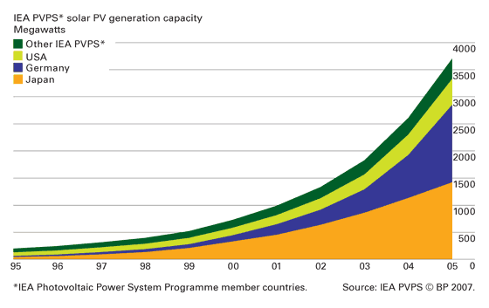

A simple calculation for the US can demonstrate the scale needed for PV farms.

- We assume 1000 watts per square meter as an annual average at a good location in the American Southwest (including Nevada) over an average solar day of 8 hours.

- We assume PV efficiency of 10%.

Theses assumptions yield the canonical value of 1000 square kilometers of PV array needed. Furthermore, this only generates 100,000 MW of electrical power 8 hours or 1/3 of a day.

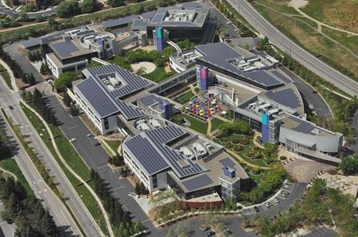
Hence, PV electrical production seems to be a poor choice for any kind of centralized power distribution and therefore should be more strategically considered as a distributed solution. On the commercial building scale, the current best example is provided by Google’s headquarters in Mountain View California. Their installation of 8200 separate panels on 8 rooftops and 2 parking garages results in capacity of approximately 1600 KW. On a more local scale, a typical household rooftop contains about 50 square meters of useful solar exposure. At 1000 watts per square meter of solar irradiance, such a roof top would generate about 5KW of power, far more than the typical household would require. Computational advances in PV design or materials research might be able to increase nominal rooftop operating efficiency of PVs from 10-20%. This would be very significant as that would mean that a typical household could act as a 10KW power plant during the day and thus be able to supply the grid with electricity. In turn, a corporate facility like Google would then transform into a 3 MW power plant during the day time. In this way, the use of advance materials to increase the overall efficiency of the PV rooftop offers a highly scalable way to produce and distribute power within the densely populated commercial sectors of large urban areas. However, to take advantage of this potential would require a substantially new design and functionality for the electrical grid.

The Critical Need for Alternative Transportation Fuels:

The scale and need for significant new sources of alternative fuels is larger than that needed for new sources of electricity generation. Current daily usage of refined gasoline for transportation in the US is 9.3 MBD (or approximately 400 million gallons). Domestic refineries, however, can only produce about 8.2 MBD of gasoline refined to meet our clean air standards. Thus we require 1.1 MBD of refined gasoline from overseas suppliers every day to meet our demand while maintaining federal clean air standards.
Fuel Consumption Scale

Americans collectively spend 1.35 Billion dollars per day via the consumption of gasoline in vehicles that have not seen significant increases in average fuel economy for 20 years.

Our currently large consumption rate is the result of the convolution of relatively constant average fuel economy and annual increases of 2-3% in total vehicle miles traveled per year (see figures below):

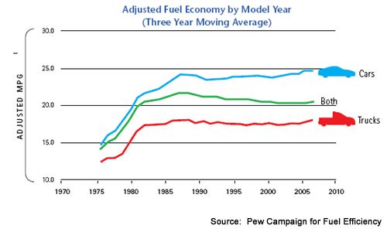

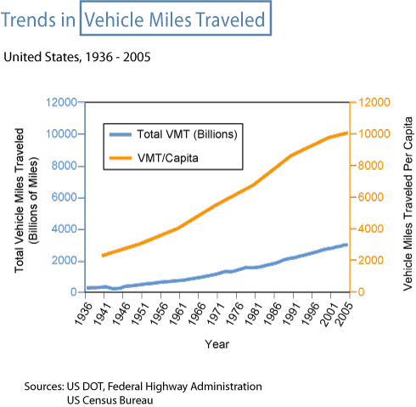

If nothing changes with respect to this basic transportation mode, then US daily consumption of gasoline will reach 13-13.5 MBD by the year 2020 – this is well beyond our refinery limits.

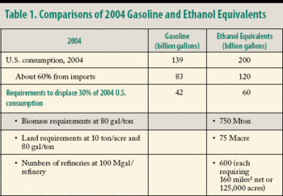
It is thus imperative that new fuel sources be developed and brought on line, whether such fuels are crop-based or hydrogen-based. The need is critical and this need calls for new forms of investment to improve the overall efficiency of the process so that significantly less agricultural land use will be required to reach similar levels of equivalent consumption of gasoline. The current situation makes significant penetration of biofuels untenable due to the large amounts of required acreage and individual refineries.

Three decades ago, the US was faced with a similar potential shortage of transportation fuel. At that time, no significant investment in alternative fuels was made and our priority was to maintain our dependence on fossil fuels for transportation by simply finding and mining more the resource domestically. The figure below represents the waveform of that faulty thinking which prioritizes short term fixes at the expense of long term sustainability. This lack of foresight has consistently plagued US energy policy. In brief, to combat an increasing reliance on foreign oil, the US sought to seek energy independence by harvesting new oil fields in Alaska – but that resource was quite finite with respect to our consumption and represented only about 10 years worth of relief as US consumption continued to rise and fuel efficiency remained basically flat. That time was one opportunity to invest R&D resources into the development of significant sources of alternative fuels. No such investment was forthcoming and today we find our selves not only with a large dependence on foreign oil, but also with a transportation habit that is becoming a significant source of US greenhouse gas emissions.

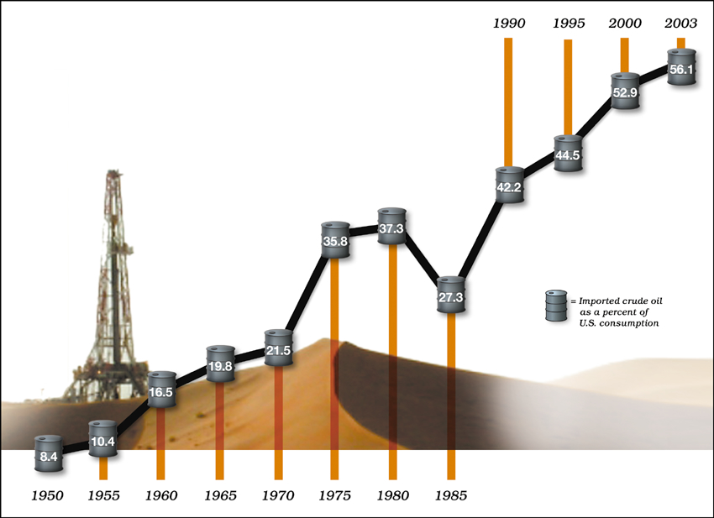

To maintain our main mode of transportation (single occupancy private vehicle) will require an R&D investment in three areas of alternative fuels:

- Plug-in Hybrid Vehicles (PHEV)
- Crop-based fuels (BioFuels)
- Hydrogen Fuel Cells

Each of these areas has significant technical hurdles that must be overcome if they are to scale with the use of gasoline as a primary transportation fuel.

In the case of PHEV’s significant new advancements need to be made in battery energy storage and this requires research into using advance materials for energy storage that have operating temperatures within some acceptable safety range. At present, the standard NiMH battery back in PHEV’s has 50 times less energy density storage, per unit mass, as gasoline. This gap needs to be narrowed, considerably and a common figure of merit is to develop batteries with materials that have energy density storage of approximately 500 watt-hours per kg. At that level of storage, a 250 kg battery pack would to provide an all electrical vehicle range of approximately 300 miles.

In the case of BioFuels, the efficiency of the sugar extraction process from the enzyme walls needs to increase by a factor of a few, from the present values of approximately 0.5%. In addition, dry ton yields per unit acre of cropland need to substantially increase. For the case of switchgrass, the current yield is approximately 5 dry tons per unit acre. With R&D invested in crop breeding techniques (similar to that which has been done for corn) yield estimates as high as 15 dry tons per acre have been published. At that level, a commitment of 10% of current US agricultural land would produce annually 100 billion equivalent gasoline gallons of cellulosic ethanol which would satisfy 1/3 of our current consumption. Even greater promise lies in biocatalysis processes involving algae. While significantly more R&D work is needed in this area, NREL has estimated a theoretical yield of 5000 gallons per aquatic acre of algae. At this rate, approximately 0.3% of the surface area of the US could produce enough algae based fuel (essentially biodiesel) to account for all of our current fuel utilization.
Reduced Carbon Emission

Transportation end use currently accounts for 1/3 of total US CO₂ emissions (or approximately 0.6 Giga tons of carbon per year). A 20% market penetration of clean burning Hydrogen would then offset 120 million tons of carbon per year.

In the case of hydrogen there are the usual problems of production, storage and distribution (which are more fully discussed elsewhere in this report). In the case of production, however, one could imagine constructing wind turbines in the Aleutian Islands (the most consistently large scale windy location on the planet) for the purposes of producing hydrogen via electrolysis (as the cost of extending a transmission grid to this remote location is likely prohibitive). Populating the entire 1900 km Archipelago with the future generation 20 MW turbines, at a rate of 20 turbines per KM, would result in 760,000 net MW. At an electrolyzer efficiency of 50 KWh per kg of produced hydrogen, a single days worth of wind energy capture in this way would produce 360 million KG of hydrogen fuel per day. Since the energy density of hydrogen per KG is approximately 2.5 times higher than that of gasoline, in principle, this hypothetical Hydrogen wind farm has produced the equivalent of 300 million gallons of gasoline per day (or ¾ of our daily consumption). To take advantage of this potential, however, requires significant investment in fuel cell research. In particular, conventional fuel cells require platinum as a catalyst and the scalability of that technology is therefore strongly limited by the amount of platinum available in the lithosphere. Alternative hydrogen engines thus need to be developed to by pass this limitation.

While each one of these technologies individually can not solve our consumption problem, all three combined, with the appropriate investment in R&D to improve efficiencies could, in principle, completely eliminate our use of gasoline as our primary transportation fuel if we also simultaneously commit to achieve fuel standards as high as 40-50 mpg. In turn, this would eliminate our dependence on foreign oil and greatly reduce our net greenhouse gas emissions.

Furthermore, these new forms of alternative fuels have lead to the Vehicle-to-Grid (V2G) concept. The V2G concept is that battery, hybrid, and fuel cell vehicles all can send power to the electric grid, during those times where they are not using power from the grid for charge up. This underscores even further that the evolution of the grid must be such that these distribute forms of power input back into the grid can seamlessly be accommodated. For battery and plug-in hybrid vehicles, the power connection is already there. For fuel cell and fuel-only hybrids, an electrical connection must be added.

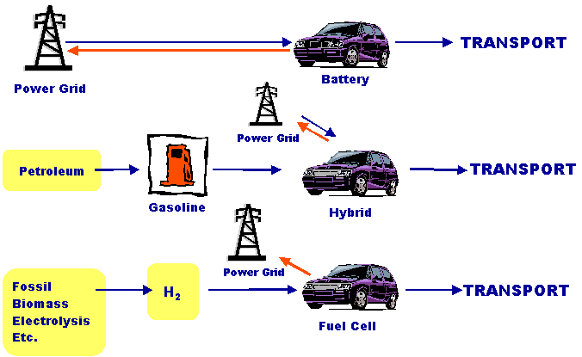

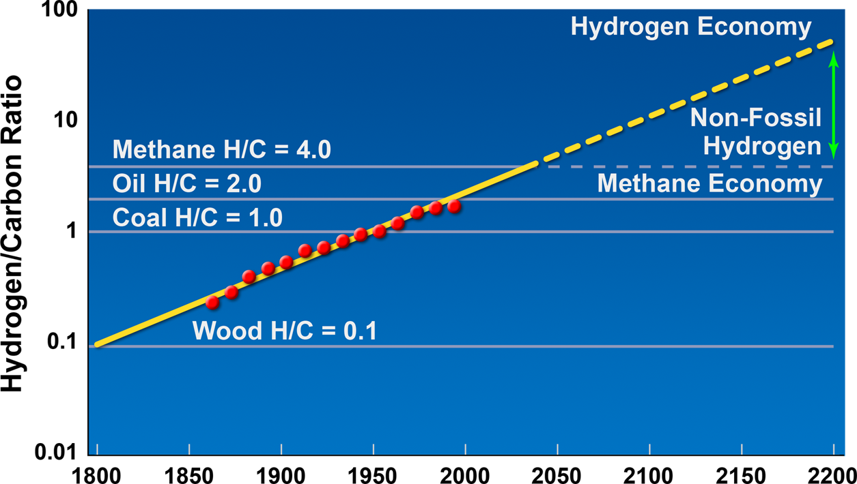
In sum, renewable energy sources do have the potential to transition our energy economy away from that which is based on fossil fuels and the subsequent release of greenhouse gases to one based on sustainability with a dramatic reduction in overall greenhouse gas emission. This is clearly a worthy goal to achieve as a nation and, in some sense, bears similarity to an earlier national goal of manned lunar landings. The realization of this goal can best be achieved by investing in the PRDs identified in this report as we collectively aim to better engineer and optimize the devices needed to meet this grand challenge in providing new sources of electricity generation, distribution and storage and new sources of transportation fuels. Our successful transition (as illustrated) away from an energy economy founded on high carbon density to a non-fossil low carbon intensity economy is critically dependent on improvements in the overall operation, efficiency and design of various forms of renewable energy devices. The priority research directions identified in this conference represent a concrete first step towards this realization.

