Sunshine Moonbeam Times

Electric Vehicles: to Buy, or Not to Buy
Published: Monday, March 12, 2010
By Annie Thompson

With both gas prices and average world temperature “soaring”, becoming green is all the rage. In fact, these next couple of years may prove to be a monumental time for green technology as a number of Electric Vehicles (EV) and Plug in Electric Vehicles (PHEV) models hit the market, replacing the conventional gasoline engine, transmission and fuel tank with a lithium-ion battery system, electric motor and charging system. The difference between the two electric vehicle types is that EVs will need to be plugged in and has a range limited by the battery pack, whereas PHEVs may either run off the battery or the engine.
It will be interesting to see how America reacts to such vehicles, but in the meantime, as conscious consumers, it’s a good idea to inform ourselves as to the potential that this technology holds. Evaluating the benefits and shortfalls of EVs and PHEVs can be tricky as there is a wealth of disparate material on the subject. That is why the staff of Sunshine Moonbeam Times finds it imperative that the facts are separated from fiction and then conveyed to the American public. We will focus our energy on four models: the Chevrolet Volt, the Nissan Leaf, the Mitsubishi i-MiEV and the Coda Sedan.
First on our list of contenders is the Chevrolet Volt. This PHEV is expected to be launched around November of this year as a 2011 model. It is thought that the free range of the vehicle will be 40 miles, which represents the distance wherein the car will be powered only by electrical energy stored in its 16 kWh (only 8 usable) lithium-ion battery. After this point, the car may be charged or switched to gasoline power. Although the zero emission range of 40 miles of the car seems shockingly small, the company defends its engineering by saying their goal was to find a battery range that would allow the majority of people to drive gas-free on a day-to-day basis. And, according to the survey conducted by the U.S. Bureau of Transportation Statistics, 75% of the American population commutes 40 miles a day or less. In terms of the charging time of the battery, the manufacturers estimate it to be 8 hours with a 120V conventional hookup, and only 3 hours with a 240V charging station installed in your garage. The price is expected to roll in at $40,000, however with a federal tax credit it could be more like $32,500.

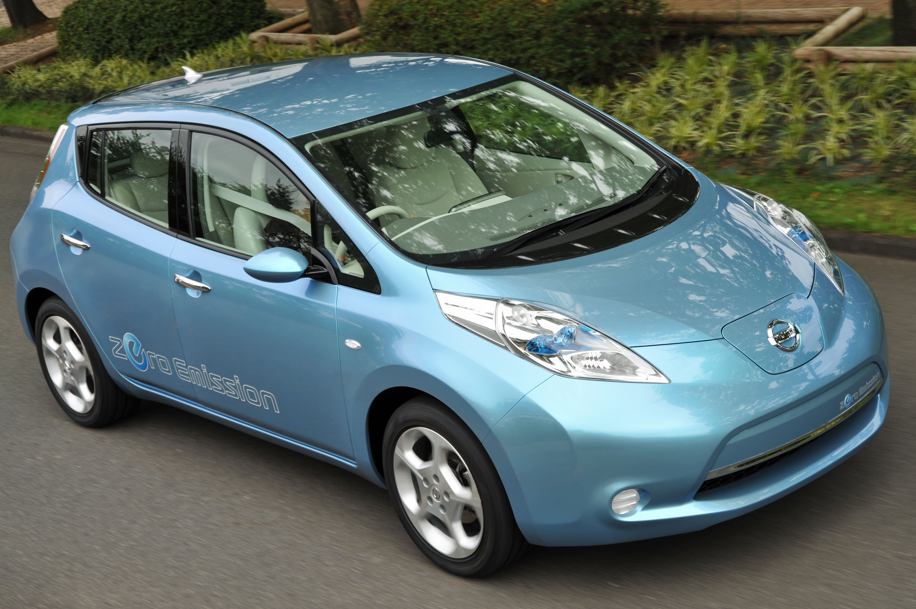

If the price of the Chevy Volt seems a little exorbitant, then maybe you’ll find the Nissan Leaf more appealing. This medium sized hatchback is, unlike the Chevy Volt, a pure electric vehicle and has been advertising as the "world's first affordable, zero-emission car". The vehicle is expected to hit the markets in late 2010 as well, at a sticker price probably around $35,000, or mid-20s as long as funding continues for the federal clean car credit program. At this price, the Nissan Leaf would seriously undercut the Volt. It has been stated that the new EV model has the longest driving range per charge (around 100 miles) on its 24 kWh lithium-ion battery, which would make this vehicle suitable for over 80% of American motorists. In regard to its charging time, yielding a full charge with the standard 120V home

http://gm-volt.com/chevy-volt-faqs/
Source Vol. 3, Issue 4, Oct. 2003 Omnistats - U.S. Dept. of Transportation. Bureau of Transportation Statistics.
http://www.chevrolet.com/pages/open/default/future/volt.do
http://www.nissan-global.com/EN/NEWS/2009/_STORY/090802-02-e.html
http://green.autoblog.com/2009/08/01/2010-nissan-leaf-electric-car-in-person-in-depth-and-u-s-b/

