Electricity Generation in the US:
Predictions for 2030: Wind vs Natural Gas vs Nuclear vs Clean Coal

Historically, electricity generation in the United States has come from the thermal heating of water either by burning coal, natural gas or oil. These fossil fuel based technologies have also been supplemented by hydroelectric dams and nuclear fission plants (which are also thermal electric in nature). As we are now entering an era where electricity demand is continuing to rise and fossil fuels are continuing to dwindle, we must look forward to news forms of electricity generation particularly involving wind and solar technologies. It is therefore instructive to look, not at energy consumption or net energy generation, but rather the nameplate facility history of the US over the time period 1990 – 2008. Note that nameplate capacity is a true representation of actual infrastructure investment and deployment but no individual facility ever operates at its name plate value. For instance, a 2000 MW nameplate hydroelectric facility may have actual performance considerably less because of insufficient stream flow to power the turbines. A wind farm suffers from intermittency and coal and natural gas fired plants may suffer deviations from nameplate capacity due to variable fuel delivery. Only nuclear power plants tend to operate near their nameplate capacity.

Table I summarizes the evolution of nameplate capacity in various electricity generating technologies over the last 20 years. All listed values are in units of GigaWatts.

Table 1: Nameplate Capacities in Electricity Generating Technologies 1990-2008
(Listed numbers are in units of GigaWatts).

Year | Coal | NGas | Oil | Hydro | Nuclear | Wind | Solar
1990 | 330 | 153 | 86 | 72 | 108 | 1.8 | ---
1992 | 334 | 164 | 81 | 74 | 108 | 1.8 | ---
1994 | 335 | 178 | 80 | 75 | 108 | 1.8 | ---
1996 | 338 | 190 | 80 | 76 | 109 | 1.7 | ---
1998 | 338 | 196 | 73 | 77 | 105 | 1.7 | 0.01
2000 | 336 | 243 | 68 | 77 | 105 | 2.4 | 0.02
2002 | 338 | 352 | 66 | 77 | 105 | 4.5 | 0.05
2004 | 335 | 422 | 65 | 77 | 106 | 6.5 | 0.16
2006 | 335 | 442 | 64 | 77 | 106 | 11.3 | 0.34
2008 | 337 | 454 | 64 | 77 | 106 | 25.0 | 0.82
2009 | 340 | 461 | 64 | 77 | 106 | 35.0 | 1.25
2010 | 347 | 466 | 64 | 77 | 105 | 40.1 | 2.13

The above table reveals much of what we are really doing in the US in terms of facilities construction to meet new demand for electricity. Note that total nameplate capacity has grown from 0.783 TW in 1990 to 1.1 TW in 2008. This is equivalent to an annual growth rate of 2% per year. For reasons to be discussed below, that 2% growth rate is likely to increase (somewhat) over the next 20 years. For instance, from 2008 – 2010 only 38 MW of new nameplate came on line which represents an increase of 3.5% over this two year period compared to the expected value of 4.04%. The table above reveals that virtually all of this growth in demand has been met by building out our Natural Gas infrastructure over the last 20 years. Natural Gas Fired electricity is clean in the sense that it does not create the serious SO₂ pollution that is contain in coal fired electricity. However, per generated GigaWatt, natural gas fired electricity is only ½ as clean as coal in terms of the associated CO₂ output. Natural gas fired electricity is therefore very much a greenhouse gas contributor. Note also, that not all natural gas facilities make electricity. Many of these facilities are dedicated to steam generation for space heating. This other use of Natural Gas is why Coal continues to dominate our electricity generating portfolio though every year its overall contribution is now coming down by 1-2 %. The most recent snapshot of our US electricity use portfolio is shown below:

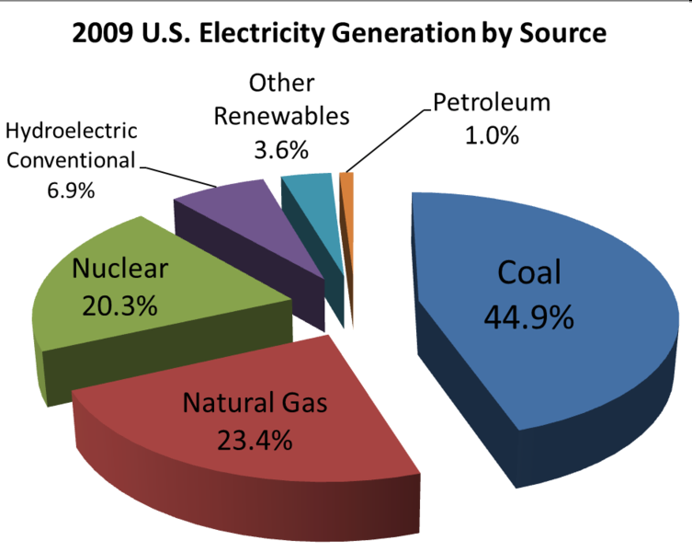

From the table it is also clear that our Coal, Hydro and Nuclear facilities have been static over the last 20 years. There are physical, economic and political reasons for the static nature of these facilities and these reasons are unlikely to change in the near future so, to first order, it seems like a safe assumption that no new such facilities will be created on any scale that really matters. Over the 1990-2008 time period, oil fired electricity is declining as it naturally should. This is a very old technology (literally burn oil to heat water) that was prevalent circa 1900 but has been effectively replaced by coal and natural gas. In another 10 years we should expect all of these facilities to have been phased out.

So, based on the table above we can make some reasonable extrapolations to predict what this table might look like in the year 2030. Before assembling that table, it is useful to address each listed technology separately:

Slow/Zero Growth Technologies:

Coal: It is very difficult to predict the future of coal fired electricity in the US. On the one hand, there are adequate coal reserves in the US to generate electricity for at least the next 120 years at the current rate, and for 60-80 years at a slightly accelerated rate. This would require the construction of new “Clean Coal” plants. Clean coal plants are those which basically burn coal at higher temperatures than traditional coal fire plants – this allows for about a 50% increase in efficiency (i.e. from 40% to 60%) along with somewhat reduced emissions. But its still coal (Carbon) combusting with Oxygen (O₂) to produce CO₂ output. How many new Clean Coal plants will be built? This is anyone’s guess. The history is shown in the figure below which comes from the National Energy Technology Laboratory. While there are approximately 160 new proposed coal facilities, history clearly shows that the actual deployment lags greatly behind the proposed build out. To be sure, some new coal fired plants will be built (to likely replace some aging facilities) but based on real world activities we predict that our nameplate capacity in coal will increase from its current value by at most 30% in the year 2030.

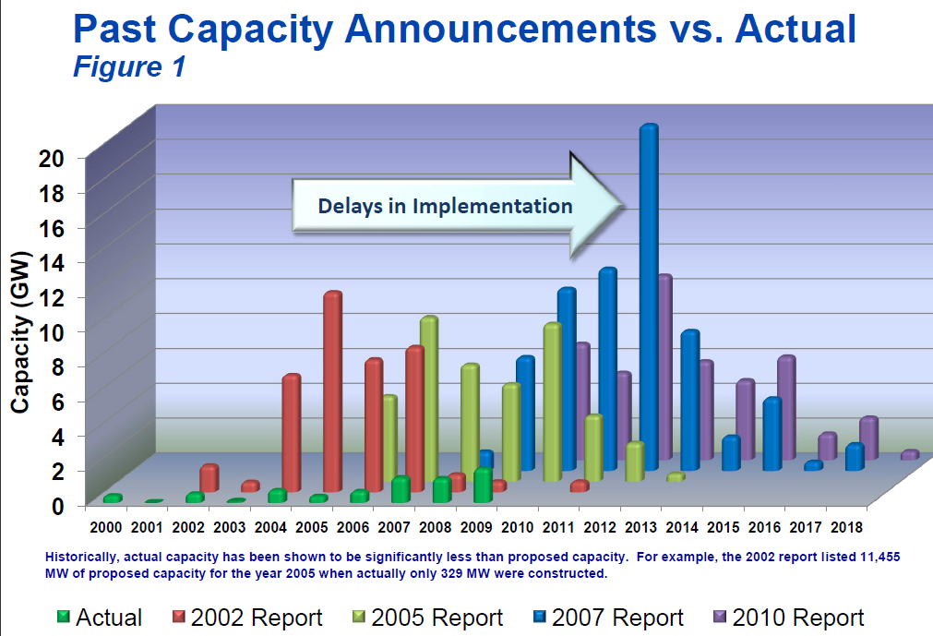

Hydropower: It seems very unlikely that any new hydroelectric facilities will be built in the US for a variety of licensing and environmental concerns. While its possible to improve existing dam nameplate capacity by the addition of more modern turbines, this is unlikely to be very significant. On the other hand, its also unlikely that any of the existing dams will be removed prior to 2030 and thus the current nameplate capacity will likely still exist in 2030.

Oil: We predict this goes to zero by the year 2030.

Nuclear: In 2000, the US had 109 operating nuclear facilities. In the year 2010, that number has dropped to 104 which still produce 20% of US electrical output. By mid 2007 there were 16 license applications to build 24 new nuclear reactors. And 4-5 new units are expected to come on line by the year 2018 according to a recent study done by the World Nuclear Association. The high capital cost and the very long licensing/approval/construction/commissioning phase (it takes about 16 years for a new plant to be constructed and come ON line) are likely to strong limit the growth rate of new nuclear facilities. While there is much talk about Thorium reactors the simple truth is that we have no infrastructure to handle thorium has its much more complicated than Uranium as thorium “ore” is intrinsically much more radioactive than Uranium-235. We therefore predict slow growth in the nuclear industry at a level that maintains the current 20% of our total production. It seems unlikely and unrealistic to expect wholesale decommissioning of these plants by the year 2030.

Rapid Growth Technologies:

Natural Gas: The data indicate over the 1990-2008 period that Natural Gas facilities grow at an annual rate of 6% a year or, more specifically, over the last 18 years our nameplate capacity is NG grew by a factor of 3! With the discovery of potentially significantly new NG reserves in the last 2 years, it seems very likely that US policy will continue to push hard in this direction. From an environmental point of view centered on reducing our carbon footprint this is not good news. Indeed, already some new energy companies are pulling out of investments in Wind and Solar and moving them to NG since that seems like a more secure future. From 1990-2002, the growth in NG was particularly, urr, explosive but from 2002 to 2008 relaxed back to about 4% annual growth rate – much of this slow down was related to the increasing volatility of NG wellhead prices. For our future 2030 scenario we predict that NG will continue to grow at an average rate of 3% over the next 20 years, or essentially doubling from its current value. There seems to be no way to avoid this.

Wind Energy: As the table shows, wind energy growth is non-existent until about the year 2000 when turbine technology became more mature and scalability starts to become built in to wind farms. That is, wind farms built in the year 2000 used standard 1.5 MW commercial wind turbines but today, that standard has increased to at least 3 MW and soon could be come 6 MW with the continued deployment of the new Enercon 126 model. Its unclear how much bigger horizontal wind turbines can get due to the limiting factors of a) differential turbulence over the entire swept out rotor diameter, and b) the difficulty of hanging a heavy 6 MW generator in a gravity field. By the end of 2010, the total installed capacity in Wind in the US was 40,000 MW, more than a factor of 10 above the value in 2000. This is extraordinary relative growth, again fueled by the significant increase in unit turbine capacity (it takes the same road, crane, crew to assemble a 1.5 MW turbine as it does to assemble and erect a 6 MW turbine – this is the economy of scale in the wind industry). Growth of wind turbine erection in the US will start to slow down due to material costs and material supply chain limitations (you can only build so many blades, towers, hubs and generators per year) but we predict it can average 10% over the next 20 years – which would be very good.

Solar Thermal/PV Grid Connected Power: Here the future is extremely uncertain in terms of grid connected power. It is really only in the last two years (2009 and 2010) that any kind of significant relative growth has occurred with 435 MW added in 2009 and 870 MW added in 2010. Though this relative scaling is impressive (factor two growth every
Year) the current value of 2 GW is still a very small contribution to the overall nameplate capacity in the US of about 1100 GW. Recently the Blythe 964 MW plant got approved for construction but is currently budget at 6 Billion dollars (about 6$ per watt capital construction- which is very high compared to the current wind cost of about $1.75 per watt). Perhaps its likely that most solar power will be on a more distributed/local scale, particularly in the area of PV power which likely ends up on roof tops (e.g. the GooglePlex 11 MW facility) instead of as a grid connected solar farm. Solar thermal trough farms and Solar Stirling dishes are still being planned for the Desert Southwest by various power companies at a scale of 1000 MW per facility. At the moment, only 2-3 of such projects are approved and/or planned. To be on the optimistic side, we therefore assume that we can add 1000 MW per year of Solar Thermal to the US gird over the next 20 years but we doubt very much that the Solar Thermal industry can find the same scalability that exists for Wind Power.

The 2030 Scenario:

As stated early, over the period 1990-2008 US electrical nameplate capacity grew by 2% per year on average. Over the next 20 years, however, we expect this growth rate to be closer to 3%. This is due to primarily to two factors: a) increase mobile based computing requiring significantly more device re-charging particularly in the area of large fold out displaces (based on OLED technologies) and b) increased dependence on the electrical grid for charging up plug in hybrid vehicles. While electrical energy efficiency will continue to increase, we expect the combined effects of a) and b) to overwhelm those gains. Under this scenario the 2030 name place capacity of the US is thus predicted to be 2 TW. Given our previous predictions for technology growth, how do we fare on providing the needed 2 TW?

- Coal: Expected to increase by 30% to 430 GW
- Nuclear power to remain @10% of nameplate capacity (and hence 20% of end use) would be about 220 GW by 2030
- Hydro: To stay static at 80 GW
- Oil Expected to be 0

The above components sum to a value of 730 GW. This leaves a void of 1.27 TW to be produced by NG, Wind and Solar. We can approximately achieve that by the following scheme:

- Concentrated solar power increases by 1000 MW per year so that’s 20 GW
- Natural gas @3% per year: 825 MW
- Wind @10% per year: 260 MW

Those technologies sum to 1.105 TW by the year 2030 and combined with the 730 GW of slow growth technologies yields a total capacity of capacity of 1.835 or about 10% less than our model value of 2 TW.

Table 2: Almost Achieving The 2 TW 2030 Scenario:

Year | Coal | NGas | Oil | Hydro | Nuclear | Wind | Solar
2030 | 430 | 825 | 0 | 80 | 220 | 260 | 20

Does this scenario make any sense? Can we really get on this pathway towards the creation of a combined 1.8 TW? Mostly yes, but let’s consider some of the caveats:

End Use Efficiency: Currently, integrating over all sources of electricity generation, our net energy generation efficiency is 47%. Thus of the 1.1 TW of nameplate electricity capacity we use 517 GW. If the growth rate of our end use is also 3% per year then in 2030 electrical end use would be 942 MW. If we can increase our electrical throughput efficiency from 47% to 51% over the next 20 years (which seems quite likely) then our 1.835 TW in combined TW of nameplate capacity (table 2) will be sufficient

Nuclear scaling factor: 10% maybe too optimistic as it would call for a doubling of our present nuclear name plate capacity. That’s probably not going to happen and a more conservative value might be 1.5 factor increase over the next 20 years. So that would leave us with 165 GW instead of 220 GW or a shortfall of 55 GW.

Wind Farm Capacity Factor: Commercial wind farms average a capacity factor of about 1/3 → that is, the intermittent nature of the wind mains that name plate capacity is only achieved 1/3 of the time. However, there is essentially little to no efficiency loss in the actual turning of the rotor blades. That is, if the blades are rotating on the 3 MW wind turbine, then it’s going to be producing 3 MW of electricity into the grid. Given that average throughput on the grid is 47% then it means that equivalent through put for a wind farm is 1/3 ÷ 0.47 or about 67%. Accounting for intermittency and overall system throughput means that the 260 GW of nameplate is equivalently reduced to 0.67*260 or 175 GW. This leaves us short of 55+85 = 140 GW.

Can we do something about this 140 GW shortage? Yes, over 20 years, very small changes in the assumed rates can make a significant difference in the eventual yield. This of course is why the US must stick to committed growth paths in electricity efficiency, production or management (ie. The SmartGrid). For instance, if our current 2% annual growth rate can be maintained (rather than accelerating to the 3% we used), then we will need only 1.6 TW of nameplate capacity by the year 2030 which is fully satisfied by the distribution in Table 2, given the caveats listed above.

Finally, if we really need to get to 2TW then this can be done by any of the following routes:

- Double coal nameplate from current value of 330 to 660 – this seems like an enormously bad idea.

- Maintain a Natural Gas Growth rate of 4% per year instead of the assumed 3% per year

- Maintain a Wind build out rate of 15% per year instead of the assumed 10% per year.

Alternatively, one could keep the assume rates the same and hope for an additional 300 GW of solar thermal power by the year 2030, but that would require a solar thermal build out rate that’s at least 10 times larger than our current rate. This does not seem physically possible. . Note also that under the Table 2 scenario, the contribution of nameplate coal capacity to our electricity portfolio would decrease from its current value of 33% down to 23% and that wind energy would increase from 3% to 14%. This puts us well on the pathway of effectively shutting down coal fired electricity and replacing it with wind.

In sum, the US can continue to meet rising demand in electricity to the year 2030 via three systematic principles and investments.

- Continue to improve the overall system throughput from its current value of 47% to higher numbers (hopefully up to 55%).
- Continue the current rate of natural gas build out (4% per year) and devote increasingly more of that infrastructure to electricity production and not steam
- Continue our currently aggressive build out in wind energy.

If these three items are maintained, coupled with modest increases in some other technologies discussed above, then we would be well on our away to a carbon free electricity producing nation by the year 2050. 2030 is an intermediate first step that we must reach meaning we must commit to these pathways now. If material shortages can be overcome, and wind energy were to grow by 13% per year until the year 2050 then we will have 4 TW of wind power (presumably distributed over large regional wind farms) which will easily meet our demand. Or of course, we could continue to exploit our dwindling coal and gas resources and revisit this problem in the year 2050, at which point the CO₂ concentration in our atmosphere would be about 550 ppm and we would still not have achieved a sustainable alternative to carbon produce electricity. Commit now, or pay later, its really our only choice.

