Notes on Least Squares Method:

- Are X and Y linearly correlated in some way:

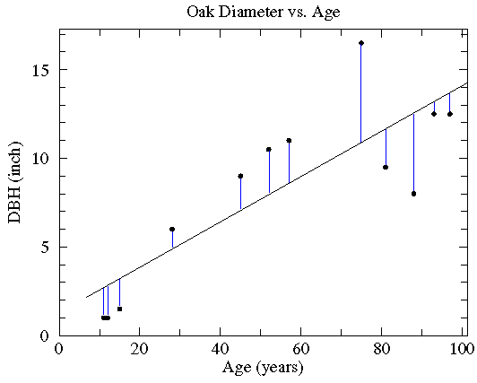

For example, the above is a data set in X and Y. We are interested in finding the line which slope and intercept such that the square of the residuals (the deviations from the actual Y-values compared to the line at a given value of X) is minimized. The line above is adjusted so that a minimum value is achieved. This is easily proved using a bit of calculus which seems unnecessary. In producing a linear regression, one uses this method of “least squares” to determine the parameters. The important parameters which are determined are the following:

    - The slope of the line (denoted as a)
    - The intercept of the line (the value of Y at X=0) – denoted as b
    - The scatter of dispersion around the fitted line – denoted as σ (this is also referred to as the standard error of the estimate)
    - The error in the slope of the line – denoted as σ_{a}
    - The correlation coefficient – denoted as r

In our use of linear regression we care about the accuracy of being able to predict Y from X. Thus the scatter and the error in the slope are most important to us.

Note that r² is called the coefficient of determination. Thus if r = 0.9 then r² = 0.81. This is taken to mean that 81% of the value of Y is determined by X, on average. For us physical scientists, this a meaningless statement and hence we will not make use of these parameters for this course. An example is provided below.

Please guard against the not uncommon situation of "statistically significant" correlations (i.e., small p values) that explain miniscule variations in the data (i.e., small r² values). For example, with 100 data points a correlation that explains just 4% of the variation in y (i.e., r=.2) would be considered statistically significant (i.e., p<.05). Here is what such data looks like in a scatter plot:

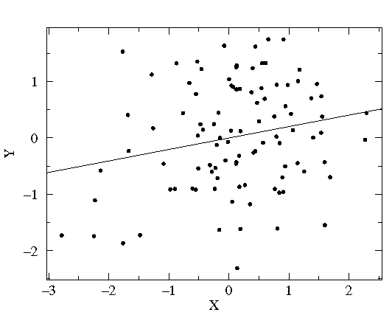
The correlation may be statistically significant, but it is probably not important in understanding the variation in y.

In addition, the correlation coefficient itself can be expressed as:

r = a(σ_{x}/σ_{y})

Where a is the slope of the line and σ represents the respective standard deviations of the input X and Y data distributions. Hence, a steep slope usually guarantees a high value of r, even though the overall correlation might have a lot of noise.
Now refer to the excel spread sheet that you downloaded that contains 9 (X,Y) data pairs. Note the columns B thru F:

Column B contains the X data
Column C contains the Y data
Column D contains X*Y
Column E contains X²
Column F contains Y²

Line 11 in the spreadsheet contains the respects sums of columns B thru EF. We need these sums to compute the least squares quantities:

A standard expression that appears in many of the relevant equations is this:

nΣx_{i}² – (Σx_{i})²

We will refer to this expression as Dx.

The slope of the line is then found from this expression (worked out exactly in the excel spread sheet):

[nΣ(x_{i}y_{i}) – (Σx_{i}) (Σy_{i})]
a = ---------------------------- (=7.26)
Dx

Similarly the intercept, b, is found from this:

[(Σx_{i}²)(Σy_{i}) - (Σx_{i}) (Σx_{i}y_{i})]
b= ---------------------------------- (=-81.42)
Dx

However, b can also be found in a much simpler way than just involves the averages of the X and Y data.
__ ___
b = Y - aX

Via the computation involving the sums we now have the best fitting line of the form

Y = ax + b.

By definition, this line represents the line in which the square of the residuals (the residual is the difference between the actual or observed value of Y and the predicted value of Y from the equation y = ax + b) is at a minimum. So, in other words, the scatter about that line is minimized.

The scatter can be calculated as follows:

σ = sqrt[(Δy_{i}²)/(n-2)] = 2.17
Where Δy is the residual value (contained in column I). Note that n-2 comes into play because 2 degrees of freedom in the system have been used up in determine the slope (a), and intercept (b).

The sum of the square of the residuals in this example is 33.05 and the denominator is 9-2 = 7. So the square root of 33/7 is the dispersion for the example in the spreadsheet.

One last item is the error in the slope. That is given by

σ_{a} = σ(sqrt(n/Dx))

So the error in the slope actually depends directly on the dispersion in the data. This should be intuitive. We can also express the error in the slope in a more compact form:

σ_{a =} σ/σ_{x}$\sqrt{n}$

Which means in order to minimize slope error you want a) a small dispersion of the data around the line, b) a large sample or c) a large dispersion in the input data set X. But as the error only goes down as the square root of the sample size, you won’t make much headway here. Errors in the slope are very important to account for in determining the overall accuracy of your predictions.

