A data story: a) raw data 🡪 is the systematic deviation in recent years important – should we weight it more? - B) bin the data in 9 year bins leaving out the last two years – C) adding in 2015 and 2016 as separate bins (therefore they carry more weight in the time series) and fitting a non-linear function:

A B

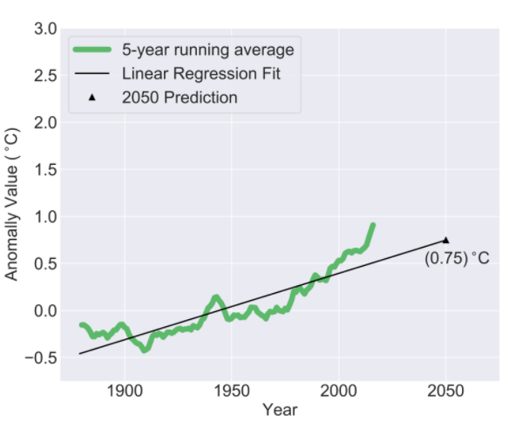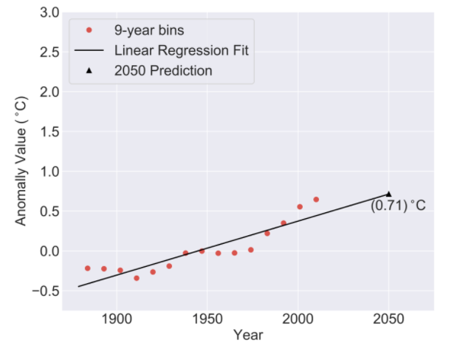

C

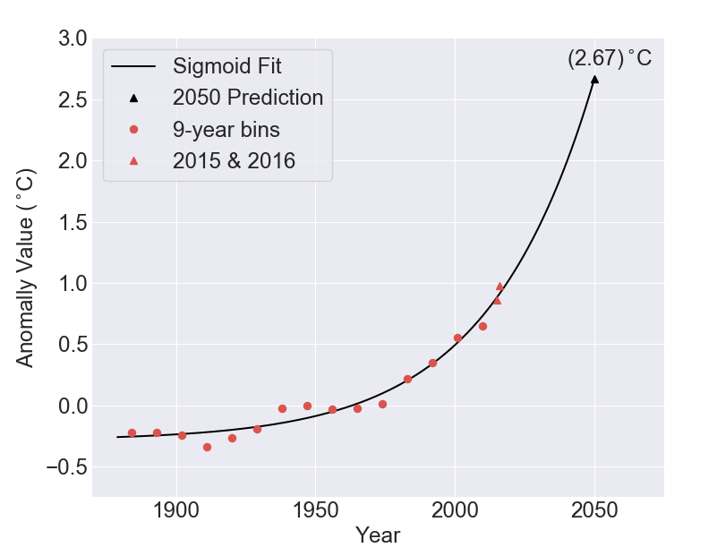

If the system response to perturbation is non-linear (because it’s a complex system) – then this non-linear behavior will eventually emerge and should carry more weight in predicting the future:

A and B 🡺 not too serious

C 🡺 We need aggressive climate change policy right now

Code of Conduct, Data Scientist Assocation

*If a data scientist reasonably believes a client is misusing data science to communicate a false reality or promote and illusion of understanding, the data scientist shall take reasonable remedial measures, including disclosure to the client, and including, if necessary disclosure to the proper authorities. The data scientist shall take reasonable measures to persuade the client to use data science appropriately.*

