We started off with a general discussion involving graduate students and authorship on papers that was based on the following excerpt from the reading:

*But why is authorship such a provocative issue? The "publish or perish" culture of science places enormous value on how many papers you've authored and in which journals those reports appear. In short, authorship has become "scientific currency." And as such, it is a major factor in key decisions, such as who gets hired and who gets grant money*

There were no firm conclusions on this but it was noted that there are real differences between group practices. Some disciplines just publish “group” papers where author order is not so important. Indeed, perhaps the author should be use “McMorran Group”. Then there is the issue raised by Fehmi (who should change his name to Fermi to be even more famous …) of who gets to be an author of a paper as it pertains to the use of someone’s else’s infrastructure of instrument. Much of the discussion was related to whether or not one can define someone’s contribution to a project and then how to best show that contribution – authorship, acknowledgements, etc. This is highly field dependent and to a likely extent, journal dependent.

The discussion led to two important questions

Upshot: How many graduate students do you list as authors on a PRL paper given the high prestige of this journal?

Are graduate students simply employees? Legally – yes; Ethically – no.

Most importantly, these issues really matter in the context of what constitutes a PI (is the PI the originator of the idea or is the PI the main funding source) and where they are academically. In general, any junior faculty needs to establish themselves via first authorship on paper in “perceived impact journals” in order to properly play the game of academic advancement. While there are important questions about the ethics of this, they seem to pale in comparison to the current and long standing reality of this game. As shown below, I had to play this game as well.

Here is a snapshot of my first authorship relative to total number of papers published.

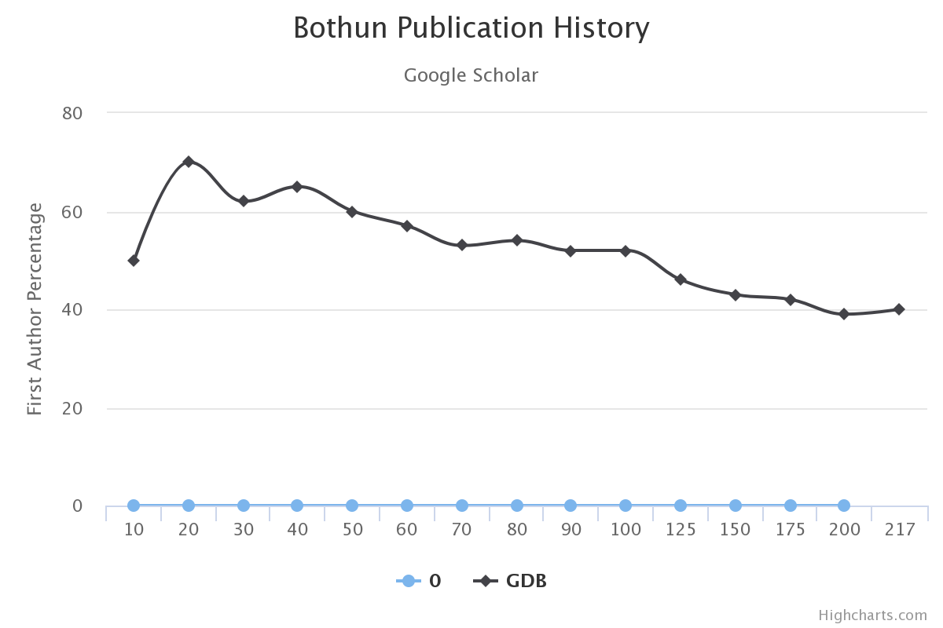

Features:

* First 10 as mostly a graduate student
* 10-30 As hybrid postdoc/research faculty (just mean I could teach as a postdoc) – **This is when I want first authorship**
* 30-60 Caltech years
* 73 = Tenure
* 42 more pubs before Promotion to Full at pub about 130 over an 18 year period
* Deadwood now: 87 pubs since Full over a 22 year period. First authorship percentage somewhat maintained due to more **single author papers**

From the APS Survey:

1. Perceived impact factors: *The only real answer to the ethics problem is for tenure review boards to stop rewarding the Science/Nature/PRL culture above all else.*
2. Style over substance? *Our scientific community promotes the search of the surface and superficiality [to the] detriment of content and deepness.*
3. *Many breaches of ethics arise from the pressure to publish …* What breaches?
4. *The researcher … will be judged [by] the number of articles, and the corresponding journal names, appearing on the CV. He or she will not be judged [by] the work spent on each paper, how many backup checks were performed to confirm the results, and so on. High number of papers, in highly ranked journals, is what builds a career…. The recent sad events [show] that it is for many people more important to publish spectacular results than to publish true results.* Kind of an extreme view.

The end result is that most of these graduate students in this survey regard science as kind of an elitist field where one can gain prominence over one’s completion by publishing in the right places.

Lastly we spend some time on the issue of Open Access journals and the relation between the Public and the scientist.

Advantages of OA:

1. Faster sharing of data and idea than traditional journals 🡪 indeed this is the principle motivation for the LANL archive
2. No pay wall barriers so in principle the public has better access, not that they give a shit.
3. An ethical consideration: research that is publicly funded should be made freely available to the public who paid for it for reasons of accountability
4. OA publications can inform and promote public discussion; is a scientist then ethically obligate to publish a form of their research in this forum?
5. Commercial journals have the potential to profit unfairly from the unpaid labor by academic researchers, but I doubt this is much of an issue in the physical sciences but seems to be a real issue in medical journals.
6. The publishers of traditional journals require that authors sign over the copyright of the published articles to the publisher, arguing that they bear the cost of producing and making the article available.  This was once an issue but now anyone can make a Web Page.