1. This lens should really be applied to all the topics under consideration to decide if there indeed are ethical issues associated with these topics. Indeed this is one of the challenges; many scientists have argued that not much belongs in the ethical domain. While ultimately that is your own decision to make, you should not make these decisions in a vacuum of knowledge about the wide range of issues that do merit ethical consideration. Then you can choose to ignore it.

**The Ethical Lens:** Ethical decisions are hard to make. In the first class (week 1) we discussed the steps needed to make and an ethical decision. The two big steps were a) reflective thinking and b) full consideration of unintended consequences. We have been going through these topics with this lens in mind because, in the real world, almost all of the time principles are sacrificed for expediency.

This is one of the reasons the Ryberg (2003) paper was assigned – even though it is directly about ethics and military research – the broad principles he raises are important. **Unfortunately, it doesn’t seem like anyone for this week’s class was able to read this paper to help promote a discussion about its overall merit.** Overall, this class will work a bit better if the students are able to be slightly better prepared for discussion. Remember, I don’t know shit, I just pretend that I do.

2. We started our discussion with Vannevar Bush and his driving vision for the NSF. While formulating that vision he writes two important things:

* Basic research is performed without thought of practical ends.
* One of the peculiarities of basic science is the variety of paths which lead to productive advance. Many of the most important discoveries have come as a result of experiments undertaken with very different purposes in mind. Statistically it is certain that important and highly useful discoveries will result from some fraction of the undertakings in basic science; but the results of any one particular investigation cannot be predicted with accuracy

Taken together these statements, along with the rest of his vision strongly argues that the Nation (and Bush does become Nationalistic in his vision) **needs to invest in scientific curiosity**. This is an excellent principle but it will, in general, largely dissipate into the strong budget constraint that only “safe” projects receive funding (see more on this below). In turn, peer review panels tend to also operate in a group think mode where only safe projects a funded. In essence, this denies scientific exploration and therefore denigrates the entire discovery process and that ain’t right, but that’s what we do. If something ain’t right, but it consistently done, then that becomes an **ethical consideration.**

**3.** Early on in our more enlightened pathway to scientific funding in the US, the Oct 4, 1957 sputnik launch caused a massive over-reaction and likely completely changed our funding strategies. This is largely because the enemy had reached space first with a 200 lb beach ball size thing that orbited for 98 minutes. An accurate succinct history of this can be found here: <https://history.nasa.gov/sputnik/> -- To many, the Sputnik launched signaled that America was not technically superior in the world and this caused a wide spread change. NASA was quickly established (like 6 months later) and the US DoD put lots of government resources into the Explorer project whose first launch was Jan 31, 1958 (just 4 months after the enemy launch) and that launch discovered the magnetic radiation belts around the earth – i.e. these things:

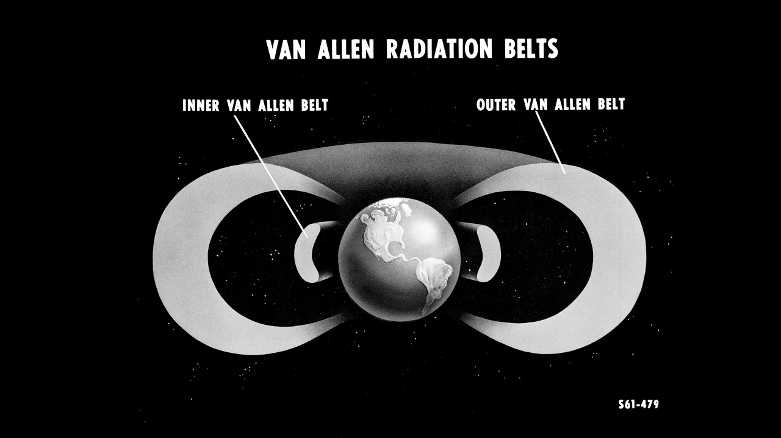

This fundamental discovery (which also helps explain why life can exist on the surface of a planet that is subject to large energetic ion flux) was an accidental by product of the ensuing arms race started by Sputnik. Overall, funding science largely for reasons of an escalating arms race, or maybe more politely, to use science to establish global dominance in technology and technological brilliance, could be regarded as an **unethical** way to behave.

3. With respect to the Ryberg document and some of the points raised:

He brings up the idea of moral rectitude – we didn’t talk about this much and most people just looked up a standard definition for this – for me, moral rectitude means this:

**Staying** on a path of integrity that is defined by ethical and moral principles;

He also brings up Kant’s essay[: On a Supposed Right to Lie from Altruistic Motives](https://www.unc.edu/courses/2009spring/plcy/240/001/Kant.pdf). To quote from Diderot: *There is no example that the truth was not harmful for the present nor for the future.*

While this may all be philosophical bullshit, it does bring up the important point that **intentions matter and that is part of ethical decision making.**

More specifically, Ryberg raises the following issues that scientists usually use to absolve themselves of any responsibility for the possible repercussions of their research:

*In short, since the essential nature of inquiry is that one cannot foresee what one will discover, the scientist cannot properly be held responsible for the results that follow from his research*.

The Scientists-do-not-decide-on-application Argument --

*More plainly put, the argument says that “If I did not do it, someone else would” therefore “I did not really do anything wrong”.*

The Cog in the Chain Argument - *If the work of a scientist who contributes to military research is a necessary condition for the final application of, say, a certain weapon system or some other piece of military technology, then the fact that the scientist is far distant from the application of the weapon system, in the sense that many others’ work and decisions are also necessary for the application, does not reduce the responsibility of the scientist.*

**In sum, Ryberg dismisses all of these arguments and asserts that scientists are obligated to engage in unintended consequences thinking. Of course, we really do this because of our own absolution using the previously mentioned arguments.**

**4. Ethical Issues and Some Unintended Consequences for University Research**

Let’s start out with good intentions: Vannevar Bush – author of [*Science, The Endless Frontier*](https://www.nsf.gov/od/lpa/nsf50/vbush1945.htm) (1945)

* Architect of the role for Federal Government in science
* Needs for Post WW II investment
* Government had important role to play in fostering creation of new knowledge and in training individuals to create that knowledge
* Ultimately this leads to the formation of the NSF
* Thought universities were right place because they were “least under pressure for immediate, tangible results.”

After essentially 70 years of this, one can now identify some unintended consequences as this has played out in the real world which includes **overbuilding, overtraining, and over emphasis on safe projects.**

First a small aside (imagine that …): In May 2013 I was asked by the National Science Board to do an audit and make a presentation about the evolution of science funding over the previous 20 years. Presentation was made a Johns Hopkins University (that ranks very high, if not number 1, on the collective faculty arrogance scale). In that presentation I talked about that the Nation was no longer honoring the “greater good” in terms of how science is being funded. The argument in brief was based on dividing science funding into 4 areas:

* New Facilities
* Legacy Facilities (large DOE national labs)
* Individual PI Grants (see the rant below related to KDI on consortium funding)
* Graduate Student Training (i.e. future science successes for the US).

These 4 areas are being supported basically on a flat dollar budget over this 20 year period.

1) Inflation associated with building new facilities is 8-12% a year

2) Labor costs associated with Legacy Facilities have increased about 5-7% a years (largely due to rising health care costs).

As a result of 1 & 2 🡪 Individual PI grants are very squeezed (this is also due to consortium granting priority) which greatly impacts the training of our future scientists. That’s what we have sacrificed by having a flat budget (see also below). The National Science Board did pay attention to that, but of course, nothing on a significant scale has happened.

On Overbuilding

* Biomedical research facilities built assuming NIH funding would grow.
* Building binge among universities used to recruit the *star scientist*
* Makes other disciplines feel like second class citizens, in the same way that UO athletics makes academics feel second class.
* Much of this overbuilding was done on the basis of Overhead dollars. [(A good discussion of the overhead issue)](http://proflikesubstance.scientopia.org/2013/04/11/the-overhead-problem/)

The overhead issue has an interesting history. At one point some Universities (like Stanford, Michigan) had overhead rates approaching 100%. Those institutions strongly encouraged faculty to submit lots of proposals – even gave faculty internal seed money to develop ideas and so set out an overhead arms race in the country among research universities until limits were put on this system, around the year 2000. Indeed, the review panel conflict of interest arose primarily so that panelists would not highly rate proposals from their own institution to further game the overhead system

In addition, there really are no guidelines for how overhead is to be distributed to better support the overall scientific research. Each university does things differently and many universities now use overhead dollars for startup so that can land the elusive *star scientist*

This has led to demonstrable growth in research infrastructure on many college campuses and the overall expense of other areas, particularly in the biomedical arena (as witnessed now by our own Knight Campus**). Universities exist to provide equal access to knowledge and facilities for all students and not to build a class system. We should be more thoughtful.**

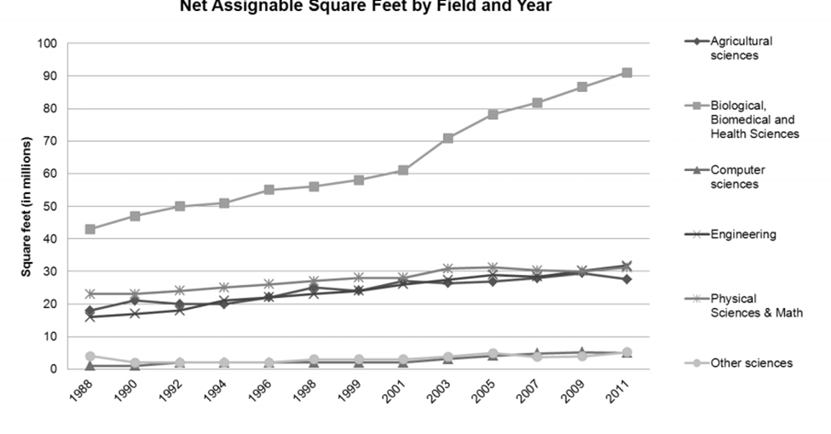On Overtraining:

Recent graduate students have had difficult times finding a job and often times end up in a long series of postdoc appoints as there is no faculty position waiting for them. [Read this 2017 Nature paper on this.](https://www.nature.com/news/many-junior-scientists-need-to-take-a-hard-look-at-their-job-prospects-1.22879)

This situation might discourages best and brightest from entering science

So, currently once a science PHD is acquired, the probability of that person continuing on in that field is going down. It might seem **unethical**, therefore, that graduate programs are not training these PHD students more broadly for other possible career pathways. Here is some recent data – note that none of the trajectories go up:

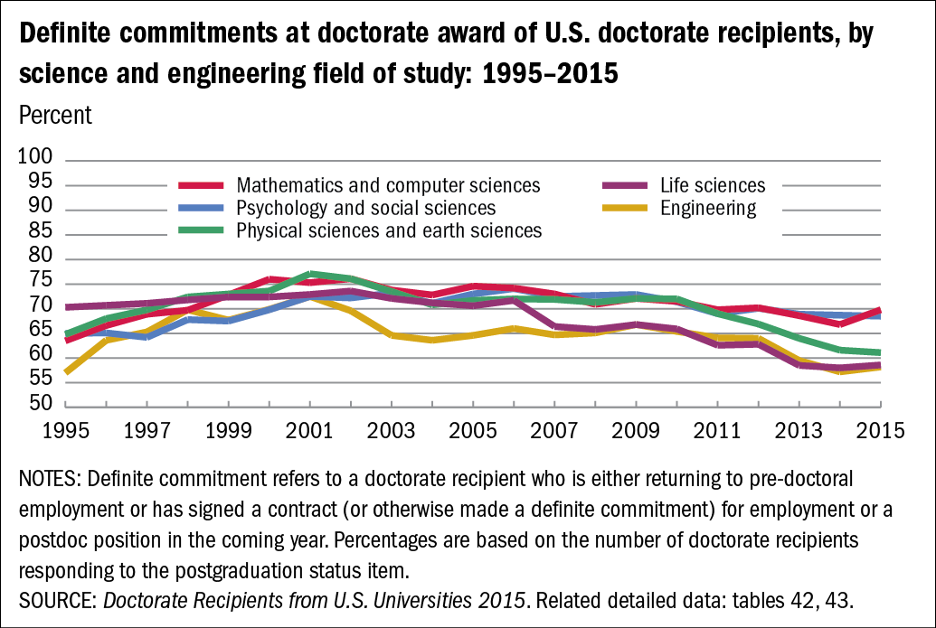

Over emphasis on safe projects on part of investigators as opposed to risky agenda:

* Detracts from ability to make fundamental breakthroughs— if most scientists are risk adverse little chance that transformative (Knight Camps) research will occur.
* One must have external support to keep lab going; university only supports lab for 3 to 4 years
* Need for faculty to obtain grants to support their salary—especially important for faculty on soft money and for tenure-track faculty at medical schools
* Low probability of success for risking projects: Reviewers prefer proposals with convincing preliminary data: To quote Nobel laureate Roger Kornberg, “*If the work that you propose to do isn’t virtually certain of success, then it won’t be funded”*
* Proposal continuations have higher success rates than new proposals - some investigators have been continually funded to do the same myopic thing for 30 years!
* Peer view panel group think very much rewards continuing projects compared to new ones, especially if the new ones are perceived as “risky”.
* Risk factors become highly negatively impactful because the oversubscription rates to most programs are high. While the table below is for the NSF, many programs, like using the Hubble Space telescope can be oversubscribed 20 to 1.

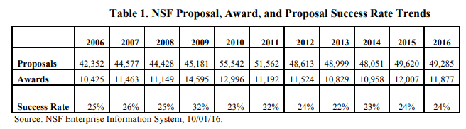

5. Science Funding:

Below we see that once upon reasonable funding for sciences had a period of about 20 years (1960-1980) – since then funding is mostly flat, even the size of the scientific community has grown significantly**. We are not scaling.**

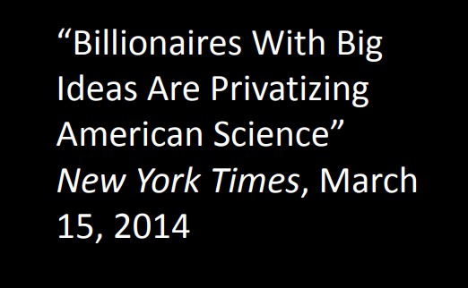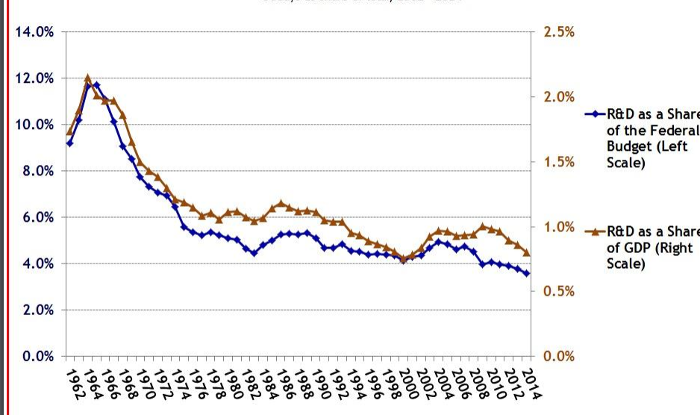

Once upon a time, like the 17th to 19th century, a lot of European science was privately funded by dilettantes. In the US we may be starting to return to some of this One example of this might be provided by: [Elon Musk and the 2 billion dollar sulfate aerosol cannon.](https://www.c2g2.net/ethical-issues-geoengineering/) We will discuss the ethics of geoengineering later as an example of the science policy interface and various ethical considerations.

6. Changing how funding is awarded

To being, a major shift occurred in 1998 when the NSF launched their first consortium funding under the marketing title, Knowledge and Distributed Intelligence. No, no one knew what this meant, or how to achieve it but you could get up to $10 million dollars, distributed over several institutions, if your proposal was accepted. In my view, this definitely started the decline of individual PI support by the NSF in favor of funding all kinds of “mega” things. The jury is still out on the overall success of this approach. As a PI I was a member of a group about 10-12 years ago that strongly argued, to no avail, that the NSF needs to better prioritize individual PIs that want to support a couple of grad students on exploring an idea. The response of the NSF was “ha, [we fart in your general direction](https://www.youtube.com/watch?v=FWBUl7oT9sA)”. In essence, this means the NSF is no longer funding people, but projects instead.

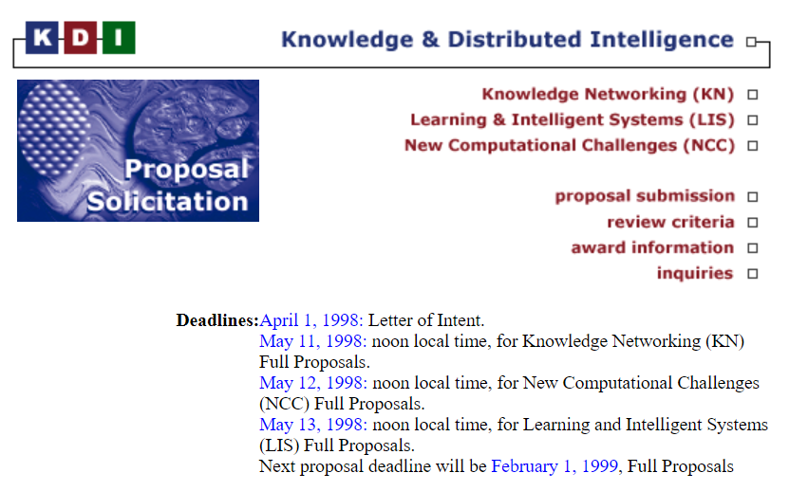

7. Finally I provide a link and the abstract of a paper that examines whether or not it is even worth a young investigators time writing good grants in the current funding climate.

[Is it worth it to write grants as a young investigator?](http://journals.plos.org/plosone/article?id=10.1371/journal.pone.0118494)

