**The Number one Frame on all of this is the following:**

**Scientists believe that they are intrinsically ethical …**

Here are some snippets from various codes of ethics by professional organizations.

Read through these prior to class on Friday and see which of these sentiments you think are applicable to science , scientific research, and being a scientist. Note, in general, most all professional codes of ethics are:

* Way too long and redundant
* Generally focus too little on issues of integrity, being unbiased, and not exercising favoritism

But this one is nice and short! However, as discussed at least I think that only the last two matter. Morever, it is this idea of scientific honesty which scientists seem to equate with being ethicial.

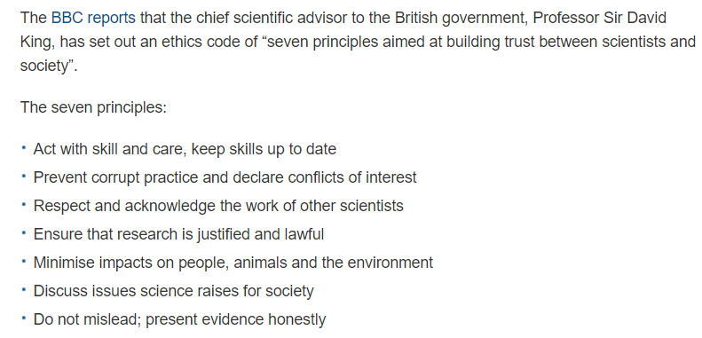

READ THIS: <https://www.wired.com/story/should-data-scientists-adhere-to-a-hippocratic-oath/>

AND THIS: <http://www.tissuegroup.chem.vt.edu/chem-ed/ethics/vinny/ethix_4.html> - this is the article about the Professional Coded of Ethics AAAS endeavor.

Now Consider This:

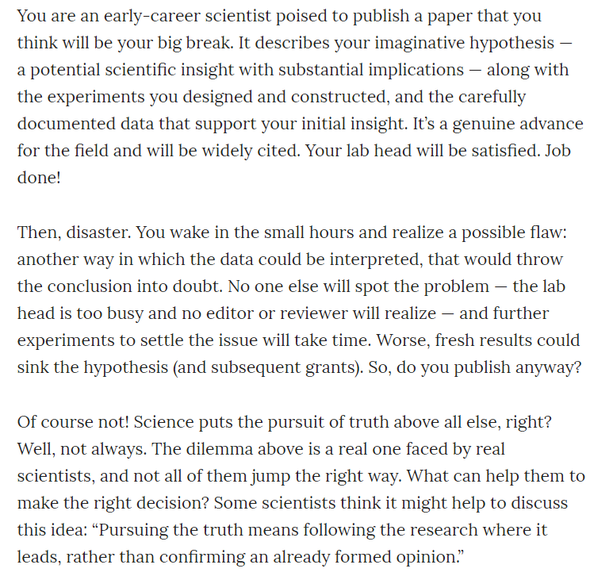

Some Editorial in 1963: (<http://science.sciencemag.org/content/142/3594/916.1>)

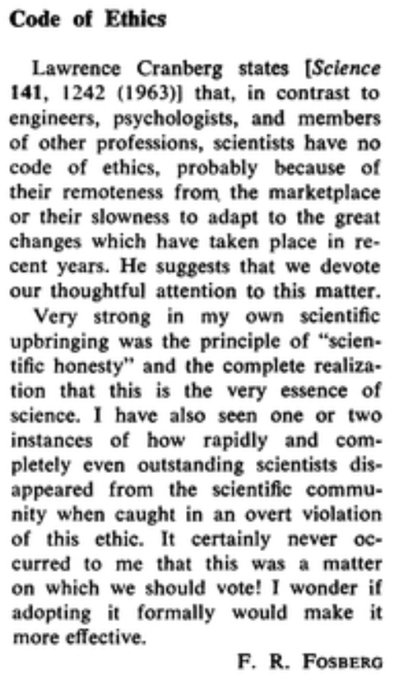

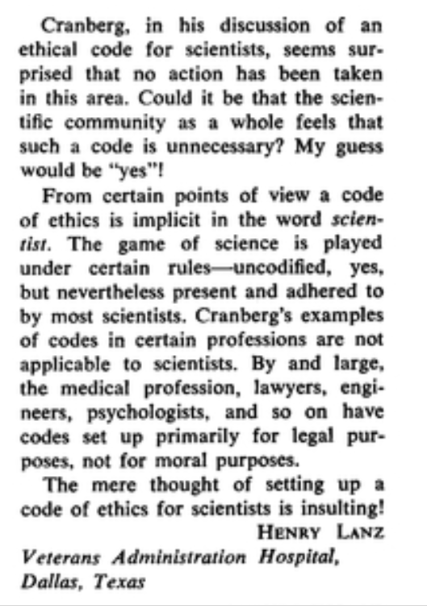

An update from the AAAS which is kind of silly as it now wants to link Human Rights into all of this. Once again, this is a move away from a) the greater good and b) thinking about unintended consequences

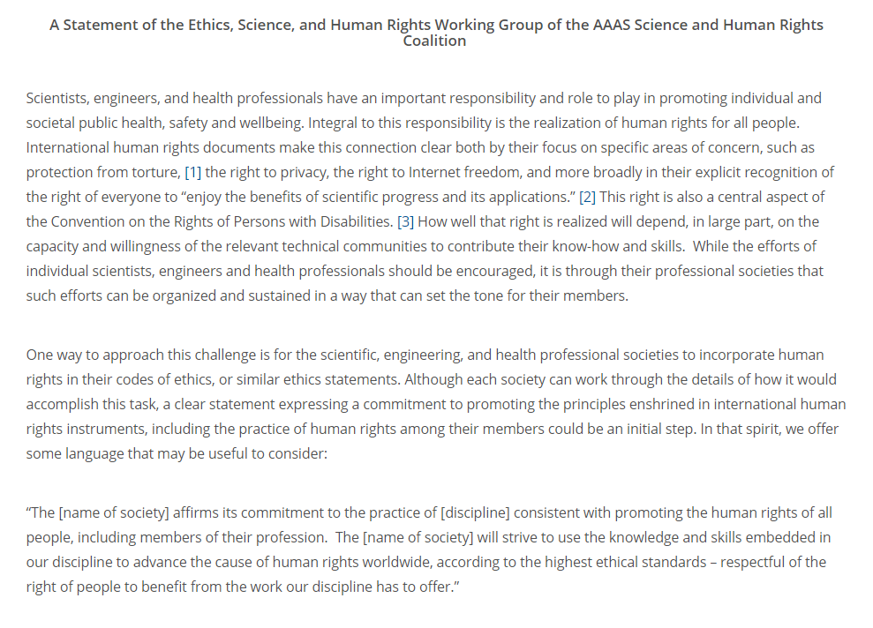

Some Examples:

From the PRSA (Public Relations Society of America)

A member shall:

* Follow ethical hiring practices designed to respect free and open competition without deliberately undermining a competitor.
* Preserve intellectual property rights in the marketplace.

Examples of Improper Conduct Under This Provision:

* A member employed by a “client organization” shares helpful information with a counseling firm that is competing with others for the organization’s business.
* A member spreads malicious and unfounded rumors about a competitor in order to alienate the competitor’s clients and employees in a ploy to recruit people and business.

From DJ Pital (google on him if you don’t know the name):

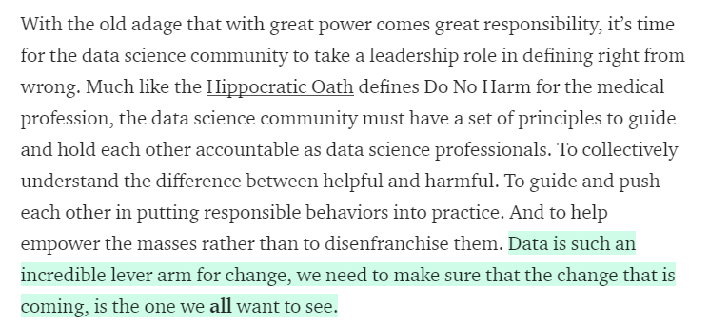

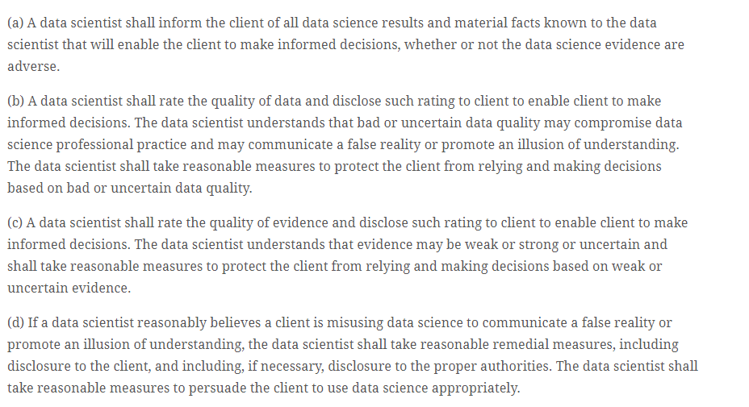

At the end of class, a discussion randomly broke out about the ability for scientific knowledge to always count on the responsible behavior with that knowledge. This is in relation to the DO NO HARM idea. We also talked a bit about the self-policing of various disciplines and holding each other accountability to some code of ethics. There are indications that the open source community does this and the sentiments of Pital above essentially demands that data scientists hold each other accountable.

Now most of these words or concepts are vacuous with some specific examples.

So here is an example I used: If the inevitable result of e-mail communication is the wholesale removal of empathy in humans, then was it worth inventing in the first place?

Finally, consider this – the ethics of giving aid to other countries. I would argue that the biggest need is to improve infant mortality rate – that need is far bigger than the need for foreign countries to build bombs and then drop them on another tribe’s children.

Here is some relevant data on this:

