Type of the Paper: Review

Climate Change: Global Consumption, Ocean Heating and

Differential Adaptation is our Future

G. Bothun 1,

1 Dept. of Physics, University of Oregon; dkmatter@uoregon.edu

Academic Editor: name

Received: date; Accepted: date; Published: date

**Abstract: We provide a data-based overview on the current situation with respect to a) rising greenhouse gas emissions and b) rising rates of global consumerism and resource usage. We make the physical argument, backed by observations, that the industrial waste heat associated with our ability to support an escalating consumer world using fossil fuels as the principal source of energy is directly heating the oceans and changing the temperature profile of those oceans. Since ocean circulation directly connects to atmospheric circulation then, after some lag time, this extra heat added to the oceans manifests itself as increasing weather volatility and climate change. Using that physical basis, we then discuss the policy implications of dealing with non-linear changes in natural systems. We further discuss the prospects of reaching a stabilization target of 450 ppm for CO2 by 2050 and directly show that we are unlikely to reach that goal as well as the goal promised by the Paris Accord of 2105. Finally, we use various GDP based data and some simple models to focus on the 50 countries that we identify that are most vulnerable to climate change as they have little to no ability to marshal sufficient resources for adaptation.**

**Keywords:** climate change, greenhouse gases, stabilization, adaptation deficit

1. Introduction

In this contribution we present various data related to the rate of both climate change and global consumption in order to a) show how these are linked together in the sense that global consumption is the fundamental drive of climate change via its associated, required, industrialization and b) that the rate of change indicates an acceleration and therefore increased urgency in effective policy planning aimed at sensible adaptation to a more extreme and volatile climate future. We also focus some discussion on the actual scale of the climate change problem relative to our ability for adaptation. For sure, adaptation will be highly differential as various impacted regions have limited resources. A direct example is provided by the country of Bangladesh. In 1998, Bangladesh experienced is severe monsoonal based flood, which inundated about 50% of the land area and had very long-term impacts on basic nutrition in that country [1]. Well at some, likely relatively near point in the future, 100% of Bangladesh will be flooded due to rising sea level, storm surge, and catastrophic monsoonal moisture. Currently, Bangladesh is the 8th most populated country (165 million) and its inhabitants are in danger of being permanently displaced. What kind of adaptation is available for an entire country which has been lost?

In addition, as we show by data, while are efforts on the sustainability front are broad and laudable, in the real world, we are now living at the most unstainable time in history as measured by the consumption of consumer goods. This makes achieving actual sustainability, which is a quantitative result based on reducing consumption, quite difficult as the developing world is gaining increased access to electricity and internet mobility. Clearly, this access should never be denied but the global reality of our consumption and its strong evolution needs to be better accounted for in thinking about the future world. A promising avenue is the concept of “just sustainability” [2].

In this concept, social justice and global equity are the long-term goals of the overall adaptive process. At some point, a priority system based only on economic gain should be replaced so that our collective value system is no longer based on prosperity being directly equated with economic gains. Issues of fairness, environmental justice, dignity and global equity should become more important if we are to manage our planet better and work together in a more cooperative manner that produces a more intelligent way of managing dwindling planetary resource. Yet, we appear to be taking the exact opposite path. In short, we need to living in partnership with nature within ecosystem limits rather than dominating all of nature and ignoring those limits. The current rapid escalation of volatile/extreme climate events is a good signal that the Anthropocene [3] is here and that humans are now a global geophysical force that can dictate how the Earth system behaves. The primary purpose of this article is to illuminate all of the above with real world data. The ultimate importance of good data is a) data driven decision making becomes possible and b) in principle, data tells a story that you cannot hide from, not matter how much you want to.

2. Climate Change: The Data View

In this section we combine various measurements with simple models to demonstrate that, by any measure, the rate of global change is acceleration. We will refer to acceleration as non-linear change. For the most part, the input to this non-linear change is a global increase in per capita consumption of most all resources. We will show some specific examples below, but this trend can be effectively codified as,

Resource Usage  (Pop_growth) N,

where N > 1. If the perception of the lay public as well as policy makers is that change or growth is mostly linear (e.g. N=1), then in the real world of accelerating changes, each passing year puts us farther behind in our ability to mitigate of adapt to a growing problem. It is within that vein that we present various aspects of the non-linear rate of global consumption which has the direct consequence of a) increasing out annual CO2 emissions to the Earth’s atmosphere and b) adding heat content to the oceans which eventually changes their thermal profiles. That heat content addition is accelerating and since the oceans couple directly to atmospheric circulation, then we can expect, and likely are observing, increases in regional weather volatility that often times translate into single, large scale weather events.

2.1 Mitigation: Opportunity Lost

In general, the term climate change mitigation refers to policies that reduce the atmospheric build-up of CO2 in future years [4]. While there are a host of possible mechanisms to achieve this goal, three stand out as having the most impact a) moving away from fossil-fuel based electricity generation and more towards renewable electricity generation, b) a wholesale change in transportation away from the personal transportation “pod” that runs on fossil fuels, and c) reducing the rate of habitat alteration that produces a net loss of CO2 absorption efficiency in either the plants or soils of that habitat. In addition to these three would the construction of carbon, capture and storage infrastructure that could directly sequester carbon into the terrestrial biosphere. Since options exist, it becomes a simple data test to determine if we are making any impact in our goal of reducing atmospheric build-up of CO2. As shown below, the data are quite clear: atmospheric CO2 concentration is not reducing but, in fact, is accelerating in its overall accumulation. This acceleration effectively means that we have failed in establishing any mitigation strategy.

The simplest way to portray this acceleration is shown in Figure 1 which plots decadal averages of CO2 concentration, as measured in units of parts-per-million (ppm). The plotted data comes from the Mauna Loa Observatory which has been making reliable, well-calibrated measurements since 1958 [5]. Details about the manner in which the data are plotted are in the figure caption. From this figure we can glean a few details:

* The current decadal annual increase in CO2 concentration is 2.23 +/- 0.51 ppm. This is twice as large as the 1.07 +/- .52 ppm value during the 1960-1990 periods.
* For the current decade, every single year has a large annual emission than the long term 1960-2000 average of 1.14 ppm.
* The decades of the 1980s and 1990s have noticeably larger variation in individual years emission than decades before or after indicating the CO2 cycle during that time was nosier than it is today.
* 2015 set a record of 3.01 ppm for annual CO2 emissions; a disturbing trend for future CO2 forecasts or target stabilization levels.

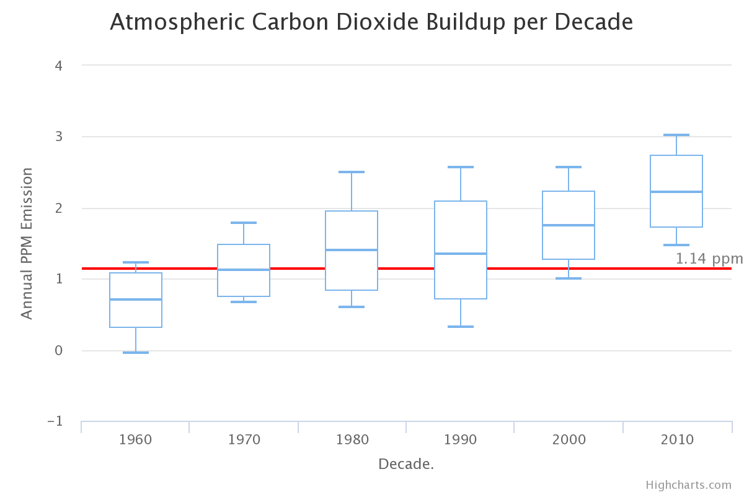

Figure 1: Decadal average of annual CO2 emissions from the Earth. The solid red line is the average annual emission over the period 1960 – 2000. Average ppm emissions for the decade are indicated by the blue solid line in each decade box; the vertical size of the box represents +/- 1 standard deviation around the mean value. The top and bottom bars represent the maximum and minimum individual years for that particular decade.

We can next ask if the most recent decade’s emission rate is statistically significantly larger than the previous rates. For the previous 6 decades, the average annual emission rate would be 1.27 +/- 0.39 ppm. This decade’s current value of 2.23 ppm has less than a 1% chance of randomly occurring from the previously established baseline. This indicates systematically increasing annual CO2 emissions and therefore a more rapid buildup of atmospheric CO2. Hence the data clearly show that emissions are significantly increasing and the opportunity for mitigation has vanished. In terms of exponential rates, the period form 1960-2000 has an exponential growth rate of ~ 0.4% per annum – leading to a doubling time of 175 years. For the 2000-2017 period, the rate has increased to ~0.6% per year (50% larger!) which leads a doubling time of 116 years. We thus are living in a period of accelerating global deposition of CO2.in our atmosphere. This is clearly seen in the simple business as usual (BAU) scenario in which we will see another 50% increase in the global emission rate in the coming two decades and that would lead to an atmospheric concentration of CO2 in the year 2050 of ~ 550 ppm thus reaching a doubling of the traditional 280 ppm value for CO2 concentration in the pre-industrialized era, a situation first described in crude climate models in 1975 [6].

Examples of missed mitigation windows are shown in Table 1. Here we use the observed decadal rates and assume an early awareness of CO2 buildup such that a policy arises which has flat emission rates and then reduces planetary annual emissions by 10% per decade 30 years later. The column labelled difference tabulates the difference between adopting the policy compared to the observed CO2 value for 2020 which we estimate to be 415 ppm (extrapolated form current value using observed rate increase). For example, had we acted in the 1970s, our observed 2020 CO2 concentration would be some 72 ppm less than it actually will be. But even waiting until the 1990s would have produced significant net gain relative to our current situation. We also compute and tabulate the concentration of CO2 in the year 2050 resulting from these simple models. These results indicate that if we wished to avoid getting above 400 ppm we should have enacted this simple policy by the start of this last decade (now 17 years ago). Instead, we do nothing.

Table 1: Possible Mitigation Windows

|  |  |  |
| --- | --- | --- |
| Hypothetical Mitigation Window | Difference of 2020 - Mitigation Decade | Year 2050 concentration (ppm) |
| 1970s | +72 ppm | 350 |
| 1980s | +58 ppm | 367 |
| 1990s | +47 ppm | 379 |
| 2000s | +32 ppm | 401 |
| 2010s | +6 ppm | 473 |
| BAU | ---- | 550 |

In addition, to increasing CO2 deposition we are also experiencing rising methane (CH4) levels which exacerbate the potential warming effects of CO2 alone. One of the not very well-known outcomes of the Fifth IPCC report is the elevation of the global warming potential (GWP) of CH4 from its long-standing value of 21 to its revised value of 32—35 (a 60 -70%) increase although there is still uncertainty on what GWP convention to adopt for CH4 [7,8,9]. One of reasons for the increase is that some recent results showed that CH4 can act as a catalytic surface for atmospheric chemistry processed that accelerate the removal of sulfate aerosols (which act as global coolants) thus creating a positive feedback term [10]. It is thus alarming the, after a long period of no change, atmospheric methane concentrations are once again rising, as shown in Figure 2:

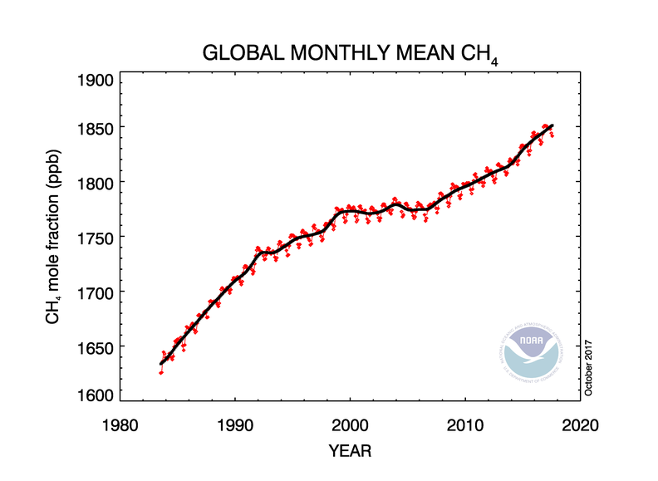

Figure 2: Observed Annual Methane Emissions

Here we adopt a value of 34 for the GWP of methane – this value is appropriate for the full feedback cycle notice above. The current concentration of CH4 is 1.85 ppm. With this value the current level of carbon dioxide equivalent is:

+ 1.85*34 = 473 ppm

Historically, total global methane emissions can have large variations due to complicated wetland dynamics [11,12]. These variations, on approximately a decadal time scale, appear in the data as rate changes (see Figure 2). In particular, the data show a period of flat emissions ending in around 2008. During times of globally low precipitation over wetland regions, methane emissions are reduced and this is a likely recent for the observed flat behavior. Since 2008 methane emissions again are rising with the most recent uptick starting in 2014 with an annual increase of about .009 ppm. Methane emissions can also be reduced by sheer loss of wetlands, much of which has occurred in China over the last two decades [13]. However, wetter and warmer climates for wetlands will increase the rate at which wetlands, particularly peat-lands, emit methane. If the current rate remains unabated, then, in combination with the BAU model above, the 2050 value for ${CO}_{2e}$ will be 550 + 2.15*34 = 623 ppm.

Section 2.2: Ocean Heating: The Root of Climate Change

At its foundation, climate change is driven by our systematic heating of the oceans, since the industrial revolution, through human industrialized processes and their associated thermodynamic waste heat. Waste heat is the inevitable result of work done by an inefficient machine that gives of heat to the environment while doing the work. Fossil fuel burning is simple one of the waste heat channels. Well, doesn’t this waste heat just rapidly dissipate into the air? No, the air is just the initial repository for waste heat, but ultimately, largely because of precipitation, as shown in Figure 1 – most all of this waste heat ends up in the Oceans which have been systematically store this extra heat content for the last 150 years. For example, if the reader were to light a candle in a room, eventually that extra heat would be rained out of the atmosphere, relocated to groundwater, and eventually end up in the oceans as its final resting place. There are four major heat storage systems on the Earth: a) the oceans (water), b) the atmosphere (air)) c) the continents (rock) and the cryosphere (ice). The right left panel in Figure 3 indicates the percentage heat stored in each of these 4 reservoirs and clearly shows the dominance of the oceans. The right panel breaks out the various cryosphere components as we will soon discuss Arctic Sea Ice.

|  |  |
| --- | --- |
| chart (7) | chart (8) |

Figure 3: Components of heat storage measured for the period 1993 to 2003 from the data contained in IPCC *AR4* 5.2.2.3.

The rate of heat content addition to the ocean is now rapidly accelerating (see Figure 4) as globalization runs amuck. The differential surface warming waters of the ocean directly couple to the behavior of the atmospheric jet stream which determines regional weather patterns. If you change the heat distribution in the world’s oceans you will correspondingly change weather patterns [14,15,16]. But, since there are significant lags in the system, it will take some time for this overheated ocean to manifest itself in terms of increasing weather volatility. Based on the data shown in Figure 4, we argue that ocean heat addition by industrialized processes has been out of equilibrium since about 1990.

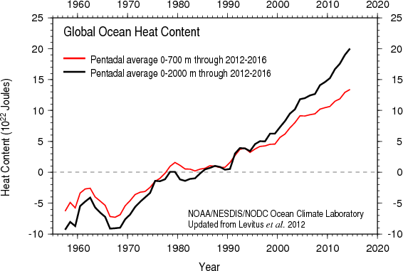

Figure 4: Calibrated heat content to the ocean as measured since 1957 [17]. This representation of the data is averaged every 5 years. The divergence between the red and black lines indicates the more and more of this ocean heat is being absorbed and stored at depth. The dashed line indicates represents a long-term equilibrium average.

Figure 4 informs us of a few things:

a) The rise in ocean heating since the mid-1990s is fairly linear although the most recent data lies a bit above the linear extrapolation, particularly for the black line,

b) Prior to 1990 or so the oceans have a capacity to absorb more heat and distributed it through its normal channels. The most important channel for removing excess surface heat from the oceans is deep sea transport [18,19] but this mixing operates over a few hundred years timescale [20]. Since 1990, the oceans have experienced reduced efficiency in terms of handling waste heat input and are clearly retaining more heat. In turn, this inevitably changes the horizontal (ocean currents) and vertical temperature distributions within the oceans and this directly drives jet stream patterns which determine regional weather. [21,22] Simply put, the coupled ocean-atmospheric system has more energy to work with it, due to our human input.

c) Because of b) we would expect the signature of climate change as increasing weather volatility to start to emerge around 1990 and continue to escalate simply because more energy is being added to the system.

We stress here that the Y-axis in Figure 4 is not temperature – instead ocean surface buoy measurements of temperature have been converted to heat content [17]. On an annual basis we are adding approximately 1022 Joules of energy to the world’s oceans. These units are likely meaningless to most readers but their equivalency is as follows:

* Each person on the planet using 10,000 gallons of gasoline per year
* One trillion annual barrels of crude oil
* Each person on the planet using 1.4 billion AA batteries per year

The above numbers represent the sheer nonsensical scale of global consumerism. But how is this possible? How can globalization continue to produce increasing amounts of waste-heat? Easy, our industrialized processes simply constantly scale up to meet increasing consumer depend and the best proxy for that scaling is commercial shipping traffic.

For the most part, consumer goods are shipped via containers on large container ships. These containers are known as TEUs (20-foot equivalent units). These ships disembark at about 20 major container ports around the world from which the goods are distributed via road, rail or plane. The total energy associated with this process is large and mostly consists of a) the energy associated with extracting the raw resources, b) the energy associated with converting raw resources in to consumer products and c) the integrated transportation of these goods. Remarkably, the global industry has been able to keep up with consumer demand simply by building larger container ships and larger container ports. The explosive growth in capacity is shown in the Figures 5-7. We begin with Figure 5 that shows a 10 year ramp up period for the combined top 10 container handling points in the world (6 are in China, one each in Singapore, Hong Kong, South Korea, and the United Arab Emirates; the largest US port at Los Angeles is rated number 18 and handles 4 times less volume than the world’s largest port at Shanghai) as well as the two top ports themselves. Note that as of 2013, some ports were handling 30 million containers which is about the same as the number of seconds in a year. The global economic meltdown of 2009 is not readily apparent in the total data but can be seen for the two busiest shipping ports as about a 15% reduction in volume handled for that year, from which there was a quick rebound to maintain BAU growth.

The overall scaling of with respect to world population growth during the same period is the following:

* World Population grew by 13%
* Total container handling essentially doubled
* Container handling at the two busiest ports also nearly doubled.

As will be shown explicitly with other resources below in Section x.x, this is a strong indication that global consumption grows in a strong non-linear fashion with population increases. The industrial waste heat associated with the necessary energy to process and move this increasing number of containers contributes directly to ocean heating.

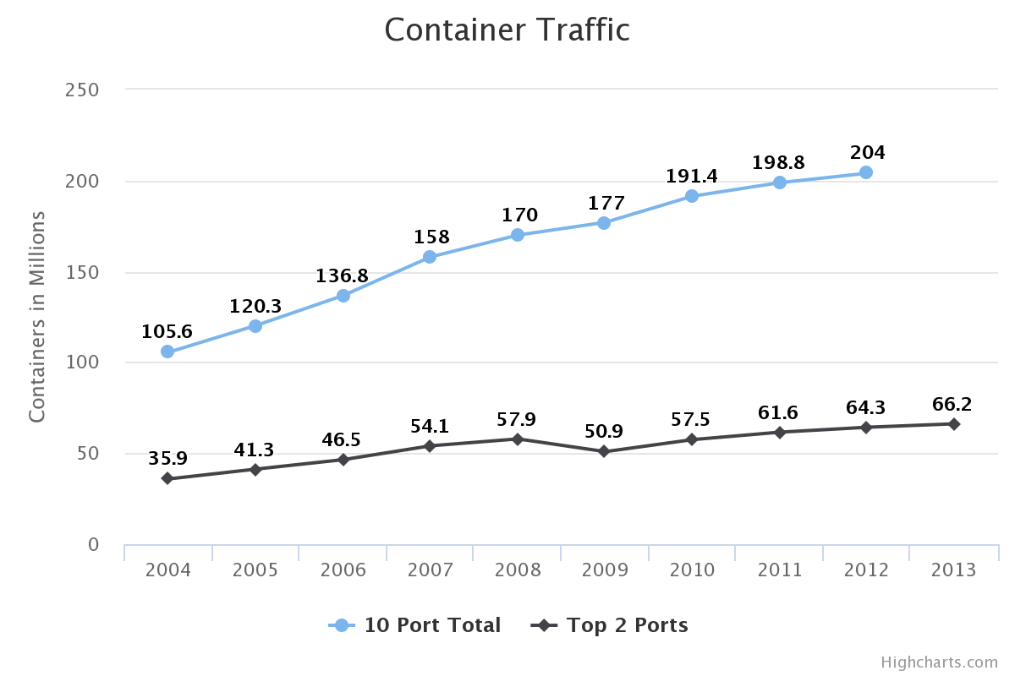

Figure 5: Evolution of container traffic from 2004 – 2013. Blue line is the combined total of the world’s 10 busiest ports; black line is for the two top ports, both located in China.

Next, we consider the tremendous increase in total container traffic volume. Figure 6 shows the data together with a 10% growth curve fitted to the 1990-2008 data. The economic meltdown of 2009 put a temporary halt to this enormous growth curve but the data show a rapid rebound and continued growth now at the level of about 5.5% per year. Perhaps this discontinuity is one of the silver linings associated with the global slowdown.

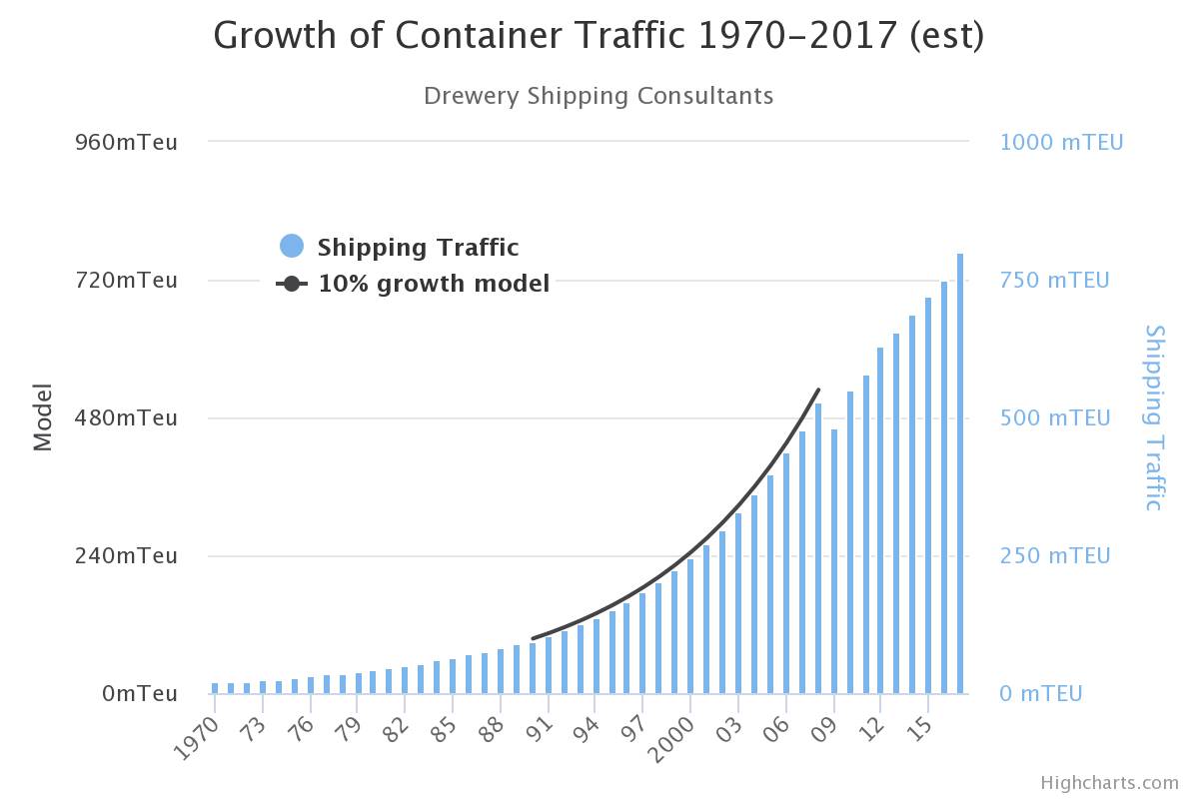

Figure 6: Evolution of container traffic growth in units of millions of TEUs shipped for a given year. The solid black line shows a 10% growth rate on top of the 1990-2008 data. This growth was temporarily interrupted by the global economic meltdown of 2009.

In figure 7 we show the evolution of the container ship itself. Over the last 50 years, the individual capacity of container ship has grown by approximately a factor of 15. In turn significant growth in container port facilities must also occur to handle this increased discharge of goods. Moreover, the container ships over 18,000 TEUs are generally too big to navigate through the Panama Canal. In response to this, there is an effort, now somewhat stalled, to build a larger and wider canal through Nicaragua that transits directly through Lake Nicaragua [23,24]. Altogether, Figures 5,6 and 7 reveal our remarkable ability to scale delivery facilities to the escalating global market and the business as usual (BAU) trajectory is to simply continue this trend of doing more, faster. It is the combined waste heat of all the industrial processes associated with keeping us on these BAU curves that has increased the heat content of the oceans leading to global climate change. As these curves continue to accelerate upwards, the rates of impact on the natural system will correspondingly increase.

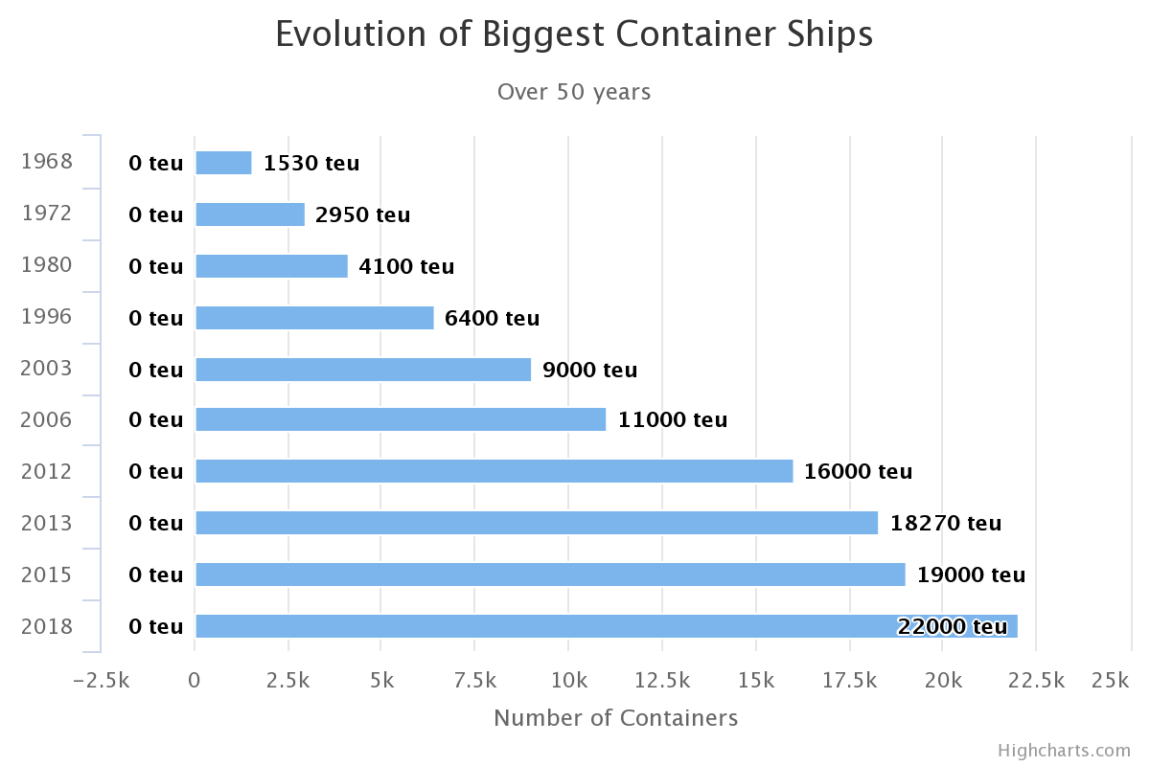

Figure 7: Evolution of individual container ship maximum capacity. These large ships built since 2013 have difficulty navigating the Panama Canal.

Using the data for increased container traffic we can show how the observed CO2 levels in the atmosphere respond (or correspondingly how the ocean heat content responds) by examining the data over 5-year periods. Due to lags in the system, there is never a one to one correspondence between our energy activity on the Earth and immediate atmospheric response; hence the CO2 content of our atmosphere did not see a reduction, even though the year 2009 saw a planetary wide reduction in greenhouse gas emissions of about 10%. Table 2 below summarizes the relation between ppm increase and container traffic increase in these 5-year periods. Again, because of various time lags there will generally not be a one to one correspondence between shipping traffic and automatic CO2 increases; only over a suitably long time will some trend emerge and that is shown in Figure 8 which plots an exponential fit in the relation between increasing CO2 emissions and increasing shipping container traffic. The fit has a lot of scatter around it, and the 1990-1995 time-period is clearly deviant. Indeed, contrary to uninformed opinion, the particular details of the Pinatubo volcanic explosion in 1991 show that there was a corresponding drop in atmospheric CO2 concentration. This is true for similar explosive volcanic events [25,26,27] and of course such events demonstrably serve to cool the Earth for about 18 months because of the large amount of sulfur aerosols ejected into the upper atmosphere. Whatever the particular details are in Figure 8, we here are only interested in the general trend with time and clearly there is one. Using that trend for future predictions is not very reliable but in line with the BAU trajectory, if we were to double the number of containers in the next 5-year period that would result in a CO2 increase of ~ 25 ppm. For comparison, it took the period 1980 – 1996 to cause a similar increase. This is yet another example of accelerated build up.

Table 2: Increasing container traffic and increasing planet wide CO2 emissions.

|  |  |  |  |
| --- | --- | --- | --- |
| Time Period | Container Traffic | CO2 Increase | Ratio |
| 1970 - 1975 | 10 mTEU | 5.63 ppm |  |
| 1975 -- 1980 | 14 | 7.45 |  |
| 1980 -- 1985 | 21 | 7.35 |  |
| 1985 -- 1990 | 30 | 8.65 |  |
| 1990 -- 1995 | 58 | 6.49 |  |
| 1995 -- 2000 | 93 | 8.83 |  |
| 2000 -- 2005 | 150 | 10.43 |  |
| 2005 -- 2010 | 153 | 9.85 |  |
| 2010 -- 2015 | 170 | 12.08 |  |
| 2015 – 2020 | 215 (est) | 13.5 (est) |  |

Figure 8: Exponential fit to the growth of container ships and the increase of atmospheric CO2; again, container ship traffic is used here as proxy for planetary industrial output.

Our oceans ability to absorb and redistribute waste heat is now reduced as Figure 4 clearly shows the oceans are systematically storing more heat each year. As the rate of per capita consumption increases, then total resource consumption accelerates and we have previously demonstrated a correlation between total shipping traffic and rises in annual carbon dioxide emissions. In addition to shipping traffic, there are a number of other indicators of rapid non-linear growth of certain kinds of resource as globalization continues. We document four particular resources which exhibit explosive growth that indicate our accelerating global consumption.

We begin with Figure 9 which is likely the best proxy for the impact of technology and social media on a planet wide basis. Here we plot World Lithium production and immediately see its character of exponential growth. This is not surprising as Lithium is the basic raw material for any kinds of batteries, from those in smartphones and laptop computers, to the battery packs needed to power Electric Vehicles (EVs). Indeed, one of the channels availability for reducing carbon emissions would be the replacement of gasoline powered vehicles by EVs. Because lithium is in such high demand for other types of batteries, the availability of Lithium strongly limits the annual production which is possible for EVs [28,29,30] and that limit is about 2-3% of the annual production of gasoline powered vehicles.

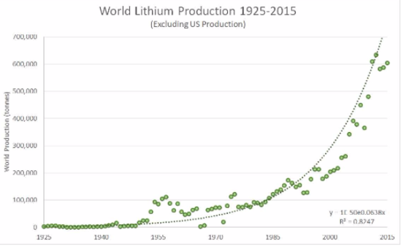

Figure 9: Exponential growth of world lithium production (us production is minimal).

One of the most revealing indicators of growth lies in world steel production is shown in Figure 10 and this strong growth couples directly to building infrastructure.

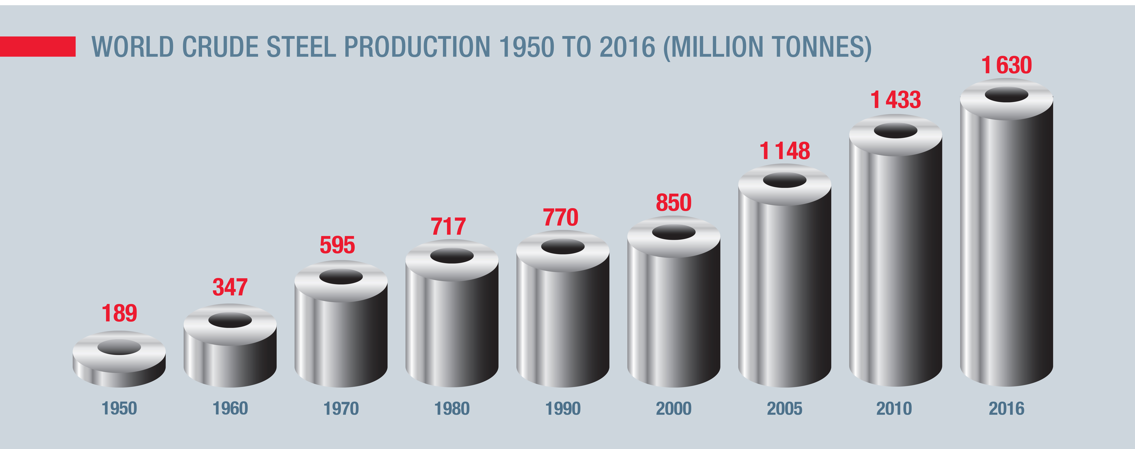

Figure 10: Decadal growth of world steel production.

Over a span of 56 years, steel production has increased by a factor of 8.6 yet the world’s population only grew by a factor of 2.8; this yieldsN ~ 3 – if you double the population then steel production goes up by a factor of 8. Economic price corrections at some future date, as resource scarcity goes down, are likely to eventually reduce production [31] but there is no evidence that has yet occurred for steel production.

Next, we consider the case of Soy production (Figure 11). The 2016 Living Planet Report [32] has now a special section on the soy production problem and the associated vast amounts of savannah forest in South America (Brazil in particular) that have been sacrificed to accommodate the increasing consumer demand for soy products (e.g. a soy latte). In this case, over the period 1985-2015, production of soy increased by a factor of 7 while world population increased by a factor of 1.5 indicating that N ~ 4.5 – doubling the population requires the production of 23 times more soy.

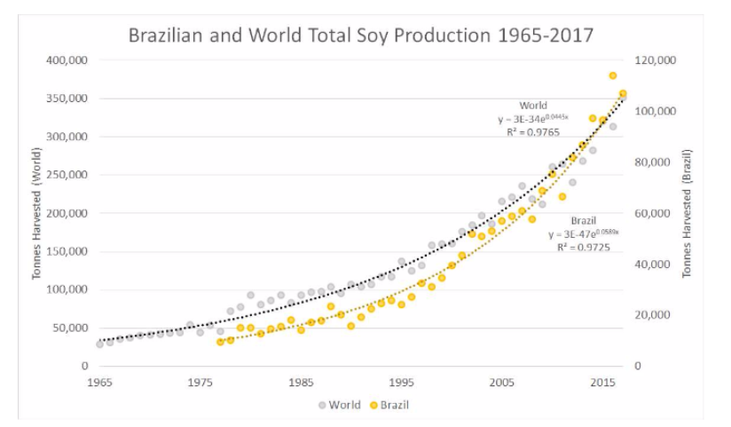

Figure 11: Global soy production growth compared to Brazil. The two growth rates merge in about 2015. The growth in Brazil is associated with significant habitat loss [32].

The final resource the clearly reveals strong non-linear growth is provided by documented global use of fertilizer [33,34]. In Figures 12 and 13, data from [35] clearly show how the use of Nitrogen fertilizer ramps up much fast than the population growth over the period of 1961-2009. This again is a reflection of N > 1 or that per capita use of fertilizer, on a global basis, is increasing. In Figure 13 we show the raw increases over a much longer period in history. The noticeable dip in the data around 1990 is related to the breakup of the former Soviet Union and its subsequent loss of production in a variety of areas [36,37]. For determining the value of N for fertilizer use, we use the period 1950-2015. Over that period fertilizer use grow by a factor of about 9 while population growth is a factor of about 3 which indicates that N ~ 2. This growth behavior has also brought with it the notion of “Peak Phosphorus”, which like “Peak Oil” [38,39] suggests that the production of phosphorus will globally peak sometime around 2030 [40,41].

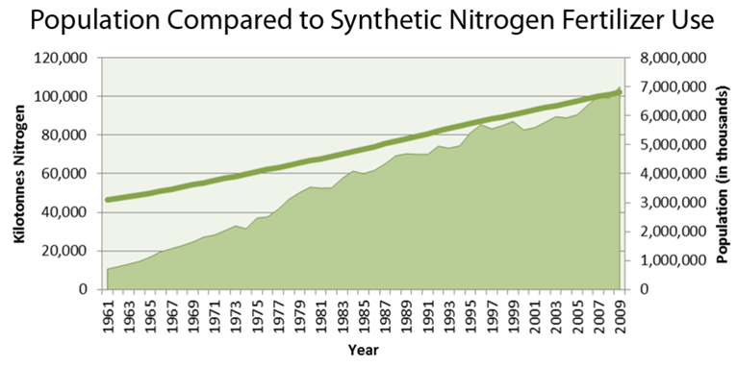

Figure 12: Population growth compared directly to global fertilizer growth.

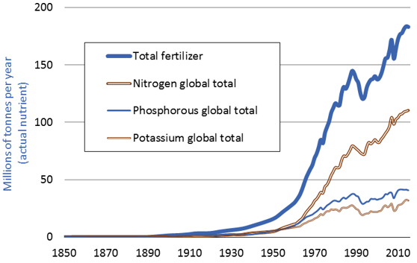

Figure 13: Historical Global consumption of fertilizer and its components from 1850 to 2015.

While the value of N varies from resource to resource, the point is that increasing the number of consumers causes a strong non-linear response to the production of consumer goods. In turn, this leads to an accelerate loss of resources and/or manipulation of habitat so that more goods can be processed per unit area of land. It is this strong non-linearity, again reflected in actual shipping container traffic of these goods that is increasing the heat content of the world’s oceans that drive global changes to the behavior of the Earth’s climate system. All of this is accelerating which means that we are currently living in the most unstainable time in history.

Section 2.3 Policy Implications

From the physical point of view, we would expect continued increases in ocean heat content would likely lead to a non-linear response in the atmosphere, which means that the rate of global climate change will accelerate. As shown below, the most recent data on global land+sea temperature anomalies indicate suggest that we have now entered the expected non-linear regime and future policy planning should account for this. Here we make use of the composite Land-Ocean temperature anomalies, with respect to the baseline of 1951-1980, as provided by NASA Goddard [42]. The use of both land and ocean is a far more sensible approach than just using land based data. For instance, urbanization effects over the period of record are not likely to influence ocean based temperatures compared to the land temperatures.

We start this data journey in Figure 14 which simply plots the raw data and a standard, unweighted, linear regression fit. For constant reference, we project the fit out to the year 2050 which in this treatment of the data suggest a value of +.75 C. Of course, we are completely aware that the “fit” shown in Figure 14 is not appropriate (we will make the appropriate fit later), but here we are using data to illustrate a story about the nature of data combined with our overall linear thinking about the future world, to show how dangerous and foolish linear thinking in terms of future planning can be. For instance, we have already shown that resource use does not scale linearly with population growth so why would we think that the rate of temperature evolution would scale linearly as well?

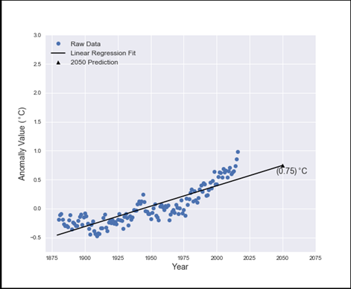

Figure 14: Historical temperature anomalies for the composite land+sea data since 1880 as full calibrated by NASA [42}. The straight line does not fit the data adequately but we use it here for illustrative purposes only.

In figure 14, the predicted 2050 temperature anomaly (T) refers to the 1951-1980 period. To compare to the Paris Accord we need to renormalize and refer the anomaly to the typical 1881-1910 period that is used for the “pre- industrialized” level. That renormalization adds 0.26 to the 2050 value indicated on the various graphs. The stated goal of the Paris Accord is to “keep a global temperature rise this century will below 2 degrees C [above the pre-industrialized value] …”. [43] While the term “well below” is not specific, we here will simply adopt a value of T =+2 as the Paris Accord target and ask if our data trajectories suggest we can meet this target. Figure 14, convolved with the implicit policy statement that “the linear trend is the most appropriate” suggests that we can meet this target as by 2050 T = 1.01. But the scientific view of this data is much different which leads to the following kinds of questions or statements:

* The data clearly show that recent years (starting around 2000) are systematically departing from the linear trend and perhaps another kind of fit is in order.
* Should this data be equally weighted as if all temperature points are independent and equally valid?
* Should this systematic departure of the recent data carry with it more weight as being indicative of an actual manifestation of climate change?

We investigate these statements below. However, we note here that at the time of the Paris Accord policy statement, many analyses of extant data concluded that, we have already experienced T =1.5 [44,45] which leads very little room left to meet the stated goal.

For this kind of data, it is often better to average the data over some timescale (often times a 5-year running average is used). Here we will bin the data in units of 9 years. This gives us 15 bins from 1880 to 2014 and we will initially leave the 2015 and 2016 data points out. Note that there are no special “scientific” rules for how to bin and smooth data – one just wants enough binning to see the waveform, but not too much binning to see the noise. The resulting plot is shown in Figure 15; this time T = 0.71, not appreciable different from what was obtained before, but of course the fit remains erroneous.

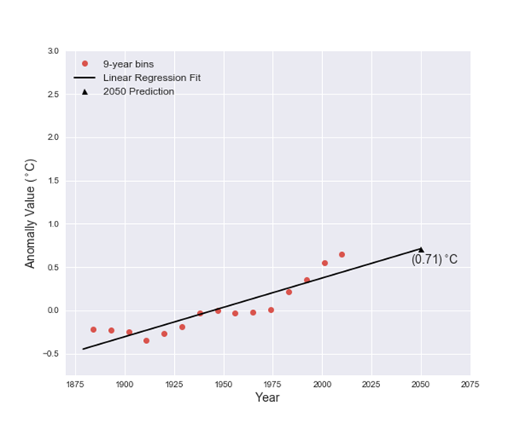

Figure 15: The historical data binned into 9-year bins from 1880 to 2014.

This data depiction clearly shows the well-known “mid-century” cooling (flat period from 1940 – 1975) that followed the period of warming earlier in the record. This behavior has been used to suggest that a similar event will happen in the near future due to the hypothesized cyclical nature of “global warming” [46]. While the origin of this cooling is unknown, a very plausible scenario is that industrial pollution from aerosols (which are coolants) dominated human atmospheric greenhouse gas pollution leading to that saw no temperature increase. This is plausible because a) there was little law or regulation concerning industrial aerosol pollution during this period and b) during this period total greenhouse gas emissions was ~ 3-4 times less than today (the 1958 Mauna Loa data show 0.6—0.7 ppm per year; 2015 was ~2.5 ppm).

But clearly a linear fit to this data is not appropriate and in Figure 16 we show the best fitting non-linear function extrapolated to 2050. Strictly speaking, we find a non-linear function that minimizes the collective residuals in the data (i.e. we find the minimum  fit). In addition, we also weight the data by adding the years 205 and 2016 as separate points. The scientific reasoning behind this form of weighting is simple: a) the years 2015 and 2016, are two successive record breaking years and b) this is likely an indicating that we indeed are now in the non-linear regime of climate response to ocean heating. In Figure 16, the Y-axis T values refer to the 1950-1980 baseline; comparison to the Paris Accord pre-industrialized levels would add .26 degrees to the indicated 2050 values.

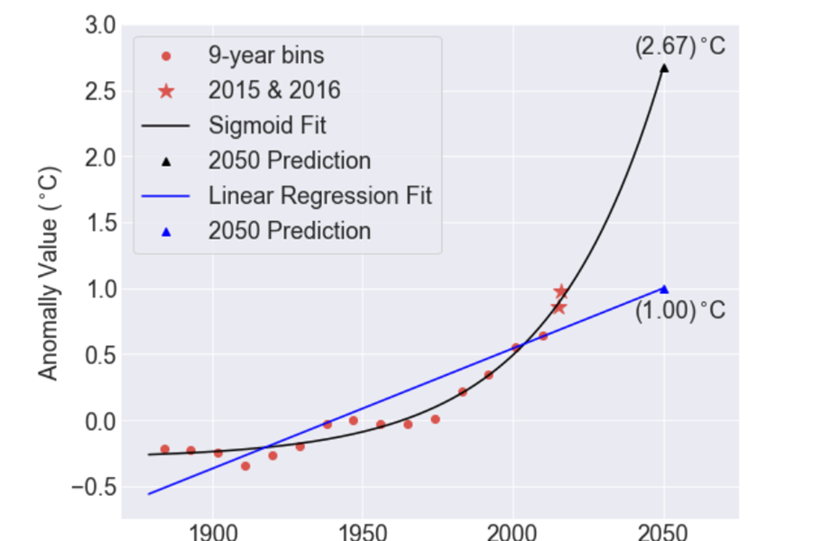

Figure 16: The black line is the best non-linear weighted fit to the data while the blue line is a similarly weighted fit regression.

The obvious strong difference between the linear and non-linear treatments of the data reveals the entire policy issue. How does the policy world deal with this large difference between the linear responses of the system in the past compared to the current non-linear response of the system? If for instance we “believe” that linear fits are the best, then our future is far less dire, than that predicted by Figure 16. Furthermore, this more correct data-fitting approach predicts a value of 2.93 C by 2050 as the pre-industrialized temperature rise which now strongly violates the Paris accord even though we are only half way through this century!

To further illustrate the significant difference between linear and non-linear planning we can use the annual data on Arctic sea ice loss in the context of the policy question “when will the Arctic Ocean be free of ice? More colloquially one might re-phrase this question to “when will we melt Santa’s home”. In the Arctic the peak of the ice melting season occurs around September 15; after that the ice accumulation periods starts until about mid- March when the ice beings melt and that melt rapidly escalates during the proper Arctic summer. While measurements of Arctic Sea Ice extent go back to the mid 19-th century [47], here we only use the data obtained in the Satellite era starting in 1979 and available from the National Snow and Ice Data Center [48]. That data is shown in Figure 17. In that figure there are three “policy” lines/fits, described below, which each extrapolate to the year of zero ice.

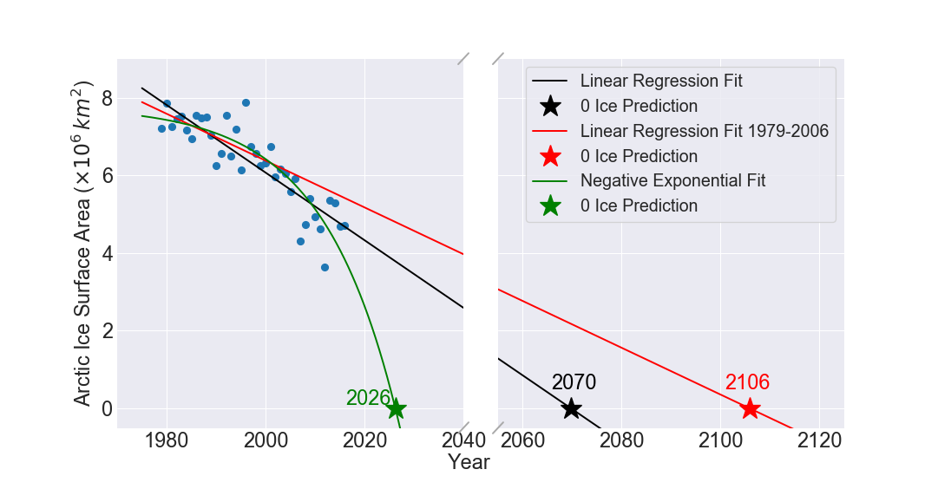

Figure 17: Different scenario fits for the Arctic Sea Ice minimum extent evolution with time. The scenarios are fully described in the text.

The scenarios that each of these three lines corresponds to are the following:

A. Suppose that in 2007 a policy concern arises about an ice-free Arctic ocean. Some international committee is formed to study the issue and produce policy recommendations. Well, the red line in Figure 1 would show the policy linear fit to the data available at that time (i.e. 1979-2006) that extrapolates to zero ice in the year 2106. The committee meeting is quite short: the problem won’t occur for 100 years so why worry about it now?

B. Okay, we now reconvene the committee 10 years later to update the situation based on 10 years additional data. Well, now the linear extrapolation from 1979-2016 (black line above) leads to the ice-free Arctic in 2070. Yes, the new data has produced a shorter timescale but, hey, that’s still 50 years away so again, why worry about it now? This scenario is consistent with the earlier point of weighting the most recent years of data to better reflect the intrinsic non-linear nature of the phenomenon

C. But wait, what is that “weird” green line on this infographic (Figure 17)? Well, the green line, which produces a prediction of 2026 (less than 10 years from now) is the best fitting non-linear relation to the data. Does this matter?

The difference between the linear and non-linear fit predictions is ~45 years, which is significant in terms of human decision-making timescales. In the linear policy world, we would just punt on the issue since the crisis point is way into the future. However, if the non-linear approach yields the correct trend, but we remain stuck with our linear mindset then it’s quite likely that policy will be set after the time when children can visit Santa’s home on a cruise ship. The lesson here is clear: when you are on an accelerating rate of change, the future becomes harder to predict – which adds uncertainty to the overall process. Instead of paralyzing the policy process, this increased uncertainty should focus efforts for policy to be based on more accurate trend forecasting. In this case, the data clearly show that the rate of Arctic Sea Ice loss is accelerating, global greenhouse gas emissions are accelerating, and global temperature anomalies are increasing. This is not “fake new” – this is what the data say. If we really want to move to a world of data driven decision making, then we have to listen to the data, even if we do not like what it says.

Section 2.4. Adaptation and Global Justice

In this section, we will link together the ideas of “just sustainability”, “global justice”, and adaptation to climate change. In addition, we use various economic indicators to assess particular countries or regions of the world to adapt to the major effects of climate change over the next 50 years. The compiled data that shows that adaptation to climate change is highly differential and those countries with low GDP are disproportionally affected by climate change indicating the great social injustice that is being brought about. In terms of adaptation, the impactful 1987 Brundtland Report *Our Common Future* [49} in the context of sustainable development states

*“development that meets the needs of the present without compromising the ability of future generations to meet their own needs,”.*

However, global climate change is the agent that most definitely compromises and individual countries ability to meet their own needs, especially if there in country resource base has been negatively affected (e.g. its underwater in some cases). Clearly global climate change produces regional environmental changes that can compromise the ability to achieve sustainability. And, of course the number one reason to not adopt any kind of emissions limitation policy is the overwhelming fear that this will compromise economic growth which we continue to view as the principle measure of prosperity. While it can be argued that prosperity defined in a manner which ignores issues of dignity and equity is a profoundly western view of the world, it seems clear that this view is the principle driver in our evolution as a consumptive species. This point is readily apparent in the previously presented data revealing the accelerating output of CO2 by the collective consumption actions of the planet.

We have therefore placed ourselves in the difficult position of a dwindling time window in which to decide that potential compromising of economic growth (in fact, there is no proof that stagnant economic growth will be the direct result of reduced emissions – it’s just something that most of the developed world believes) serves the greater good for a planet that can achieve global sustainability, justice can equity. Some data that shows we may be on a small path in this direction involves global energy emissions which, due to the addition of renewables, appears to be flattening (see Figure 18). Indeed, this is a direct form of adaptation/substitution where countries or regions simply adopt renewable infrastructure for an increasing part of their energy generation needs.

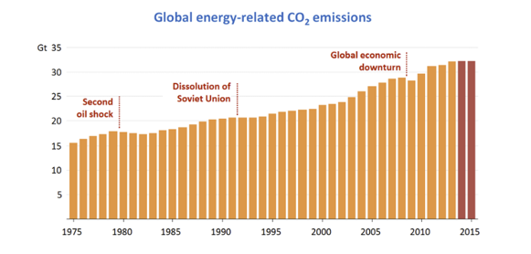

Figure 18. IEA analysis of 2015 showing that renewables combined with improvements in energy efficiency have kept energy-related emissions flat for the years 2014 and 2015.

Section 2.4.1 Maintaining Our Fossil Fuel Habit

Despite these considerations, fossil fuel production out of drilled well-heads over the last 10 years in the US continues to escalate. We can use two pieces of data to illustrate this trend: Figure 19a shows the relation between new exploration wells (i.e. let’s drill here and hope we find oil) and subsequent discovery of new oil resource while Figure 19b shows our projected oil use. Figure 19a is likely the best visual manifestation of BAU – each year we add more new exploration wells as we desperately search for new resource. Of course, we actually find new resource and therefore have no incentive to cut our use of fossil fuels; as apparently, we can still find them, which leads to the projections shown in Figure 19b.

|  |  |
| --- | --- |
| Image result for global creaming curve |  |

Figure 19. Left most panel (19A) shows the cumulative rate of new well head discovery oil resource; the right panel shows that US production of petroleum and continue to increase via the harvest of non-conventional petroleum sources

This renewed dependence on fossil fuels is primarily the result of tapping new, short term sources of oil. These are described in Figure 19b as “tight oil” (e.g. North Texas oil fields, Bakken formation in North Dakota) which find resource via the new technique of hydraulic fracking. In the real world, despite all the rhetoric about sustainability we continue to arduously pursue new and unconventional sources of oil which are difficult to extract and during the extraction process do considerable local environmental damage. Hence, we are not even giving ourselves a chance to adapt to new sources of energy generation that don’t involve the release of greenhouse gases.

For the US, Figure 20 shows the recent history (1980 – Nov 2017) of field production of crude oil [50]. In 2012, production began to ramp when various shale oil basins were sufficiently drilled and our subsequent fetish attraction to fracking as America’s “clean energy choice” began [51,52,53]. Alas, these shale oil resources are not very large (with respect to our demand) and hence accessing them is just another short term “fix” while we maintain our addiction to BAU. The data shown indicate that US production peaked in July of 2015 at 9.6 million barrels per day (MBD). Fourteen months later production had declined by 1.2 MBD but has recently ramped back up to 9.3 MBD. The point is that the initial discovery rate of new resource (i.e. around 2012) ramped up rather quickly and has now peaked. Since our demand has not peaked, then imports of crude oil to the US are once again rising as, like Alaska, these new sources of “infinite” supply, are in fact quite limited.

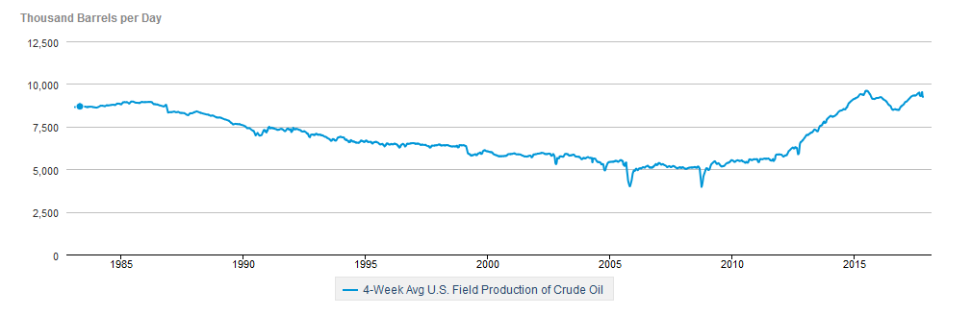

Figure 20. 4-week average US production of Crude Oil from 1980 through July 2017.

Overall, we stay on the BAU trajectory through continual drilling of new well heads to tap unconventional sources of fossil fuels such as shale oil and shale gas (via fracking). There is certainly no partnership with nature as our dominance continues, manifesting itself by wholesale drilling into the Earth. In the larger view of public trust, harmony with nature would seem to be mandatory so as to better preserve that world for future generations. Yet we dig and dominate and disregard important instructions from previous ancient generations:

*When we dig precious things from the ground, we invite disaster - Hopi Prophecy*

Section 2.4.2: Global Justice

A relevant lens to use when considering the previously described forms of acceleration involves the issue of global equity/global justice. A good historical starting place comes from the 1996 World Commission on Environment and Development report [54] which states:

*The environment must be protected … to preserve essential ecosystem functions and to provide the wellbeing of future generations; environmental and economic policy must be integrated; the goal of policy should be an improvement in the overall quality of life, not just income growth; poverty must be ended and resources distributed more equally; and all sections of society must be involved in decision making.*

There are two key concepts in this early report: 1) resources distributed more equally – this seems to be a vital need for achieving sustainability but currently we are rather far from this ideal. For example, the 2008 World Bank report [55] showed that for 2005, the world share of consumption can be broken down as follows:

* 75.6% is consumed by the Worlds’ richest 20%
* 21.9% is consumed by the middle 60%
* 1.5% is consumed by the world’s poorest 29%

This is anything but equal. An update to this situation is available from the 2013 Oxfam International Report and clearly shows inequality is rapidly rising. Indeed, that report claims we are moving toward a rather absurd situation in which the richest 1% of the world will own more than 50% of the world’s wealth by the year 2016 (it will take some years to verify if this came true). In this situation, the richest 1% owns more wealth than the other 99%; the scale of inequality is thus staggering and every year the gap between the 1% and the rest widens. A useful visual representation of this is shown in Figure 21where the land area of the world is converted to wealth: the bottom 50% (red) of the world owns only an area of the size of Mongolia; the middle 40% (red) can own most of the former Soviet Union; the remaining 10% (gold – naturally) owns all the rest.

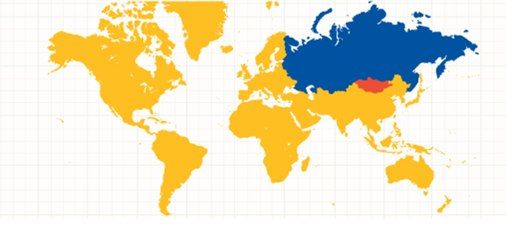

Figure 21. Global conversion of wealth ownership into percentage ownership of the land surface. Colors are described in the text.

The second point is that the quality of life has more importance than income growth. As long as the personal perception of prosperity is related solely to income issues, which ultimately drive consumption, then no move to sustainability is possible. This is one of the major challenges for the more developed countries of the world – how to enlighten their citizens that the drive for steady personal income growth is now less important than considerations which raise the probability of a livable world for future generations. One potential litmus test involves our global attempts at CO2 stabilization. For instance, if policy advisors in the area of economics fundamentally believe that increases in income growth or country GDP demand increasing fossil fuel burning then we clearly have a clash of values if achieving this more livable world for future generations.

Section 2.4.3 CO2 Stabilization

Achieving CO2 stabilization is also necessary to limit the extent of the current global climate change. Yet we have already shown that CO2 is accelerating and the longer this continues the more control we lose in reaching any sensible stabilization target. This again is an example of failure to meet a mitigation target in some time window. A popular stabilization value is 450 ppm by the year 2050 [56,57]. A practical strategy for achieving this has been well articulated and formulated via the concept of stabilization wedges [58]. In this case, a particular sector of greenhouse gas emission is identified so that alternative sources can be made available to replace previous infrastructure that produced GHG emissions. For reference, global carbon emissions from fossil fuel burning were 10 gigatons (Gt) in the year 2015 [59] and stabilization requires limiting the amount of Gts per year for this particular sector in the future. However, issues of scale are important. Two examples are offered below which needed to become operational by the year 2000 to achieve a 2050 goal of 1 Gt of carbon saved. For now, we will ignore the gigantic upfront costs that would be needed for implementation:

* Fuel switching to prevent the future release of Gts of carbon. Here we will replace Coal fired electricity plants with natural gas (NG) fired ones. To prevent an additional 1Gt of future release would require replacing about 1400 existing coal fire plants with new NG facilities. To support those facilities would require 50 LNG tanker discharges a day, each discharge containing 200,000 cubic meters of gas, to meet that goal. While the US is, ramping up its infrastructure to deal with NG (in liquefied form –e.g. LNG – [60]) there is no conceivable way that the required NG facilities and their associated fuel delivery can be met at this scale. In a similar vein, to meet the equivalent Gt reduction goals for electricity generation by using nuclear based electricity instead of NG based, would require tripling, by 2050, our current nuclear electricity capacity. Given the very long time it now takes to build a single nuclear plant [61] strongly precludes us from meeting this target even if we wanted to do it.
* For transportation, globally there were about 600 million vehicles in 2000 with a projected vehicle fleet of 2 billion by 2050 [62,63,64]. A stabilization wedge can be achieved if the total emissions associated with transportation in the year 2050 are the same is in the year 2000. This requires that this vehicle fleet would have to have 3 times better fuel efficiency than in 2000 or a per capita reduction in driven vehicle miles per year by that same factor of 3. For reference, in the US fuel economy in 2015 compared to that in 2000 increased by about 20% [65] – far short of the pace required to reach a factor of 3 by 2050.

In more general terms, Table 3 shows various scenarios that would be needed to reach the 450-ppm goal by the year 2050 as well as other stabilization goals. For each stabilization target we offer a range of years in which to start the stabilization trajectory and then quantitatively state the rates associated with that trajectory. As we have not yet started any kind of stabilization pathway, future trajectories of carbon emission reduction are necessarily steeper If the policy world is serious about reaching stabilization at some level, then Table 3 contains some example options and considers two cases: a) emissions rise at the same rate until 2050 as they were at start year (PPM 205) and b) an overshoot and decline model. The overshoot model implies that annual CO2 emissions accelerate (as the data shows) for some period until awareness kicks in and emissions are required to decline.

Most of these options are likely too extreme to adopt and hence any stabilization will occur at higher values of CO2 concentration. Indeed, in the BAU approach, stabilization at some level will be automatically achieved as we will have just used up all the fossil fuel there is to burn. In table 3, the column labelled PPM gives the CO2 concentration at the decade start and the rate column is calculated for the prior 5-year period (e.g. 1985-1990 for 1990). In all cases, achieving stabilization will require the onset of negative carbon emissions (e.g. a reduction in the annual rate) prior to 2050. This is because the rates have increased as the decades wore on. The BAU scenario which allows for continued acceleration of the rates (as previously discussed) would produce about 550 ppm by 2050. At the very least, the annual rate CO2 emissions has to stop increasing per decade like it has been ever since 2000. Figure 22 shows the various wave forms of these 4 overshoot scenarios and clearly the longer we wait, the steeper the decline trajectory must be to meet the stabilization target.

Table 3: Example Scenarios to Stabilize Atmospheric CO2 at 450 ppm

|  |  |  |  |  |
| --- | --- | --- | --- | --- |
| Year to Start | PPM | Rate | PPM 2050 @ rate | 450 ppm |
| 1990 | 355 | 0.4% | 450 | Rise by 0.6% until 2035; decline at 0.2% |
| 2000 | 369 | 0.45% | 462 | Rise by 0.8% until 2030; decline at 0.2% |
| 2010 | 389 | 0.5% | 475 | Rise by 1.0% until 2030; decline at 0.3% |
| 2020 | 414 | 0.6% | 495 | Rise by 1% until 2035; decline at 0.5% |

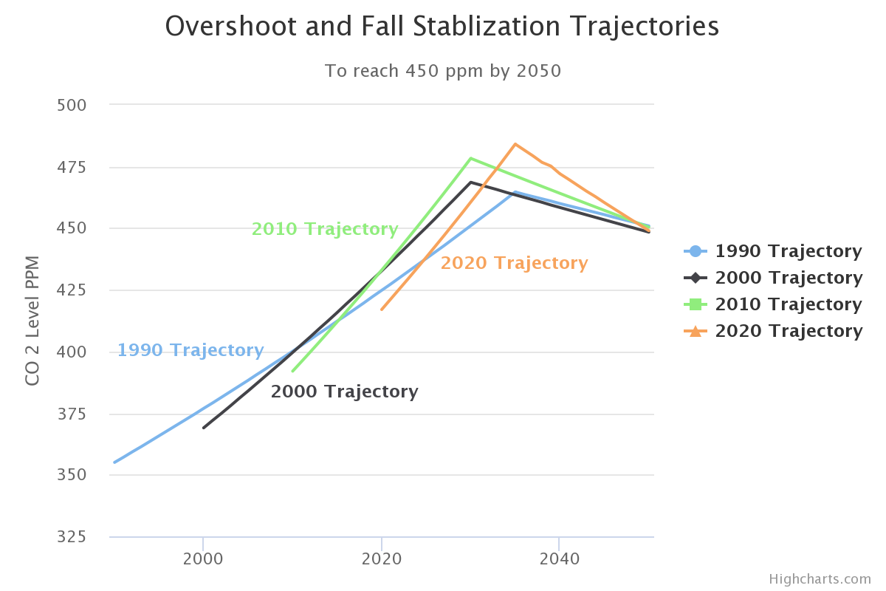

Figure 22. Visual representation of the trajectories described in Table 3.

Of course, it is physically not just CO2 that needs to be stabilized by rather CO2E which primarily includes methane. Methane levels are now rising (see Figure 2) and even if CO2 stabilization can occur, given the methane rise rate the CO2E value would be 523 ppm or 16% higher than the CO2 stabilization value alone.

Section 2.4.4 “Just” Sustainability

Our real-world behavior strongly suggests that we will live in the mechanical philosophy system first championed by Descartes [66]. In that system, nature has no intrinsic value but serves humans only as a resource. This must change. There is a strong need to make issues of equity and social justice as prevalent as the issue of climate change. Sustainability is not about the more efficient harvesting of resources, it’s about establishing a more equilibrium use of resources with respect to the innate planetary cycles. This is well articulated here [67,68]

*“Sustainability cannot be simply a ‘green’, or ‘environmental’ concern, important though ‘environmental’ aspects of sustainability are. A truly sustainable society is one where wider questions of social needs and welfare, and economic opportunity are integrally related to environmental limits imposed by supporting ecosystems”*

*“The need to ensure a better quality of life for all, now and into the future, in a just and equitable manner, whilst living within the limits of supporting ecosystems*

These two statements, which embody “just sustainability”, are in stark contrast to our systematic heating of the oceans which has taken that system entirely out of equilibrium resulting in increasing weather volatility. We are certainly not living within our environmental limits and are explicitly and actively transcending them. As a result, we have invited disaster and are putting the entire system in danger. This process of continually defining social needs by consumption leads directly to a kind of social inequality that ultimately does significant damage to various social structures [69]. One of the frameworks for a just sustainability is then to replace consumption based social identity with something considerably more meaningful.

Section 2.4.45 Overshooting Earth Boundaries

The most straightforward manner to characterize the rate at which we are living beyond our environmental limits involves the concept of ecological debt and the global ecological footprint of human resource use [70,71,72]. Tracking the evolution of this ecological debt with time has been one of the principle outputs of the Living Planet Report [32]. Figure 23 offers the most recent view

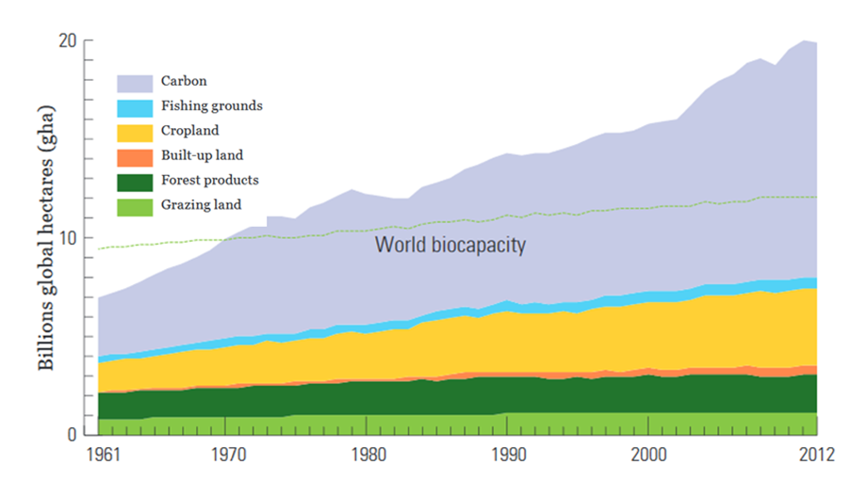

Figure 23. Exceeding the world biocapacity on an annual basis. Image from the Living Planet Report 2016.

In Figure 23, the green line is the (slowly increasing) availability of Earth resources to support annual consumption. If the total consumption were less than the green line, then we would be consuming within our ecosystem limits. We have not been in this regime since 1970. Since 1970 we have been using Earth resources, on an annual basis, faster than they can be renewed. We are effectively mining the Earth Because of the presence of buffers (like the stored energy in fossil fuels) in the system we can engage in this out of equilibrium behavior for some time. For example, we can mine the ocean for decades, in the sense that we harvest more fish than the oceans can replenish. But we have been engaged in this overshoot for 40 years by now and consequences in terms of habitat and species loss are becoming noticeable [73]. The most direct manifestation of our overshoot action is to displace Carbon from its natural earth reservoirs and relocate it to the atmosphere where the accumulation is increasing as it cannot be removed as fast as we are relocating it. Of particular note is the change in slope of the grey envelope occurring around the year 2003 – this is when the Chinese economy emerged into the global consumer market and by 2006 GHG emission from China exceeded that from the US [74]. The economic meltdown of 2009 is but a small blip in the overall increase. The small decreases in other particular years also mark short term recessions (e.g.1980-82 event), from which a quick recovery keeps us on the same escalating trajectory, a situation that was first pointed out in 1972 [75] and well updated in 2009 [76].

The more colloquial way to represent the situation shown in Figure 24 is to use Earth masses for the Y-axis. In this way our overconsumption is relative to how many Earth’s would be needed to provide resources for a particular year’s consumption. Since we are in overshoot mode, then there is the overshoot day, which is the day for a particular year when we have used more than 1 Earth mass. Figure 24 represents our consumption data this way. For the current year, the overshoot day was August 5 or day 216 of the year. Since that is approximately 60% of the year, then for the full year we will use 1/.6 ~ 1.7 Earth Masses.

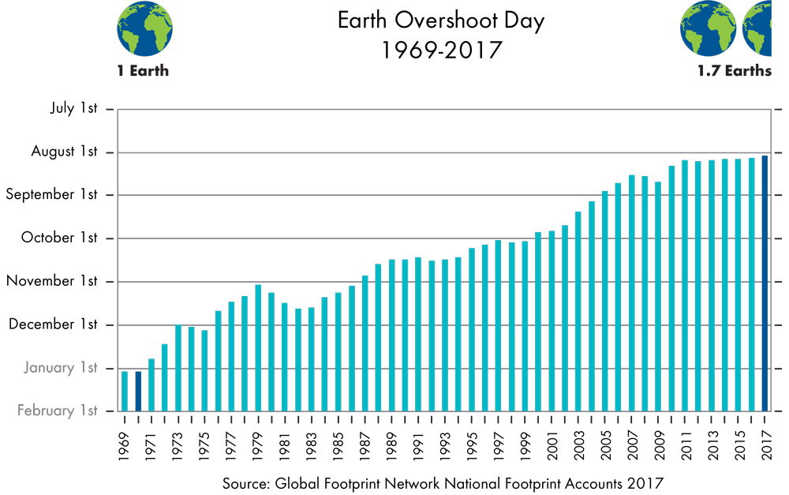

Figure 24. Time history of Earth Overshoot day

Our demonstrable inability to consume within our global resource limitations clearly shows, as Descartes originally argued, that the Earth is essentially a machine that offers us resources that we can just use up. We simply do not acknowledge that our resources are finite and operate under the implicit assumption that new technology will open up new resources. Indeed, there is some truth to this idea as a variety of new (and old) techniques are still finding significant new deposits of oil [77,78] with rapid plans for harvesting to maintain our dependence on fossil fuels through rapid exploitation which continues our BAU trajectory. In turn this only serves to accelerate the overall impact of climate change.

Section 3.0 Differential Adaptation and the 50 Poorest Countries

Climate change will have a highly differential impact on various countries and regions on the planet. In general, this impact requires two forms of country or regional response:

* Resiliency to recover from large scale climate changed induced weather events. In the USA, Hurricanes Sandy (2012) and Harvey (2017) represent the kind of large scale events for which there has been little resiliency or recovery plan.
* Adaptation to loss of natural resources as a result of mostly changing precipitation patterns and/or wholesale loss of land due to sea level rise and associated inland flooding.

Effective response to these issues requires substantial country investments in new forms of infrastructure and governmental emergency responses in order to effectively cope with the problem. This requires available capital and, to first order, GDP per capita can serve as a proxy for available capital that can be redirected towards adaptation. A related index, known as the Gini coefficient, often used in economics, can also serve as a proxy, or at the very least provides a uniform measure of economic inequality between countries [79]. GDP per capita data for the year 2016 is available from the World Bank database [80] which we have used to construct Table 4.

In table 4 we select the 50 poorest countries under this criterion. Note that we omit very small island countries from this list. Investments required for climate change adaptation within a given country, despite being heavily researched [81 - 85] remain rather unknown and are highly dependent on the details of any given county. Many estimates suggest that the annual cost for a country like the US is a few tens of billions of dollars per year (BN) perhaps up to as much as 100 BN. While it is difficult to estimate adaptation costs for any county, we do not here that most adaptation would consist of new kinds of infrastructure (better flood control, improved irrigation for agriculture, new kinds of crops, etc) and infrastructure. In addition, these costs are likely to be significantly higher for countries vulnerable to sea level. As the goal of this exercise is to reveal the strong disparity in individual country resources with respect to their ability to invest in climate change resiliency we adopt the following scheme): for land locked countries we use a cost of 5 BN per annum and for countries vulnerable to sea level rise we use 10 BN. Obviously, these costs are a strong function of the area of the country that requires protection but those details are very difficult to obtain and not necessary for our primary purpose of illuminating disparity in terms of the fractional GDP cost needed for environmental adaptation.

Table 4: The 50 poorest countries in terms of GDP per capita comparison to the United States

|  |  |  |  |  |
| --- | --- | --- | --- | --- |
| Country | Index | Principle contributions to GDP | % of GDP | Land/Sea |
| 1. Burundi | 0.005 | Agriculture | >100 | Land |
| 1. Malawi | 0.005 | Agriculture/Biodiversity | 95 | Land |
| 1. Niger | 0.006 | Agriculture/Uranium | 75 | Land |
| 1. Mozambique | 0.007 | Agriculture | 90 | Sea |
| 1. Central African Republic | 0.007 | Agriculture | >100 | Land |
| 1. Madagascar | 0.007 | Agriculture/Textiles/Vanilla | 100 | Sea |
| 1. Somalia | 0.008 | Agriculture | >100 | Sea |
| 1. Dem. Rep of Congo | 0.008 | Agriculture/Mineral Extraction | 15 | Land |
| 1. Liberia | 0.008 | Agriculture/Forestry/Shipping | >100 | Sea |
| 1. Sierra Leone | 0.009 | Agriculture/Mining/Tourism | >100 | Sea |
| 1. Guinea | 0.009 | Bauxite Mining/Fisheries | >100 | Sea |
| 1. Afghanistan | 0.01 | Livestock/Forestry/Mineral Extraction | 25 | Land |
| 1. Togo | 0.01 | Agriculture/Phosphates | >100 | Sea |
| 1. Uganda | 0.011 | Coffee/Mineral Extraction | 20 | Land |
| 1. Guinea-Bissau | 0.011 | Trade via Port Traffic | >100 | Sea |
| 1. Burkina Faso | 0.011 | Cotton and Gold Exports | 40 | Land |
| 1. Chad | 0.012 | Oil Exports | 50 | Land |
| 1. Rwanda | 0.012 | Agriculture/Coffee | 65 | Land |
| 1. Ethiopia | 0.012 | Agriculture/Livestock | 7 | Land |
| 1. Nepal | 0.013 | Tourism/Agriculture | 20 | Land |
| 1. Haiti | 0.013 | Agriculture/Mineral Extraction | >100 | Sea |
| 1. Mali | 0.013 | Agriculture/Livestock/Cotton | 35 | Land |
| 1. Benin | 0.013 | Trade | 95 | Sea |
| 1. Tajikistan | 0.013 | Agriculture/Mineral Extraction | 70 | Land |
| 1. Tanzania | 0.015 | Agriculture/Natural Gas | 25 | Sea |
| 1. Senegal | 0.017 | Trade/Fisheries | 70 | Sea |
| 1. Yemen | 0.017 | Agriculture/Fisheries/Oil and Gas | 40 | Sea |
| 1. Zimbabwe | 0.017 | Tobacco/Precious Metals | 30 | Land |
| 1. Cameroon | 0.018 | Agriculture/Oil Exports | 40 | Sea |
| 1. Kyrgyzstan | 0.018 | Agriculture/Gold Exports | 85 | Land |
| 1. Mauritania | 0.019 | Agriculture/Livestock/Iron Ore | >100 | Sea |
| 1. Zambia | 0.02 | Cooper exports | 20 | Land |
| 1. Cambodia | 0.022 | Rice and Garment Exports | 50 | Sea |
| 1. Myanmar | 0.022 | Rice and Garment Exports | 15 | Sea |
| 1. Bangladesh | 0.023 | Rice and Garment Exports | 5* | Sea |
| 1. Kenya | 0.025 | Tourism/Agriculture | 15 | Sea |
| 1. Pakistan | 0.025 | Wheat, Coal and Mineral exports | 4 | Sea |
| 1. Ghana | 0.026 | Tourism; Gold and Cocoa exports | 25 | Sea |
| 1. Ivory Coast | 0.026 | Coffee and Cocoa exports | 35 | Sea |
| 1. Rep. of Congo | 0.027 | Petroleum Exports | >100 | Sea |
| 1. India | 0.029 | Multi-Faceted | <1 | Sea |
| 1. Moldova | 0.033 | Wheat and Wine exports | 80 | Land |
| 1. Uzbekistan | 0.035 | Wheat, Cotton and Gold exports | 7 | Land |
| 1. Nicaragua | 0.037 | Coffee, Cotton and Tourism | 75 | Sea |
| 1. Nigeria | 0.037 | Agriculture; Oil Exports | 3 | Sea |
| 1. Vietnam | 0.037 | Rice, coffee and oil exports | 5 | Sea |
| 1. Ukraine | 0.038 | Wheat, corn and mineral exports | 12 | Land |
| 1. Laos | 0.041 | Rice exports; tourism | 35 | Land |
| 1. Honduras | 0.041 | Coffee exports | 50 | Sea |
| 1. Sudan | 0.042 | Gold, cotton and Oil exports | 5 | Land |

*Bangladesh, thanks to large exports in the clothing industry has shown one of the world’s highest GDP growth rates over the last 2-3 years [86,87]

A recent study [88] has found that the current global spending on climate change adaptation is only ~ 0.4% of global GDP. This paltry amount is similar to what the US chooses to invest in its well documented crumbling infrastructure [89,90] (e.g. sewers, roads, bridges, airports, etc). This is a direct indication that, like the US, countries of the world, collectively, are steadfastly ignoring the kinds of infrastructure investments needed for climate change adaptation even though many of them to have the resources to make the requisite investment. From Table 4, we can group the selected 50 countries into four categories

* Category A: The 19 countries with GDP percentages > 75%. These countries that have no ability to invest in their own climate adaptation and hence are dependent upon foreign investment. In general, these countries are fairly small and/or dependent upon a single sector to support their export economy. In most cases, infrastructure investment will be required to better manage water resources for agricultural and/or mining operations. Of these 19 countries, only 3 (Kyrgyzstan, Moldova, Nicaragua) or not located in Africa:
* Category B: The 16 countries with GDP percentages from 25-75%. In general, these countries have larger total economies than those in previous category but investments at this level, while financially possible, are very unlikely to occur. Of these 16 countries, 10 are located in Africa.
* Category C: The 7 countries with GDP percentages from 10-25%. In most cases, particularly for the countries of Africa in this category, their total economy is strongly buoyed by the kinds of mineral resources that are being overconsumed in the rest of the world. This indicates an interesting kind of climate change adaptation dynamic. While the rest of the world may de-facto claim it is up to individual countries to marshal their own resources, when climate change threatens a valuable worldwide commodity harvest (e.g. Cooper in Zambia) the tenor of this attitude may well change.
* Category D: The 8 countries with GDP percentages < 10%. These countries, in general, have large global economies. India is a numerical artifact here as its GDP per capita is relatively low since its capita is very large. Bangladesh in this category as arguably the most in danger country in the world due to sea level rise. Currently Bangladesh is a rising economy and its GPD has rapidly increased thus giving that country perhaps some much needed capital to help with mitigate rising sea level and storm surge. Vietnam is another country where rising sea level poses a serious threat to its extensive rice fields [91,92] but has also emerged as a growing economy.

Section 3.1.1 Some Specific Country and Regional Examples

A noteworthy precursor of the devastating effects of storm surge induced flooding on an agricultural economy is provided by Honduras in the case of Hurricane Mitch 1988. That system devastated many productive agricultural areas in Honduras and it took years for that country to recover from that single event [93,94]. If the nature of climate change is to increase the frequency of these kinds of events [95, 96] then countries like Honduras, Vietnam and Bangladesh may be put on an irrecoverable trajectory. In cases like these, which may become numerous, what international organizations are going to come to the aid of these countries, when they are stressed beyond their own means? In the specific case of Bangladesh, if their country is completely inundated, how can they be recompensed?

Overall Table 4 shows that most all of Africa will have the most difficult time adapting to climate change. Those countries where overall industry contributes similar or more as agriculture to the overall GDP will likely be more resilient. For most of the country of Africa, climate change will likely have dramatic effects on agriculture and livestock breeding [97,98,99,100]. Irrigation practices will have to be changed (that will be an infrastructure investment); new forms of crops will need to be planted as traditional crop yields of wheat and maize will no longer be efficient in the new climate. These new forms will likely involve fruits and vegetables than can flourish in the expected coming very hot and dry climate. In addition, changes in climate invariably will produce changes in the kinds of insect populations that bring disease to livestock and Africa is particularly vulnerable to this outcome [102,103]. A specific example is provided by Ghana where climate change and rising sea level will impact fisheries, agriculture and biodiversity which will lead to a predicted loss in labor productivity that will be equivalent to 6% of GDP in 2030 [101].

A good example of climate change adaptation as an international problem lies in the form of deep water port vulnerability. Currently, some 80-90% of world freight moves by ship to fuel the global consumption craze. Is it therefore the correct expectation that the individual country that contains a specific port should be solely responsible for making the large-scale infrastructure needed to reduce its vulnerability to sea level rise and the associated occasional storm surge? The specific example of the deep-water port in Karachi serves to illuminate this problem. Recently, China has made a large-scale investment to establish and economic corridor (e.g. a superhighway) from western China through Pakistan to Karachi [102,103]. This will allow for the manufacturing base in western China to get its goods to the global market earlier. However, sea level rise models suggest that this port will be underwater by 2060 [104]. Clearly Pakistan does not have enough GDP resources to deal with eventuality and so who pays for preserving Karachi as a point of global distribution? China alone? The rest of the world? Who? And even if it is decided who, who is, how do they pay?

The existence of the port of Karachi means that the global consumer has access to resources/goods. Removal of this part would therefore decrease resource availability. As resource availability becomes an increasingly fundamental limit to economic growth, individual countries then need to attack the problem with increasing severity if they are to remain economically competitive. Climate change directly threatens resource availability which then directly affects any countries future ability to remain economically competitive. A specific example here would involve the Ukraine, which is listed in Table 4, and is the 6th leading exporting of wheat with a total export amount that is about 75% of the USA. If climatic conditions in Ukraine change to the point that their wheat crop is substantially compromised, then much of the economic livelihood of the Ukraine will also be compromised.

The concept used above for countries can be applied to individual cities to again show very strong difference in adaptation. A good example of direct adaptation is provided by the city of London and the construction of the Thames (river) Barrier to protect citizens and businesses against future storm surge events exacerbated by sea level rise. Indeed, elevated flood risk is one of the main predictions of most all climate models, and example of which is shown in Figure 25 and indicates that most of Europe well experience a 100% increase flood risk this century compared to the last century. Indeed, over the period of 2010-2016 there have been 13 once in a century floods induced by very heavy rain events. The 2012 floods in Russia and the 2014 floods in Romania, Croatia and Serbia were both accompanied by significant fatalities. The frequency of these recent far larger than the statistical average of these events would predict and there is growing recognition that changing and increasing flood patterns across Europe are a major component of their regional climate change [105,106,107]

|  |  |
| --- | --- |
|  |  |

Figure 25. Expected change in European Flood risk by 2050.

In table 5 we compare the spending rates [88] in a few selected cities in both the developed and developing world to indicate the overall disparity. Here we tabulate spending amounts over a two period, 2014-216 for 5 selected cities, compared to their populations, to again show strong disparity between the developed and developing world. The data in this table show a range of about 60 in this kind of spending. Huge urban populations may be particular vulnerable to single climate induced events which serve to stress emergency response, facilities for care, and probable short-term relocation needs. Obviously, cities like Lagos and Mumbai have not made anywhere near the required investments to help prevent a large-scale catastrophe.

Table 5: Per citizen climate change adaptation spending for 5 selected cities

|  |  |  |  |
| --- | --- | --- | --- |
| City | Total Spending (millions) | 2016 Population (millions) | Spending Per Citizen |
| New York City | 1624 | 8.58 | 190 |
| London | 991 | 8.78 | 113 |
| Beijing | 853 | 21.5 | 40 |
| Mumbai | 329 | 21.3 | 15 |
| Lagos | 52 | 17.5 – 21* | 2.5 -- 3 |

*The official population of Lagos, Nigeria is in dispute.

We close this section with particular reference to two recent climate scenarios and their associated costs. The wettest scenario comes from the National Center for Atmospheric Research (NCAR - USA) and the driest scenario comes from the Commonwealth Scientific and Industrial Research Organization (CSIRO – Australia). In general, adaptation costs can be broken up into six sectors; infrastructure improvements, coastal zone remediation, water supply management, agricultural stocks, human health (i.e. the well documented rise of vector borne diseases such as malaria and dengue fever [108, 109, 110]), and recovery from extreme weather events. The likely two largest near-term expenditures will involve coastal zone protection and recovery from extreme weather events (which are most likely to happen in coastal zones). Over time, infrastructure costs are likely to be the highest. Some highlights of these studies are:

* For a world which will be +2C warmer in 2050, the estimated annual costs over the period 2010-2050 are 75 – 100 BN. This is very likely an underestimate as our accelerating rates are putting us on a trajectory of +3C by the year 2050. In addition, the costs are unlikely to be thought of as annual costs (similar for instance to foreign aid) but these costs are negatively impacted by the sticker shock that 100 BN per year for 4 years is 4 trillion dollars.
* For both scenarios, the region of highest impact is East Asia which is predicted to bear 25% of the total coast and the lowest impact region is that of the Middle East and North Africa (not surprisingly since it already is mostly a desert) at a level of 3%. This once again shows there to be significant disparity from region to region.
* In general adaptation costs will increase over time, particularly the longer one waits to strategically implement them. Mathematically, these costs do become a lower percentage of predicted GDP growth which means that may some countries (like Bangladesh above) will become less vulnerable to climate change as their economies grow. But there is an important interplay him: if economic growth (like coffee exports in Honduras) require resources particularly vulnerable to climate change, then GDB growth won’t matter if no initial protection mechanisms arise.

Section 3.1.2 The Adaptation Deficit

We can map our previous idea of differential adaptation on to the term *adaptation deficit*, which is widely used in the literature [111,112,113,114]. There are two manners in which this term is commonly employed: a) defining the notion that countries are generally underprepared for current climate change conditions, let alone future ones and b) poor countries have significantly less capacity to adapt, as discussed previously. Since adaptation costs and weather volatility are both likely to rise over the next few decades, a proper visualization of adaptation deficit is shown in Figure 26 from which it is qualitatively clear that we are currently under capacity (because a deficit exists) and further delay of planning and investment will only cause costs to rise to meet the inevitable required additional capacity.

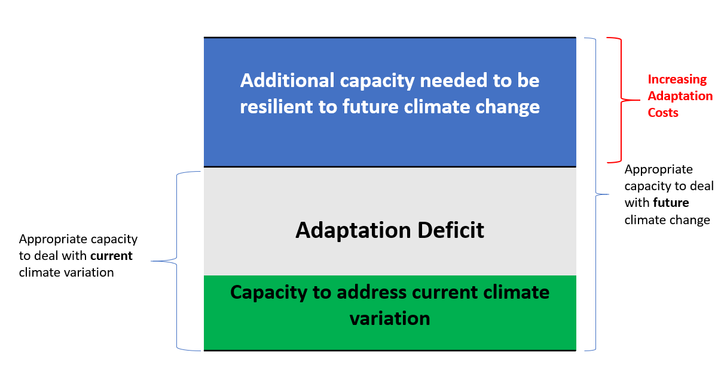

Figure 26: Visual representation of adaptation deficit as presented to include a vertical expansion to better represent increasing adaptation costs as time goes by.

Clearly, determining the correct level of adaptation to current climate variability is very challenging, and this challenge is exacerbated if, by their very nature, poor countries are unable to make adequate investments. A good example is provided by storm surges in low lying coastal areas, perhaps triggered by a Category 5 Hurricane or a super-typhoon. These large storms, of course, do not respect country boundaries and the amount of physical damage they inflict upon a landscape is certainly independent of GDP. So, a situation that occurs in the state of Texas will likely have a much different social impact and recover than if the same situation occurs in Haiti, Bangladesh, or Vietnam. Currently there is an insufficient global response to help mitigate this highly differential adaptation ability. Part of the problem likes in the tremendous uncertainty of the actual impact of potential climate events [115,116,117,118]. But we seem to let this uncertainty paralyze global planning for the future, instead of catalyzing the international community to be much more proactive under the assurance that significant events will happen in the future, we just don’t know when and to whom.

Section 4: Summary Remarks

In this contribution we have used available data to support the view that most all forms of global change are accelerating. We have also directly linked accelerating global consumption with the observed accelerated ocean heating that in turn drives the overall climate system that determines the regional severity of weather. Since the oceans are an enormous buffer in the system, that buffer can accumulate various inputs until it is saturated. The data shown in section 2.1 indicates that the rate of change of our climate system has now entered the non-linear regime, which is a direct physical expectation for any system whose buffers have been saturated. In view of these more rapid changes, climate change policy must become more aggressive. However, we have also shown a very large differential in the ability for individual countries or regions to enact effective steps against the rise of climate change. This has put us in the situation where we have created a problem over a relatively long timescale (since the industrial revolution) which now requires a solution implemented over quite a short timescale (a couple of decades) but we likely have inadequate resources to make the requisite investments. But more telling is our collective failure to adopt a proper global view in how we treat the planet and its resources. Currently, this failure goes by the buzzwords of “environmental justice” or “ecological debt” or “global justice”. While these are laudable concepts there still is too little collective action on the ground that honors the need to adhere to these concepts as a hallmark of being better stewards of our planet.

The concept of justice is complex and nuanced [119] and was likely first mapped onto the idea of environmental justice in 1999 [120]. The meaning of environmental justice [121] is now widely discussed and has now expanded to the domains of climate justice and ecological debt [122,124] While this issue maybe complex and nuanced, it does seem to distill to one reality – the Earth’s climate and energy resources should be equally available to all its citizens if we truly have a just global society. Data clearly shows this is quite far from the case and differential consumption of resources, by individuals and countries, leads to the kind of enormous inequity discussed in section 3.1.1. As long as the global playing field remains in this extremely unleveled situation, progress on important environmental issues is likely to be strongly impeded. Moreover, it should be clear that we truly live in a world of finite resources to support escalating global consumerism. If, de facto, this is our collective priority then our end result lies in accelerated climate change, which the data suggest is now happening. No improved technology with more efficient resource extraction will overcome the basic problem that our current value system is skewed too much towards economic growth and too little toward the more fundamental values of environmental justice, social justice, equity and dignity for all the citizens of the Earth.

Section 4.1: The Insanity of maintaining Business as Usual

Our collective value system and decision making needs to move away from purely economic considerations and towards a moral viewpoint that includes the overall cost of our choices. But why is a change in value system away from consumption and towards sustainability so difficult. To conclude we delve into this dilemma by using a well-known rubric in the business world for why the business culture cannot change.

1. There isn't any real need for the change
2. The change is going to make it harder for them to meet their needs
3. The risks seem to outweigh the benefits
4. They don't think they have the ability to make the change
5. They believe the change will fail
6. Change process is being handled improperly by management
7. The change is inconsistent with their values

Let’s now briefly map these 7 reasons onto various kinds of quick reactions against changing our cultural consumption habits; these reactions are the kind that are made in a data vacuum

1. Maps to: There is no evidence that suggests our current consumption habits are damaging in any way; consumption produces a better standard of living – why change that?

2. Maps to: Reducing material and energy consumption will significantly compromise my current lifestyle. Furthermore, since there is no evidence that compels me to make such a change, why would I/we do it?

3. Maps to: My short term economic security is far more important than any long-term benefit for the planetary ecosystem

4. Maps to: I am an individual, what can I do to make any impact?

5. Maps to: Since there is no evidence that changing our consumption habits will have any positive effect then any such mandate to change will surely fail and have significant negative consequences.

6. Maps to: We don't trust our government to make a fair set of regulations. We don’t trust scientific advisors to the government to be unbiased. All policy recommendations serve only self-interests.

7. Maps to: We are not part of nature; we control nature; nature does not control us. We are not in partnership with nature. Nature is a machine that we are entitled to us as we are indeed “masters and possessors of nature” [124].

Well that certainly is a daunting list but it does seem to be a succinct expression of the basic obstacles that we, as individuals, communities or nations face in trying to change our consumptive waves to better combat emerging climate change. Of this list, point number 7 is key – we must change our value system away from economic gain and towards the notion that global equity and dignity as well as preservation of biodiversity and overall environmental health are more important. In a very real sense we must collective regain the notion that the Earth is sacred and we need to respect its boundaries, not conquer them. And yet on the ground behavior is very much related to conquering nature: blowing the tops off of Appalachian Mountains to mine coal; drilling for possible oil located under 5000 feet of water and 15,000 feet of marine sediments (e.g. Deep Water Horizon). These are acts of desperation to maintain BAU. Drilling a 20,000-foot-long pipe into the ground, for instance, to sustain personal vehicle transportation while accelerating climate change, is likely insane and echoes an earlier and appropriate commentary by Mate [125]:

*We seldom consider how much of our lives we must render in return for some object we barely want, seldom need, buy only because it was put before us...And this is understandable given the workings of our system where without a job we perish, where if we don't want a job and are happy to get by we are labeled irresponsible, non-contributing leeches on society. But if we hire a fleet of bulldozers, tear up half the countryside and build some monstrous factory, casino or mall, we are called entrepreneurs, job-creators, stalwarts of the community. Maybe we should all be shut away on some planet for the insane. Then again, maybe that is where we are.*

References

1. del Ninno C. & Lundberg, M. (2005) Treading water: The long-term impact of the 1998 flood on nutrition in Bangladesh, Economics & Human Biology 3, 1 pp. 67-96

2 Agyeman, J., R. Bullard, and B. Evans (eds) (2003) Just Sustainabilities: Development in an Unequal World. Cambridge MA: MIT Press

3. Steffen, W., Crutzen, P, McNeill, J. (2007) The Anthropocene: Are Humans Now Overwhelming the Great Forces of Nature? Journal of the Human Environment 36, 614 doi:10.1579/0044

4. Marland, G. et. al. 2003 The climatic impacts of land surface change and carbon management, and the implications for climate-change mitigation policy, Slimate Policy 3,2

5. Keeling Curve Data (2017) retrieved from: http://scrippsco2.ucsd.edu/data/atmospheric_co2/

6. Broecker, W. 1975, Climatic Change: Are we on the Brink of Pronounced Global Warming Science, 189, 460 doi: 10,1126/science.189.4201.460

7. van den Berg, M, et. al 2015 Impact of the choice of emission metric on greenhouse gas abatement and costs, Environmental Research Letters xx,xx

8. Garland, J et. al (2014) Carbon dioxide and methane emissions from an artificially drained coastal wetland during a flood: Implications for wetland global warming potential, Journal of Geophysical Research 119, 1698 doi: 10.1002/2013JG002544

9. Caulton, D. et. al. (2014) Toward a better understanding and quantification of methane emissions from shale gas development, PNAS 111, 6327 doi: 10.1073/onas.1316546111

10. Shindell, D et. al. Improved Attribution of Climate Forcing to Emisions, Science 326, 716 dpo: 10.1126/science.1174760

11. Zhang, Z, et. al. (2017) Emerging role of wetland methane emissions in driving 31st century climate change, PNAS 114, 9647 doi: 10.1073/pnas.1618756114

12. Bridghan, S., et al (2013) Methane emissions from wetlands: biogeochemical, microbial, and modeling perspectives from local to global scales Global Change Biology 19, 1325 doi: 10.1111/gcb.12131

13. Zhu et al. 2016 Climate-driven increase of natural wetland methane emissions offset by human-induced wetland reduction in China over the past three decades Scientific Reports 6, Artcile number 38020

14. Barron, E et.al. (1993) Past climate and the role of ocean heat transport: Model simulations for the Cretaceous, Paleoceanography xx,xx doi: 10.1029/93PA02227

15. Blackport, R. and Kushner, P. (2017) Isolating the Atmospheric Circulation Response to Arctic Sea Ice Loss in the Coupled Climate System Journal of Climate 30, 2163-2185 doi: 10.1175/JCLI-D-16-0257.1

16. Gill, A. (2016) Atmosphere—ocean dynamics Elsevier 2016

17. Levitus, S. et al (2000) Warming of the World Ocean, Science 287, 2225-2229 doi: 10.1126/science.287.5461.2225

18. Bryden, H. & Imawaki, S. (2001) Ocean Heat Transport, International Geophysics 77, 455-475

19. Hoffert, M, Callegari, A., and Hsieh, C. (1980) The Role of deep sea heat storage in the secular response to climatic forcing, Journal of Geophysical Research 85, 6667-6679 doi: 10.1029/JC085iC11p0667

20. Hansen, J. et. al (1985) Climate response times: dependence on climate sensitivity and ocean mixing, Science 229, 857

21. Huber, M. & Sloan, C. (2000) Climatic responses to tropical sea surface temperature changes on a “greenhouse” Earth, Paleoceanography 15, 443-450 doi: 10.1029/1999PA000455

22. Griese, K. and Polvani, L. (2014) The response of midlatitude jets to increased CO2: Distinguishing the roles of sea surface temperature and direct radiative forcing, Geophysical Research Letters 41, 6863—6871 DOI: 10.1002/2014GL061638

23. Meyer, A & Jorge, A. (2014) Nicaragua Canal would wreak environmental ruin, Nature 506, 287-289 doi: 10.1038/506287a

24. Jorge, A, Meyer, A. and Alvarez, P. (2015) Rethink the Nicaragua Canal, Science 347, 355 doi: 10.1126/science.aaa6998

25. Frolicher et al. (2013) Atmospheric CO2 r response to volcanic eruptions: The tole of ENSO, season and variability, Global Biogeochemical Cycles 27, 239 do1:10.1002/gbc.20028

26. Robock, A. (2000) Volcanic eruptions and climate, Reviews of Geophysics 38, 191-219 doi: 10.1029/1998RG000054

27. Stenchikov, G. et. al. (1998) Radiative forcing from the 1991 Mount Pinatubo volcanic eruption, Journal of Geophysica Research, 103, 13837-13857 DOI: 10.1029/98JD00693

28. Rauer, J. & Kaufmann, L. Mitigating External Barriers to Implementing Green Supply Chain Management: A Grounded Theory Investigation of Green-Tech Companies’ Rare Earth Metals Supply Chains, Supply Chain Management 51, 65-88 doi: 10.1111/jscm.12063

29. Jaffe, S. (2017) Vulnerable Links in the Lithium-Ion Battery Supply Chain, Joule 1m 225-228 doi: 10.1016/joule.2017.09.021

30. Speirs, J. et. al. (2014) The future of lithium availability for electric vehicle batteries, Renewable and Sustainable Energy Reviews 35, 183-193 https://doi.org/10.1016/j.rser.2014.04.018

31. Su, C. et. al. (2017) Do iron ore price bubble occur? Resources Policy 53, 340-346 https://doi.org/10.1016/j.resourpol.2017.08.003

32. Living Planet Report (2016) - http://awsassets.panda.org/downloads/lpr_living_planet_report_2016.pdf

33. Lassaletta, L. et. al. (2014) 50 year trends in nitrogen use efficiency of world cropping systems: the relationship between yield and nitrogen input to cropland Environmental Research Letters 9, 10

34. Conant, R., Berdanier, R., and Grace, P. (2013) Patterns and trends in nitrogen use and nitrogen recovery efficiency in world agriculture, Global Biogeochemical Cycles 27,558-566 DOI: 10.1002/gbc.20053

35. Figure retrieved from: https://sustainablesecurity.files.wordpress.com/2013/02/population-and-fertilizer-use.png Data based that available at www.fao.org/faostat (FSOSTAT)

36. Brizga, J., Kuishuang, F., and Hubacek, K. (2013), Drivers of CO2 emissions in the former Soviet Union: A country level IPAT analysis from 1990 to 2010, Energy 59, 743-753 https://doi.org/10.1016/j.energy.2013.07.045

37. Reynolds, D. and Marek, K. (2008) Former Soviet Union oil production and GDP decline: Granger causality and the multi-cycle Hubbert curve, Energy Economics 30, 271-289 https://doi.org/10.1016/j.eneco.2006.05.021

38. Kerr, R. (2011) Peak Oil Production May Already Be Here, Science 331, 1510-1511 doi: 10.1126/science.331.6024.1510

39. Holland, S. (2008) Modeling Peak Oil, The Energy Journal 29, 61-69

40. Walan, R. et. al (2014) Phosphate rock production and depletion: Regional disaggregated modeling and global implications, Resources, Conservation and Recycling 93, 178-187 doi: 1016/resconnrec.2014.10.011

41. Cordell, D. and White, S. (2011) Peak Phosphorus: Clarifying the Key Issues of a Vigorous Debate about Long-Term Phosphorus Security, Sustainability 3, 2027-2049 doi: 10.3390/su3102027

42. Data obtained from https://data.giss.nasa.gov/gistemp/

43. Paris Accord (2015) United Nations Framework Convention on Climate Change (available at: https://unfccc.int/resource/docs/2015/cop21/eng/l09r01.pdf)

44. von Schuckmann, K. et. al. An imperative to monitor Earth’s energy imbalance, Nature Climate Change 6, 138- 144 doi: 10.1038/nclimate2876

45. Rogeilj, J., et. al Paris Agreement climate proposals need a boost to keep warming well below 2 C, Nature 534, 631-639 doi: 10.1038/nature18307

46. . Capstick, S. & Pidgeon, N. What is climate change skepticism? Examination of the concept using mixed methods study of the UK public, Global Environmental Change 24, 389-401 doi: 10.1016/j.gloenvcha.2013.08.012

47. Polyak, L. et. al. (2010) History of sea ice in the Arctic, Quaternary Science Reviews 29, 1757-1778 https://doi.org/10.1016/j.quascirev.2010.02.010

48. Data is retrievable from https://nsidc.org/data

49. Brundtland Report (1987) Report of the World Commission on Environmental and Development: Our Common Future (retrieved from http://www.un-documents.net/our-common-future.pdf)

50. Data is retrievable from https://www.eia.go v/dnav/pet/pet_cons_wpsup_k_w.htm

51. Natural Gas – A Clean Energy Source: (2017) https://www.igscompanies.com/natural-gas-clean-energy-choice/

52. Can Natural Gas Be a Bridge to Clean Energy? (2014) http://environment.nationalgeographic.com/environment/energy/great-energy-challenge/big-energy-question/can-natural-gas-be-a-bridge-to-clean-energy/

53. The Clean Power Plan: A Critical Step Toward Decarbonizing America’s Energy System (2015) https://www.americanprogress.org/issues/green/news/2015/04/15/111188/the-clean-power-plan-a-critical-step-toward-decarbonizing-americas-energy-system/

54. (1996) World Commission on Environment and Development, Our Common Future, available at: http://www.un-documents.net/our-common-future.pdf

55. (2008) World Bank Report, available at: http://siteresources.worldbank.org/EXTANNREP2K8/Resources/YR00_Year_in_Review_English.pdf

56. Meinshausen, M., et. al. (2009) Greenhouse-gas emissions targets for limiting global warming to 2 C, Nature 459, 909 doi: 10.1038/nature08017

57. Wigley, T, Richels, R., & Edmonds, J. (1996) Economic and environmental choices in the stabilization of atmospheric CO2 concentrations, Nautre 379, 240 doi: 10.1038/379240a0

58. Pacala, S. & Socolow, R. (2004) Stablization Wedges: Solving the Climate Problem for the Next 50 Years with Current Technologies, Science 305, 9680972 doi: 10.1126/science.1100103

59. Data available from http://www.globalcarbonproject.org/carbonbudget/

60. Wood, D. (2012) A review and outlook for the global LNG trade, Journal of Natural Gas Science and Engineering 9, 16-27 https://doi.org/10.1016/j.jngse.2012.05.002

61. Thurner, P., Mittermeir, L. and Kuchenhoff, H. (2014) How long does it take to build a nuclear power plant? A non-parametric event history approach with P-splines, Energy Policy 70, 163-171 https://doi.org/10.1016/j.enpol.2014.03.015

62. Gross, M. (2016) A planet with two billion cars, Current Biology 26, R307-R310 https://doi.org/10.1016/j.cub.2016.04.019

63. Transportation Forecast: Light Duty Vehicles (2016) Report at: https://www.navigantresearch.com/research/transportation-forecast-light-duty-vehicles

64. Sperling, D. and Gordon, D. (2009) Two Billion Cars Transforming a Culture; http://onlinepubs.trb.org/onlinepubs/trnews/trnews259billioncars.pdf

65. Data available at: https://www.fueleconomy.gov/feg/download.shtml

66. Descartes, R. (1635) Discourse on Method (best accessed and read at: https://plato.stanford.edu/entries/descartes/)

67. Agyeman, J, Bullard R and Evans, B (2002) Exploring the nexus: bringing together sustainability, environmental justice and equity.’ Space and Polity Vol. 6 No. 1 pp 70-90.

68. Agyeman, J. (2005) Sustainable Communities and the Challenge of Environmental Justice. New York. New York University Press.

69. Wilkinson R., and K. Pickett (2009) The Spirit Level: Why equality is better for everyone. Allen Lane, London.

70. Wyman, R. (2013) The Effects of Population on the Depletion of Fresh Water Population and Development Review 39,687

71. Dunning, A. (1992) How much is enough? The Consumer Society and the Future of the Earth The Worldwatch Environmental Alert Series

72. . Ernst, W. (2002) Global Equity and Sustainable Earth Resource Consumption Requires Super-Efficient Extraction, Conservation, Recycling and Ubiquitous, Inexpensive Energy International Geology Review 44, 1072

73. Tittensor, D. et. al (2014) A midterm analysis of progress towards international biodiversity targets. Science 346,6206

74. Vidal, J. and Adam, D. (2007) China overtakes US as world's biggest CO2 emitter, The Guardian, available at: https://www.theguardian.com/environment/2007/jun/19/china.usnews

75. Meadows, D., Meadows, D., Rangers, J. and Behrens, W. (1972) The Limits of Growth; commissioned by the Club of Rome

76. Rockström, J. et. al (2009) Planetary boundaries: exploring the safe operating space for humanity. Ecology and Society Vol. 14 No. 2 p. 32.

77. Hersher, R. (2016) USGS Announces Largest Oil and Gas Deposit Ever Assessed in US, http://www.npr.org/sections/thetwo-way/2016/11/16/502337471/usgs-announces-its-largest-oil-and-gas-discovery-ever

78. Egan, M. (2017) Massive oil discovery in Alaska is biggest onshore find in 30 years http://money.cnn.com/2017/03/10/investing/alaska-oil-discovery-repsol-spain/index.html

79. Inoue, J. et. al (2015) Measuring social inequality with quantitative methodology: Analytical estimates and empirical data analysis by Gini and k indices Physica A: Statistical Mechanics and its Applications 429, 174-204 https://doi.org/10.1016/j.physa.2015.01.082

80. Data retrievable from: https://data.worldbank.org/indicator/NY.GDP.PCAP.PP.CD

81. Hinkel, J. et. al. (2014) Coastal flood damage and adaptation costs under 21st century sea –level rise, PNAS 111, 3292 – 3297 doi: 10.1073/pnas.1222489111

82. Eakin, H., Memos, M. and Nelson, D. (2014) Differentiating capacities as a means to sustainable climate change adaptation Global Environmental Change 27, 1-8 https://doi.org/10.1016/j.gloenvcha.2014.04.013

83. Wise, R. et. al. (2014) Reconceptualising adaptation to climate change as part of pathways of change and response, Global Environmental Change 28, 325-336 https://doi.org/10.1016/j.gloenvcha.2013.12.002

84. Linnerooth-Bayer, J. & Hochrainer-Stigler, S. (2015) Financial instruments for disaster risk management and climate change adaptation, Climatic Change 133:85 doi: https://doi.org/10.1007/s10584-013-1035-6

85. Neumann, J. et. al. (2015) Climate change risks to US infrastructure: impacts on roads, bridges, coastal development, and urban drainage, Climatic Change 131:97 doi: https://doi.org/10.1007/s10584-013-1037-4

86. Asadullah, M., Savoia, S. and Wahiduddin, M. (2014) Paths to Development: Is there a Bangladesh Surprise? World Development 62, 138-154 https://doi.org/10.1016/j.worlddev.2014.05.013

87. Dutta, C., Haider, M. and Das, D. (2017) Dynamics of Economic Grwoth, Investment and Trade Openness: Evidence from Bangladesh, South Asian Journal of Macroeconomics and Public Finance 6, 82-104

88. Georgeson, L. et. al (2016) Adaptation responses to climate change differ between global megacities, Nature Climate Change 6, 684 doi:10,1038/nclimate2944

89. Haberman, C. (2014) A Disaster Brought Awareness but Little Action on Infrastructure, The New York Times https://www.nytimes.com/2014/03/03/us/a-disaster-brings-awareness-but-little-action-on-infrastructure.html

90. Kanter, R. (2015) Move: How to Rebuild and Reinvent America’s Infrastructure, W.W. Norton & Company, New York

91. Adger, W. (1999) Social Vulnerability to Climate Change and Extremes in Coastal Vietnam, World Development 27, 249-269 https://doi.org/10.1016/S0305-750X(98)00136-3

92. Wassmann, R. et. al. Regional Vulnerability of Climate Change Impacts on Asian Rice Production and Scope for Adaptation, Advances in Agronomy 102, 91-133 https://doi.org/10.1016/S0065-2113(09)01003-7

93. Morris, S. et. al. (2002) Hurricane Mitch and the Livelihoods of the Rural Poor in Honduras, World Development 30, 49-60 https://doi.org/10.1016/S0305-750X(01)00091-2

94. Kok. K. and Winograd, M. (2002) Modelling land-use change for Central America, with special reference to the impact of hurricane Mitch, Ecological Modelling 149, 53-69 https://doi.org/10.1016/S0304-3800(01)00514-2

95. Webster, P. et. al. (2005) Changes in Tropical Cyclone Number, Duration, and Intensity in a Warming Environment, Science 309, 1944-1846 DOI: 10.1126/science.1116448

96. Estrada, F., Botzen, W. and Tol, R. (2015) Economic losses from US hurricanes consistent with an influence from climate change, Nature Geoscience 8, 880–884 (2015) doi:10.1038/ngeo2560

97. Maddison, D. (2007) The Perception of and Adaptation to Climate Change in Africa, Policy Research Working Papers https://doi.org/10.1596/1813-9450-4308

98. Conway, D. and Schipper, L. (2011) Adaptation to climate change in Africa: Challenges and opportunities identified from Ethiopia, Global Environmental Change 21, 227-237 https://doi.org/10.1016/j.gloenvcha.2010.07.013

99. Thornton, P. et. al. (2009) The impacts of climate change on livestock and livestock systems in developing countries: A review of what we know and what we need to know, Agricultural Systems 101, 113-127 https://doi.org/10.1016/j.agsy.2009.05.002

100. Olwoch, J. et. al. Climate change and the tick-borne disease, *Theileriosis* (East Coast fever) in sub-Saharan Africa, Journal of Arid Environments 72, 108-120 https://doi.org/10.1016/j.jaridenv.2007.04.003

101. Asante, F. and Amuakwa-Mensah, F (2015) Climate Change and Variability in Ghana: Stocktaking, Climate 3, 78-101 http://dx.doi.org/10.3390/cli3010078

102. Shaikh, F., Ji, Q. and Fan, Y. (2016) Prospects of Pakistan–China Energy and Economic Corridor, Renewable and Sustainable Energy Reviews 59, 253-263 https://doi.org/10.1016/j.rser.2015.12.361

103. Irshad, M. (2016) One Belt and One Road: Dose China-Pakistan Economic Corridor Benefit for Pakistan's Economy? Journal of Economics and Sustainable Development, Vol. 6, No. 24, 2015

104. Hanson, S, et. al. A global ranking of port cities with high exposure to climate extremes, Climactic Change 104, 89-111 https://doi.org/10.1007/s10584-010-9977-4

105. Alfieri, L. etl al. (2015) Ensemble flood risk assessment in Europe under high end climate scenarios, Global Environmental Change 35, 199-212 doi: 10,1016/j.gloenvcha.2015.09.004

106. Roja, R., Feyen, L., & Watjiss, P. (2013) Climate change and river floods in the European Union: Socio-economic consequences and the costs and benefits of adaptation, Global Environmental Change 23, 1737-1751 doi: 10,1016/j.gloenvcha.2013,08.006

107. Madsen, H. et. al. (2014) Review of trend analysis and climate change projections of extreme precipitation and floods in Europe, Journal of Hydrology 519, 3634-3650 https://doi.org/10.1016/j.jhydrol.2014.11.003

108. Chevalier, V. et. al. (2015) Climate Change and Vector-Borne Diseases , Climate Change and Agriculture Worldwide. Springer, Dordrecht doi: 10.1007/978-95-017-7462-8_8

109. Parham, etal (2015) Climate change and vector-borne diseases of humans, Phil. Trans. R. Soc. B 2015 370 20140377; DOI: 10.1098/rstb.2014.0377

110. Bouzid, M. et. al (2014) Climate change and the emergence of vector-borne diseases in Europe: case study of dengue fever, BMC Public Health 14:781 doi: 10.1186/1471-2458-14-781

111. Smit , N. and Wandel, H. (2006) Adaptation, adaptive capacity and vulnerability, Global Environmental Change 16, 282-292 https://doi.org/10.1016/j.gloenvcha.2006.03.008

112. Gifford, R. (2011) The dragons of inaction: Psychological barriers that limit climate change mitigation and adaptation, American Pyschologist 66, 290-302 doi: 10.1037/a0023566

113. Eisenack, K. et. al. (2014) Explaining and overcoming barriers to climate change adaptation, Nature Climate Change 5, 867-872 doi:10.1038/nclimate2350

114. Ford, L., Ford, J. and Patterson, J. (2011) Are we adapting to climate change? Global Environmental Change https://doi.org/10.1016/j.gloenvcha.2010.09.012

115. Gersonius, B, Shley, R. and Pathirana, A. (2012) Climate change uncertainty: building flexibility into water and flood risk infrastructure, Climatic Change 116, 411-423 DOI 10.1007/s10584-012-0494-5

116. Asseng, S. et. al. (2013) Uncertainty in simulating wheat yields under climate change, Nature Climate Change 3, 827-832 doi:10.1038/nclimate1916

117. Shepherd, T. (2014) Atmospheric circulation as a source of uncertainty in climate change projections, Nature Geoscience 7, 703–708 (2014) doi:10.1038/ngeo2253

118. James, R. Washington, R. and Rowell, D. African Climate Change Uncertainty in Perturbed Physics Ensembles: Implications of Global Warming to 4°C and Beyond, Journal of Climate 327, 4677-4692 https://doi.org/10.1175/JCLI-D-13-00612.1

119 Sen, A. (2009) The Idea of Justice. Allen Lane, London.

120. Schlosberg, D. (1999) Environmental justice and the new pluralism. The challenge of difference for environmentalism. Oxford, University Press

121. Shiva, V. (2015) Soil Not Oil: Environmental Justice in an Age of Climate Crisis North Atlantic Books

122. Warlenius, R, Pierce, G. and Ramasar, V. The concept of “ecological debt” and its value for environmental justice. Global Environmental Change 30, 21

123. Schlosberg, D. and Collins, L. (2014) From environmental to climate justice: climate change and the discourse of environmental justice Wiley Interdisciplinary Reviews: Climate Change 5, 291

124. Merrill, T. (2008) Masters and possessors of nature review of Discourse on Method by René Descartes, New Atlantis 19, 91-107

125. Mate, F. (1993 )A Reasonable Life: Toward a Simpler, Secure, More Humane Existence