Article Title:

Ignoring Quantitative Reasoning in the Initial Estimates of the size of the Deepwater Horizon oil spill of 2010: The Role of Science in Properly Shaping the Policy Response

Abstract:

The initial estimate of the flow rate of now liberated crude oil following the explosion and sinking of the Deepwater Horizon oil platform turned out to be a factor of 50 times lower than the physical reality. This initial estimate of 1,000 barrels per day was not based on any scientific approach and was never put into context of whether this was a big or small number (i.e. how many barrels a day is equivalent to filling a bathtub for 24 hours). As a consequence, the initial response to the disaster could plan for a scope that was much smaller than what ultimately unfolded. Furthermore, since 1,000 barrels per day turns out to be a small number, the initial strategy was based on belief that the leak could be patched and therefore a fix was manageable. Here we show that a) simple physical reasoning would lead to initial estimates that were close to the final estimate of about 50,000 barrels per day; b) there was an unnecessarily slow time evolution to involve the scientific community to gather relevant data that would vastly improve the estimate and; c) this slow evolution in unmasking the physical reality of the situation prevented a more robust governmental response to the problem. Even though the government, through NOAA, revised the leak rate to 5,000 barrels a day one week after the disaster, another month would elapse before it was officially recognized that the leak rate was essentially 10 times higher.

1. Introduction

The Deepwater Horizon oil rig explosion and subsequent release of crude oil into the Gulf of Mexico represents a good case study (see also Skogdalen & Vinnem 2012; Spiro et al. 2012; Harlow, Brantley, & Harlow 2011) in the lack of using basic scientific principles to make initial, reliable assessments of the amplitude of the problem. More specifically, the overt lack of using quantitative reasoning as part of Federal response policy resulted in paralysis due to initially inadequate estimates for the volume of crude oil release which no one immediately questioned. In the end, these initial estimates will have proven to be incorrect, by a factor of 50 (!). Yes, the situation is complicated and somewhat difficult to initially assess and factors of 2-3 uncertainty in complex systems are to be expected; but a factor of 50? – that usually means fundamental aspects of the problem are just being ignored. Yet it was in BP’s own financial interest to lowball the flow estimates so as to avoid paying substantial fines and penalties. However, this initial lowballing seemed to dominate the initial view of the problem. Quantitative reasoning was not initially applied as a means to estimate the flow rate. This means that weeks went by without an adequate response to the correct volume of leaking crude oil. An apt analogy involves earthquakes: suppose an earthquake occurred in the Los Angeles area at an actual magnitude of 9.0 (devastating – large scale structural damage) but was reported as being a 7.3 earthquake (strong, but little structural damage). Clearly, far too little resources would be devoted to the 7.3 perceived event, as dictated by a corporate entity, compared to the 9.0 physical reality. In the early days of the Deepwater incident, affairs were strongly driven by perception rather than using scientific reasoning to determine the proper reality.

2.0 Estimates and determinations of the leakage rate

2.1 The early estimate of 1,000 barrels per day (bpd)

The Deepwater Horizon explosion occurred on April 20, 2010 which resulted in 11 fatalities and a 2-day fired that destroyed the platform which ultimately sank. Initially, much of the liberated oil was consumed/destroyed by fire. The initial oil slick did not appear until 3 days after the event. The first flow rate estimate of 1,000 bpd was made on April 24 via joint announcement by the US Coast Guard and BP oil. This number was never put it any context and appears to be nothing more than a big round number. In addition, the nature of the leakage was not well understood in this initial phase. As a result of uncertainty and likely wishful thinking, a “fix it with duct tape” approach seems to have been the initial solution. The amount of needed duct tape is directly related to the size (diameter) of the pipe out of which the oil was flowing and that was either a) unknown at the time or b) information that was not forthcoming from BP. For example, if you are using your garden hose at full pressure to wash your driveway and suddenly that hose is cut in two, the diameter of the leaking hose is the same as the original hose and the water is still gushing out. Instead, if you drill a ¼ inch hole in the hose, most of the water will still go through the hose and the leak rate will be much less than the total volume of water flowing through the hose. Indeed, you might even be able to patch that leak with duct tape. This “duct tape” approach adequately describes the initial assessment; 1,000 bpd is sufficiently small to encourage the attempts to simply “patch the hole” and such efforts were made, and of course, they failed. You can’t patch the hole in your garden hose if it’s been cut in two and essentially, the Deepwater Horizon pipe was cut in two.

It is also important to remember three physical parameters of the outflow situation: 1) The source of the outflow is via some severed pipe (called the riser) that is located 5000 feet below water. This means there is a hydraulic head pressure on the top of pipe which would tend to suppress any outflow 2) the pipe is fitted with a blowout preventer (BOP) that had a rated pressure of 15,000 psi. The failure of the BOP directly shows that the internal pressure driving the flow could be as high as 15,000 psi, if that pressure can be sustained by the gas/oil pocket that was initially penetrated by the rig; 3) The diameter of the pipe through which the outflow was emanating was initially unknown. This pipe diameter confusion can be seen in Figure 1 where the outflow is coming from some the rise which has an outside diameter of 21-inches (known as the casing diameter). The pipe in which the flow was emanating is clearly of a smaller diameter and some initial estimates were 9 inches presented. Note this video image was taken approximately 6 weeks after the initial incident.

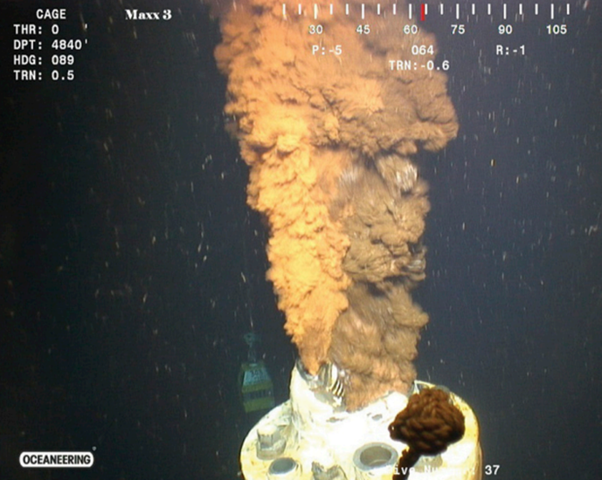

2.2 Why the flow rate has to be larger than 1,000 bpd.

The flow rate through any pipe is a function of the internal pressure of the flowing fluid and the diameter of the pipe (as well as the viscosity of the fluid). From these parameters simple physical arguments could have been made at the time showing that the 1000 bpd rate could not possible be correct. Three arguments/analogies are given below but none of this physical reasoning appears to have been applied to the initial assessment of the leakage rate and the planned response to that rate

* Bathtub analogy: A household bathtub outflow, as driven by 40 psi water through a 1.5-inch pipe is 5 Gallons per minute (GPM) or the equivalent of 175 barrels per day. Thus 6 household bathtubs would be the equivalent of 1000 barrels a day. Yes, the viscosity of crude oil is higher than water so 2-3 times more bathtubs would be needed but that is still only a handful. This is where the 1000 bpd figure needs to be put in context as nowhere in any media reporting is the simple analogy made with a bathtub that would immediately plant seeds of doubt that the flow rate was really this low. In addition, the outflow pipe is likely much larger than 1.5 inches (i.e. closer to 12 inches) and the internal pressure driving the flow has to be orders of magnitude higher than 40 psi.
* Hydraulic Pressure Argument: A 5000-foot head of water would apply a pressure of 7500 psi. This would represent a confining pressure to suppress any flow. At the time of the accident the deep reservoir pressure in which the rig was drilling was estimated by the Coast Guard to be 8000 psi (by the way, this is the estimate that allowed BP to just use a BOP rated at 15,000 psi). It is this 8000 psi that initially allows the oil to flow vertically up a 4000-meter-long pipe. The pressure of oil in that 4000 m pipe would be about 5000 psi meaning there is a differential pressure of +3000 psi that determines the crude oil flow rate. This positive pressure is less than the 7500-psi confining pressure which means there would be no flow initially, if the 8000 psi were the correct figure and clearly it is not since the BOP failed. Moreover, the internal flow pressure driving the flow of crude oil from the eventually severed pipe has to be at least 7500 psi for any oil to emerge from the pipe to eventually produce a surface oil slick. Mud pumps are a fair analogy to the viscosity of crude oil. Specifications [ref] for a typical mud flow pump rated at 7500 psi are 300 GPM for a 4.5- inch pipe. This is equivalen to 10,500 bpd, not 1000! At constant pressure, the GPM flow rate will go as the square of the pipe diameter. For an outflow pipe of 9 inches, 10,500 barrels per day expands to 42,000 bpd. For pipe flow, the flow rate goes as the square root of the pressure differential so if you double the internal pressure to 15,000 psi (because the BOP failed) then the flow rate increases to 1.4 x 42,000 = 58,000 bpd. Thus, simple considerations of likely internal flow pressure and pipe diameter lead to estimates that are at least an order of magnitude larger than 1000 bpd.
* The common-sense argument: Individual oil rigs in the Gulf of Mexico oil fields can have daily production rates as high as 100,000 – 200,000 bpd (the URSA and Atlantis platforms) with typical averages of 40,000 bpd (BP Working Paper 2010). The Deepwater Horizon did not begin drilling operations until Feb of 2010 so there is no production data on its operations prior to the explosion (it takes a few months for a typical oil rig to ramp up its production). According to the design specs, the Deepwater Horizon platform was capable of producing at least 40,000 bpd which, depending upon the internal pressure supplied by natural gas fields, could go as high as 100,000 bpd. So how is that if you effectively cut the oil pipe hose in two, the subsequent leakage rate is now only 1,000 bpd? A “duct tape” solution will clearly not work.

2.3 Upwards revision from oil slick image analysis

On April 28, 2010 NOAA scientists “officially” up graded the leak rate to 5,000 bpd now making the problem 5 times worse. NOAO said this number was uncertain, and of course is still significantly lower than the previous physical reasoning implies. This estimate was largely based on image analysis of the evolving surface oil slick which is also highly problematical as discussed below. However, for now we note the following: a) this revised estimate of 5000 will remain the same for approximately a month, b) on May 24, 2010, BP executive Daniel Rainey also provided a 5,000 bpd estimate to Congress, as BP’s “best scientific guess” at the flow rate (Rainey would later go on trial for directly lying to congress but was eventually acquitted), c) there is still no video of the leakage that is available for the scientific community to analyze.

The NOAA’s April 28 estimate of the leakage rate is largely based on the following (processed to increase contrast) image of the oil slick as it appeared on April 27:

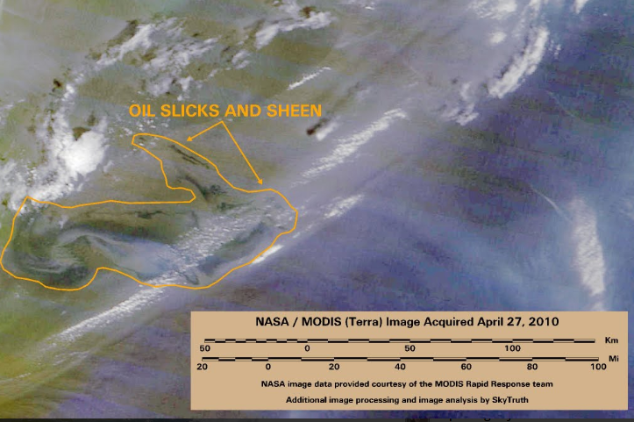

This image is taken from the MODIS satellite that can identify various kinds of objects based on their spectral reflectivity. For an oil slick to be “visible” from MODIS, its thickness as a floating layer on water must be at least 1 micron. The visible oil slick in Figure 2 covers 2233 square miles. If the oil slick has a uniform thickness (quite unlikely) of 1 micron then the oil slick would represent:

* 5783 cubic meters
* 1,527,705 gallons
* 36,374 barrels.

This visible oil slick did not emerge until April 24 suggesting that the “leaking” oil had been mostly consumed by the two-day fire that occurred before the rig sank. This implies that the oil slick is now entirely due to leaking from the riser, 5000 feet below the surface. For an oil slick to grow to this volume in 3 days implies a leakage rate of ~ 12,000 bpd. In addition, a variety of MODIS images suggested a stronger spectral response than would be provided by a uniform thickness of 1 micron. Indeed, at this time a BP exec claimed that 3% of the slick was 100 microns thick and the remaining 97% was “only one or two molecules thick”. Well, that’s a physically absurd statement to make. Oil slicks are diffusive and tend toward uniform thicknesses except when interrupted by coastlines where the oil piles up. In addition, a one or two molecule “thick” oil sheen will not return any spectral signature back to the satellite. If we take BP at their word on the 3% value of 100 microns and the rest at least at one micron (to ensure there is a detection of the slick), then the resulting volume is now 4 times higher at 6 million gallons or a flow rate of 40,000 bpd (consistent with the earlier suggestions). The thickness of the oil is the critical factor for using image analysis of oil spills to determine the flow rate and it takes many images to best estimate this. Hence the NOAA estimate of 5000 bpd really is premature and could easily be an underestimate. Still this revision is qualitatively important as it means the “disaster is larger than we initially thought”.

2.4 Quantitative analysis of in situ video data.

So, we are now a week into the crises and most of this time has been spent trying to “cap” the flow and to start surface clean up efforts. All the time, the oil is gushing out of a pipe of unknown size, under 5000 feet of water, at an unknown flow rate, but a flow rate that is certainly larger than 5000 bpd. Now, for reasons that are rather unclear, it is not until May 12 that video of the flow was publicly released. Immediately after release, many scientists and scientific organizations recognized the real flow rate had to be substantially higher than the 5000 bbd “official rate”. Estimates of the flow rate will be determined by measurements of particle velocity. On May 19 (almost one month since the incident) the Flow Rate Technical Group (FRTG) was formed. This was a group of scientists at various institutes who were given two primary tasks:

* Generate a preliminary estimate of the flow rate as soon as possible.
* Within two months generate a final estimate of the flow rate which will be then taken as the official estimate.

Initial estimates by several groups using different methods and techniques range from 24,000 +/- 9000 bpd to 68,000 +/- 14,000 bpd (McNutt et al. 2012; Camilli et al. 2012). The range in flow estimates and their uncertainty is largely driven by the variable oil to gas mixture. If this ratio is high, then the combined fluid is more viscous, has larger volume but lower particle velocities. If the ratio is low, then the additional gas pressure drives higher flow velocities but gas takes up a larger proportion of the volume. The video data always shows methane bubbles present but the bubbling rate changes; this implies highly variable oil to gas mixture with time so groups that use different time frames of data analysis will get different results, Work documented by the Plume Modeling Team (2010) produced a revised estimate on May 27 of 12-19,000 bpd. This was later revised upwards to 25-30,000 on June 10 and then, in meeting their second charge, the FRTC adopted the range 35,000 to 60,000 bpd.

2.5 Could it be as large as 100,000 bpd?

Since the internal pressure that is driving the flow cannot be known, the only reasonable alternative is to estimate the velocity of the flow from video frame rate data. Since a video camera will take 24-30 frames per second, flow rates of 1-2 meters per second are easily resolved. Here we show the kind of example calculation that could have been made to illustrate a worst possible case:

* Pipe diameter = 21 inches or a cross section (r2) = 0.2 square meters (e.g. the entire casing is severed)
* Volume flow rate at 1.5 meter/sec = 0.3 cubic meters per second
* 0.3 cubic meters per second =720,000 liters per hour
* One barrel of oil = 159 liters; 720,000 liters per hour ~ 4500 barrels per hour
* 4500 barrels per hour x 24 hours per day = 108,000 barrels a day

There are two principle uncertainties in going from flow velocity to the final flow rate: a) the determination of the average flow velocity will depend upon the amount of time you include in your analysis so that you can smooth over the large fluctuations to establish a baseline flow velocity. Therefore, your final estimate will depend on what is adopted for the average velocity; b) in reality there were three separate leaks that were occurring so the combined pipe diameter is difficult to determine. Clearly there is not one main leak occurring at the scale of the 21-inch casing diameter, so the above is an overestimate. At some point in this overall process, an inner diameter of 14 inches was announced and adopting that would decrease the previous estimate by a factor of 2 down to 54,000 bbd.

Overall, because of the presence of gas in the effluent it is scientifically impossible to precisely know the volume flow rate. It is also clear that the actual flow rate could fluctuate considerably from day to day and this fluctuation was plausibly 10,000 to 100,000 bbd. Indeed, internal documents at BP do show estimates as large as 100,000 bbd (Scheyder 2010) were possible. It is also physically likely that the flow rate does start to degrade over time as the internal pressure driving the flow lowers. The final scientific consensus by McNutt et al. (2012) suggests a discharge rate of 50-70,000 bbd yielding an integrate release of 5 million barrels (210 million gallons) into the Gulf of Mexico ecosystem and perhaps only ½ of that was recovered. Sadly, that discharge is actually less than the amount of gasoline used by Americans in a single day.

3.0 Conclusions:

The principle result from the quantitative view presented here is that the Federal Government in initially dealing with the Deepwater Horizon explosion and subsequent sinking did not adequately use simple scientific methods to estimate the size of the problem. The initial public release statement on the leakage rate will turn out to be 50 times too low. The initial estimate of 1000 bpd has about a 1-week lifetime before it is revised to 5000 bpd – still a factor of 10 off. It then took another month for an official Federal Task Force flow committee to arrive at a rate of 12,000 – 19,000 bpd which is still a factor of 2-3 less than the kind of estimates which could have been made initially. More accurate estimates of the leak rate took about 2 months to generate and reached levels of 50 – 70,000 bpd. By then most of the environmental damage has been done and the leak would be mostly capped by July 15. We emphasize that these final estimates of the volume leak are close to what could have been estimated on day 1. Indeed, if the size of the spill was initially declared at 50,000 bpd subsequent response to the incident would have been substantially more robust. Instead, a full two months elapsed before this leakage figure would become official. Federal policy needs to be based on having sufficient resources to respond to a worst-case disaster and that response needs to be based on sound, scientific estimates of the amplitude of the event. Federal policy cannot rely on wishful thinking or be controlled by corporate interests, but that is exactly what happened in the case of the Deepwater Horizon oil spill.

References

Camilli, R. et al. (2012) Acoustic measurement of the Deepwater Horizon Macondo well flow rate, Proceedings of the National Academy of Sciences 109 (50) 20235-20239; DOI: 10.1073/pnas.1100385108

Harlow, W., Brantley, B, & Harlow, R. (2011) BP initial image repair strategies after the Deepwater Horizon spill, Public Relations Review 37, 80-83 https://doi.org/10.1016/j.pubrev.2010.11.005

McNutt, M. et al. (2012) Review of flow rate estimates of the Deepwater Horizon oil spill, Proceedings of the National Academy of Sciences 109 (50) 20260-20267 https://doi.org/10.1073/pnas.1112139108

Plume Modeling Team (2010) Deepwater Horizon Release Estimate of Rate by PIV. Report to the Flow Rate Technical Group. Available at http://www.doi.gov/deepwaterhorizon/loader.cfm?csModule=security/getfile&PageID=68011. Accessed September 2, 2018

Scheyder, E. (2010) BP estimates oil spill up to 100,000 barrels per day in document, https://www.reuters.com/article/us-oil-spill/bp-estimates-oil-spill-up-to-100000-barrels-per-day-in-document-idUSN1416392020100620 Retrieved September 2, 2018

Skogdalen, J. & Vinnem, J. (2012) Quantitative risk analysis of oil and gas drilling, using Deepwater Horizon as case study, Reliability Engineering and System Safety, 100, 58- 66 https://doi.org/10.1016/j.ress.2011.12.002

Spiro, E. et al. (2012) Rumoring during extreme events: a case study of deepwater horizon 2010, Proceedings of the 4th Annual ACM Web Science Conference Pages 275-283 https://doi.org/10.1145/2380718.2380754