Article Title:

Ignoring Quantitative Reasoning: The Initial Estimates of the size of the Deepwater Horizon oil spill of 2010 and The Failure of Science in Properly Shaping the Policy Response

Abstract:

The initial estimate of the flow rate of now liberated crude oil following the explosion and sinking of the Deepwater Horizon oil platform turned out to be a factor of 50 times lower than the physical reality. This initial estimate, provided by the corporate owner of the oil platform, British Petroleum (BP), was a leak rate of 1,000 barrels per day (bpd). This number was not based on any scientific approach and was never put into context, for the media or the public, of whether this was a big or small number (i.e. how many bpd is equivalent to filling a bathtub for 24 hours) and was simply accepted as the physical reality. As a consequence, the initial response to the disaster would plan for a scope that was much smaller than what ultimately unfolded. Furthermore, since 1,000 bpd turns out to be a small number, the initial strategy was based on belief that the leak could be patched and therefore a fix was manageable. Here we show that a) simple physical reasoning at the time of the occurrence would have lead to initial estimates that were close to the final estimate (determined 2 months after the initial incident) of about 50,000 barrels per day; b) there was an unnecessarily slow time evolution to involve the scientific community to gather relevant data that would vastly improve the estimate and; c) this slow evolution in unmasking the physical reality of the situation prevented a more robust governmental response to the problem. Even though the government, through NOAA, revised the leak rate to 5,000 bpd one week after the disaster, another month would elapse before it was officially recognized that the leak rate was essentially 10 times higher.

**1.0 Introduction**

The Deepwater Horizon oil rig explosion and subsequent release of crude oil into the Gulf of Mexico represents a good case study (see also Skogdalen & Vinnem 2012; Harlow, Brantley, & Harlow 2011; Cleveland, 2010; Beever & Hess 2016) in the lack of using basic scientific principles to make initial and reliable assessments of the amplitude of the problem. More specifically, the lack of using quantitative reasoning as part of the initial Federal response to the incident resulted in very low estimates for the volume of crude oil being released and therefore an inadequate response. The fact that no one questioned the validity of the initial estimate made only by BP (possibly in some collaboration with the Coast Guard) is a stunning revelation of numerical illiteracy in terms of thinking about the problem. In the end, the initial estimate will have proven to be incorrect, by a factor of at least 50 (!). Yes, the situation is complicated and somewhat difficult to initially assess and factors of 2-3 uncertainty in complex systems are to be expected; but a factor of 50? – that usually means fundamental physical aspects of the problem are just being ignored. While it was in BP’s own financial interest to lowball the leakage flow estimates so as to avoid paying substantial fines and penalties, this lowballing would dominate the initial two weeks Federal view of the size of the problem. Science methodology to provide an independent estimate of the size of the flow leakage was markedly absent during this first few critical response weeks and quantitative reasoning was not initially applied as a means to estimate the flow rate. An apt analogy involves earthquakes: suppose an earthquake occurred in the Los Angeles area at an actual magnitude of 9.0 (devastating – large scale structural damage) but was reported as being a 7.3 earthquake (50 times less with little structural damage). Clearly, far too little resources would be devoted to the 7.3 perceived event compared to the 9.0 physical reality. In the early days of the Deepwater incident, affairs were strongly driven by perception, largely controlled by a corporate entity (BP), rather than using scientific reasoning to determine the proper reality.

**2.0 Time Evolution of the Leak Rate Determination**

**2.1 The early estimate of 1,000 barrels per day (bpd)**

The Deepwater Horizon explosion occurred on April 20, 2010 which resulted in 11 fatalities and a 2-day fired that destroyed the platform which ultimately sank. Initially, much of the liberated oil was consumed/destroyed by fire. The initial oil slick did not appear until 3 days after the event. The first flow rate estimate of 1,000 bpd was made on April 24 via a joint announcement by the US Coast Guard and BP oil. This number was never put it any context and appears to be nothing more than an arbitrary round number. As a result of this gross underestimate and likely wishful thinking, a “fix it with duct tape” approach seems to have been the initial solution. The amount of needed duct tape is directly related to the size (diameter) of the pipe out of which the oil was flowing and that was either a) unknown at the time or b) information that was not forthcoming from BP. Again, a simple example can help put this in perspective: if you are using your garden hose at full pressure and suddenly that hose is cut in two, the diameter of the leaking hose is the same as the original hose and the water is still gushing out where the hose was severed. Instead, if you drill a ¼ inch hole in the hose, most of the water will still go through the hose and the leak rate out of the small hole will be much less

than the total volume of water flowing through the hose. Indeed, you might even be able to patch that leak with duct tape. This approach adequately describes the initial assessment; 1,000 bpd is sufficiently small to encourage the attempts to simply “patch the hole” and such efforts were made, and of course, they failed. You can’t patch the hole in your garden hose if it’s been completely severed and essentially, the Deepwater Horizon hose (e.g. the pipe containing the crude oil) was similarly severed.

It is also important to remember three physical parameters of the outflow situation: 1) The source of the outflow is via some severed pipe (called the riser) that is located 5000 feet below water. This means there is a hydraulic head pressure on the top of pipe which would tend to suppress any outflow (and drive ocean water back into the pipe) 2) the pipe is fitted with a blowout preventer (BOP) that had a rated pressure of 15,000 psi. The failure of the BOP directly shows that the internal pressure driving the flow outward into the Gulf could be as high as 15,000 psi, if that pressure can be sustained by the gas/oil pocket that was initially penetrated by the rig; 3) The diameter of the pipe through which the outflow was emanating was initially unknown. This pipe diameter confusion can be seen in Figure 1 where the outflow is coming from some inner diameter core that is embedded in the casing which has a known outside diameter of 21-inches. The pipe in which the flow was emanating is clearly of a smaller diameter and some initial estimates used a value of 9 inches. It is important to note that this video image was taken approximately 6 weeks after the initial incident; if it had been done at the time of the incident, the Federal response would have been much swifter and no scientist or engineer looking at that video would have ever uttered the phrase “yeah, we can patch that with duct tape …”.

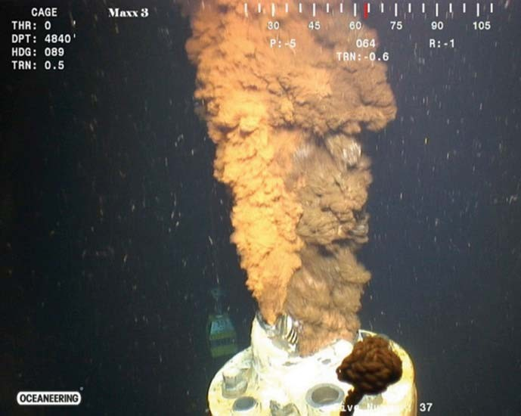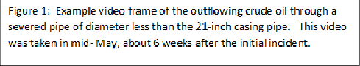

2.2 **Arguments why** **the flow rate must be significantly larger than 1,000 bpd**

The flow rate through any pipe is a function of the internal pressure of the flowing fluid and the diameter of the pipe (as well as the viscosity of the fluid). From these parameters simple physical arguments could have been made at the time showing that the 1,000-bpd rate could not possibly be correct. Four such arguments/analogies are given below:

• **Bathtub analogy**: A household bathtub outflow, as driven by 40 psi water through a

1.5-inch pipe is 5 Gallons per minute (GPM) or the equivalent of 175 barrels per day. Thus 6 household bathtubs would be the equivalent of 1000 barrels a day. Yes, the viscosity of crude oil is higher than water so 2-3 times more bathtubs would be needed but that is still only a handful. This is where the 1,000-bpd figure needs to be put in

context as nowhere in any media reporting at the time of the incident is the simple analogy made with a bathtub that would immediately qualitatively plant seeds of doubt that the flow rate was really this low. In addition, the outflow pipe is much larger than 1.5 and the internal pressure driving the flow is orders of magnitude higher than 40 psi.

• **Hydraulic Pressure Argument**: A 5,000-foot head of water would apply a confining pressure of 7,500 psi which would serve to suppress any flow of crude oil out of a pipe. At the time of the accident the deep reservoir pressure in which the rig was drilling was

(crudely) estimated by the Coast Guard to be 8000 psi (this is the estimate that allowed BP to just use a BOP rated at 15,000 psi instead of one at a higher-pressure rating). Here we use 8,000 psi as the pressure that drives the oil to flow vertically up a 4,000-meter-long pipe. While in the pipe, the weight of the oil exerts a downward pressure of about 5,000 psi. The differential pressure of +3,000 psi is what determines the upward crude oil flow rate. If the pipe is severed, the initial pressure of 8,000 psi will likely be lower (since now the gas pressure is no longer confined to a pipe). Even if 90% of the original gas pressure (8,000 psi) is somehow maintained, that outward pressure (7,200 psi) is now lower than the 7,500-psi confining pressure from the 5,000-foot head of water and the flow is stymied. The fact that it was not stymied is a strong indication that the internal pressure which was tapped was significantly larger than 8,000 psi and this served to cause the BOP failure that triggered the surface explosion.

• **Real World Example Argument**. As stated earlier, flow rates through a pipe depend on the fluid viscosity as that viscosity act as resistance to the differential pressure that is driving the flow. Mud has similar viscosity to crude oil. Southwest Oilfield products provides specifications for a mud pump rated at 7,500 psi (Mud Pump 2017) which produces 300 GPM for a 4.5- inch pipe. This is equivalent to 10,500 bpd, not 1,000! At constant pressure, the GPM flow rate will go as the square of the pipe diameter. For an outflow pipe of 9 inches, 10,500 barrels per day expands to 42,000 bpd. For pipe flow, the flow rate goes as the square root of the pressure so if you double the internal pressure to 15,000 psi (because the BOP failed) then the flow rate increases to 1.44 x 42,000 = 60,480 bpd. This argument by analog strongly suggest 1,000 bpd is a gross underestimate.

• **The common-sense argument**: Individual oil rigs in the Gulf of Mexico oil fields can have daily production rates as high as 100,000 – 200,000 bpd (e.g. the URSA and Atlantis platforms) with typical averages of 40,000 bpd (BP Working Paper 2010). The Deepwater Horizon did not begin drilling operations until Feb of 2010 so there is no production data on its operations prior to the explosion (it takes a few months for a typical oil rig to ramp up its production). According to the design specs, the Deepwater Horizon platform was capable of producing at least 40,000 bpd which, depending upon the internal pressure supplied by natural gas fields, could go as high as 100,000 bpd. So how is that if you effectively cut the oil pipe in two (remember the hose analogy), the subsequent leakage rate is now only 1,000 bpd?

Thus, simple considerations of likely internal flow pressure and pipe diameter lead to estimates that are at least an order of magnitude larger than 1,000 bpd and some estimates made in this manner do come close to the figures determined a full two months later. A “duct tape” solution will clearly not work and this could have been known at the time leading to an essential policy question: why wasn’t this kind to thinking and reasoning applied to this problem instead of simply taking the word of BP/Coast Guard as gospel? In essence, scientific thinking about the problem seems to have been squashed by various political-economic pressures that conspired to downplay the size of the problem to the American public. The mere fact that some citizens practiced citizen science by publishing their own blogs/ideas about the nature of the problem and strongly disputing the 1,000 bpd lowball figure demonstrates that alternative thinking about the situation was performed and made available. This is a good manifestation of the science-policy interface issue which is becoming of growing importance (Neal, Smith and McCormick 2008; Otto 2016).

2.3 **Upwards revision from oil slick image analysis**

On April 28, 2010 NOAA scientists “officially” up graded the leak rate to 5,000 bpd. NOAO said this number was uncertain, and of course is still significantly lower than the previous physical reasoning implies. This estimate was largely based on image analysis of the evolving surface oil slick which can be problematical, as discussed below. However, for now we note the following: a) this revised estimate of 5,000 bpd will remain the same for approximately a month, b) on May 24, 2010, BP executive Daniel Rainey also provided a 5,000 bpd estimate to

Congress, as BP’s “best scientific guess” at the flow rate (Rainey would later go on trial for directly lying to congress but was eventually acquitted), c) there is still no video of the leakage that is available for the scientific community to analyze. The first video will not be released until May 12. The NOAA’s April 28 estimate of the leakage rate is largely based on the following (processed to increase contrast) image of the oil slick as it appeared on April 27:

Figure 2: The orange outline shows the boundaries of the oil slick as it appeared on April 27

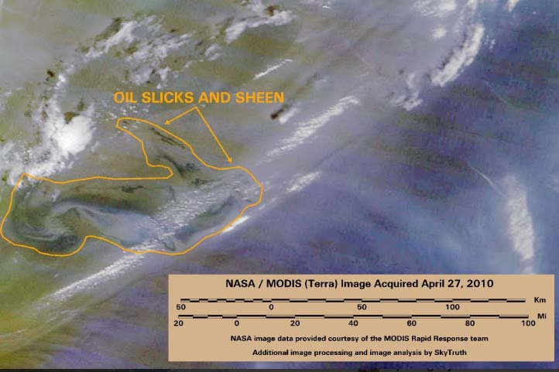

Figure 2 is taken from the MODIS satellite that can identify various kinds of objects based on their spectral reflectivity. For an oil slick to be “visible” from MODIS, its thickness as a floating layer on water must be at least 1 micron. The visible oil slick in Figure 2 covers 2233 square miles. If the oil slick has a uniform thickness (quite unlikely) of 1 micron then the oil slick

would represent (see Amos 2010):

• 5783 cubic meters

• 1,527,705 gallons

• 36,374 barrels.

This visible oil slick did not emerge until April 24 suggesting that the “leaking” oil had been initially consumed by the 2-3 day fire that occurred before the rig sank. For an oil slick to grow to this volume in 3 days implies a leakage rate of ~ 12,000 bpd. Also, at this time a BP exec claimed that 3% of the slick was 100 microns thick and the remaining 97% was “only one or two molecules thick”. Well, that’s a physically absurd statement to make. Oil slicks are diffusive and tend toward uniform thicknesses except when interrupted by coastlines where the oil piles

up. In addition, a one or two molecule “thick” oil sheen will not return any spectral signature back to the satellite to even be detected. If we take BP at their word on the 3% value of 100 microns and the rest at least at one micron (to ensure there is a detection of the slick), then the resulting volume is now 4 times higher at 6 million gallons or a flow rate of 40,000 bpd. The thickness of the oil is the critical factor for using image analysis of oil spills to determine the flow rate and it takes many days of images to best estimate this. Hence the NOAA estimate of

5,000 bpd really is premature and could easily be an underestimate. Still this revision is qualitatively important as it means the “disaster is larger than we initially thought”. This important sentiment was proposed in various blogs and other social media forums at the time (e.g. Amos 2010, Spiro et al. 2012) but completely ignored in the Federal response process.

2.4 **Quantitative analysis of in situ video data.**

We are now a week into the crises and most of this time has been spent trying to “cap” the flow and to start surface clean up efforts. All the time, the oil is gushing out of a pipe of unknown size, under 5000 feet of water, at an unknown flow rate, but a flow rate that is certainly larger than 5,000 bpd. Now, for reasons that are rather unclear, it is not until May 12 that video

of the flow was publicly released (this is almost 3 weeks after the incident). Immediately after release, many scientists and scientific organizations recognized the real flow rate had to be substantially higher than the 5,000 bbd “official rate” just from casual observations of the fluid flow. More precise estimates of the flow rate will be determined by measurements of particle velocity. On May 19 (almost one month since the incident) the Flow Rate Technical Group (FRTG) was formed. This was a group of scientists at various institutes who were given two primary tasks:

• Generate a preliminary estimate of the flow rate as soon as possible.

• Within two months generate a final estimate of the flow rate which will be then taken as the official estimate.

Initial estimates by several groups using different methods and techniques range from 24,000 +/-

9,000 bpd to 68,000 +/- 14,000 bpd (McNutt et al. 2012; Camilli et al. 2012). The range in flow estimates and their uncertainty is largely driven by the variable oil to gas mixture. If this ratio is high, then the combined fluid is more viscous, has larger oil volume but lower particle velocities. If the ratio is low, then the additional gas pressure drives higher flow velocities but gas takes up

a larger proportion of the volume. The video data always shows methane bubbles present but the bubbling rate changes quite rapidly; this implies highly variable oil to gas mixture with time so groups that use different time frames of data analysis will get different results, Work documented by the Plume Modeling Team (2010) produced a revised estimate on May 27 of 12,000-19,000 bpd. This was later revised upwards to 25,000-30,000 on June 10 and then, in meeting their second charge, the FRTC adopted the range 35,000 to 60,000 bpd.

2.5 **Could it be as large as 100,000 bpd?**

A video camera will take 24-30 frames per second so the measured flow rates of 1-2 meters per second are easily resolved. Here we show the kind of example calculation that could have been made to illustrate a worst possible case:

• Pipe diameter = 21 inches or a cross section (πr2) = 0.2 square meters (e.g. the entire casing is severed)

• Volume flow rate at 1.5 meter/sec = 0.3 cubic meters per second

• 0.3 cubic meters per second =720,000 liters per hour

• One barrel of oil = 159 liters; 720,000 liters per hour ~ 4,500 barrels per hour

• 4,500 barrels per hour x 24 hours per day = 108,000 barrels a day

There are two principle uncertainties in going from flow velocity to the final flow rate: a) the determination of the average flow velocity will depend upon the amount of time you include in your analysis so that you can smooth over the large fluctuations to establish a baseline flow velocity. b) in reality there were three separate leaks that were occurring so the combined pipe diameter is difficult to determine. Clearly there is not one main leak occurring at the scale of the

21-inch casing diameter, so the above is an overestimate. At some point in this overall process, an inner diameter of 14 inches was announced and adopting that would decrease the previous estimate by a factor of 2 down to 54,000 bpd.

Overall, because of the presence of gas in the effluent it is scientifically impossible to precisely know the volume flow rate. It is also clear that the actual flow rate could fluctuate considerably from day to day and this fluctuation was plausibly from 10,000 to 100,000 bbd. Indeed, internal documents at BP do show estimates as large as 100,000 bbd (Scheyder 2010) were possible to occur. It is also physically likely that the flow rate does start to degrade over time as the internal pressure driving the flow must eventually lower. The final scientific consensus by McNutt et al. (2012) suggests a discharge rate of 50,000-70,000 bpd yielding an integrated release of

5 million barrels (210 million gallons) into the Gulf of Mexico ecosystem.

**3.0 Conclusions:**

The principle result from the quantitative view presented here is that the Federal Government in initially dealing with the Deepwater Horizon explosion did not adequately use simple scientific methods to estimate the likely size of the problem. The initial public release statement on the leakage rate will turn out to be 50 times too low. The initial estimate of 1,000 bpd has about a 1-week lifetime before it is revised to 5,000 bpd – still a factor of 10 off from the final “official” determination. It then took another month for an official Federal Task Force flow committee to arrive at a rate of 12,000 – 19,000 bpd which is still a factor of 2-3 less than the kind of estimates which could have been made initially. More accurate estimates of the leak rate took about 2 months to generate and established levels of 50,000 – 70,000 bpd as the most probable value. By then most of the environmental damage had been done.

We emphasize that these final estimates of the volume leak are close to what could have been estimated on day 1. Indeed, if the size of the spill was initially declared at 50,000 bpd subsequent response to the incident would have been substantially more robust. Instead, a full two months elapsed before this leakage figure would become official. Federal policy needs to be based on having sufficient resources to respond to a worst-case disaster and that response needs to be based on sound, scientific estimates of the amplitude of the event. Federal policy cannot

rely on wishful thinking or be controlled by corporate interests, but that is exactly what happened in the case of the Deepwater Horizon oil spill in the initial assessment of the incident. The environment ultimately paid a heavy price for such poor decision making.

Perhaps there is a good analogy between the documented failure to properly estimate the flow rate and the current situation of properly estimating the rate of climate change. Like the BP oil spill, climate change has a set of corporate entities that can play a role in providing disinformation to the public about the nature of climate change and its overall amplitude. Indeed, in May 2019, the United States Secretary of State publicly announced that the rapid melting of the Arctic Ice cap will better improve trade. Any team of unbiased scientists on this matter would strongly argue that the melting of the Arctic Ice cap significantly changes the albedo of the planet (the planet now reflects less sunlight) thus providing positive feedback to accelerate the current rate of warming. For the case of the BP oil spill, corporate interests did dominate decision making. For the sake of the planet, the unbiased scientists must have their voice weighted more than others.

References

Amos, J. (2010) Gulf Oil Spill Rate Must Be Much Higher Than Stated – 6 Million Gallons So Far? Available at https://www.skytruth.org/2010/04/gulf-oil-spill-rate-must-be-much-higher/

Beever, J. & Hess, J. (2016) Deepwater Horizon Oil Spill: An Ethics Case Study in Environmental Engineering, Paper presented at 2016 ASEE Annual Conference & Exposition, New Orleans, Louisiana. 10.18260/p.26647 DOI: http://dx.doi.org/10.18260/p.26647

BP Working Paper (2010) A Brief History of Offshore Oil Drilling, National Commission on the BP Deepwater Horizon Oil Spill and Offshore Drilling, Chapter 2 available at https://www.nrt.org/sites/2/files/GPO-OILCOMMISSION.pdf

Camilli, R. et al. (2012) Acoustic measurement of the Deepwater Horizon Macondo well flow rate, Proceedings of the National Academy of Sciences 109 (50) 20235-20239; DOI: 10.1073/pnas.1100385108

Cleveland, C. (2010) Deepwater Horizon oil spill, http://www.bu.edu/sustainability/deepwater-horizon-oil-spill/ Accessed Sept 4 2018

Harlow, W., Brantley, B, & Harlow, R. (2011) BP initial image repair strategies after the Deepwater Horizon spill, Public Relations Review 37, 80-83 https://doi.org/10.1016/j.pubrev.2010.11.005

McNutt, M. et al. (2012) Review of flow rate estimates of the Deepwater Horizon oil spill, Proceedings of the National Academy of Sciences 109 (50) 20260-20267 https://doi.org/10.1073/pnas.1112139108

Neal, Homer A., Tobin L. Smith, and Jennifer B. McCormick. 2008. Beyond Sputnik: U.S. science policy in the twenty-first century. Ann Arbor: University of Michigan Press.

Otto, S. (2016) The War on Science, Who’s Waging it, Why it Matters, What Cane we do About it? Published by Milkweed Editions, Minneapolis MN.

Plume Modeling Team (2010) Deepwater Horizon Release Estimate of Rate by PIV. Report to the Flow Rate Technical Group. Available at http://www.doi.gov/deepwaterhorizon/loader.cfm?csModule=security/getfile&PageID=68011. Accessed September 2, 2018

Scheyder, E. (2010) BP estimates oil spill up to 100,000 barrels per day in document, https://www.reuters.com/article/us-oil-spill/bp-estimates-oil-spill-up-to-100000-barrels-per-day-in-document-idUSN1416392020100620 Retrieved September 2, 2018

Skogdalen, J. & Vinnem, J. (2012) Quantitative risk analysis of oil and gas drilling, using Deepwater Horizon as case study, Reliability Engineering and System Safety, 100, 58- 66 https://doi.org/10.1016/j.ress.2011.12.002

Spiro, E. et al. (2012) Rumoring during extreme events: a case study of deepwater horizon 2010, Proceedings of the 4th Annual ACM Web Science Conference Pages 275-283 https://doi.org/10.1145/2380718.2380754