**Policy Assignment 3:**

**Due on Sunday Feb 24 to be discussed in class on Monday Feb 25**

This assignment is meant to give you practice on how a science would use real data to produce various numerical methods of achieving the stated policy goals below.

Your team has been hired to serve as data consultants so that both a new Federal Tax policy and a new way to fund Social Security can be offered for consideration in Congress. To properly perform your consulting gig you will have to do some various numerical modelling based on the actual data and distributions. Since the methods that you will use will be essentially the same on the Tax data as the SS data, there is no reason not to take that method and achieve two policy outcomes from it.

For the federal tax policy, the intent will be to tax WEALTH (on an annual basis) and to not TAX Annual Income. A hybrid model can be considered as well where some baseline tax based on annual income is combined with a tax on wealth. To sell the policy to Congress you must make it clear that the TAX on the average household will be lower.

Part A:

Demonstrate to congress that the average household income in the US is misleading and that one should always use the median household income. Here is a relevant distribution:

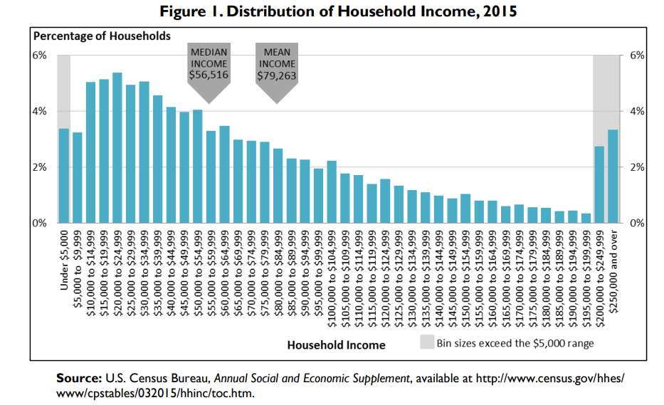

To learn about the probability density function for a skewed distribution, go here:

To show the effect to congress you want to calculate the and present the income of which 10% if all households exceed. For the Mean Income shown above, the standard deviation around that mean is about $30,000. How does that compare to the 10% value using the median income and the curve above? Also, to learn about the probability density function for a skewed distribution, go here:

<https://math.stackexchange.com/questions/1128781/whats-the-formula-for-the-probability-density-function-of-skewed-normal-distribu>

Part B:

The two distributions below can help you compare household income with household wealth and this is all the information you really need to produce a policy:

First is the percentage distribution of household income. For example, 12% of households have an annual income from 35 to 50K. This distribution largely forms the basis for the current Marginal Tax Brackets.

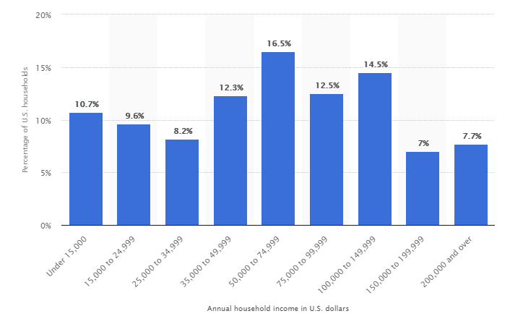

The Distribution of Wealth is shown here:

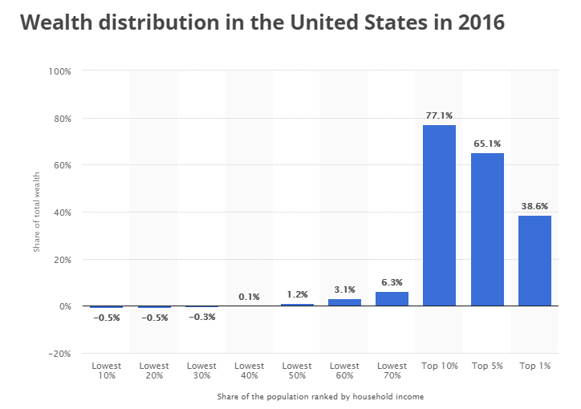

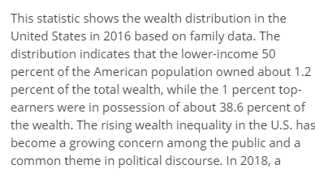

So, the rationale for the policy is simple: wealth inequity is currently much greater than income inequity and so a fairer tax base would be to consider wealth. So, using these two distributions you Team is to come up with some hybrid tax rate combining annual income with wealth. For example, the top 10% own 77% of total wealth X while earning 250K + in annual income. Where the 50% income (50 -75K) owns about 1.2% of X.

The goal of your policy is two-fold:

1. Reduce the over-all tax-burden on what you determine to be the “average household”.
2. **Double** the amount of annual revenue that is being raised by the current income tax so that taxing wealth produces revenue to be returned by increasing social services

For the purpose of this exercise consider X to be $100 trillion. This would mean that the combined wealth of the top 1% is about 40 trillion dollars (38.6% x 100T).

<https://www.wsj.com/articles/u-s-net-worth-surpasses-100-trillion-1528387386>

In round numbers, the annual revenue from income taxes on households is 2$ trillion. Via your new proposed tax scheme, you want to raise 4 Trillion

For statistical purposes there are about 125 million households in the US.

Qualitatively, all schemes will mean that the top (however you define that) will have a greater tax burden in dollars (not necessarily percentage) than the bottom. Indeed, this is the necessary correction make if your going to reduce wealth inequality.

Part C:

Stabilizing Social Security:

Goals:

1. To **double** the amount of Social Security annual funding – note in 2017 the approximate revenues from payroll tax was 1 Trillion. Note that both the employee and the employer pay payroll tax, each at 6.2% of annual (monthly) income. Currently the ceiling for annual income is about 130K, so if you make 150K, that last 20K is exempt from payroll tax.
2. To reduce the payroll tax from the current level of 6.2% down to 3%

The basic reason that the social security system is in trouble is that the ratio of workers to beneficiaries has steadily been in decline and much of this is due to increased life expectancy in retirement. In 1960 the ratio was 5:1; now the ratio is 2.8:1 – so less workers paying into the system and the benefits lifetime per retiree has been increasing. In 1960 the average lifetime in retirement from age 65 was 3 years and today its about 14 years. These reasons combine to show that outputs will exceed inputs by the year 2034.

To met your goals will require adjusting the inputs and the outputs. Here are your options to combine and remember you are to double annual revenue you will essentially be halving the payroll tax.

Inputs:

1. Raise the social security ceiling (there is lots of national dialogue on this); see also https://www.cbo.gov/budget-options/2016/52266
2. Have some “consumption” tax on certain items or venues to produce revenue for SS – this is much like a hotel tax. For example, suppose there was a Tax on every NFL ticket sold, how much revenue would that generate? Suppose there was a tax on every Taylor Swift, or Metallica, or whatever concert directed towards SS 🡪 how much revenue would that raise, etc.

Outputs

1. Increase the starting year for when benefits can be received (every 6 months makes a difference statistically). For statistical purposes consider the average annual SS benefit to be 25K.
2. Consider a policy about life expectancy – perhaps the benefit should only be paid out over X years, and not forever?