Maxwell’s Equations

Unification of Electrostatics and Magnetostatics → Electomagnetism.

From Faraday’s law: Changing B field will produce and E field.
But the opposite is true as well: A changing E field will produce a B field!

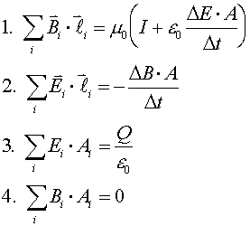

:
1) Ampere’s law . A magnetic field is produced by an electric
current, and also by a changing electric field

2) Faraday’s law – Changing magnetic flux induces and EMF and current
.
3) Gauss’s law relates electric field to charge

4) Unnamed Law: states there are no “magnetic charges”

changing electric field produces a magnetic field, → changing magnetic field produces an electric field,

once sinusoidal fields are created they can propagate on their own.

These propagating fields are called electromagnetic waves.

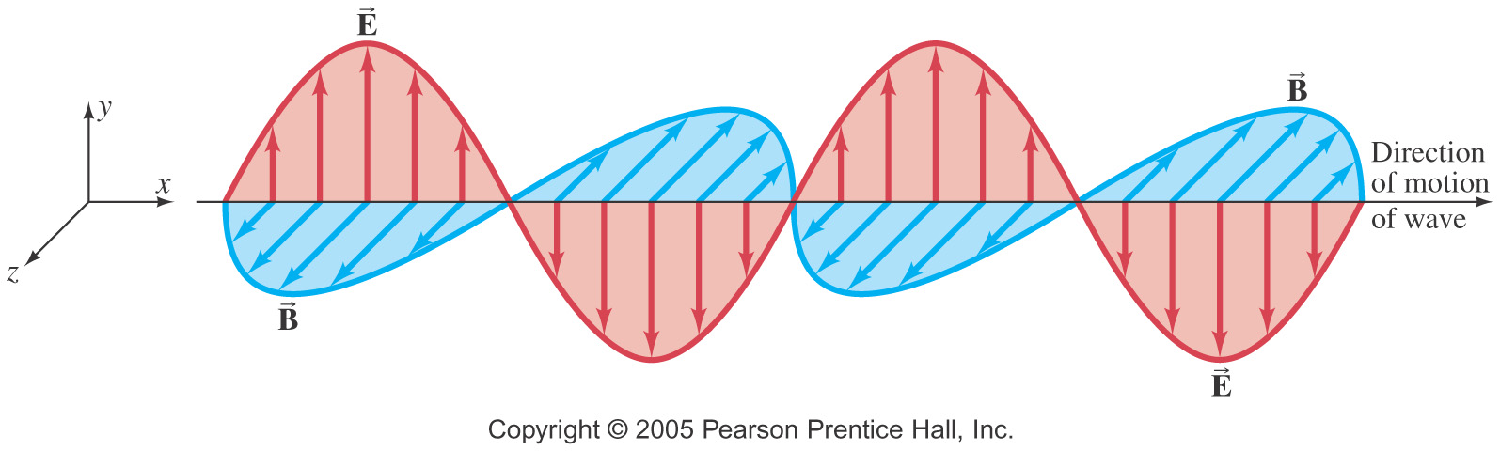

All is takes the motion of electric charges to start:
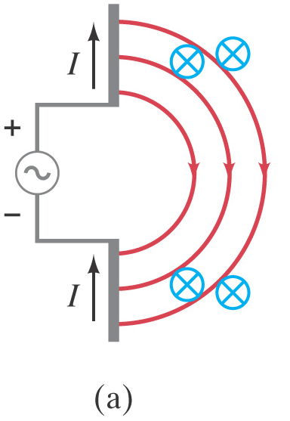
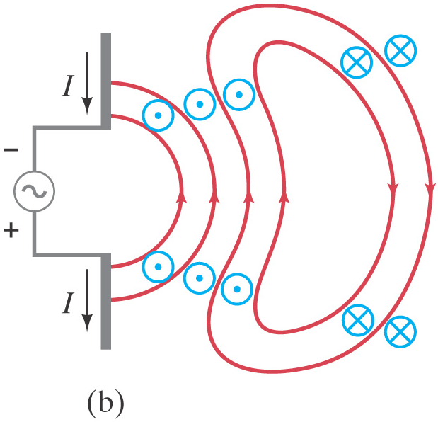

B and E fields are always perpendicular to each
other and to the direction of motion:

Right hand rule:
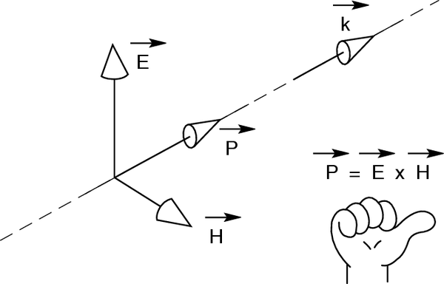

When

Maxwell calculated the speed of propagation of electromagnetic waves, he found:

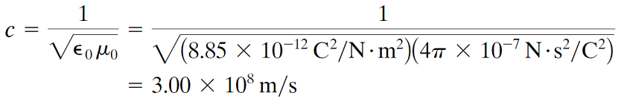

Amplitudes are related by:
E = cB

Energy in EM waves:

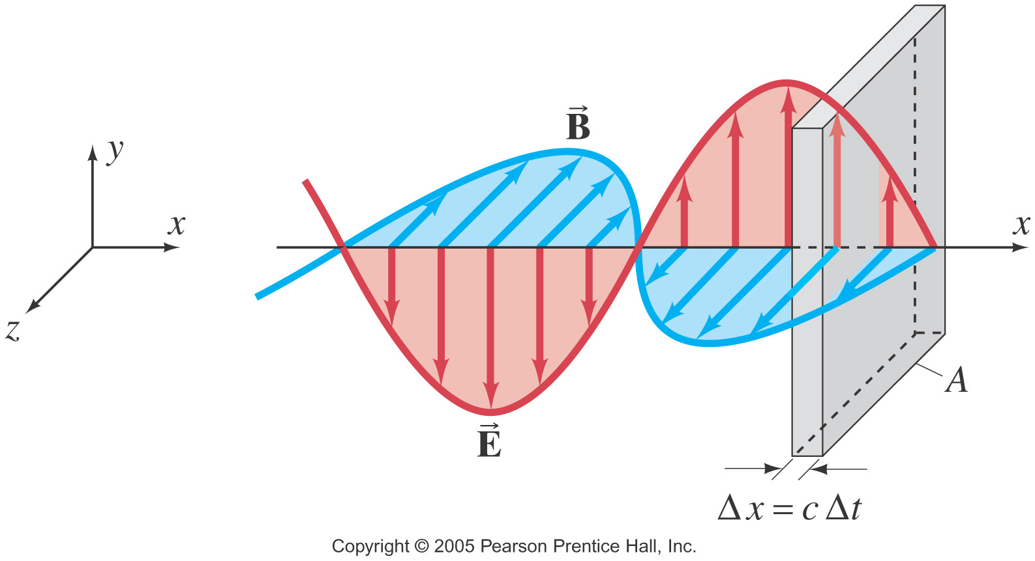
Energy is stored in both electric and magnetic fields, giving the total energy density of an electromagnetic wave

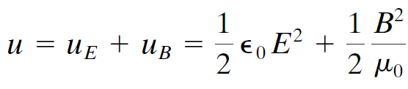

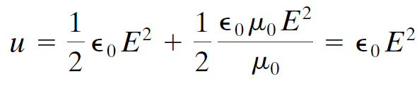

Light was known to be a wave; after producing electromagnetic waves of other frequencies, it was known to be an electromagnetic wave as well.

The frequency of an electromagnetic wave is related to its wavelength:
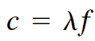

Electromagnetic waves can have any wavelength; we have given different names to different parts of the wavelength spectrum.
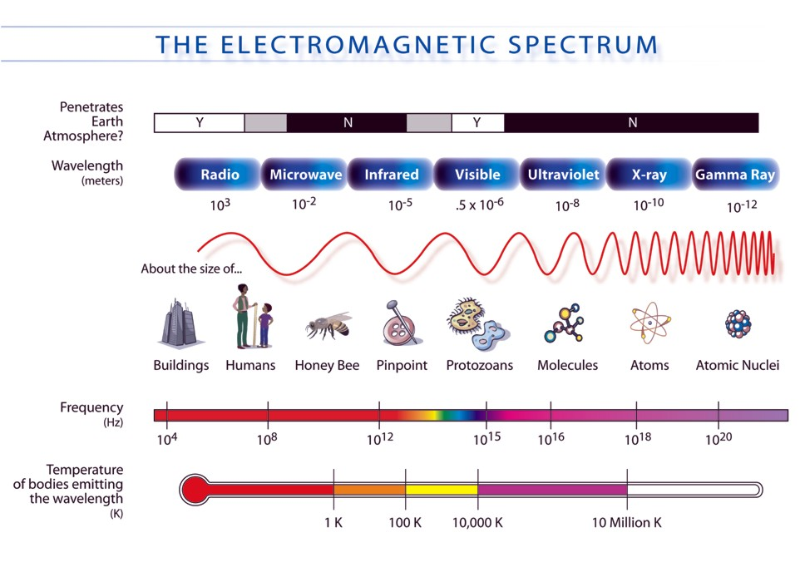

AM/FM radio signals:
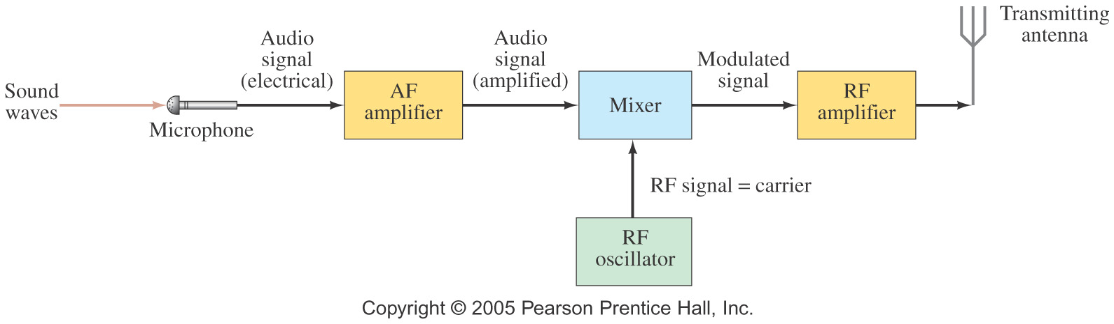

The mixing of signal and carrier can be done two ways. First, by using the signal to modify the amplitude of the carrier (AM):

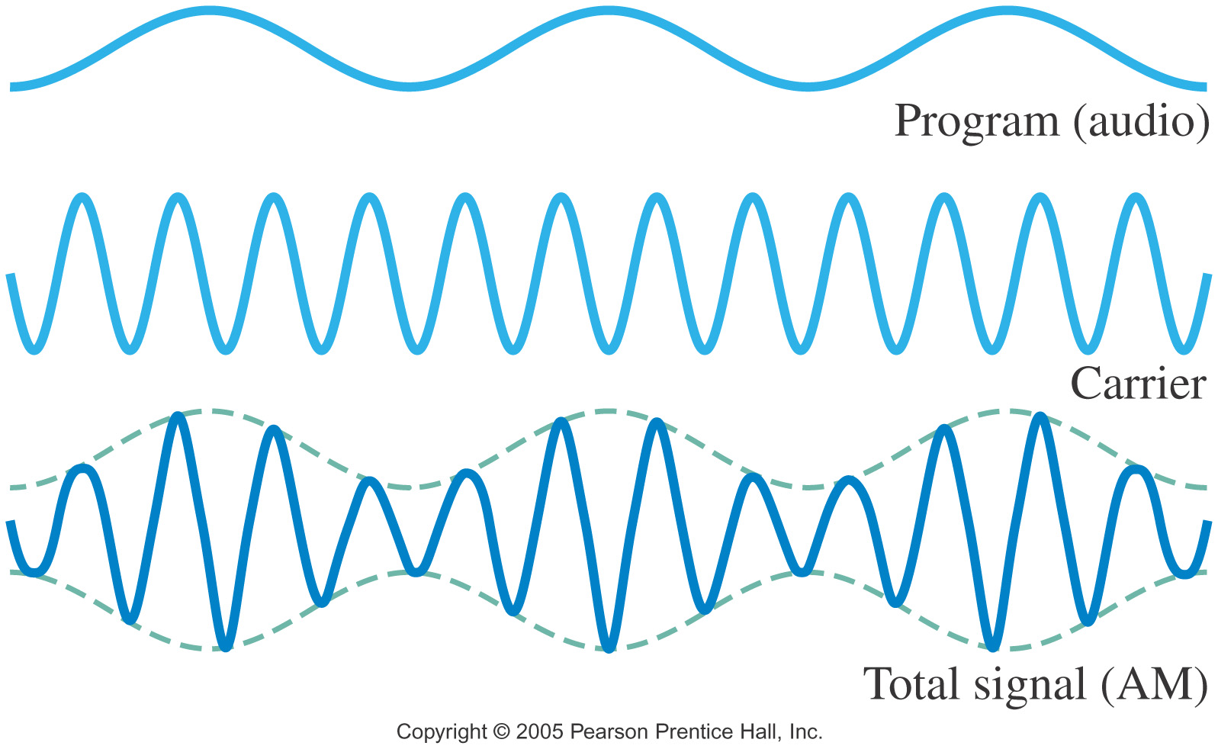

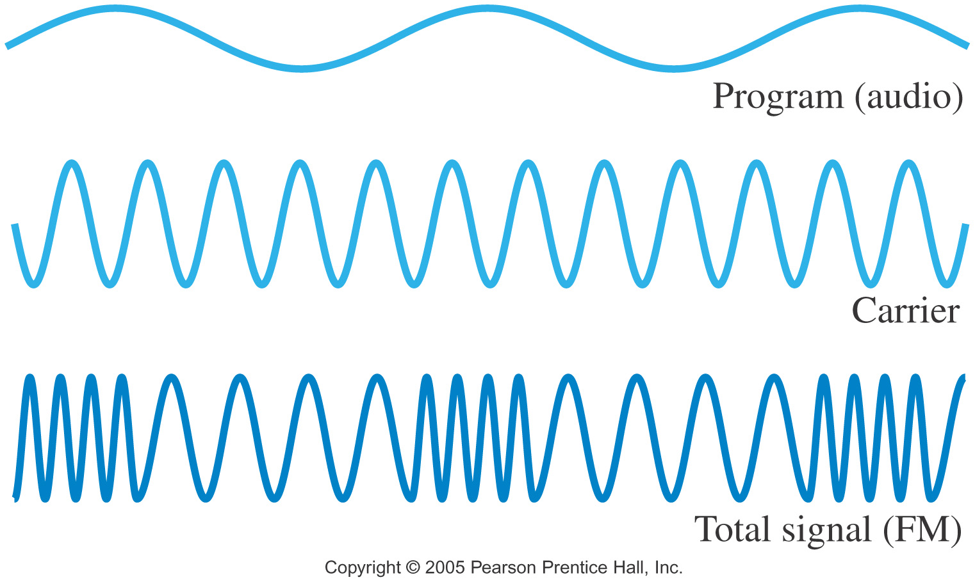
Or in the case of FM, the carrier frequency is changed according to the sound wave signal.

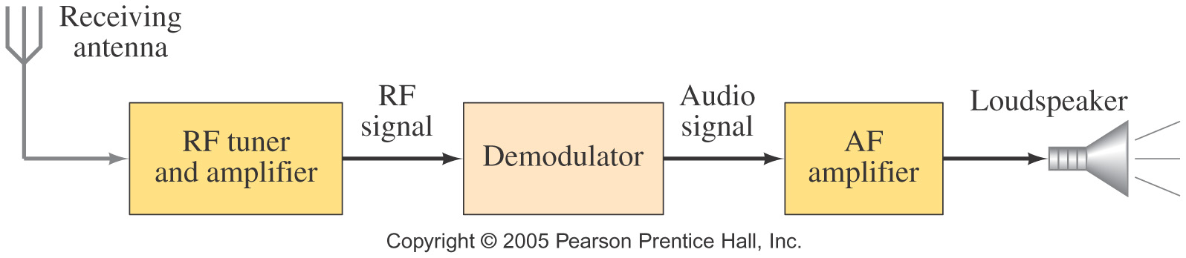
In AM or FM the signal is received:

Low pass and High Pass filters:

Using a simple RC circuit and an AC source, certain frequencies can be selected.

Trick is knowing where to measure the output voltage.

RC Low pass filter: as frequency increases, the reactance decreases:

The result is that the voltage drop across the capacitor is very small at high frequencies and very large at small frequencies

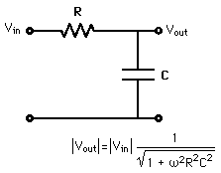
Lo Pass Filter

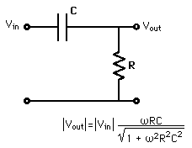
Hi Pass Filter

