Project Description

Executive Summary:

Instilling Climate Literacy via Scientific Storytelling (ICLSS) is an innovative partnership between the University of Oregon Physics Department, Pacific University College of Education, and a consortium of northwest school districts as united through the South-Metro Salem Partnership. Building on two highly successful previous ventures, ICLSS will transform environmental and climate literacy curricula in partner middle and high schools by providing a year-long teacher professional development (PD) program consisting of extensive earth systems and climate change science coursework, and training in the use of large data sets to generate data driven curriculum exercises for their students. Central to our mission is providing teachers the tools and expertise needed to build evidence-based inquiry and synthesis skill in their students. Our partnership has had a long history of providing teachers with innovative tools to assist them with data organization and analysis so that science content is taught via data driven pathways as opposed to just "lecturing about the facts". By so doing, we can stitch together these various pathways so that multiple stories can be told, using images, maps and data in order to better convey senses of environmental change that are now occurring as a result of climate change.

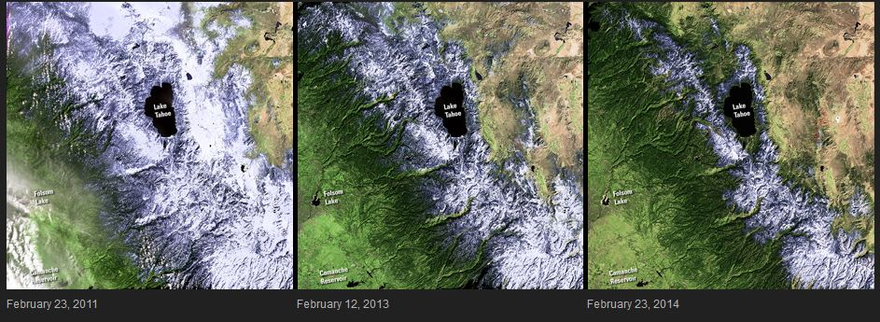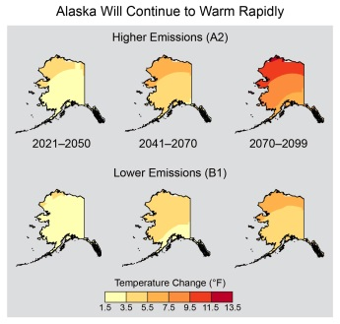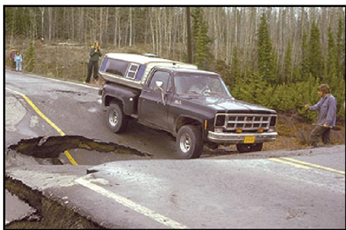One example is provided by, NASA's newly launched Images of Change website which is full of compelling chapters for this ongoing story including the current California drought as shown in this sequence of images of Lake Tahoe and its dwindling February snowpack. An additional example is provided by the May 6, 2014 White release of the National Climate Assessment report which mostly tells the story of regional climate change in the US through data, graphs and images. A good case of this story telling is for the case of Alaska (images to the right) as measured by the rapidly melting permafrost where the impacts can be immediately obvious to local residents.

The major goal of our proposed project is to train K12 science teachers and their students on how to gather and assemble relevant images and datasets that best define environmental change, as a result of climate change, on their local scale. Indeed, the State of Oregon is currently experiencing the lowest snow water equivalent ever measured (9% of normal in the case of the Willamette River basin as reported by April 7 SNOTEL data) in the Western Cascades which will have dramatic near-term environmental impacts essentially in the back yards of the participating school districts thus improving the relevancy and impact of our project. Experience has shown that climate change knowledge is best gained via direct observation on local scales; else it’s a more abstract concept that applies in the (distant) future.

Building on past practice, we will ensure maximum classroom impact on student learning by engaging scientists, teachers, and administrators together in *co-teaching partnerships*, in which all participants work together in real classrooms to enact innovative content and pedagogy. More specifically, we propose to employ our annual cadre model, where we are able to enhance teacher core content knowledge, build the capacity for inquiry-based science teaching, and develop teacher leadership for sustainable and meaningful action in schools. This is accomplished through the delivery of an interlocking set of PD activities such as an introductory week-long summer Oregon Climate Institute, a series of Friday-Saturday mini workshops, and a capstone experience often involving high altitude balloon flights and the acquisition of weather data. Under this approach improved core-content knowledge of the teachers can be sustained through a full school year which, in turn, promotes the development of curriculum that is implementable at the start of the next school year. Increased teacher climate and earth systems science literacy will be achieved by providing district-based teams of middle school science teachers 12 quarter-hours of challenging coursework on current topics and research in climate change and earth systems science, which will make extensive use of available data sets and remotely sensed images. We will provide the analysis and visualization tools to assist with the use of these data sets. Our current working model would involve 18 teachers in 4-6 districts as the annual cadre in year and additional new 18 teachers in year 2. Under this project we intend to vastly increase the core knowledge of participant teachers in basic climate science and its impacts on local and regional scales while working directly with cadre teachers to create new curriculum for students centered on framing climate change through scientific storytelling.

Motivations and Context:

Secondary science teachers have been trained to regard data literacy and academic language as separate and distinct domains from the learning of science content. More specifically, the ability to construct and communicate evidence and data-driven arguments and reasoning has been identified as a central indicator of science literacy, one that is essential to not only STEM careers, but to 21st century citizenship. Evidence-based argumentation and reasoning enfolds elements of science, math, and language literacy explicitly expressed in the Next Generation Science Standards (NRC, 2011) and Common Core State Standards in Mathematics (CCSS, 2012). As expressed by Bruce Alberts, former head of the National Science Board:

*How many talented young people are we losing in today’s schools, driven by test scores that reward teachers for drilling students to remember obscure science words? Instead we should be rewarding them for teaching science inquiry skills and literacy together, through collaborative and critical discourse* (Alberts, 2010, p.405).

The future of our communities, nation, and world depends on our ability to find innovative solutions to complex, technical, and often, sociopolitical, problems. **The area of climate change and climate change impacts encompasses and integrates all of these components**.

Many middle and secondary school science teachers resist teaching communication skills, often arguing that their role is to teach science, not English (McCoss-Yergian & Krepps, 2010). Yet, science is actually a story that is told in data, response to data, and evolution of ideas based on that interaction. While the use of data in the science classroom is more familiar to many science teachers, what data literacy means in the 21st century has changed radically. Teachers have been prepared for the past 30 years to focus predominantly on small, student-collected data sets designed to solve well-defined problems. What is required today, particularly for environmental data, is a synthesis approach that directly incorporates uncertainness and biases in the data, accesses multiple data sets, and synthesizes a consistent story, complete with the relevant language. This produces data/scientific literacy. This literacy transcends improving the core content knowledge of teachers; it consists of teachers adopting a pedagogical framework which emphasizes synthesis and argumentation that is driven by data (evidence). Such a framework requires that teachers have a deeper understanding of data, its limitations, and potential biases in various forms of sampling (see Neal 2006). For instance, the economic and political nature of various climate change issues demands that the public be able to *critically evaluate information* about climate change from an evidenced-based point of view. Public climate literacy starts at the K-12 school level, where both teachers and students need to develop skills and approaches to evaluating various kinds of data in order to synthesize an informed view of the many dimensions of the climate change problem

For more than a decade, Carr and Bothun have led many K12 Professional Development (PD) sessions, workshops, and 12-month partnerships (most of these funded under U.S. Department of Education Title IIA or Title IIB programs), with a very strong focus on synthesis and increased science literacy as the outcome. Evaluation (e.g. Carr et al; 2009) of these programs suggests some success in achieving these outcomes. It is within this scope and background that we propose our ICLSS project whose core components are:

* **Engage** teachers in a robust exploration of the various data sets that have been used to show that climate change is occurring
* **Develop** a suite of data/project-based exercises used by teachers to introduce their students to how various aspects of the state of our environment are measured
* **Improve** the understanding of the relation between weather and climate by equipping each participating school with high quality weather stations

In meeting these objectives, ICLSS will both directly impact the climate change literacy of hundreds of students in the participating school districts and will have constructed a highly interactive curriculum based on the analysis of many different kinds of datasets as described later in this proposal. A relevant framework for achieving these objectives through the acquisition of data literacy has recently been formulated by The Education Development Center Oceans of Data Institute (Kastens 2014). The components of this framework are:

1. Acquiring data from a complex world necessitates choices and trade-offs. You can’t measure everything, all the time. As a consequence, every dataset is a subset or sampling of the referent system, leaving out as much or more than it includes, and possibly including biased sampling.
2. Data can be used to make inferences about events of the past.
3. Events leave traces in the real world, and by looking at the traces, humans can sometimes make inferences about the events. Some forms of scientists’ data attempt to make permanent and visible traces that would otherwise be ephemeral or invisible.
4. A single observable parameter can reflect multiple processes or influencers.
5. Data and observations are useful for answering scientific or practical questions about the represented system and solving problems within the represented system.

ICLSS will design, prototype, and test tools and resources to enable teachers to infuse 21st century data literacy and language into science instruction, and will produce models of what such instruction looks and sounds like in classroom practice. While there is no one, universal definition of data literacy (DL), the following table outlines 6 observable skills that can be reasonably associated with DL and designed into ICLSS resources and tools.

|  |  |  |
| --- | --- | --- |
| Data Literate Skill | Explanation/Examples | Related Understanding |
| Representation | Represent simple and complex data sets using available graphical tools | 1, 3 |
| Interpretation | The ability to use various data forms or wave forms to gain better insight into the represented phenomena | 5 |
| Evidence Based Reasoning | The ability to construct and support an argument based on available data and its representation. | 4, 5 |
| Analysis/Prediction | The ability to use graphical representations, particularly time series, to estimate behavior in the future or behavior under different conditions. | 2, 5 |
| Synthesis | The ability to link together various data sets to form a big picture assessment and uncover possible data biases and/or data limitations. | 1 |
| Communication | The ability to use graphical representation of data to communicate scientific knowledge to the lay public. | 3,4,5 |

Improved scientific and data literacy will empower students to become responsible citizens in a rapidly changing world and will better prepare students for effective participation in the decisions and actions. All of this is grounded on evidence based reasoning through the mechanism of scientific storytelling where a consistent argument can be presented.

Climate/Environmental Literacy for Middle and High School Teachers:

*Climate literacy* for middle and high school teachers begins with an awareness of climate basics, i.e., the clear relationship between atmosphericgreenhouse gas concentrations (primarilywater vapor) and average global temperature. Following this, ICLSS will fully educate teachers on

* The energy-use-related factors that determine the evolution of atmospheric CO2 concentration,
* Producing a better physical understanding of what is commonly referred to as the “greenhouse-effect” and how that produces elevated temperatures.
* The complex and influential “feedback” mechanisms inherent in events such a melting icecaps and glaciers, changing precipitation patterns, shifting vegetation cover and aerosol pollution acting as a source of global diming and
* The important role of methane emissions that serve to enhance any warming signal.
* The nature of weather data as a noisy time series against a variable climate baseline

For example, through ICLSS training, the newly climate literate teacher would understand the potential surface warming of the earth to be the result of a) the water vapor feedback loop, b) increased atmospheric CO2 concentration, c) increased atmospheric CH4 concentration and d) “pipeline” warming due to the oceans acting as an enormous heat buffer. Moreover, this literate teacher would also have the tools to address the role that consumption and choices of energy generation and transport play in driving atmospheric CO2 concentration.

Classroom Pedagogy for Climate Change Literacy :

Improving overall public climate literacy requires that teacher content knowledge be joined with effective, inquiry-based pedagogy emphasizing data analysis. Our past work in science teacher PD indicates that many K-12 teachers equate inquiry-based pedagogy with teaching the “scientific method” (Carr et al, 2009). This is especially true in middle and high school, where students often apply the steps of the scientific method in simplistic, artificially contrived contexts, usually disconnected from vital science concepts. It is therefore critical that innovative pedagogy be modeled, taught, and supported in content-focused professional development, coupling content knowledge with content pedagogy to arrive at evidence-based synthesis. A particularly useful way of achieving this is via concept maps and concept linking organized around both pre-existing ideas as well as relevant questions to ask about a phenomena. Here we give a specific example that we have used to date, with much success in terms of turning scientific investigation away from fact memorization and “right answers” to a synthesized system approach. Below we show our approach in response to a basic question.

Why Does it Rain or snow?

Prior Knowledge/belief/misconceptions:

* What observations of the atmosphere do you associate with rain?
* Have you observed cases where the skies are cloudy but it does not rain?
* Do you think it takes a special kind of cloud to produce rain?
* What process is responsible for making a rain drop actually fall out of a cloud?
* Is rainfall in the Willamette Valley a seasonal event?
* How far in advance do you think you can predict rainfall (12 hours? 24 hours? ,etc)
* What conditions cause snowfall, instead of rainfall?
* Does it snow when the air temperature is above 32?
* Is it possible for metal surfaces to become wet even though it is not raining? Have you observed this (like on your car).

Concepts:

* Air Mass 🡪 a local region of the atmosphere that exists within the overall atmosphere
* Phase Change of Water: Solid 🡪 Ice; Liquid 🡪 rain; Gas 🡪 water vapor
* warm air mass 🡪 warmer than what?
* cold air mass 🡪 colder than what?
* moist air 🡪 has more H20 molecules per unit volume
* dry air 🡪 has very little H20 molecules per unit volume
  + 🡪 is moist air more or less dense than dry air?
* air mixing 🡪 when air masses of different temperature and density mix 🡪 what is the predicted behavior?
  + unstable air mass 🡪 rises because it is less dense 🡪 rises due to buoyancy 🡪 rising air **cools** and condenses to form clouds which are water vapor 🡪 why doesn’t this automatically lead to rainfall?
  + stable air mass 🡪 does not rise or fall 🡪 what conditions produce stability 🡪 density of the air mass and the environment must be the same
    - density 🡪 in context of air mass
    - buoyancy🡪 in context of air mass
    - condensation 🡪 in context of air mass

Important External Elements:

* droplet 🡪 amalgamation of water molecules 🡪 needs to grow to some size for it to fall out of the cloud due to gravity 🡪 what might determine this size? 🡪 might this explain why not all clouds produce rain?
* Condensation nuclei 🡪 what happens if rising water vapor keeps cooling? 🡪 formation of ice 🡪 liquid water condenses on these ice surfaces 🡪 promotes droplet growth 🡪 falls out of the sky 🡪 cloud seeding.
* Atmospheric Layers 🡪 different air masses can be vertically isolated and therefore not mix.

The teacher exercise is to turn the above bulleted outline into a concept map that shows relations and hierarchy such as the example below:

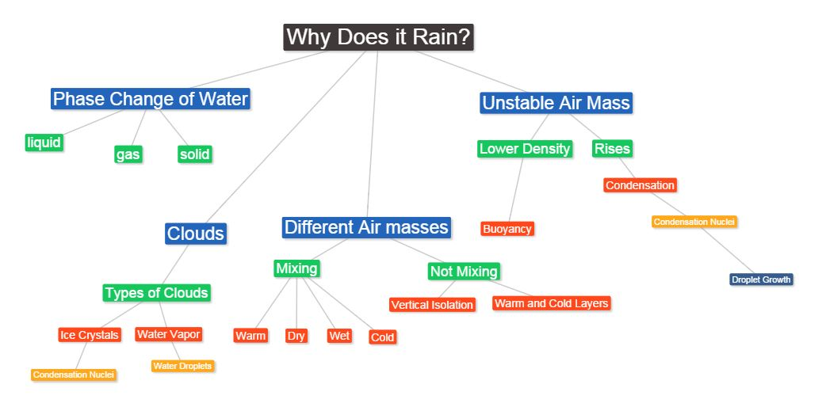

Synthesis Questions (based on the scaffolding/concept map):

* What is step sequence needed in air mixing to eventually produce rain?
* What prevents mixing air from producing rain?
* Why is rain highly seasonal in the Willamette Valley?
* What conditions likely produce snowfall and why are those rare in the Willamette Valley?
* What knowledge is needed to accurately predict rainfall?

Data-Driven, Project-Based Pedagogy With Examples:

To blend content and pedagogy in PD, ICLSS incorporates research-based *data-centered inquiry* in its courses and activities, modeling pedagogy in which *student learning is driven by the investigation and analysis of authentic observations and data* (Bothun, 2003). Data-centered inquiry differs from the “scientific method” in that the student will articulate, test, and reconstruct their possibly flawed conceptual models using real data and observations. ICLSS will use data-driven inquiry to target central yet difficult concepts necessary for understanding climate change Participant teachers will learn how climate change models have evolved by engaging in a series of data-driven projects and activities.

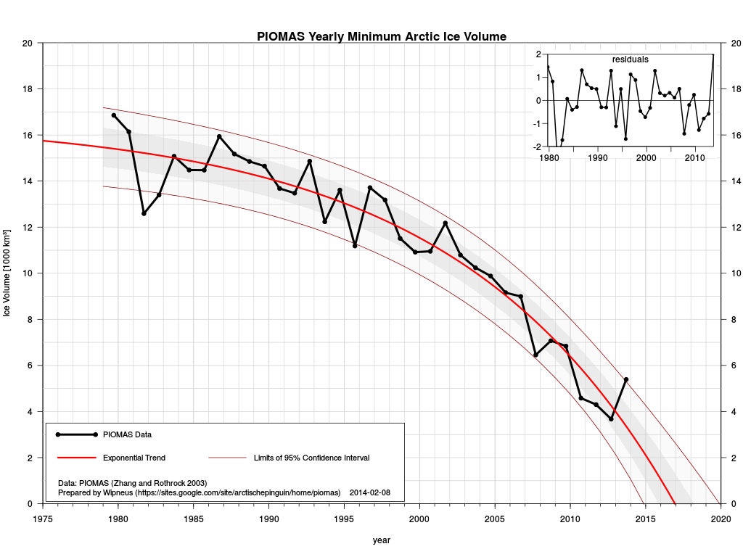Studies have suggested or directly shown that data-driven learning is an effective pedagogy that requires the application of scientific thinking to authentic, ambiguous data (Blumenfield, Krajcik, & Tal, 2006; Baker & White, 2003; Bednarz, 2000). Such exercises also lend themselves readily to collaborative, active work and a high perceived relevance of content, improving the learning and retention of science concepts (Kucharski, et al, 2005). Our data-driven pedagogical approach is consistent with recent developments in curriculum reform, aimed at the integration of science, technology, and mathematics as they relate to the real world (Yager, 2004). Maximum effectiveness occurs when scientific analysis and reasoning fits within a societal context that is meaningful to today’s student. The theme of climate change driving by resource consumption is the context of today’s student generation. Indeed, a smoking gun of climate change may have now emerged in terms of analysis of the rapid rate of Arctic Sea Ice loss (see Figure 2) and the very real possibility that the Arctic Ocean will become ice free within the next few years (!) thus, through significant albedo changes, altering the entire energy balance of the planet. One of the data driven activities will be to reconstruct this frightening curve showing the accelerating rate of loss (starting around 2007) and to emphasize the various uncertainties in the future projections.

Figure 2 The Rapid Decline of Arctic Sea Ice

Another important aspect of our PD approach is to provide tool to participant teachers to allow them to visualize and analyze data. Through the training of the use of those tools, teachers in turn can design data exercises for their students. The “Monthly Climate Visualizer” (see Fig 3), which incorporates any data set that contains the high/low temperature and precipitation data for individual days. This interface allows teachers to interrogate the data either on a monthly or annual basis. Smoothing and averaging algorithms are built in so that students can construct smooth decadal averages to search for signatures of climate change.

In order to better introduce teaches to weather data, sampling and analysis, we plan to purchase several Davis Instruments weather link stations so that each school district can make record their local daily weather. An example interface to a Davis weather link station can be found at <http://supercow.uoregon.edu/~uoweather> . After one year’s worth of data gathering, students can then analyze that data and define, by the data, the “climate baseline” for that particular school. The next year’s class of students can then determine if that defined local “baseline” has changed in a systematic error or whether or not the noise/variability in the system overwhelms any climate change signature.

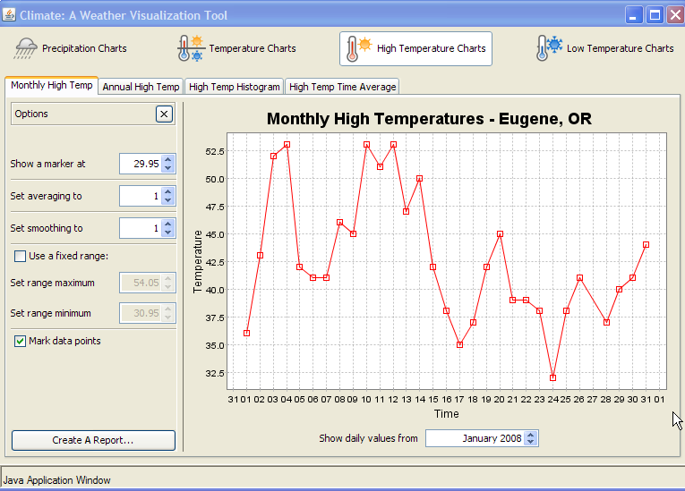

Figure 3: Monthly Climate Visualizer

A final example of available climate data tools has recently been produced by the State of California (<http://cal-adapt.org/tools/>). An assignment given in an undergraduate class can easily be modified for the PD workshops for the explicit purpose of telling a story based on the extensive climate data at this web site. Specifically the assignment reads as follows:

*Write a newspaper style article to communicate the risks of climate change in California in three separate locations - the Eureka area, the Sacramento area and the San Diego area. Your article is limited to 800 words but you can use as many graphics as you like. Under the climate tools section are five threats listed (temperature, snow pack, precipitation, sea level rise and wildfires). For each of the three areas you are to write about and show the two most serious threats as evidence by the various maps that you can make using this tool.*

|  |  |
| --- | --- |
|  |  |

Course material and exercises will also make significant use of Google Earth (to study the potential impacts of rising sea level as well as other scenarios) as well as the rich image data sets such as those available at NASA’s *Earth Observatory***.**  A consistent theme in all of our PD workshops is the use of computer-based tools to facilitate data operations and analysis on relatively large data sets. Baker and White (2003), in the case of GIS, have demonstrated a positive influence on learning ability when visual maps or graphs can be generated electronically to represent various forms of environmental data.

Examples of some ON line data sets, models and simulations that will be used as part of the curriculum foundation for coursework are summarized in Table 1:

**Table 1: ICLSS ON Line Course Resources**

|  |  |
| --- | --- |
| Resource URL | Material relative to Planned Course Work |
| http://gcmd.nasa.gov/ | * General Resource Data base – RIMFROST data base will be used for various climate data exercises |
| http://earthobservatory.nasa.gov/ | * Various white papers; satellite data bases on ice loss and deforestation |
| http://www.climatescience.gov | * Repository of white papers that deal with methane and the general issue of methane hydrates |
| http://www.ncdc.noaa.gov/ | * Best resource for US state, regional and national climate data |
| http://www.purdue.edu/eas/carbon/vulcan/ | * Project VULCAN: monitoring and visualizations of National * output of carbon dioxide – very informative |
| http://visibleearth.nasa.gov/ | * Repository of water vapor measurements in our Atmosphere- relevant to the water vapor feedback lop |
| http://flood.firetree.net/ | * Sea Level rise simulator interface to Google Maps ; elevation overlays from NASA data |
| http://ghgdata.epa.gov/ghgp/main.do | * Sources of all GHG emission (including methane and other trace emission) in the US. |
| http://www.wrcc.dri.edu/ | * All kinds of climate data for the American West (relevant to the location of this Project) |
| http://www.wcc.nrcs.usda.gov/reports/ | * Oregon SNOTEL Snow/Precipitation Update Report (used for stream flow predictions ) |
| http://or.water.usgs.gov/realtime_map.html | * Real-time stream flows in Oregon (mostly low at the time of this proposal submission) |

Earth Systems Science: Gateway Knowledge for Climate Change Literacy:

One important finding of our past professional projects (see below) that strongly informs ICLSS was the identification of considerable deficiency in teacher knowledge in the general area of Earth Systems Science (ESS). This is hardly a surprise; much of the necessary foundational material in ESS didn’t even exist in college 10-20 years ago when most participant teachers were trained. As ESS becomes increasingly important as a conduit for understanding global climate change, it becomes imperative that teachers be well trained in ESS through exposure to the wealth of data resources that are now available (see Table 1) that are currently contributing to our understanding of ESS.

Knowledge of the various pathways in which the Earth systems are all connected is critical to understanding climate change. The existence of feedback channels (positive and negative) within the overall climate system are som e of climate change’s most important physical drivers, but **teacher knowledge of the role of these feedback systems has proved to be virtually non-existent.** The lack of recognition of the connectivity of ESS processes became evident during the previous WPS project when teacher teams were assigned an earth systems analysis project. The purpose of the analysis is to sketch some of the ways “events” both natural (e.g. forest fire, flood, windstorm, volcanic activity, tsunamis, etc) or man-made (e.g. Columbia River Dredging ;) has upon the various earth system spheres (e.g. atmosphere, lithosphere, hydrosphere, and biosphere). The analyses done by teachers tended to show only the simple, direct causal connections between the given event and the four spheres, treating earth systems in isolation from each other (see Fig 7).

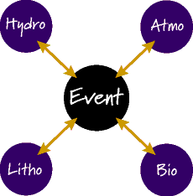

Figure 7: Simple Event-System Interactions

Clearly, in a complex system such as the Earth, multiple pathways exist. Figure 8 represents a more complete set of connections that the event ultimately triggers. Our experience, however, is that K-12 teachers have great difficulty conceptualizing these pathways, let alone identifying the physical drivers behind the pathways**. In a similar way, the linkage between these pathways and global climate change also follows many routes; a central goal of our approach to this subject is to reveal some of these routes**. In particular, it becomes important to discuss the role of **methane** in global climate change in terms of these various routes and feedback channels. Increased literacy in climate change, therefore, can be represented by helping teachers transition their concept of linkage away from Figure 7 and towards Figure 8.

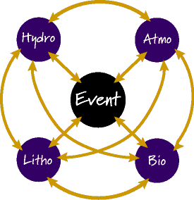

Figure 8: Complex interactions between and among systems

Climate Change Curriculum Framework:

Much of ICLSS course content originates with the wealth of undergraduate curriculum material on both global climate change and global energy production that the PI has produced over the last 5 years. This course content is consistent with the Climate Literacy Framework set out by the National Oceanic and Atmospheric Administration and the National Science Foundation. It is also intended to introduce the science that underlies much of the policy recommendations; for instance the World Bank report (2013) which concludes:

*“A 4-degree warmer world can, and must be, avoided – we need to hold warming below 2 degrees. Lack of action on climate change threatens to make the world our children inherit a completely different world than we are living in today.* C*limate change is one of the single biggest challenges facing development, and we need to assume the moral responsibility to take action on behalf of future generations, especially the poorest.”*

This report is noteworthy in that it directly acknowledges that we have missed the 2°C window and now must mitigate now to avoid 4°C.

ICLSS PD and curriculum development addresses four *essential questions* of climate change:

1. *What are the physical drivers of the climate system and the dynamics by which they are maintained or altered?* Teachers will learn about jet streams, ocean currents and the various known interaction mechanisms. Short-term fluctuations such as El Nino and La Nina will play a major role in this discussion, as they are well-documented agents of change in altering major climate patterns.
2. *How is data used to measure regional climate and to detect regional climate variations*? Participant teachers will learn how to retrieve extant climate data, how to visualize it, and how to use it to define a given climate in a physically defensible manner. Presently, most teachers (and other policy makers) simply teach the “fact” that climate change is occurring. In order to make physical sense of climate change, teachers will learn to define a regional climate, using data resources (as well as their own school instrumentation) to show that the defined climate has actually changed. Since climate data is generally noisy, it is ultimately ambiguous and the same data set may be used to support multiple points of view. One of the main indicators of climate change literacy is the ability to recognize what conclusions the relevant data can and cannot support. **The intrinsic nature of climate data offers an excellent opportunity to improve teacher’s understanding of science as an uncertain process**.
3. *How are climate and climate shifts often driven by processes that operate for decades*? Decadal changes (e.g. the PDO or the AMO) are now well defined by data, but their origins remain a significant puzzle. However, the existence of these climate cycles is very important in terms of choosing a baseline climate if one wishes to assess whether or not climate change has occurred. Indeed, the very existence of these long term fluctuations suggests that there is no representative time period in which one can define an “average climate”.
4. *What are the exchange processes between the atmosphere and the ocean, the ocean and the land, and the land and the atmosphere*? The rates of exchange of these processes are determined by planetary energy balance considerations. The basic effect of human activities on climate is to alter these rates of exchange thus taking the system out of a state of equilibrium to a more unstable state or volatile state. An example is provided by various carbon-transforming processes in socio-ecological systems at multiple scales, including cellular and organismal metabolism, ecosystem energetics and carbon cycling, carbon sequestration, and combustion of fossil fuels.  These processes: (a) create organic carbon (photosynthesis), (b) transform organic carbon (biosynthesis, digestion, food webs, carbon sequestration), and (c) oxidize organic carbon (cellular respiration, combustion).  The primary cause of global climate change is the current worldwide imbalance among these processes and their natural rates of exchange.

These essential questions are all effectively explored through data and the central pedagogical goal of ICLSS is to train teachers to effectively understand how to manage the inherent uncertainty in climate data in order to reach a trustworthy scientific conclusion. Achieving this goal, for us, is the manifestation of achieving environmental literacy.

Professional Development Model

Our overall PD model is schematically represented below as Figure 9:

Classroom Co-Teaching Partnerships

On-Site Mini-Institutes and Online Coursework

PROGRAM EVALUATION

*Resources and Data Sets*

Teacher Climate Change Literacy

Data-Driven Inquiry

Student Learning

Teacher Leadership

NOAA Oregon Climate Change Education Institute

Figure 9: ICLSS Professional Development Model

ICLSS builds on *Woodburn STEM Partnership* (WSP), a successful two-year (2010-2012) ESEA Title IIA University School Partnership (<https://sites.google.com/site/woodburnstempartnership/>), and *North Coast Teachers Touching the Sky* (NCTTS), a successful three-year (2005-2008) ESEA Title IIB Math/Science Partnership. The PI and Co-I delivered these comprehensive professional development (PD) programs to seven rural, high-poverty, high minority Oregon school districts, and serving over 80 teachers with 200+ hours of content coursework, field experiences, in-classroom mentoring, and co-teaching. Both programs trained school-based teams of K-12 teachers to better utilize inquiry-based science instruction models within a comprehensive earth and space science curriculum. Activities included two week-long summer fieldwork institutes, a series of on-site Friday-Saturday mini-institutes during the school year, and hands-on mentoring and observation of participant teachers in their classrooms. The successful outcomes of these programs has enabled the development of a robust and abiding partnership between PI Bothun and Co-PI Carr, their respective institutions, and the teaching and administrative staff of a number of high-needs, partner school districts.

A primary reason for the success of NCTTS/WSP was that each cadre of teachers (numbering from 16-24) was continuously involved with the project for 12 months instead of just attending “one-off” workshops without intensive follow-up support. This allowed for significant contact time, leading to mentoring relationships characterized by trust and the ability take pedagogical risks in the classroom in order to increase student learning. While intense PD of this kind comes somewhat at the expense of simply “exposing” large numbers of teachers to material, our prior experience shows that “one-off” workshops delivered to more teachers is a very ineffective strategy if the goal is to transform classroom curriculum. Research agrees that “one-shot” workshop approach to transmitting educational innovation has been largely ineffective (see Desimone, Smith & Ueno, 2006; Meyer & Barufaldi, 2003). In contrast, through the use of the annual cadre model, we are able to enhance teacher core content knowledge, build the capacity for inquiry-based science teaching, and develop teacher leadership for sustainable and meaningful action in schools. This articulated approach between content knowledge, content pedagogy, and a focus on teacher leadership leads to powerful and coherent teacher PD (Penuel, et al, 2007). D2CLI delivers an interlocking set of PD activities designed to sustain learning through a full school year and provide hands-on support in classrooms.

Classroom Co-Teaching Partnerships: The ultimate goal of PD is to improve student learning by increasing teacher core content knowledge and pedagogical skills. Lessons learned from NCTTS (2005-2008) prompted us to adopt in WPS (2010-2012) *classroom co-teaching partnerships* (CTP –see Roth and Tobin 2002), a strategy which we plan to continue under D2CLI. In this approach, scientists and researchers work alongside classroom teachers *in situ* (Henderson, Beach & Famaino, 2006). Each classroom co-teaching partnership will consist of four teachers representing a cross section of grade levels and STEM subjects, associated building administrators, and one project senior staff member. Each partnership will

* Engage in the development of eight data-rich climate change activities, lessons, or units (two per teacher),
* Co-teach, as a group, each activity in the classroom for which it was designed,
* Engage in reflective post-teaching dialogue,
* Conduct practical research by collecting, analyzing, and interpreting data sets documenting classroom implementation. Local weather data as gathered at their local Davis instrument site will be part of this analysis.
* Participate in some field data collection exercises. One example will be to use high quality flow meters to measure local river flow in various locations along a watershed at various times of year so that the teachers can construct their own stream flow models and then use this as a field curriculum activity for their students.

Work Plan and Timeline

The timeline below assumes a funding cycle beginning 1 Oct 2013; work will begin as soon as project is approved, giving ample time to plan and deliver the initial summer institute, the *Oregon Global Climate Change Education Summit*. We will use a generative process in developing further project components; informed by continual ongoing analysis of formative assessment data collected at all D2CLI activities (see Table 2).

Table 2: D2CLI Work Plan and Timeline

|  |  |
| --- | --- |
| Timeframe | Activities |
| Oct 1 2013-Apr 1 2014 | * Hold planning meeting and finalize institute design structure and content * Hold information meetings at district sites * Recruit initial cohort of 24 participants in school-based teams including a minimum of 3 teachers and 1 building or district-level administrator. * Develop and deliver pre-institute ON line course material * Recruit teachers for the following years workshop in the Portland/Vancouver area |
| June 2014 | * Hold *NOAA Global Climate Change Education Summit* at Pacific University Campus in Forest Grove, OR. 40 hour face-to-face course held in intensive 5-day format. Participants earn 3 quarter-hours credit. * Collect and analyze pre-assessment data. |
| Oct-Dec 2014 | * Deliver top participants second 3 quarter-hour hybrid course (online plus two Friday/Saturday mini-institutes) focusing on energy generation and the integration of climate science and energy production. * Initiate classroom co-teaching teams in participant schools. |
| Jan-Mar 2015 | * Deliver third 3 quarter-hour hybrid course (online plus two Friday/Saturday mini-institutes) focusing on the analysis and representation of climate data, computer related data analysis and the construction of data sets and exercises for students * Continue to develop classroom co-teaching teams in participant schools. |
| Apr– May 2015 | * Classroom co-teaching teams implement climate change lessons in schools * Presentation of concept map capstone projects * Summative assessment * Analysis of assessment data reflection, revision of practices |
| June 2015 | * Deliver fourth 3 quarter-hour course as a 30 hour capstone Atmospheric Institute, launching and recovering high-altitude balloons with participant-built payload packages. |
| July 2015 | * Select/recruit master teachers from D2CLI program completers for participation in new yearly cycle. * Expand program in include additional South Metro Salem STEM Education Partnership districts, and districts in Portland and SW Washington region. * Start next cycle with similar calendar as above but start next summer institute in August 2015 |

Activities: The D2CLI program will begin with the *NOAA Oregon Global Climate Change Education Summit* (NOAA GCCES)a five-day intense summer institute held at Pacific University in Forest Grove, OR, located 1-2 hour drive from partner districts. NOAA GCCES will be publicized as a significant campus and community event including public demonstrations and talks related to climate change aimed at pre-service teachers and undergraduate students. Each day will consist of a morning and afternoon session of instruction and activities using university classroom, lab, and computer resources. Participants will be provided food and refreshments, and will have the option of lodging on campus. Activity will continue during the school year in a series of four *Climate Change Mini-Institutes*, held as Friday evening dinner meetings/Saturday workshops in school district facilities. The mini-institutes will be publicized locally and the work of teachers featured in local press outlets (which always improves morale). Learning will be sustained flexibly with online activities and exercises between the mini-institutes. This model was the operational and highly effective cornerstone of the previous professional developments.

Classroom impact will be ensured by creating at each school site a *Co-Teaching Partnership* (CTP), consisting of participant teachers, the building principal, and a D2CLI scientist (PI and/or co-PI). The partnerships will develop and co-teach D2CLI lessons and units. The goal is that all partners will be significantly involved in “live” teaching of climate literacy curriculum and in post-lesson dialogue and analysis of student learning. Through a variety of co-teaching situations, all stakeholders will directly learn how professional development must be adapted, modified, or even radically rethought in order to be successfully carried out in unique school and classroom contexts. D2CLI scientists will engage in a minimum of three co-teaching sessions at participant schools. Co-teaching teams will be provided with modest funds to support class release time for planning and dialogue.

Participant Teacher Compensation: Teachers respond positively to being treated as professionals, and adequate compensation for out-of-contract time spent in PD. Our prior experience in NCTTS/WSP revealed the critical role of this compensation in producing results as well as enthusiasm for process participation. D2CLI will compensate participant teachers $1500, divided into three $500 payments tied to completion of program requirements. This sum compares well with other high-quality professional development programs in our state, some of which compensate teachers at up to $3000 per year. Participants will also earn UO graduate level credit for each completed workshop through the UO’s continuing education program. Each mini-workshop and associated ON line content will count for 3 credits of continuing education at the “masters” level.

Partnership Experience & Sustainability

D2CLI partners Bothun and Carr have substantial experience delivering sustained, collaborative professional development over the past several years, sustaining work even in the absence of a funded project. Examples of prior professional development projects involving D2CLI partners include *North Coast Teachers Touching the Sky (NCTTS)* an ESEA Title IIB MSP Grant, serving 48 K-12 teachers along Oregon’s North Coast from Nestucca to Astoria. During the three-year project, NCTTS developed a robust and valid evaluation model for assessing teacher content knowledge, classroom implementation of inquiry-based teaching, and student learning outcomes. NCTTS was noted by external evaluators for its high coherency and impact on participating teachers (Northwest Regional Education Lab, 2008). Partners are currently active with Tillamook SD and other school districts around the state as consultants on infusing service learning projects with STEM literacy development.

D2CLI Co-PI Dr. Kevin Carr (Ph. D., Science Education, M.S., Physics) will assume lead responsibility for developing and delivering instruction in data-driven pedagogy, and in developing co-teaching partnerships. Carr is a state leader in science teacher professional development, is an internationally recognized expert in conducting teacher research in K-12 schools (Kalmbach-Phillips & Carr, 2010), and teaches courses in project-based learning in environmental settings. Dr. Carr currently directs the *Pacific NSF Robert Noyce Scholarship Program* (2009-2014) embedded in Woodburn School District, and, along with D2CLI Co-PI Dr. Greg Bothun (Ph.D, Astrophysics) and Woodburn School District, directed a U.S Department of Education’s Title IIA Teacher Improvement PD program (2010-2012). Carr and Bothun, through a number of funded programs over the past ten years, have delivered to K-12 teachers extensive professional development programs in space/earth sciences and engineering design, impacting thousands of Oregon children.

Management Team: Dr. Greg Bothun (PI) will assume lead responsibility for developing and delivering D2CLI climate change curricula and digital tools. Dr. Bothun has been involved in K-12 teacher professional development since 1990. He is the director of the Pine Mountain Observatory and oversees a large in-state K12 visitation program that is done in conjunction with the *Friends of Pine Mountain Observatory* – a group of local amateurs that help to support the educational outreach mission of the observatory. Dr. Bothun has also developed an extensive series of physics/astronomy/earth system science JAVA/FLASH based visualizations, simulations and virtual experiments to serve as important aids in both data- and inquiry-driven curriculum (see http://homework.uoregon.edu/demo/). Dr. Bothun recently chaired a national conference on how improving computing infrastructure can lead to breakthroughs in various forms of renewable energy – (see <http://www.sc.doe.gov/ascr/WorkshopsConferences/CRNARE.html>) and has recently begun a large scale investigation into regional climate change in the Pacific Northwest and well as the Northeastern United States using a new statistical method of climate indexing.

Sustainability: Our past projects have been sustained by adhering to two specific principles: First, we include district superintendents and principals as active partners, not only assisting in teacher recruitment and support, but as active participants alongside teachers in selected activities. Second, we select school-based teacher teams who will mutually support each another in enacting innovative content, tools, and pedagogy into their own curriculum. D2CLI will create co-teaching partnerships, which will bring D2CLI scientists and researchers into the classroom with participants, working together for student learning. We anticipate that the relationships formed during the development of co-teaching partnerships will result in deep and transformative change for all partners in a similar manner as occurred in the previous NCTTS program. In addition, video and other resources that define the ON line courses can continue to be offered throughout the State of Oregon via the South Metro Salem STEM Education Partnership.

Evaluation

D2CLI will carry out a rigorous and comprehensive program evaluation with assistance from project partner Education Northwest (Formerly Northwest Regional Education Laboratory). Education Northwest (EN) provides research and development assistance to education, government, business, and labor as part of a national network of 10 educational laboratories funded by the U.S. Department of Education, Institute of Education Sciences (IES).

Instruments and Design

D2CLI will perform a rigorous analysis of project impact on teacher content knowledge, classroom practices and student learning. D2CLI has selected instruments and analysis procedures appropriate to a mixed-methods experimental design (see Table 3). D2CLI will implement a pre- post-test design to evaluate changes in teacher climate change literacy, and to better understand participant knowledge and misconceptions on the general topic the greenhouse effect, global climate change, and world energy use. Impact on classroom practice will be assessed during the project using the Reformed Teaching Observation Protocol (Pilburn et al, 2000). The *RTOP* details for each participant a composite measure of multiple aspects of lesson design and implementation, content taught and classroom culture. Careful training of evaluators is required for effective implementation of *RTOP*. D2CLI partners have used the RTOP for several years and have established staff inter-rater reliability.

Deliverables

EN will coordinate the compilation of annual project reports to NOAA. In addition, project investigators will work with project data to disseminate project learning and outcomes to the broader climate science education community via a web site dedicated to this project.

Table 4: D2CLI Evaluation Plan Aligns to NOAA Education Outcomes and Project Goals

|  |  |  |  |
| --- | --- | --- | --- |
| Objective | D2CLI Goals | Instrument(s) | Analysis Method |
| 1. Provide professional development opportunities to educators that results in deeper content understanding and confidence in teaching climate change and data literacy to their students | 1(a). Increase teacher climate change and earth systems science literacy | Climate Change Literacy Instrument (D2CLI-developed) | Pre-Post Comparison |
| 1(b). Improve teacher access to NOAA climate change and earth systems science resources | Field notes  Interviews | Open-coded for category access to resources |
| 2. Provide K-12 students with authentic first-hand opportunities use NOAA data and assets, thus inspiring interest in STEM disciplines and careers. | 2 (a). Encourage pedagogical innovation and (b) transform classroom practice | Field notes  Interviews  RTOP  Video Taping | Formative comparisons as project progresses |
| 2 (c). Increase the number of middle and high school students using NOAA data and educational assets. | Field notes  Interviews  RTOP | Formative comparisons as project progresses |

In sum, D2CLI will offer a comprehensive, interdisciplinary, PD program consisting of an *intensive one-week summer institute* followed up with *school year mini-institutes* delivered in a hybrid format, along with *classroom co-teaching partnerships*, an innovative strategy in which scientists and teachers work side-by-side in the classroom. Training and pedagogy will center on several different data-driven exercises involving climate data analysis, which will make heavy use of NOAA climate data and ESS resources. The expected outcomes are a) significant increases in teacher core content knowledge and competency to impart that knowledge, b) the development of a suite of data-driven exercises to enable students to better engage in evidence-based decision making and c) to vastly improve the environmental literacy of the current generation of K12 students.

|  |
| --- |
|  |
|  |  |
|  |  |
|  |  |
|  |  |
|  |  |
|  |  |

. For example, most teachers (and hence there students) think of the atmosphere as a simple “blanket,” and they apply this model when considering the effect of greenhouse gases. The “blanket” model, while somewhat useful, is insufficient to properly understand the physical interaction of solar radiation, atmospheric constituents, and terrestrial albedo in driving average global temperatures.

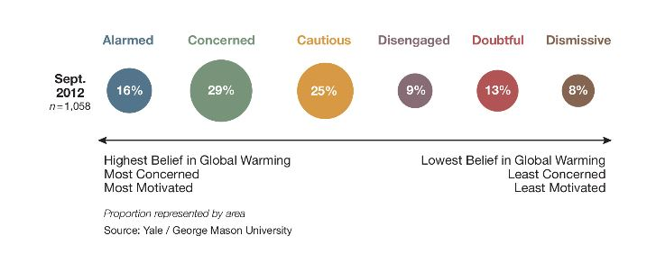 A Pew Research Survey released July 9, 2009 estimates that while 84% of AAAS member scientists “think that the earth is getting warmer due to human activity,” only 49% of the public agrees. While changes in public opinion about issues often lag behind advancing science, the consequences of continued climate change illiteracy are especially dire. We are now faced with alarming fact that public opinion about climate change is much more strongly correlated with political and ideological affiliation than level of education (Pew Research Center for People and the Press, 2009). Similar results were also found in the 2009 report by the Yale University project (<http://www.americanprogress.org/issues/2009/05/6americas.html>) who found a general complacency among the US population on both issues of climate change and energy generation. A Sept 2012 update (Leiserowitz etal 2012) has shown a positive trend in that the percentage of Americans that are now “concerned” about climate change has risen and those that were “dismissive” has lowered. The Sept 12 update in terms of the current 6americas is shown in Figure 1. The reasons for this improvement are not clear but it’s likely that various extreme weather events that have occurred over the last 3 years have had some effect. Indeed, in the March 8 2013 issue of Science, Marcott etal, provide some of the most compelling evidenced-based arguments that over the last 11,000 years we are currently in an unprecedented rate of warming.

Figure

The next few years frame a critical window for climate literacy education and subsequent change of consumer behavior. In Nov 2012, President Obama held a televised news conference in which he stated: “*I am a firm believer that climate change is real and impacted by human behavior. As a consequence, I think we’ve got an obligation to future generations to do something about it.*” Coupling this statement with Obama’s various STEM initiatives is now providing a favorable window for significantly increasing STEM literacy and practices in many areas of environmental literacy.

From previous PD workshops we know that a pretest question on the origin of the greenhouse effect often produces this kind of teacher response: “*The CO2 in the atmosphere reflects back heat emitted by the ground, like a blanket reflects back heat from my body*.” One of the key science misconceptions in this statement is the word “reflect”. To then counter this misconception, the teachers are supplied wavelength-dependent transmission data of atmospheric gases such as H2O, CO2, and CH4 which they represent using graphical software. In turn, this leads to understanding that atmospheric gases, at certain wavelengths, absorb the infrared flux from the blackbody radiation of the Earth and then re-emit a portion of that absorbed flux back to the surface, thus elevating surface temperatures. By testing initial conceptions (e.g. the blanket concept) against data, participant teachers learn not only an improved model for understanding

Objectives and Methods

1. Year 1-2: DASLI will engage in design research to produce a suite of tested curriculum resources, models, and tools (RMTs) to accelerate the data and scientific language literacy of English Language Learners (ELLs).

* A Design Research Team (DRT) will be recruited, consisting of four WSD science teachers, a DASLI scientist, and a DASLI linguist.
* The DRT will adapt and extend existing DRK-12 products to develop prototype RMTs to support teacher development of data and language driven instruction.
* Pre- and In-Service teacher participants will implement prototype RMTs to develop and deliver demonstration lesson sequences in live classrooms, collecting evaluation data including measurements of student data and language literacy, video records of instruction.
* DRTs will analyze and evaluate demonstration lesson data using tools adapted specifically to focus on data and language literacy development, leading to the refinement of RMTs.

1. Year 3: DASLI will further refine and deploy RMTs through the South Metro-Salem STEM Partnership (SMSP) school districts and as an Open Educational Resource (OER).
2. Research and Development Design

“Science literacy” has traditionally been defined with two different meanings; one concerned mainly the mastery of science content (Impey, 2012), and the other with the acquisition of scientific communication skills (Anders, 2012; Webb, 2010). Science education has traditionally emphasized the first meaning. Research at the intersection of science education and language literacy now suggests that content and language learning are most likely driven by one another (Anders, 2012; Webb, 2010; Snow, 2010; Gee, 2009), and that ELLs benefit from explicit instruction in the specialized vocabulary and language forms of science. In addition, science literacy also involves the synthesis dimension where multiple sources of data, opinion, speculation, prediction need to be aggregated together and critically evaluated so that a consistent scientific narrative results.

Evidence-based argumentation is particularly challenging for ELLs, as this type of argumentation entails proficiency in “data literacy” and “data-based arguments,” the ability to interpret and analyze scientific data and discuss the data with proper evidence. Linguistically, this type of argumentation requires students to use complex linguistic structures; ELLs particularly have difficulty with making clear and coherent evidence-based arguments due to their limited language proficiency. For example, in the scientific discourse shown below, based on NGSS expected student proficiencies, ELL students would need a significant degree of linguistic scaffolding in order to create and communicate an evidence-based argument at a high proficiency level (you just described synthesis here).

In this simple example, the Teacher prompts the Student to make a claim about a scientific phenomenon (well maybe, but before all of this one has to introduce the right voculabory, dry, moist, warm, cold, stable, unstable, rising air, condensation, mixing, etc – the student is then asked to synthesize their response in view of this language and how that response is supported by evidence), and to support the claim with evidence and reasoning. The target of instruction, the Proficient Student Response, reveals the complex interfolding of model-based reasoning (using the kinetic model to explain and predict), data literacy (), and complex vocabulary and language forms (cause and effect prediction, supported with evidence and explanation, using specialized academic vocabulary and register). Our research, involving secondary science teachers with a high degree of skill infusing language instruction in their curricula, shows that while ELL students often become proficient at communicating claims and model-based reasoning, they struggle to properly support their claims and reasoning with data and evidence (Digby, 2014).

Data-Literate Language: “Data literacy” is in fact a subset of language literacy, as scientific inquiry and argument goes beyond reviewing and decoding data. In secondary science classes, students are asked to “describe” and “explain” the data using coherent, data-based arguments, which require a high-level of language proficiency beyond understanding science concepts. Observational data of study teachers revealed that while they demonstrated adequate ability to support scientific language learning as part of model-based inquiry instruction, they lacked the curricular tools and models to infuse support for the concepts and language of data literacy (Digby, 2014).

The Typical Student Response above is reflective of the highest performing ELL students in the study. These students proficiently constructed and communicated claims about colliding air masses, but supported those claims not with provided data but with examples drawn from their own experience or from authoritative print materials. ELL student reliance on “unstructured evidence drawn from individual experience” to support claims is indicative of low data literacy (Kastens, 2014). The study found that although students were provided data (in this case maps and weather data) as potential evidence to support their claims about colliding mixing air masses, the curriculum lacked powerful data literacy instruction, and language-rich classroom discourse about the data as well as the main concept of stability.. Study teachers concluded that without deeper instruction in data literacy, ELL students were simply not able to incorporate data-driven support into their arguments.

Data Literacy: Persistent and Pervasive Understandings about Data: Data literacy is hypothesized to build in a developmental progression from (a) unstructured individual observations, to (b) small, student-collected data sets, to (c) professionally collected, large data sets used to solve well-defined problems, to (d) professionally collected, large data sets used to solve ill-defined problems (Kastens, 2014). In the above scientific discourse, students were asked to analyze and apply data level (c) data to their evidence-based arguments. Traditionally, secondary science teachers have been trained to focus students predominantly on level (b) data (small data sets used to solve well-defined problems). With the explosion in accessibility of type (c) and (d) data sets, a new type of data literacy instruction is needed. This explosion also carries with it important components related to data reliability and biases. Teachers need the appropriate tool set to analyze such data in order to avoid treating it like a Black Box that has no errors. This is what distinguishes c,d from b and understanding the role of errors is likely the highest manifestation of scientific literacy,

In order to apply data literate skills to big data (type (c) and (d) data sets), students must have access not only to the data, but also to tools for representation and analysis. In particular, we will experiment with several very robust and relatively easy to use open charting libraries that have extremely high functionality. These include Google Charts (https://developers.google.com/chart/), HighCharts (http://www.highcharts.com), Data Drive Documents (http://d3js.org/), Tableau (http://www.tableausoftware.com/)

Research and Development of Resources, Tools, and Models

In viewing data literacy as a subset of scientific language literacy, DASLI adopts a structure for teaching data-driven argumentation skills that enfolds multiple literacies (see Fig X).

DASLI will design, prototype,

Data-Driven Argumentation

Data Literacy

Scientific Language Literacy

Science Literacy

Fig X: Multiple Literacies in Data-Driven

Argumentation

and implement an innovative

suite of resources, models, and

tools (RMTs) that will enable

locally supported teachers or

groups of teachers to

adapt/redesign, implement, and evaluate current curriculum to infuse language and data literacy instruction. This work will build on prior NSF and DRK-12 work such as Tool Systems to Support Progress toward Expert-Like

Teaching by Early Career Science Educators (DRL- 0822016), SSTELLA (DRL-1316834), and various Education Development Center Oceans of Data Institute projects.

Research Questions:

1. Will infusing into instruction the multiple literacies of language and data accelerate the ability of secondary ELL science students to construct and communicate evidence-based arguments? If so, under what conditions?
2. What resources, models, and tools might effectively enable secondary science teachers to infuse multiple literacies of language and data into instruction? How important is the visual component of data in assiting with these language literacies? (for example, can you just talk about asympotitc behavior without every showing a waveform that reveals it?)
3. How might such resources lead to significant student outcomes given constraints of teacher time and resources?

Resources: DASLI will prototype and implement practical, digital, annotated lesson and unit planning templates that enable teachers to infuse data and language literacy seamlessly into instruction. Initial prototypes are anticipated to address the following elements of lesson design (see Table X):

Models: DASLI will implement and document lesson sequences in which teachers use planning resources to adapt or create data and language-infused curricula. Data collected will include lesson plans, video recordings of classroom discourse, student work, pre- and post- interviews of teachers and students, and observation protocol data generated during instruction (see below).

Tools: DASLI will adapt and extend existing observation protocols to apply to data and language-infused instruction. Specifically, DASLI will base its initial prototype on the Inquiring into Science Instruction Protocol (ISIOP, see http://isiop.edc.org, DRL #0535787 and #0815364), and the ESOL Lesson Observation Report (ELOR, Department of Education #). Both ISIOP and ELOR are comprehensive instructional observation tools suited for either live or video recorded contexts. Both ISIOP and EOLOR focus on teacher verbal practices, key components in developing data and language literacy. DASLI will focus specifically on adapting ISIOP and ELOR to create an observation tool tailored for observing data literacy processes and skills.

Resource Development Process

The goal over the three-year project period is to develop, test, and deploy prototype RMTs both locally, and as an OER.

Year 1: Design, Prototype and Piloting Phase

Year 2: Refinement, Testing, and Evaluation Phase

Year 3: Implementation and Deployment Phase

Resource prototype and apply to developing lessons. Implement lessons. Apply prototype tools.

Refine.

Use in PD with SMSP. Implement.

Refine prototype and demonstrate proof of concept.

Deploy prototypes as OER & through Oceans of Data, CADRE

1. Evaluation or External Review

External Advisory Board consisting of EdNW, WSD, OSU