Astronomy 122 mid Term Exam

Name: __________________________
Please confine your answers to the space provided and make sure to write legibly. Remember to show all work. There are a total of 171 points on this exam. This exam consists of three parts:
- Part 1: 12 Short Questions @3 points each
- Part 2: 7 Medium Answer Questions @5 points each
- Part 3: 10 Longer Answer Questions @10 points each
Part 1: Each Question in this Section is worth 3 points: (36 points total)

- If a 10000 K blackbody has a wavelength of peak emission at 3000 angstroms, what would be the wavelength of peak emission for a blackbody at a temperature of 2500 K?

- If a 1 solar mass main sequence star has a hydrogen burning lifetime of 10¹⁰ years then what would the hydrogen burning lifetime of a 10 solar mass star be?

- Star A has a surface temperature of 20000 degrees (K). Star B has a surface temperature of 10000 degrees (K). Both stars have the same radius. What is the luminosity ratio of Star B to Star A?

- You make parallax measurements of two stars. Star A is observed to have a parallax of 1/8 of an arc second. Star B is observed to have a parallax of 1/2 of an arc second. What the ratio of distance of Star A to Star B?

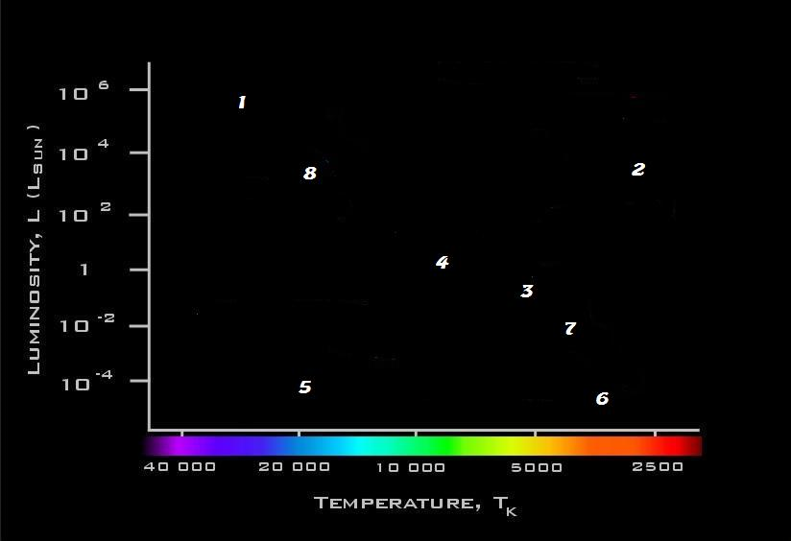

Questions 6 – 10 refer to the above diagram.

- Which star has the highest luminosity?

- Which star has the longest main sequence lifetime?

- Which star is fusing Helium as its primary energy source?

- Which star is now in its last evolutionary phase?

- Which star would appear to be the reddest?

- Which star might be starting its Post Red Giant Phase of evolution?

- Which star would most likely have strong hydrogen absorption lines in its atmosphere?

- Which star is most like our Sun?

Part 2: Each Question in this Section is worth 5 points: (35 points total)
  - Explain why it is difficult to make accurate distance measurements to nearby stars by using ground based telescopes.

  - List two physical characteristics that are common for all main sequence stars, independent of their mass

  - Briefly explain how stellar masses can be determined.

You observe 4 stars in the sky. Their properties are summarized in the table below:
Star | Flux on Detector  (Arbitrary Units) | Distance  (Light Years) | Observed  Color
A | 4 | 2 | Blue
B | 8 | 4 | Red
C | 10 | 4 | Very Blue/White
D | 32 | 1 | Yellow

  - Which of these stars has the coolest surface temperature and how do you know this?

  - What would the flux of Star D be if it were located at a distance of 8 Light Years?

  - What is the ratio of luminosities between Star B and Star A?

  - Shown below are two spectra of real stars. Explain how you can tell which of the stars is the hottest?

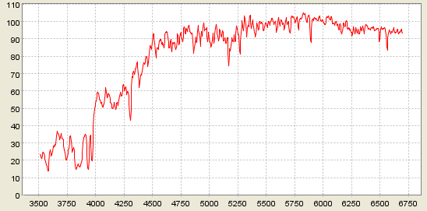
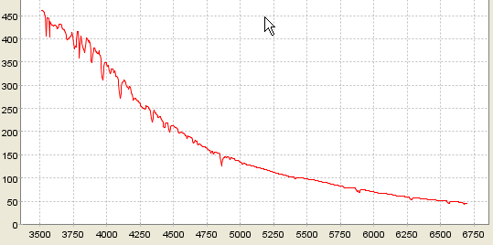

.

Part 3: Each Question in this Section is worth 10 points: (100 points total)


- The above images show two exposures of the same star field. The exposure on the right is 1 seconds, the exposure on the left is 50 second. Explain why you can more easily detect the stars in the 50 second exposure than in the 1 second exposure.

2. Explain how astronomers determine the spectral type of a star

- A simplified atom has 4 energy states in it. The ground state has zero energy, the first excited state has energy = 5 units above the ground state, the second excited state has energy = 8 units above the ground state, and the third excited state has energy 10 units above the ground state.
  - draw a sketch of these energy states
  - If an electron resides in the third excited states, list all possible kinds of photon emission and/or absorption that could be associated with an electron in that energy level

- Explain why the main sequence lifetime of a star is strongly dependent on its mass.

- Circle the correct choice in each triplet option (bold face in parentheses) in the paragraph below:

If the temperature in the core of a star decreases, the pressure in the core would (decrease, remain unchanged, increase). In this case, the pressure will be (less than, the same as, greater than) the gravity. So the core of the star will (contract, not change, expand). As a result the temperature in the core will (decrease, remain unchanged, increase). In this case the rate of energy generation in the core will (decrease, remain unchanged, increase) and the pressure in the core will (decrease, remain unchanged, increase).

- You observe a stellar cluster and make an HR diagram of the stars in it. From that you notice that the most massive star that is still on the main sequence is 2 solar masses. What is the approximate age of this cluster and how is this age determined?

- Explain why low mass stars such as the sun can never produce any elements heavier than Carbon or Oxygen.

- Briefly explain why the luminosity of a star begins to increase as it evolves from the main sequence to the red giant phase of stellar evolution.

- Explain the post main sequence evolutionary process of a star that leads to most of the mass of the star being lost and to the brief appearance of the planetary nebula phase of stellar evolution.

- Explain why, in a randomly selected sample of stars, the most common star that we would expect to find is a low mass main sequence star.

