Environmental Sustainability and Systems Thinking

**In response to Call** "Handbook of Sustainability and Humanities: linking social values, theology and spirituality towards sustainability"

**Purpose: Scientific and Legal Exploration of the Spiritual Value of Earth and its resources as it relates to sustainability**

G.D. **Bothun**, Dept. of Physics, University of Oregon, Eugene Oregon, 97401

R.F. Mann, University of Oregon School of Law 1221 University of Oregon, Eugene, OR 97403-1221

**Abstract:**

Humans are in a necessary physical partnership with nature. Physically, the Earth is a connected feedback system of which human activity is one channel. Since we are part of that system, then harm to nature is harm to humans. Despite this reality, many human cultures have pursued dominance over the Earth’s resources. This dominance is asserted by the mechanical philosophy of Descartes. Under this world view, the Earth is just a (soul-less) machine and man is distinct from nature and therefore entitled to dominate it; the Earth has no spiritual value. So this gives us license to dig up the planet to create the escalating distribution of products to global consumers. The industrial waste heat associated with this domination has now changed the temperature distribution within the oceans, resulting in accelerated global climate change and overall human activity has now taken the system out of equilibrium. To restore equilibrium requires a systems thinking approach that prioritizes human equity, dignity, environmental justice and environmental health over escalating global GDP. In turn the view of the Earth as a resource to exhaust must be supplanted with the view that the Earth is a **sacred** equilibrium system for the welfare of all.

1. Introduction

In this contribution we consider the coupled issues of a) increasing global consumption, b) accelerated climate change, and c) the need for a systems thinking approach to shift consumer values away from GDP based prosperity and towards the more overwhelming need to human equity and overall environmental health. Furthermore, we argue that the Public Trust Doctrine (PTD) should also include resources in the ground so as to extend the current protection of clean water and clean air to future generations so that they still have the ability to use raw materials. Much of our framework lies in the notion that the use of renewable energy sources is far more consistent with the spirit of the PTD than incessantly digging up the ground to enable increased resource usage as if the Earth is infinite in its supply. Living in harmony with nature, with respect to its energy resources, does represent the kind of physical partnership that all species must participate with. In turn, this contributes to the spiritual guideline that the Earth is not a resource to use up as we please, but rather the Earth operates as connected equilibrium system that corrects when it is perturbed. At the heart of this spiritual guideline is the notion of the Sacred. Under this notion the Earth is a scared equilibrium system that promotes the welfare of all. This last concept is well embodied by two indigenous sayings:

*If we dig precious things from the land, we will invite disaster (Hopi Prophecy)*

*We are all visitors to this time, this place. We are just passing through. Our purpose here is to observe, to learn, to grow, to love, and then we return home. (Aboriginal saying)*

Together, these sayings state that the Earth is a system to protect, not to exploit. Achieving future sustainability will require adhering to the mandate to protect the system and such adherence is completely consistent with the PTD.

We begin by presenting various data related to the rate of both climate change and global consumption in order to a) show how these are linked together in the sense that global consumption is the fundamental drive of climate change via its associated, required, industrialization and b) that the rate of climate change indicates an acceleration to a more volatile climate future and such a future is likely a violation of the PTD. In addition, as we show by data, while efforts on the sustainability front are broad and laudable, in the real world, we are now living at the most unstainable time in history as measured by the consumption of consumer goods. This makes achieving actual sustainability, which is a quantitative result based on reducing per capita consumption, quite difficult as the developing world is gaining increased access to electricity and internet mobility. Clearly, this access should never be denied but the global reality of our consumption and its strong evolution needs to be better accounted for in thinking about the future world. A promising avenue is the concept of “just sustainability” [1]. In this concept, social justice and global equity are the long-term goals of an evolving consumer world. At some point, a priority system based only on economic gain should be replaced so that our collective value system is based on issues of fairness, environmental justice, dignity and global equity. These values are all consistent with the PTD.

In short, we need to living in partnership with nature within ecosystem limits rather than dominating all of nature and ignoring those limits. The current rapid escalation of volatile/extreme climate events is a good signal that the Anthropocene [2] is here and that humans are now a global geophysical force that can dictate how the Earth system behaves. One likely manifestation of this change is the country of Bangladesh. In 1998, Bangladesh had a preview of their likely dismal future as they experienced a severe monsoonal flood, which inundated about 50% of the land area and had very long-term impacts on basic nutrition in that country [3]. As perhaps the best example of a violation of some global PTD, at some point in the likely near future 100% of Bangladesh will be flooded due to rising sea level, storm surge, and catastrophic monsoonal moisture. In essence, the homeland of some 200 million people will be lost – all as a direct result of continued usage of fossil based energy to accelerate global consumption. At that time, conventional crude oil is likely to be an exhausted resource. Thus we have fulfilled the prophecy: we dug all the precious things from the ground and the disaster occurred.

**II. The Data View: Climate change and global consumerism**

In this section we use data to directly argue that the rate of global climate change and the rate of global consumption are both accelerating. We will refer to this acceleration as non-linear change. In general, non-linear growth can be expressed as

Resource Usage  (Population growth) N ; N > 1

For linear change, N =1.

**a) Resource Usage**

For an initial example, we consider the growth of world steel production. In terms of our framework, steel (iron ore + alloy like tin or manganese) would represent a precious thing in the ground and we are clearly digging that up much faster than it can be replaced. The decadal growth of steel since 1960 is shown in Figure 1.

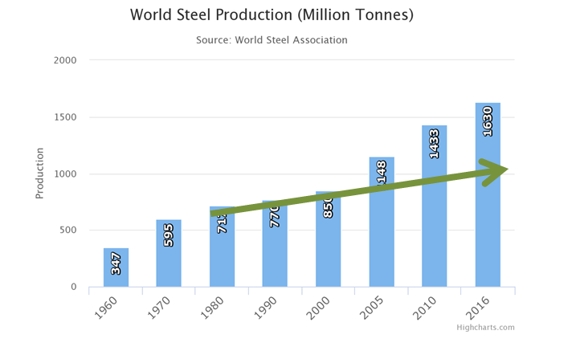

The form of this Figure shows an important theme. The period 1980 to 2000 shows that production can be represented by shallow linear growth (green arrow). However, the world changed primarily due to the emerging global economic power of China, starting around 2003 [4]. The linear prediction based on the previous period clearly under predicts current steel consumption; we will see the same behavior when we examine climate data. The value of N is arrived at as follows: a) over a span of 56 years steel production has increased by a factor of 4.7; b) over this same time population growth has increased by a factor of 2.45. This yields N = 1.75 for this particular case. This means that if the population doubles, the world economy does not simple double its steel output, but rather output increases by 21.75 = 3.6 times more steel. Thus the change in steel production has accelerated because of its non-linear dependence on population growth.

Most any resource usage conforms to this general non-linear dependence between number of consumers (proxy by population growth) and actual usage. Some other examples are: over the period of 1985—2015 N for soy production was 4.5 (doubling the population requires the production of 23 times more soy); over the period 1950—2015 N for fertilizer production was approximately 2; and over the period 1970 –2015 N for lithium production was about approximately 3.6. These accelerating resource usage rates a) are indicators that we are currently living in the most unstainable time in history, b) “peak” resource is a likely part of our future – for instance Peak phosphorus (fertilizer) is likely to be around 2030 [5,6] c) compromises the ability to deploy these resources in the future; for the case of lithium this directly and strongly impacts future production of EVs [7,8] and d) the non-linear behavior is a direct result of increases in per capita consumption.

In the very real sense, if moving towards a more sustainable means of energy production relies on the availability of certain raw materials (e.g. lithium for batteries, neodymium or dysprosium for magnetic motors on wind turbines, platinum for fuel cell catalysis, tellurium for more efficient solar PV panels) then the lack of these resources available for such a transition to a new energy economy might also constitute a violation of the PTD. Simply put, we have harvested the Earth under a collective value system that started in the Industrial Revolution largely based on the Mechanical Philosophy of Descartes [XX] in which the Earth has no value other than to support humans. Under that philosophy we have harvested about 70% of available Earth resources. As expanded upon in Section III, we clearly need to be much wiser with what remains so as to insure a more sustainable and livable Earth for future generations (e.g. the PTD). In our view, this can only be achieved by abandoning our legacy thinking and embracing the physical reality that we are part of nature and cannot sustain ourselves by rising above its boundaries.

If the perception of the lay public as well as policy makers is that growth is mostly linear (e.g. N=1), then in the real world of accelerating changes, each passing year puts us farther behind our ability to mitigate or adapt to a growing problem. We will refer to this as linear thinking. In terms of systems thinking, the Earth has always behaved as a coupled non-linear system and this behavior has allowed that system to adapt after many strong perturbations (e.g. Ice Ages, Asteroid Impacts, Plate Tectonics) temporarily destroy its equilibrium (and it is likely the Anthropocene is another temporary event). As shown below, we can apply the same linear thinking problem to the real world of accelerated climate change.

**b) Climate Change**

For the case of climate change we can use the observed concentration of atmospheric CO2 (in units of ppm) as the input and temperature anomaly (T) as the output to examine non-linear behavior. In figure 2 we plot the decadal average of atmospheric CO2 from the Mauna Loa Observatory which has been making reliable, well-calibrated measurements since 1958 [9] and the solid red line in Figure 2 is the average annual emission over the period 1960-2000 (1.31ppm). Also, the size of the vertical box for each decade represents the observed standard deviation range around the average shown as the blue line. The circle above each rectangle is the maximum of a particular year’s CO2 emission.

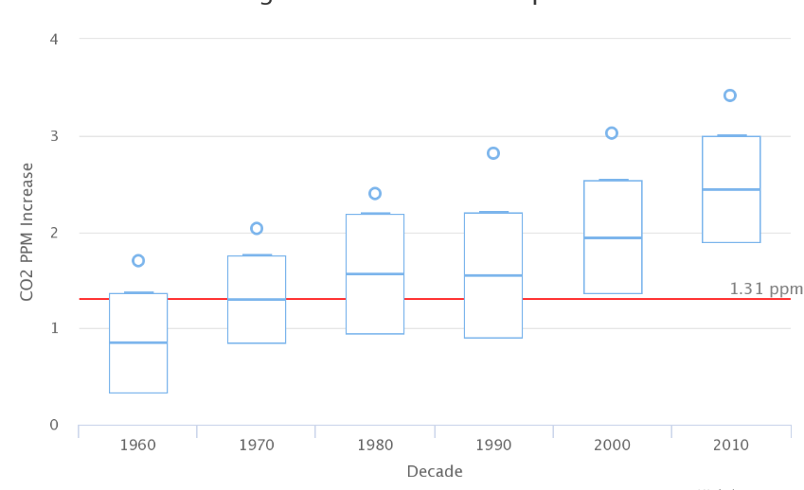

From this figure we can glean a few details:

* The current decadal annual increase in CO2 concentration is 2.43 +/- 0.55 ppm. This is almost twice as large as the 1.31+/- .34 ppm value during the 1960-2000 periods.
* For the current decade (2010), every single year has a larger annual emission than the long term 1960-2000 average of 1.31 ppm.
* The variation around the means for each of the plotted decades is similar. This indicates that while we have not (yet) systematically change the natural variations in the annular CO2 emissions cycle, we have changed the zero-point of that cycle through systematically increased addition of CO2 to the atmosphere.
* 2017 set a record of 3.42 ppm for annual CO2 emission – making it blatantly obvious that emissions have accelerated.

We can next ask if the most recent decade’s emission rate is statistically significantly larger than the previous rates. For the previous 5 decades, the average annual emission rate would be 1.44 +/- 0.40 ppm. This decade’s current value of 2.40 is 2.5 standard deviations larger than the previous decadal value. This has less than a 1% chance of randomly occurring and therefore statistically indicates systematically increasing annual CO2 emissions and a more rapid buildup of atmospheric CO2 . In section 2c below we argue that this build-up is a direct result of increasing global consumption (see Figure 3).

To assess the change in average surface temperature we make use of the most recent data on global land+sea temperature anomalies as provided by NASA Goddard [10]. The use of both land and ocean is a far more sensible approach than just using land based data. For instance, urbanization effects over the period of record are not likely to influence ocean based temperatures compared to the land temperatures. By NASA convention, the measured T values use a baseline of 1951-1980. These data are plotted in Figure 2 where again we show that a linear extension based on the previous rise of T starting in 1980 does not predict the observed change seen over the last 3 years (where 2014, 2015, and 2016 all set successive world records). In this way the data reveal that non-linear changes are now starting to happen to our climate system and the most likely result of that is increasing weather volatility and catastrophic large scale events (such as Hurricane Harvey, the California Wildfires, etc). Indeed, 2017 set a new record for insured financial losses related to Natural Disasters [11].

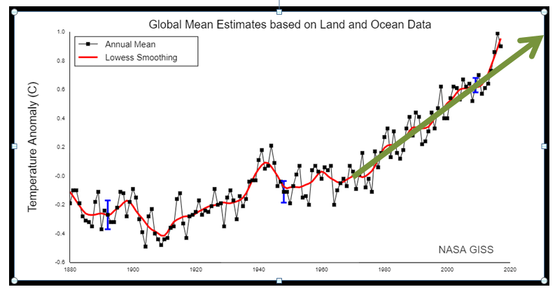

c) The Rise of Global Consumerism

Global consumerism was first born in the USA as post World War II escalating consumer spending was regarded as the best way for the USA to retool its War Time economy toward higher manufacturing to become the dominant economic world power as quickly as possible [12,13,14]. Two important quotes from this period are illustrative of this approach and its effect on American consumer culture and the subsequent throw-away society [15,16]

*Only if we have large demands can we expect large production. Ever-increasing consumption on the part of our people is one of the prim requisites for prosperity. Mass consumption is essential to the success of a system of mass production – Robert Nathan 1944* [17]

*Our enormously productive economy demands that we make consumption our way of life, that we convert the buying and use of goods into rituals, that we seek our spiritual satisfaction and our ego satisfaction in consumption. We want things consumed, burned up, worn out, replaced and discarded at an ever-increasing rate. –Victor Lebow 1955* [18]

This consumer mind set convolved with making America an economic power meant getting goods to market as fast as possible. This mantra has now carried over to a global context, with China now dominating the goods to market infrastructure [19]. This treatment of the Earth as merely a market commodity is about as far away from the sacred as you can get and has led directly to over consumption, ocean heating (see section d below) and global climate change. Amazingly, the world has been able to build infrastructure that has allowed consumer scaling of consumption on the global level. The best proxy for that scaling is commercial shipping traffic.

For the most part, consumer goods are shipped via containers on large container ships. These containers are known as TEUs (20-foot equivalent units). These ships disembark at about 20 major container ports around the world from which the goods are distributed via road, rail or plane. The total energy associated with this process is large and mostly consists of a) the energy associated with extracting the raw resources, b) the energy associated with converting raw resources in to consumer products and c) the integrated transportation of these goods. Remarkably, the global industry has been able to keep up with consumer demand simply by building larger container ships and larger container ports. This explosive growth in capacity is shown in the Figures 4, 5 & 6

We begin with Figure 4 that shows a 10 year ramp up period (2004-2013) for the combined top 10 container handling points in the world (6 are in China, the remaining are in Singapore, Hong Kong, South Korea, and the United Arab Emirates; the largest US port at Los Angeles is rated number 18 and handles 4 times less volume than the world’s largest port at Shanghai) as well as the two top ports themselves. Note that as of 2013, some ports were handling 30 million containers which are about the same as the number of seconds in a year! The global economic meltdown of 2009 is not readily apparent in the total data but can be seen for the two busiest shipping ports as about a 15% reduction in volume handled for that year, from which there was a quick rebound to maintain business as usual (BAU) growth. Indeed, a world that uses resources in a sustainable matter would not have growth which looks like that shown in the following figures. In addition, the overall scaling of with respect to world population growth during this 10-year period is the following:

* World Population grew by 13%
* Total container handling essentially doubled
* Container handling at the two busiest ports also nearly doubled.
* N ~ 5.8 ; at this rate, if the world doubled its population it would use 25.8 or 55 times more resources and it is likely that Earth resources would be exhausted before this point is reached

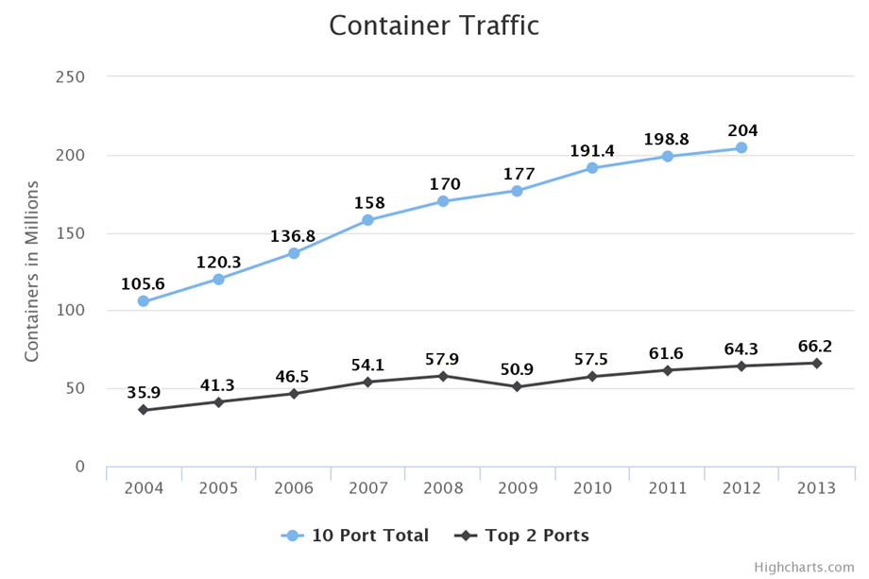.

Next, we consider the tremendous increase in total container traffic volume. Figure 6 shows the data together with a 10% growth curve fitted to the 1990-2008 data. The economic meltdown of 2009 put a temporary halt to this enormous growth curve but the data show a rapid rebound and continued growth now at the level of about 5.5% per year. Perhaps this discontinuity is one of the silver linings associated with the global slowdown.

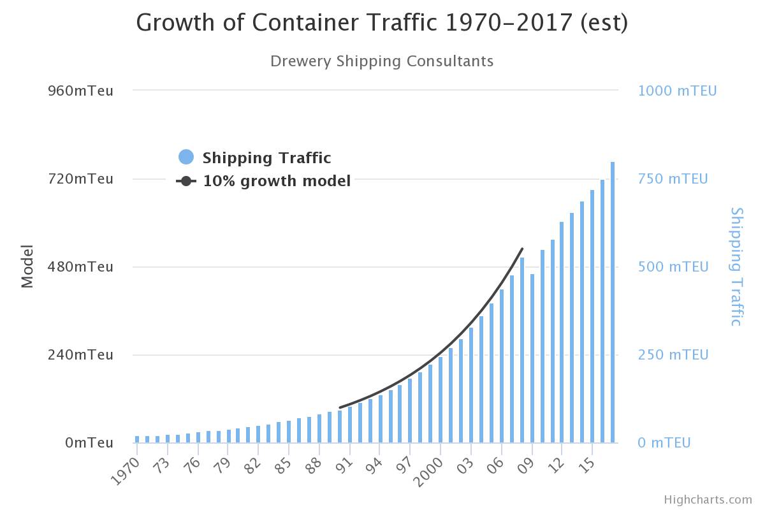

Finally, in figure 6 we show the evolution of the container ship itself. Over the last 50 years, the individual capacity of container ship has grown by approximately a factor of 15. In turn significant growth in container port facilities must also occur to handle this increased discharge of goods. Moreover, the container ships over 18,000 TEUs are generally too big to navigate through the Panama Canal. Altogether, these data reveal our remarkable ability to scale delivery facilities to the escalating global market which maintains the BAU trajectory – let’s do more, faster.

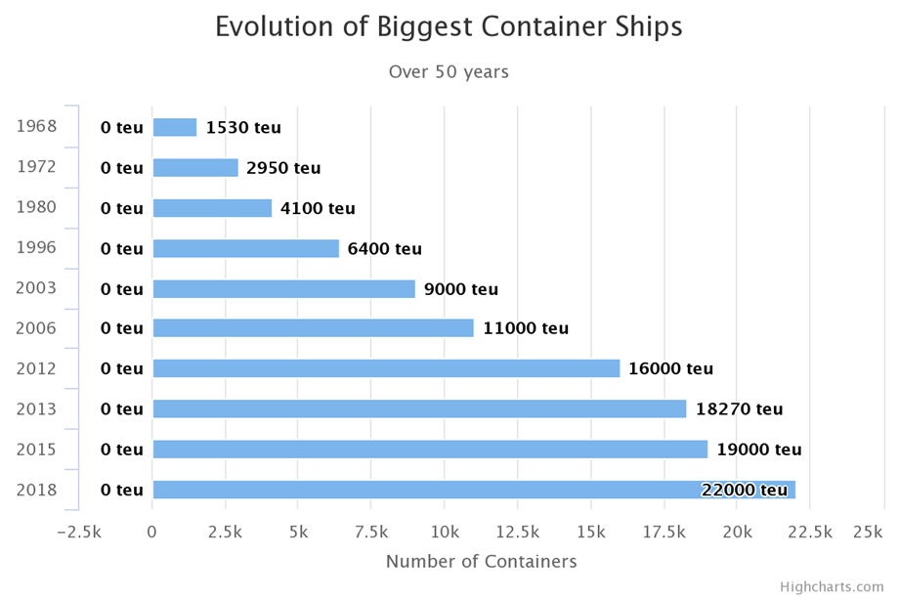

Using the data for increased container traffic we can show how the observed CO2 levels in the atmosphere respond (or correspondingly how the ocean heat content responds) by examining the data over 5-year periods. Due to lags in the system, there is never a one to one correspondence between our energy activity on the Earth and immediate atmospheric response; hence the CO2 content of our atmosphere did not see a reduction, even though the year 2009 saw a planetary wide reduction in greenhouse gas emissions of about 10%. Table 1 summarizes the relation between ppm increase and container traffic increase in these 5-year periods and Figure 7 shows the long term trend that emerges from this comparison. The plotted exponential fit has a lot of scatter around it, and the 1990-1995 time-periods are clearly deviant. This deviance is driven by the 1991 Pinatubo volcanic explosion which temporarily changes atmospheric chemistry that mixes out CO2 at a faster rate, leading to some reduction in average atmospheric concentration [20, 21, 22]. The indicated trend for this BAU trajectory would be that if we were to double the number of containers in the next 5-year period that would result in a CO2 increase of ~ 25 ppm. For comparison, it took the period 1980 – 1996 to cause a similar increase. This is yet another example of accelerated build up and clearly the world is escalating its consumption year after year.

Table 1: Relation between increasing container traffic

and increasing CO2 emissions.

|  |  |  |
| --- | --- | --- |
| Time Period | Container Traffic | CO2 Increase |
| 1970 - 1975 | 10 mTEU | 5.63 ppm |
| 1975 -- 1980 | 14 | 7.45 |
| 1980 -- 1985 | 21 | 7.35 |
| 1985 -- 1990 | 30 | 8.65 |
| 1990 -- 1995 | 58 | 6.49 |
| 1995 -- 2000 | 93 | 8.83 |
| 2000 -- 2005 | 150 | 10.43 |
| 2005 -- 2010 | 153 | 9.85 |
| 2010 -- 2015 | 170 | 12.08 |
| 2015 – 2020 | 215 (est) | 13.5 (est) |

d) Ocean Heating: The Root of Climate Change

At its foundation, climate change is driven by our systematic heating of the oceans, since the industrial revolution, through human industrialized processes and their associated thermodynamic waste heat. Waste heat is the inevitable result of work done by an inefficient machine that gives off heat to the environment while doing the work. Fossil fuel burning is one of the waste heat channels. Well, doesn’t this waste heat just rapidly dissipate into the air? No, the air is just the initial repository for waste heat, but ultimately, largely because of precipitation, most all (93% - [23]) of this waste heat ends up in the oceans which have been systematically store this extra heat content for the last 150 years. The differential warming of ocean surface waters directly couples to the behavior of the atmospheric jet stream which determines regional weather patterns. If you change the heat distribution in the world’s oceans you will correspondingly change weather patterns [24,25,26]. Humans have now successfully performed this change which now directly leads to changes in regional weather patterns, more volatile weather systems, and long term climate change. It is the combined waste heat of all the industrial processes associated with keeping us on the BAU trajectory that has increased the heat content of the oceans leading to global climate change. As we continue to escalate global consumption, the rates of impact on the natural system will correspondingly increase.

As shown in Figure 8, the rate of heat content addition to the ocean is accelerating. Since there are significant lags in the system, it will take some time for this overheated ocean to manifest itself in terms of increasing weather volatility. Based on the data shown in Figure 8, we argue that ocean heat addition by industrialized processes has been out of equilibrium since about 1990.

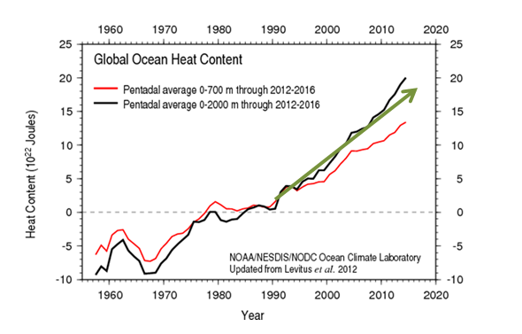

Figure 8 informs us of a few things:

a) The rise in ocean heating since the mid-1990s is fairly linear (green arrow) although the most recent data lies a bit above the linear extrapolation, particularly for the black line,

b) Prior to 1990 or so the oceans have a capacity to absorb more heat and distributed it through its normal channels. The most important channel for removing excess surface heat from the oceans is deep sea transport [27,28] but this mixing operates over a few hundred years timescale [29]. Since 1990, the oceans have experienced reduced efficiency in terms of handling waste heat input and are clearly retaining more heat. In turn, this inevitably changes the horizontal (ocean currents) and vertical temperature distributions within the oceans and this directly drives jet stream patterns which determine regional weather. [30,31] Simply put, the coupled ocean-atmospheric system has more energy to work with it, due to our human input.

c) Because of b) we would expect the signature of climate change as increasing weather volatility to start to emerge around 1990 and continue to escalate simply because more energy is being added to the system

We stress here that the Y-axis in Figure 8 is not temperature – instead ocean surface buoy measurements of temperature have been converted to heat content [32]. On an annual basis we are adding approximately 1022 Joules of energy to the world’s oceans. These units are likely meaningless to most readers but their equivalency is as follows:

* Each person on the planet using 10,000 gallons of gasoline per year
* One trillion annual barrels of crude oil (current world consumption is 35 times less than this)
* Each person on the planet using 1.4 billion AA batteries per year (that’s 10 billion batteries)

The above numbers represent the sheer nonsensical scale of global consumerism and the resulting extra energy that is delivered to the system. . Human actions have taken our sacred equilibrium system most definitely out of equilibrium. The spirit of the PTD implies that all generations (perhaps all species) should enjoy the right of living in the same equilibrium system enjoyed by previous generations but now threatened by future generations. This threat is the likely result of continuing belief that prosperity is best measured in by economic means only.

III. Discussion

a) Historical Considerations

From the physical point of view, humans are in a necessary partnership with nature. Despite this obvious boundary condition, many human cultures historically have pursued dominance over the Earth’s resources as their operational philosophy. Until the invention of the steam engine, that operational philosophy had only local impact and not global impact. But how does such an operational velocity come about? Here we greatly simplify history and assert that this ethos becomes operational with the rise of the Mechanical Philosophy, primarily through the work of Descartes [33]. Under this world view, the Earth is nothing more than a (soul-less) machine – it has no spiritual value and no sacred value. Furthermore it becomes established that man is distinct from nature and therefore entitled to dominant it. As Descartes put is

*…and thus render ourselves the lords and possessors of nature* (see also [34])

This Mechanical view of the world is firmly in place before the industrialized revolution so that sustainable harvesting of Earth resources is never part of our operational value system. The invention of the steam engines eventually launches the industrialized era of rapid growth that beings to take the Earth system out of equilibrium. This mechanical philosophy mode of digging up the planet as fast as possible and churning the crank for the escalating global distribution of consumer products is completely opposite of both the systems thinking approach and the physical manner in which the Earth system operates. Accelerated climate change with increasing weather volatility is the direct system reaction to this non-equilibrium state which is driven primarily by our increasing consumption.

Our real-world behavior strongly suggests that we still live in the mechanical philosophy system. In that system, nature has no intrinsic value but serves humans only as a resource. Some of the consequence of this value system as applied to nature were recognized somewhat early in the 1930s by the historian and sociologist Lewis Mumford [35,36] as articulated by these relevant quotes:

*Our national flower is the concrete cloverleaf.*

*Today, the degradation of the inner life is symbolized by the fact that the only place sacred from interruption is the private toilet.*

In addition, Mumford was one of the first policy champions of using renewable energy to substitute for fossil fuels – more specifically to use hydro power to generate electricity instead of Coal. In various writings [37] Mumford described coal as serving as the engine of the industrial revolution’s “upthurst into barbarism”. He described the production of coal as a thing that produced “a befouled and disorderly environment” and described coal mining as a process that “wrenched coal from the Earth requiring the simultaneous exploitation of labor and nature”. In perhaps an early vision of the PTD, Mumford states that “with hydro -electricity, the clear sky and clean waters would come back again” and would finally bury the “maggoty corpse” of the Coal era. Alas, the corpse is still rather far from being buried. Indeed, as of Feb 13, 2018 the world energy situation [38] can be summarized in Figure 10 which shows that renewable energy sources stand as only 8.5% of the total world energy production, still almost entirely driven by that which produces a befouled and disorderly environment.

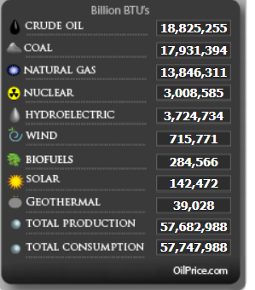

b) Policy implications

In guiding future policy to facilitate a move towards sustainability the most relevant lens may be that of global equity/global justice. A good historical starting place, which also contains elements of the PTD, comes from the 1996 World Commission on Environment and Development report [39] which states:

*The environment must be protected … to preserve essential ecosystem functions and to provide the wellbeing of future generations; environmental and economic policy must be integrated; the goal of policy should be an improvement in the overall quality of life, not just income growth; poverty must be ended and resources distributed more equally; and all sections of society must be involved in decision making.*

There are two key concepts in this early report: 1) resources distributed more equally – this seems to be a vital need for achieving sustainability, and 2) the overall quality of life should supersede mere income growth. With respect to point 1, data indicate that we are increasingly moving away from resource equity. For example, the 2008 World Bank report [40] showed that for 2005, the world share of consumption can be broken down as follows:

* 75.6% is consumed by the Worlds’ richest 20%
* 21.9% is consumed by the middle 60%
* 1.5% is consumed by the world’s poorest 29%

An update to this situation is available from the 2013 Oxfam International Report [41] which claims we are moving toward a rather absurd situation in which the richest 1% of the world will own more than 50% of the world’s wealth by the year 2016 (it will take some years to verify if this came true). In this situation, the richest 1% owns more wealth than the other 99%; the scale of inequality is thus staggering and every year the gap between the 1% and the rest widens. A useful visual representation the data in the Oxfam report is shown in Figure 11 where the land area of the world is converted to wealth -- the bottom 50% (red) of the world owns only an area of the size of Mongolia; the middle 40% (blue) owns most of the former Soviet Union; the remaining 10% (gold – naturally) owns all the rest.

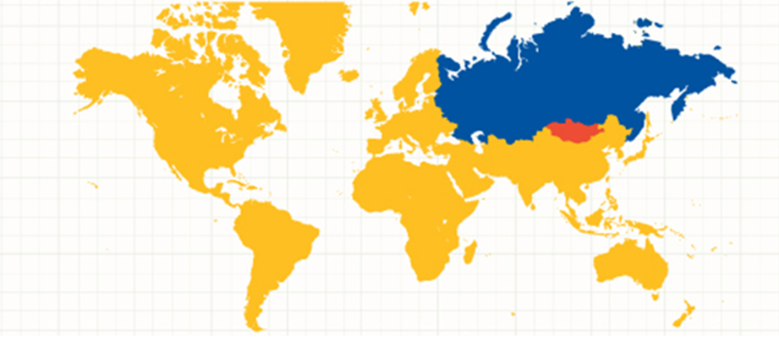

The second point is that the quality of life has more importance than income growth. As long as the personal perception of prosperity is related solely to income issues, which ultimately drive consumption, then no move to sustainability seems possible. This is one of the major challenges for the more developed countries of the world – how to enlighten their citizens that the drive for steady personal income growth is now less important than considerations which raise the probability of a more livable world for future generations. So this second point also strongly relates to the issue of “just sustainability” [1]. There is a direct need to make issues of equity and social justice as prevalent as the issue of climate change. Sustainability is not about the more efficient harvesting of resources, it’s about establishing a more equilibrium use of resources with respect to the innate planetary cycles (see more in section d below). This is well articulated here [42,43]

*“Sustainability cannot be simply a ‘green’, or ‘environmental’ concern, important though ‘environmental’ aspects of sustainability are. A truly sustainable society is one where wider questions of social needs and welfare, and economic opportunity are integrally related to environmental limits imposed by supporting ecosystems”*

*“The need to ensure a better quality of life for all, now and into the future, in a just and equitable manner, whilst living within the limits of supporting ecosystems*

These two statements, which embody “just sustainability”, are in stark contrast to our systematic heating of the oceans which has taken that system entirely out of equilibrium resulting in increasing weather volatility. We are certainly not living within our environmental limits and are explicitly and actively transcending them. As a result, we have invited disaster and are putting the entire system in danger. This process of continually defining social needs by consumption leads directly to a kind of social inequality that ultimately does significant damage to various social structures [44]. One of the frameworks for a just sustainability is then to replace consumption based social identity with a more meaningful grounding in global justice and environmental welfare.

c) Legal implications

In the previous section we have argued that policy needs to move away from economic priority and towards ensuring a healthy planetary ecosystem, for the benefit of now and future generations. We have argued that such a move is the very essence of the PTD and therefore and evolving legal framework may be need to catalyze such a transition. An early vision of this can be found in the 1987 Brundtland Report *Our Common Future* [45} which states,

*“… development that meets the needs of the present without compromising the ability of future generations to meet their own needs,”*

This seems simple enough, but do we a) know how to do this and b) care about doing this.

d) Systems thinking: and recovering the Sacred

A systems thinking approach involves making decisions and policies within the conceptual and quantitative framework of an interconnected system with robust feedbacks. A good environmental example of this is provided in Cronon’s 1996 essay “*The Trouble With Wilderness*” [46] in which he asserts that the system of wilderness is “everywhere” and not just in protected and isolated places. But this systems approach is rarely taken in the real world who instead views a system as merely a collection of components and the interaction of these components is largely ignored. However, there is strong evidence that suggests certain indigenous cultures organized their entire way of life around systems thinking, largely because of holding a sacred view of Nature [47,48]. Rediscovering this world view is likely the most promising ways to curb our short term consumption addiction so as to better maintain the system for future beings.

Physically, the Earth is a large connected feedback system of which human activity is but one channel in the overall cycle. All cycles are characterized by two things a) material exchange rates between various reservoirs and b) the existence of buffers in the system that can store material/energy over some timescale. In this way, a system can be out of equilibrium on either short spatial or temporal timescales, but on average equilibrium is always maintained. Human dominance over Earth resources disrupts energy pathway exchange rates and modifies buffers (e.g. paving over a wetland). These actions keep us out of equilibrium. This is well described in the Living Planet Report [49] which has consistently plotted our global “ecological debt” – which is the number of Earth’s that would be needed to instantaneously support our annual consumption. Because there are buffers in the system (we don’t use all the available crude oil in a single year because a lot of it is still stored) overshoot of equilibrium is allowed but only on small timescales (e.g. 100 years). The more colloquial way to represent the situation shown in Figure XX is to use Earth masses for the Y-axis. In this way our overconsumption is relative to how many Earth’s would be needed to provide resources for a particular year’s consumption. Since we are in overshoot mode, then there is the overshoot day, which is the day when, for a particular year, we have used more than 1 Earth mass. For the year 2017, the overshoot day was August 5 or day 216 of the year. Since that is approximately 60% of the year, then for the full year we will use 1/.6 ~ 1.7 Earth Masses.

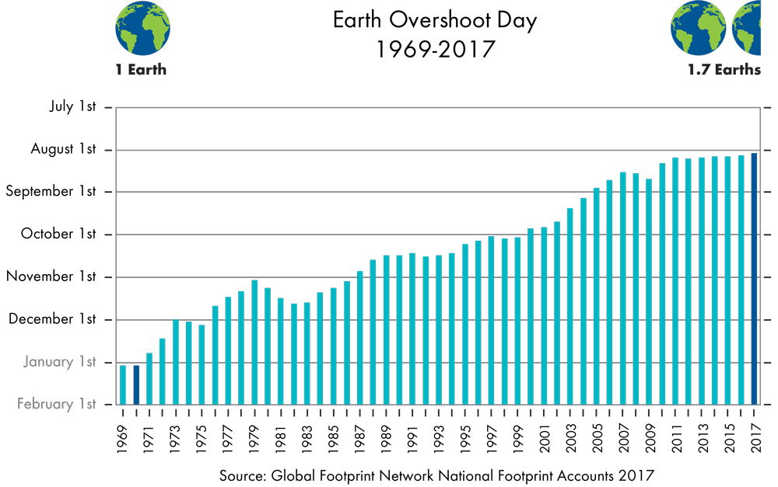

Our demonstrable inability to consume within our global resource limitations clearly shows, as Descartes originally argued, that the Earth is essentially a machine that offers us resources that we can just use up. We simply do not acknowledge that our resources are finite and operate under the implicit assumption that new technology will open up new resources. While the past has proven this adage to be somewhat true, the price we have paid over the last 150 years of human industrial activity has now changed the horizontal and vertical temperature distributions within the oceans. We have changed the very system that we live in.

As an example of living within a system, let’s consider two cultures (see [50]), culture D (for dominance) and culture S (for sustainability or S for sacred – the two might be the same) and their treatment of an energy resource in the context of planetary subjugation and climate change. We have argued that our continued reliance on mined resources as the principle source of electricity and energy generation carries with it a tremendous environmental cost as well articulating a consistently inappropriate message that we exist to dominate the planet (long live culture D). When we mine resources (*dig precious things from the ground*) that is largely an action which is invisible to the end user -the pollution from fossil fuels is mostly invisible CO2, and on the individual human scale, the Earth is essentially infinite so what is the harm of digging a hole or two (or several million)? This is fully consistent with the evolution of Culture D; digging up resources represents dominance on the part of the digger and the Mechanical Philosophy gives entitlement to that digger. Harmony with nature is completely absent.

In stark contrast is the harmony of a spinning wind turbine. In this case, we only get electricity when the wind is blowing and therefore are in a necessary partnership with nature for the use of that resource (e.g. culture S). Such a partnership tends to foster better resource management and resource equilibrium as well as having a culture which recognizes and conforms to environmental limits.. Using machines to dig holes in the ground from a seemingly infinite resource, unbinds us from any notion of partnership and allows resource consumption to steadily increase. In this way culture D can never honor the PTD but culture S is bound by it. Culture S is clearly practicing systems thinking and is living within the natural limits of that system.

Hence, A proper integration of systems thinking into the way we behave means that issues of fairness, environmental justice, dignity and global equity become more important than what should become the obsolete notion that increased human prosperity only comes from increased consumption. While the concept of environmental justice is complex and nuanced [51,52,53,54] it does seem to distill to one reality – the Earth’s climate and energy resources should be equally available to all its citizens if we truly have a globally just society. Moreover, it should be clear that we truly live in a world of finite resources to support escalating global consumerism. If, de facto, this is our collective priority then our end result lies in accelerated climate change, which the data suggest is now happening. No improved technology with more efficient resource extraction will overcome the basic problem that our current value system is skewed too much towards economic growth and too little toward the more fundamental values of environmental justice, social justice, equity and dignity for all the citizens of the Earth.

Clearly we must collective regain the notion that the Earth is sacred and we need to respect its boundaries, not conquer them. We are part of the system and our global behavior needs to incorporate this physical reality. And yet our on the ground behavior is still very much related to conquering nature: blowing the tops off of Appalachian Mountains to mine coal; drilling for possible oil located under 5000 feet of water and 15,000 feet of marine sediments (e.g. Deep Water Horizon). These are acts of desperation to maintain BAU. Drilling a 20,000-foot-long pipe into the ground, for instance, to sustain personal vehicle transportation while accelerating climate change, is likely insane and echoes an earlier and appropriate commentary by Mate [55]:

*We seldom consider how much of our lives we must render in return for some object we barely want, seldom need, buy only because it was put before us...And this is understandable given the workings of our system where without a job we perish, where if we don't want a job and are happy to get by we are labeled irresponsible, non-contributing leeches on society. But if we hire a fleet of bulldozers, tear up half the countryside and build some monstrous factory, casino or mall, we are called entrepreneurs, job-creators, stalwarts of the community. Maybe we should all be shut away on some planet for the insane. Then again, maybe that is where we are.*

It really is incumbent on us to shift our priorities. The current legal success of the PTD in terms of prosecuting that climate change is a danger to future children needs to be expanded to the basic notion that escalating use of planetary resources to promote “ever-increasing” consumption is a danger to not only future children, but millions of other species. It’s one Earth, one tiny vessel that has sustained all forms of life over the last 4 billion years – who the hell are we to disrupt that?

References

1. Agyeman, J., R. Bullard, and B. Evans (eds) (2003) Just Sustainabilities: Development in an Unequal World. Cambridge MA: MIT Press
2. Steffen, W., Crutzen, P, McNeill, J. (2007) The Anthropocene: Are Humans Now Overwhelming the Great Forces of Nature? Journal of the Human Environment 36, 614 doi:10.1579/0044
3. del Ninno C. & Lundberg, M. (2005) Treading water: The long-term impact of the 1998 flood on nutrition in Bangladesh, Economics & Human Biology 3, 1 pp. 67-96
4. Vidal, J. and Adam, D. (2007) China overtakes US as world's biggest CO2 emitter, The Guardian, available at: https://www.theguardian.com/environment/2007/jun/19/china.usnews
5. Walan, R. et. al (2014) Phosphate rock production and depletion: Regional disaggregated modeling and global implications, Resources, Conservation and Recycling 93, 178-187 doi: 1016/resconnrec.2014.10.011
6. Cordell, D. and White, S. (2011) Peak Phosphorus: Clarifying the Key Issues of a Vigorous Debate about Long-Term Phosphorus Security, Sustainability 3, 2027-2049 doi: 10.3390/su3102027
7. Jaffe, S. (2017) Vulnerable Links in the Lithium-Ion Battery Supply Chain, Joule 1m 225-228 doi: 10.1016/joule.2017.09.021
8. Speirs, J. et. al. (2014) The future of lithium availability for electric vehicle batteries, Renewable and Sustainable Energy Reviews 35, 183-193 https://doi.org/10.1016/j.rser.2014.04.018
9. Keeling Curve Data (2017) retrieved from: http://scrippsco2.ucsd.edu/data/atmospheric_co2/
10. Data obtained from https://data.giss.nasa.gov/gistemp/
11. Tabuchi, K. (2018) 2017 Set a record for losses from natural disasters. It could get worse. New York Times, retrieved from https://www.nytimes.com/2018/01/04/climate/losses-natural-disasters-insurance.html
12. Nelson, R. and Wright, G. (1992) The rise and fall of American technological leadership: The post war period in historical perspective, Journal of Economic Literature 30, 1931-1964
13. Maier, C. (1977) The politics of productivity: foundations of American international economic policy after World War II. International Organization, 31(4), 607-633. doi:10.1017/S0020818300018634
14. David, A. and Wright, G. (1997) Increasing Returns and the Genesis of American Resource Abundance, Industrial and Corporate Change, Volume 6, Issue 2, 1 March 1997, Pages 203–245, https://doi.org/10.1093/icc/6.2.203
15. Durning, A. (1992) How Much is Enough? The Consumer Society and the Future of the Earth, The Worldwatch Environmental Alert Series, ed. L. Starke, WW Norton & Company
16. Whitely, N (1987) Toward a Throw-Away Culture. Consumerism, 'Style Obsolescence' and Cultural Theory in the 1950s and 1960s, Oxford Art Journal 10,3
17. Nathan, R. (1944) Quote found in the book Mobilizing for Abundance, McGraw-Hill.
18. Lebow, V. (1955) Quote found in Price Competition in 1955, The Journal of Retailing
19. Wang, S. etal. (2016) The relationship between economic growth, energy consumption, and CO2 emissions: Empirical evidence from China, Science of the Total Environment 542, 360 https://doi.org/10.1016/j.scitotenv.2015.10.027
20. Frolicher et al. (2013) Atmospheric CO2 r response to volcanic eruptions: The tole of ENSO, season and variability, Global Biogeochemical Cycles 27, 239 do1:10.1002/gbc.20028
21. Robock, A. (2000) Volcanic eruptions and climate, Reviews of Geophysics 38, 191-219 doi: 10.1029/1998RG000054
22. Stenchikov, G. et. al. (1998) Radiative forcing from the 1991 Mount Pinatubo volcanic eruption, Journal of Geophysica Research, 103, 13837-13857 DOI: 10.1029/98JD00693
23. Dahlman, L (2015) Climate Change: Ocean Heat Content retrieved at: https://www.climate.gov/news-features/understanding-climate/climate-change-ocean-heat-content
24. Barron, E et.al. (1993) Past climate and the role of ocean heat transport: Model simulations for the Cretaceous, Paleoceanography xx,xx doi: 10.1029/93PA02227
25. Blackport, R. and Kushner, P. (2017) Isolating the Atmospheric Circulation Response to Arctic Sea Ice Loss in the Coupled Climate System, Journal of Climate 30, 2163-2185 doi: 10.1175/JCLI-D-16-0257.1
26. Gill, A. (2016) Atmosphere—ocean dynamics Elsevier 2016
27. Bryden, H. & Imawaki, S. (2001) Ocean Heat Transport, International Geophysics 77, 455-475
28. Hoffert, M, Callegari, A., and Hsieh, C. (1980) The Role of deep sea heat storage in the secular response to climatic forcing, Journal of Geophysical Research 85, 6667-6679 doi: 10.1029/JC085iC11p0667
29. Hansen, J. et. al (1985) Climate response times: dependence on climate sensitivity and ocean mixing, Science 229, 857
30. Huber, M. & Sloan, C. (2000) Climatic responses to tropical sea surface temperature changes on a “greenhouse” Earth, Paleoceanography 15, 443-450 doi: 10.1029/1999PA000455
31. Griese, K. and Polvani, L. (2014) The response of midlatitude jets to increased CO2: Distinguishing the roles of sea surface temperature and direct radiative forcing, Geophysical Research Letters 41, 6863—6871 DOI: 10.1002/2014GL061638
32. Levitus, S. et al (2000) Warming of the World Ocean, Science 287, 2225-2229 doi: 10.1126/science.287.5461.2225
33. Descartes, R. (1635) Discourse on Method (best accessed and read at: https://plato.stanford.edu/entries/descartes/)
34. Merrill, T. (2008) Masters and possessors of nature review of Discourse on Method by René Descartes, New Atlantis 19, 91-107
35. Mumford, L. (1934), quote found in book Technics and Civilization re-published in 1963 by Mariner Books
36. Mumford, L. (1938), quote found in book The Culture of Cities re-published in 1981 by Green Wood Press
37. Needham, A. (2014) Power Lines: Phoenix and the Making of the Modern Southwest, Princeton Univ. Press
38. Data retrieved from oilprice.com monitor
39. (1996) World Commission on Environment and Development, Our Common Future, available at: http://www.un-documents.net/our-common-future.pdf
40. (2008) World Bank Report, available at: http://siteresources.worldbank.org/EXTANNREP2K8/Resources/YR00_Year_in_Review_English.pdf
41. Data retrieved from: https://d1tn3vj7xz9fdh.cloudfront.net/s3fs-public/file_attachments/story/oxfam_annual_report_2013_-_2014_final.pdf
42. Agyeman, J, Bullard R and Evans, B (2002) Exploring the nexus: bringing together sustainability, environmental justice and equity.’ Space and Polity Vol. 6 No. 1 pp 70-90.
43. Agyeman, J. (2005) Sustainable Communities and the Challenge of Environmental Justice. New York. New York University Press.
44. Wilkinson R., and K. Pickett (2009) The Spirit Level: Why equality is better for everyone. Allen Lane, London.
45. Brundtland Report (1987) Report of the World Commission on Environmental and Development: Our Common Future (retrieved from http://www.un-documents.net/our-common-future.pdf)
46. Cronon, W. (1996) The Trouble with Wilderness; Or, Getting Back to the Wrong Nature, Environmental History, Volume 1, Issue 1, 1 January 1996, Pages 7–28
47. Barnhardt, R, (2005) Indigenous Knowledge Systems and Alaska Native Ways of Knowing, Anthropology & Education Quarterly, 36, 8 DOI: 10.1525/aeq.2005.36.1.008
48. Breildlid, A. (2009 Culture, indigenous knowledge systems and sustainable development: A critical view of education in an African context) International Journal of Educational Development 29,140 https://doi.org/10.1016/j.ijedudev.2008.09.009
49. Living Planet Report (2016) retrieved at http://awsassets.panda.org/downloads/lpr_living_planet_report_2016.pdf
50. Bothun G.D. (2017) Thinking About Sustainability: Issues and Themes for College Students. In: Davim J. (eds) Curricula for Sustainability in Higher Education. Management and Industrial Engineering. Springer, Cham
51. Sen, A. (2009) The Idea of Justice. Allen Lane, London.
52. Schlosberg, D. (1999) Environmental justice and the new pluralism. The challenge of difference for environmentalism. Oxford, University Press
53. Schlosberg, D. and Collins, L. (2014) From environmental to climate justice: climate change and the discourse of environmental justice; Wiley Interdisciplinary Reviews: Climate Change 5, 291
54. Warlenius, R, Pierce, G. and Ramasar, V. (2015) The concept of “ecological debt” and its value for environmental justice. Global Environmental Change 30, 21
55. Mate, F. (1993) A Reasonable Life: Toward a Simpler, Secure, More Humane Existence

