Salient points regarding the first homework assignment:

- Below are two example graphs of World Oil Production (many of you used the first one)

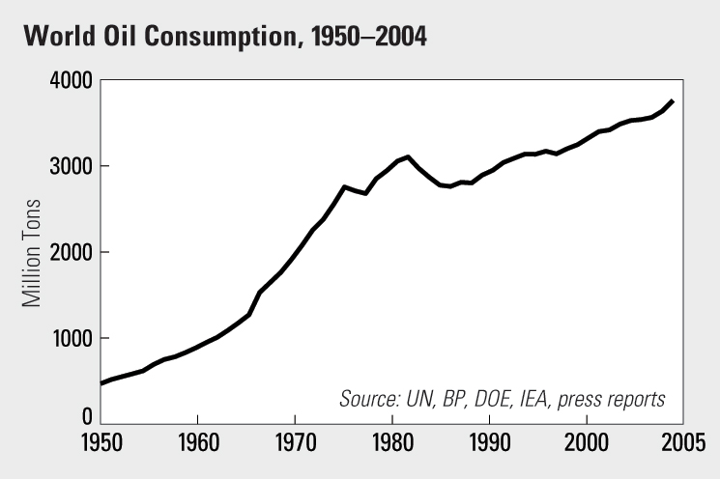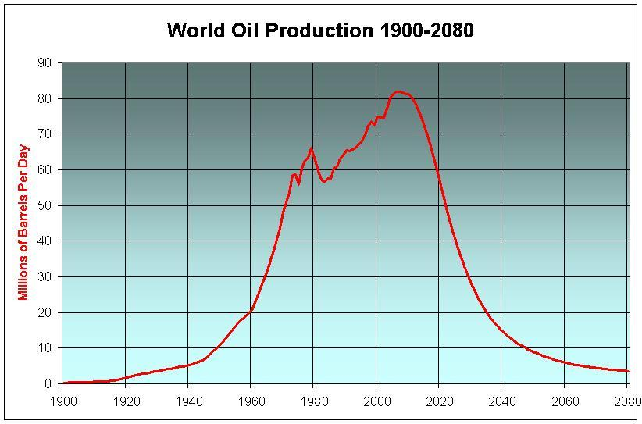

The top graph has the most resolution and is best used the answer the posed questions but it also in inconvenient units (Million of Tons of Oil Equivalent per year). More sensible units are given by the bottom graph (Million Barrels Per Day).

