Introduction and Background:

Often times identifying the characteristics of extreme examples of galaxy morphology and properties (e.g. Perseus A, Malin 1, NGC 1569) provides very important constraints on our overall understanding of galaxy evolution. Since these extreme galaxies exist, then there are obviously physical mechanisms available for their formation and/or current evolutionary state. Moreover, the last decade of both ground and spaced based observations has established two clear tenets: a) most galaxies are harassed by their environment and b) galaxy formation via the assembly of proto-galactic fragments occurs at redshifts of 1-4 (Conselice 2007). Most of our knowledge of this assembly process is based on morphology as the physical details of the sub-units are generally unknown but remains an intense focus of many deep surveys (e.g. Pozzetti etal 2007). Hence it would be useful to identify possible low-redshift analogs to this process. Along those lines, in 1998 Conselice and Gallagher introduced “a new morphologically defined form” of galaxy that they discovered inhabited the Coma cluster. They dubbed this new morphological form as a galaxy aggregate suggesting, through this moniker, that these objects represent some form of dynamical dis-equilibrium via interaction with the cluster gravitational potential or the hot ICM within the cluster. In studies of galaxy morphology at high redshift there is ample evidence of galaxy assembly (e.g. Conselice etal 2005; Bundy etal 2005; Papovich etal 2005; Corbin etal 2005). Presumably the precursors to the assembly might look like “galaxy aggregates”. This idea has been further pursued by Straughn etal (2006) in the form of yet another new morphological class dubbed “tadpole” galaxies. There is also evidence that massive individual star clusters themselves may merge to become dwarf galaxies (e.g. Fellhauer and Kroupa 2002).

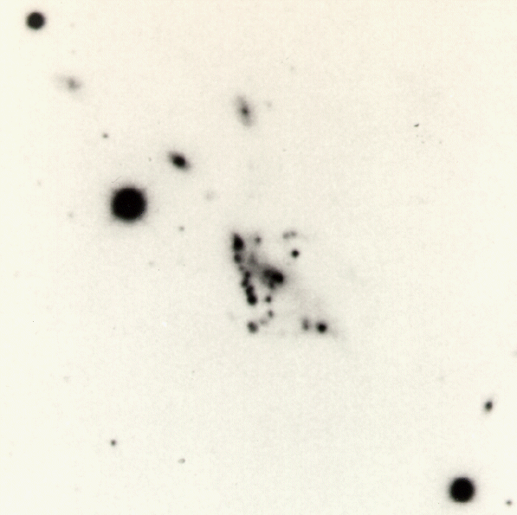
The Figure to the right introduces a previously understudied object that may well be the most massive example of a galaxy aggregate that just might also serve as a compelling analog to the overall galaxy assembly process.
This peculiar looking galaxy certainly has the morphological signature of the galaxy aggregate and/or assembly line production. There appears to be some kind of nucleus/main body, perhaps a very diffuse disk emanating from that inner region, but the main characteristic is the large number of high surface brightness notes that are readily apparent in this photographic plate reproduction of the original Las Campanas 100-inch plate with scale of 10” per mm. The total angular size of the object is 1.2 arcminutes. At first glance, most experienced observers that have been polled peg this galaxy to be a nearby dwarf irregular galaxy of approximate size 2-3 kpc which currently has a disturbed morphology in response to stochastic star formation and kinematic feedback. Alas, appearance can be misleading – this object is not nearby and has a size of approximately 45 kpc!

This object was discovered by Dressler (1980) in his survey of the morphological properties of galaxies in nearby clusters. This galaxy is #109 (D109) in the spiral rich cluster Abell 2634 which has a redshift of 0.03. D109 came to the attention of Bothun (1981) in his survey of the H I and color properties of disk galaxies in clusters of galaxies when he discovered that D109, in fact, was not the foreground dwarf galaxy that morphological logic had dictated but instead had the same redshift as A2634 proper. At the nominal distance of A2634 (e.g. H = 70), D109 has the following global properties (adapted from Bothun etal 1985):

- M_{V}: -19.2 +/- 0.4 (this is similar to M33)
- H I Mass: = 5 +/- 1 x 10⁹ solar masses (with an undisturbed global 21-cm profile)
- “Integrated Colors”: B-V = 0.36; U-B = -0.51; V-R = 0.10
- Total linear size = 45 kpc (!)

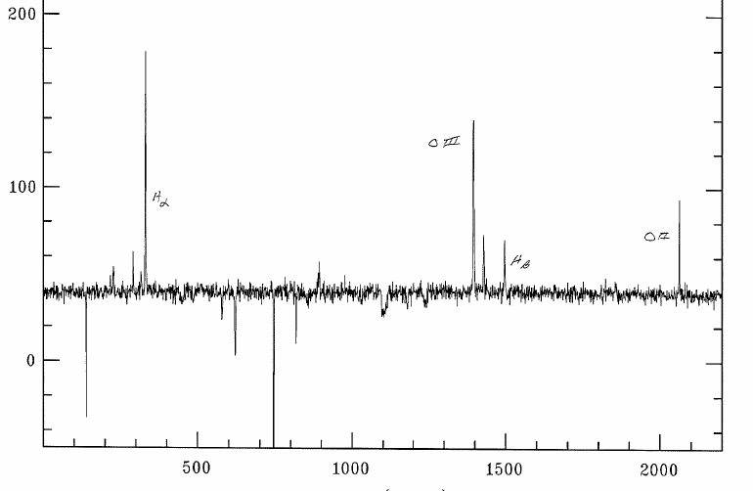
Thus D109 has the global characteristics of a typical late type spiral (like M33) but it is composed mostly of knots. The nature of these knots is not well known and forms the basis for this proposal. The most extraordinary global characteristic of D109 is the extreme V-R color. It is virtually impossible for galaxy stellar populations to have V-R colors this blue unless there is almost a complete absence of a red giant branch. Thus, globally, this object appears to be very young. Further V and I CCD imaging obtained in 1985 using the Palomar 60 inch telescope allowed individual measurements to be made of some of the brighter knots. The average luminosity of these knots (with sizes of 2-5 kpc) was measured to be M_{V} ~ -16.2 (substantially brighter than most dwarf galaxies) with individual luminosities ranging from -15 < M_{V} < -17. Moreover, their colors were extremely blue in (V-I) averaging -0.15 +/- 0.06. Thus, these knots have properties similar to the kind of superstar clusters noted in NGC 1569 (see Origlia etal 2001), but scaled up by at least an order of magnitude in size and total luminosity. In Nov 2008, 2.1m GoldCam slit spectroscopy on several of the knots that comprise D109 was performed. The figure at the right shows a rudimentary sky subtracted spectrum, done at the telescope, of one of the knots. The spectra confirm that the knots a) have very strong emission lines (this spectrum shows 3727, H-beta, 4959/5007, and H-alpha going from right to left) b) have very little underlying continuum signal, c) have line ratios consistent with low metallicity. HST imaging will allow for more precise positions to be determined for the knots which will aid in fiber-optic spectroscopy of each individual knot.
The overall velocity behavior of the knots reveals some evidence of rotation with an observed rotation velocity < 100 km/s (the inclination along the line of site is not well determined). This is consistent with the form of the global H I profile and indicates the knots likely form a coherent dynamical system. Based on its ensemble properties as well as the extremely blue nature of the knots, we suggest that D109 is the best example of a nearby, relatively massive, galaxy that truly is undergoing the first stage of galaxy assembly and furthermore, that the knots may very well be sites of first generation star formation occurring during this assembly process. We thus have a unique opportunity for high resolution imaging of this process to better understand the structural detail and stellar populations in these merging galactic sub-units. The fact that this object is located in the cluster environment is, admittedly, mysterious since the cluster environment contains generally more evolved galaxies (note that CG98 in the Coma cluster has very similar morphology to D109 but is not nearly as blue in overall color). Nonetheless it is in a cluster and hence D109 could be the result of some cluster induced formation process or perhaps the delayed infall of remaining galactic sub-units that are now aggregating to produce another galaxy. Whatever the situation, it seems clear that an aggregation process is occurring, by some mechanism, and studying the structural detail at high spatial resolution of that aggregation process will yield further insight into what now appears to be a fundamental aspect of galaxy formation.

Proposed New Imaging Observations:

In this supplementary cycle of HST we request a small amount of time to obtain high resolution imaging (with WFPC2) of this collection of knots in as many filters as practical. Having a better photometric characterization of the knots over a broader color baseline than obtainable from the ground coupled with higher resolution imaging of their morphology are necessary to both better resolve the knots in the aggregate and to determine their mean stellar ages (which are likely quite young). At the moment it is unknown if these knots are single star clusters, collections of star clusters or are mergers of smaller dwarf galaxies. Such information would help resolve the various speculative ideas about galaxies which exhibit these kinds of morphologies/structures: are they a) rare examples of an intense starburst caused by the cluster environment, b) truly young and undergoing first generation star formation in these knots, or c) an example of intense, ram-pressure modification of low mass galaxies that represents a transient (but important) phenomena that many low mass cluster galaxies would undergo at higher redshift. Whatever the intrinsic physical nature of D109 turns out to be, it seems clear that we have the rare opportunity to be catching some kind of transient evolutionary state in galaxy assembly. In addition, this new imaging data will better refine and inform efforts to obtain modern ground based spectroscopy of the individual knots to better characterize their abundances and the overall kinematics of the system.

To better investigate this unique object, we propose to make observations through the F435W (Blue), the F555W (Johnson V), and the F814W (I-band) filters. We also propose one additional exposure using the SBC F140LP filter which has effective wavelength of 1562 Angstroms. If these knots are super star clusters then they will be detectable though this filter and the 1562 – B color will serve as an effective age indicator of the stellar population. The V-I color will effectively constrain the age of any underlying older stellar population, it if really is present. Exposure time estimates through each filter are listed below. Input parameters to the ETC were the following:

- Desired S/N = 100 (20 in the case of the F140LP filter)
- Spectral Type of Knots assumed equivalent to a BO star.
- Input flux was taken as Johnson U in the range 16-17 mag distributed over a diameter of 5 arcseconds
- Foreground reddening E(B-V) = 0.18

The resulting range (from the faintest to brightest knots) of exposure times needed to achieve the desired S/N is:

F439W: 180 – 400 seconds.
F555W: 95 - 240 seconds
F814W: 30 - 75 seconds
F130LP: 2750 seconds (most important scientifically)

The longest times then sum to 3465 seconds or 57 minutes, beyond the target visibility time for its declination. Given the respective overhead with changing filters as well, the desire for the additional F140LP observation which will have the most constraining power for the mean stellar age, extends the requested time to 2 orbits.

In sum, this unique collection of extremely blue and bright individual knots which are dynamically bound to one another and appear to have very young stellar populations may well be the best nearby example of a galaxy assembly process presently ongoing. The total baryon mass involved is equivalent to the assemblage of a galaxy like M33, not a dwarf galaxy. While there are other nearby examples of fairly blue/metal poor/ young galaxies, those examples occur at much lower mass and luminosity scales than that which hold for D109. We emphasize that the total aggregate starlight is equivalent to a galaxy like M33 and the individual knots have scales like that of NGC 6822/IC 1613. Observations of D109 then offer a window into this assembly process, on the appropriate mass scale, in a very detailed and high resolution manner. We therefore request 2 orbits of time to acquire the superior imaging data and color baseline that will allow for a better overall characterization of this enigmatic galaxy “aggregate/tadpole” structure and the stellar populations that compromise the conspicuous knots.

References:

Bothun 1981 Ph.D. Thesis
Bothun etal 1985 Ap.J. Supp 57,423
Bundy etal 2005 ApJ 625, 621
Conselice and Gallagher 1998 MNRAS 297, L34
Conselice etal 2005 ApJ 620, 564
Conselice 2007: The Assembly History of Massive Galaxies: What Do We Know? – to appear in “Pathways through an eclectic Universe” ASP Conference series
Corbin etal 2005 ApJ 629, L89
Dressler 1980 ApJ Supp 42, 565
Fellhauer and Kroupa 2002 A&SS 281,355
Origlia etal 2001 AJ 122, 815
Papovich etal 2005 ApJ 635, 101
Pozzetti etal 2007 A&A 474, 443
Straughn etal 2006 ApJ 639, 734

