Scaling up NGC 1569: Galaxy Disintegration and IGM Feedback.

Introduction and Background:

Often times identifying the characteristics of extreme examples of galaxy morphology and properties (e.g. Perseus A, Malin 1, NGC 1569) provides very important constraints on our overall understanding of galaxy evolution. Since these extreme galaxies exist, then there are obviously physical mechanisms available for their formation and/or current evolutionary state. In some cases these mechanism involve gravitational/hydrodynamical interactions with the environment/IGM. Indeed, the last decade of both ground and space based observations have now established the clear importance of feedback in the process of galaxy formation and evolution and reveals how star formation/supernova heating serve to drive significant outflows, particularly in the case of actively star forming dwarf galaxies. The most impressive and well studied nearby example of this kind of feedback is provided by NGC 1569 from which three important attributes have been established (see Martin etal 2002).

- The current metal enriched outflowing gas will escape the galaxy potential as its mean thermal velocity exceeds the escape velocity. This physical situation is enhanced by the relatively small mass of NGC 1569.

- The heating is due to a sustained period of star formation that is substantially above the mean star formation rate for this galaxy. Much of this star formation is contained in a few super star clusters (of dynamical mass approximately 4 x 10⁵ solar masses - see Origlia etal 2001; Larsen etal 2008).

- The outflowing gas produces both an extended disk and bi-polar halo X-ray component of temperatures 0.7 and 0.3 keV respectively. As the gas it is unlikely the gas is in dynamical equilibrium, these temperatures are a reflection of mechanically/shocked heated gas and are not virial temperatures.
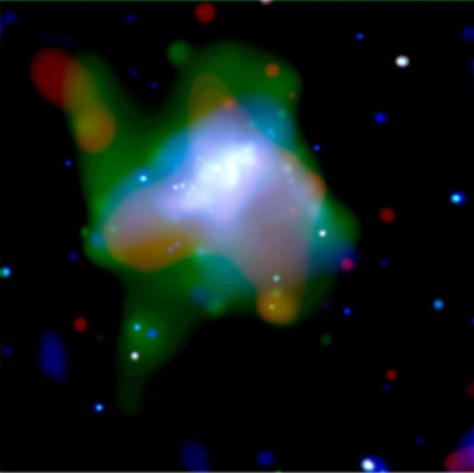
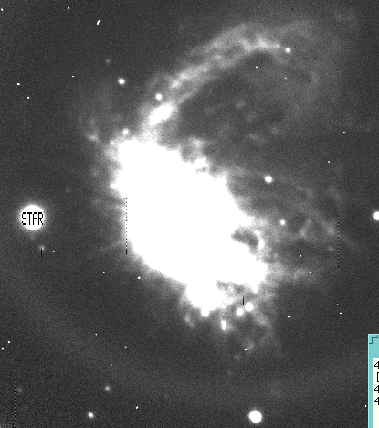
The overall x-ray morphology of NGC 1569 is both spectacular and artistic and reveals the feature enumerated above. What perhaps is most noteworthy is the sheer scale of the X-ray atmosphere or bubble relative to optical size of NGC 1569 directly showing that pollution of the IGM can occur at large distances from the source. Indeed, given the overall intensity of the star formation/supernova rate relative to the shallow gravitational potential indicates that NGC 1569 may be in the process of disrupting itself completely. Supporting evidence for large scale velocity flow also comes from some old and unpublished Fabry-Perot observations from the KPNO 4-meter telescope. The image to the right shows a large scale H-alpha filament that is defined in a velocity channel 160 km/s higher than the mean velocity of NGC 1569. The overall morphology of the H-alpha intensity map is very complex but does effectively trace similar structures as have been revealed in the Chandra X-ray observations of this galaxy. What motivates this proposal is the discovery of another galaxy, with very similar morphology and overall stellar population properties as NGC 1569 but which is 3 orders of magnitude larger in scale. Instead of a disintegrating 2 kpc galaxy, this object may currently be in a similar mode of disruption/outflow driven feedback on a linear scale of 50 kpc! While outflow is now commonly observed in low mass very actively star forming dwarfs (e.g. Ott etal 2005), this phenomena has not really been yet detected on significantly larger mass scales. We therefore propose to observe the galaxy described below to determine if, like NGC 1569, it too has an extended spatial distribution of hot gas.

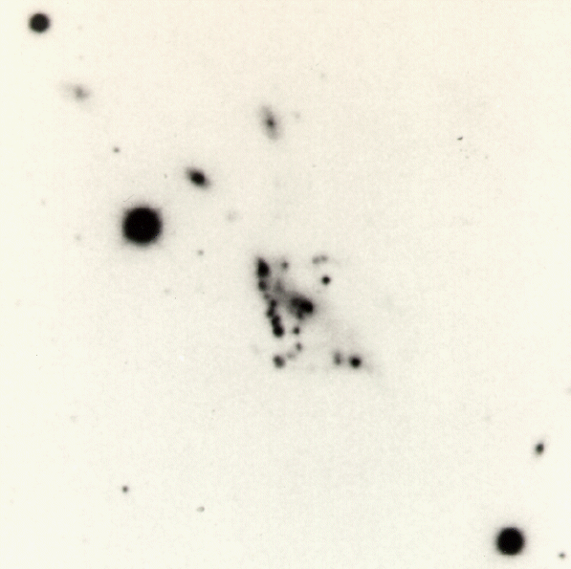
The Figure to the right introduces a previously understudied object that may well be the most massive example of a globally star bursting that has yet been identified. This peculiar looking galaxy certainly has the morphological signature of NGC 1569. There appears to be some kind of nucleus/main body, perhaps a very diffuse disk emanating from that inner region, but the main characteristic is the large number of high surface brightness notes that are readily apparent in this photographic plate reproduction of the original Las Campanas 100-inch plate with scale of 10” per mm. The total angular size of the object is 1.2 arcminutes. At first glance, most experienced observers that have been polled peg this galaxy to be a nearby dwarf irregular galaxy of approximate size 2-3 kpc which currently has a disturbed morphology in response to stochastic star formation and kinematic feedback. Alas, appearance can be misleading – this object is not nearby and has a size of approximately 45 kpc!

This object was discovered by Dressler (1980) in his survey of the morphological properties of galaxies in nearby clusters. This galaxy is #109 (D109) in the spiral rich cluster Abell 2634 which has a redshift of 0.03. D109 came to the attention of Bothun (1981) in his survey of the H I and color properties of disk galaxies in clusters of galaxies when he discovered that D109, in fact, was not the foreground dwarf galaxy that morphological logic had dictated but instead had the same redshift as A2634 proper. At the nominal distance of A2634 (e.g. H = 70), D109 has the following global properties (adapted from Bothun etal 1985):

- M_{V}: -19.2 +/- 0.4 (this is similar to M33)
- H I Mass: = 5 +/- 1 x 10⁹ solar masses (with an undisturbed global 21-cm profile)
- “Integrated Colors”: B-V = 0.36; U-B = -0.51; V-R = 0.10
- Total linear size = 45 kpc (!)

Thus D109 has the global characteristics of a typical late type spiral (like M33) but it is composed mostly of knots. The nature of these knots is not well known and forms the basis for an HST Cycle 17 proposal (especially UV imaging) – we regard the Chandra observations as potentially complementary to those data.

However, the most extraordinary global characteristic of D109, and one that is similar to but bluer than NGC 1569, is the extreme V-R color. It is virtually impossible for galaxy stellar populations to have V-R colors this blue unless there is almost a complete absence of a red giant branch. Thus, globally, this object appears to be very young. Further V and I CCD imaging obtained in 1985 using the Palomar 60 inch telescope allowed individual measurements to be made of some of the brighter knots. The average luminosity of these knots (with sizes of 2-5 kpc) was measured to be M_{V} ~ -16.2 (substantially brighter than most dwarf galaxies) with individual luminosities ranging from -15 < M_{V} < -17. Moreover, their colors were extremely blue in (V-I) averaging -0.15 +/- 0.06. Thus, these knots have properties similar to the kind of superstar clusters noted in NGC 1569 (see Origlia etal 2001), but scaled up by at least an order of magnitude in size and total luminosity. In fact, each one of dozen or so identifiable knots has a total spatial scale that is equivalent to that of NGC 1569 itself. Low S/N spectroscopy of some of these knots was done in the mid 1980s on a commissioning spectrograph run with the Palomar 200 inch telescope. Of course, that original data has long been lost and only a cursory analysis of that data was ever performed. The knots, not surprisingly, had very strong emission lines and an overall collection of line ratios that indicated quite low metallicity. The overall velocity dispersion of the knots, however, was less than 150 km/s indicating that they likely formed a coherent dynamical system.

Based on its ensemble properties as well as the extremely blue nature of the knots, we suggest that D109 is the best example of a large scale galaxy that truly is undergoing the first stage of galaxy assembly and furthermore, that the knots may very well be sites of first generation star formation occurring during this assembly process. Alternatively this object may be a manifestation, since its in the cluster A2634 which does have an ICM, of an extreme ram pressure event (although its velocity is only +500 km/s from the cluster mean) that has served to create these knots of extreme star formation. Whatever the process, the purpose of the Chandra observations is to establish the presence of an extended X-ray component to D109 that would be a manifestation of global, star-formation driven mass outflow on the dynamical mass scale of at least 10^10 solar masses.

NGC 3310

Too Fast, Too Furious: A Galaxy's Fatal Plunge
These images offer a dramatic look at a spiral galaxy like our Milky Way being ripped apart as it races at 4.5 million miles per hour through the heart of a distant cluster of galaxies. The images, taken over several wavelengths, provide evidence of the "galactic assault and battery," namely, gas being stripped from the doomed galaxy, called C153.
The composite photograph at left was made by combining the four images at right, taken in X-ray, radio, and visible wavelengths as well as the green light of oxygen gas. Astronomers studied the galaxy across several wavelengths to trace how stars, gas, and dust are being tossed around and torn from the fragile galaxy.
The composite image at left shows long streamers of gas flowing from the galaxy as it travels through the cluster, called Abell 2125. Hot gas from the cluster is stretching the galaxy's cooler gas into long streamers. Velocity measurements of several hundred galaxies in the cluster indicate that C153 is moving away from Earth within the cluster. The image, therefore, shows the streaking tail of "stripped gas." The image spans about 1 million light-years across. Abell 2125 is about 3 billion light-years away, on the boundary between the constellations Ursa Minor and Draco.
The visible-light image [above, right], taken by the Wide Field Planetary Camera 2 aboard NASA's Hubble Space Telescope, reveals intricate detail in the structure of stars and dust within C153. The galaxy exhibits evidence of a large-scale disturbance that has left its star-forming regions concentrated to one side of its disk and beyond. Dust features are twisted into chaotic patterns, obscuring any spiral pattern

We thus have a unique opportunity for high resolution imaging of this process to better understand the structural detail and stellar populations in these merging galactic sub-units. The fact that this object is located in the cluster environment is, admittedly, mysterious since the cluster environment contains generally more evolved galaxies (note that CG98 in the Coma cluster has very similar morphology to D109 but is not nearly as blue in overall color). Nonetheless it is in a cluster and hence D109 could be the result of some cluster induced formation process or perhaps the delayed infall of remaining galactic sub-units that are now aggregating to produce another galaxy. Whatever the situation, it seems clear that an aggregation process is occurring, by some mechanism, and studying the structural detail at high spatial resolution of that aggregation process will yield further insight into what now appears to be a fundamental aspect of galaxy formation.

Proposed New Imaging Observations:

In Cycle 17 of HST we request a small amount of time to obtain high resolution imaging of this collection of knots in as many filters as practical. Having a better photometric characterization of the knots over a broader color baseline than obtainable from the ground coupled with higher resolution imaging of their morphology are necessary to both better resolve the knots in the aggregate and to determine their mean stellar ages (which are likely quite young). At the moment it is unknown if these knots are single star clusters, collections of star clusters or are mergers of smaller dwarf galaxies. Such information would help resolve the various speculative ideas about galaxies which exhibit these kinds of morphologies/structures: are they a) rare examples of an intense starburst caused by the cluster environment, b) truly young and undergoing first generation star formation in these knots, or c) an example of intense, ram-pressure modification of low mass galaxies that represents a transient (but important) phenomena that many low mass cluster galaxies would undergo at higher redshift. Whatever the intrinsic physical nature of D109 turns out to be, it seems clear that we have the rare opportunity to be catching some kind of transient evolutionary state in galaxy assembly. In addition, this new imaging data will better refine and inform efforts to obtain modern ground based spectroscopy of the individual knots to better characterize their abundances and the overall kinematics of the system.

To better investigate this unique object, we propose to make observations through the F435W (Blue), the F555W (Johnson V), and the F814W (I-band) filters. We also propose one additional exposure using the SBC F140LP filter which has effective wavelength of 1562 Angstroms. If these knots are super star clusters then they will be detectable though this filter and the 1562 – B color will serve as an effective age indicator of the stellar population. The V-I color will effectively constrain the age of any underlying older stellar population, it if really is present. Exposure time estimates through each filter are listed below. Input parameters to the ETC were the following:

- Desired S/N = 100 (20 in the case of the F140LP filter)
- Spectral Type of Knots assumed equivalent to a BO star.
- Input flux was taken as Johnson U in the range 16-17 mag distributed over a diameter of 5 arcseconds
- Foreground reddening E(B-V) = 0.18

The resulting range (from the faintest to brightest knots) of exposure times needed to achieve the desired S/N is:

F435W: 180 – 400 seconds.
F555W: 95 - 240 seconds
F814W: 30 - 75 seconds
F140LP: 2750 seconds

The longest times then sum to 3465 seconds or 57 minutes, beyond the target visibility time for its declination. Given the respective overhead with changing filters as well, the desire for the additional F140LP observation which will have the most constraining power for the mean stellar age, extends the requested time to 2 orbits.

In sum, this unique collection of extremely blue and bright individual knots which are dynamically bound to one another and appear to have very young stellar populations may well be the best nearby example of a galaxy assembly process presently ongoing. While there are other nearby examples of fairly blue/metal poor/ young galaxies, those examples occur at much lower mass and luminosity scales than that which hold for D109. We emphasize that the total aggregate starlight is equivalent to a galaxy like M33 and the individual knots have scales like that of NGC 6822/IC 1613. Observations of D109 then offer a window into this assembly process, on the appropriate mass scale, in a very detailed and high resolution manner. We therefore request 2 orbits of time to acquire the superior imaging data and color baseline that will allow for a better overall characterization of this enigmatic galaxy “aggregate/tadpole” structure and the stellar populations that compromise the conspicuous knots.

References:

Bothun 1981 Ph.D. Thesis
Bothun etal 1985 Ap.J. Supp 57,423
Bundy etal 2005 ApJ 625, 621
Conselice and Gallagher 1998 MNRAS 297, L34
Conselice etal 2005 ApJ 620, 564
Conselice 2007: The Assembly History of Massive Galaxies: What Do We Know? – to appear in “Pathways through an eclectic Universe” ASP Conference series
Corbin etal 2005 ApJ 629, L89
Dressler 1980 ApJ Supp 42, 565
Fellhauer and Kroupa 2002 A&SS 281,355
Origlia etal 2001 AJ 122, 815
Papovich etal 2005 ApJ 635, 101
Pozzetti etal 2007 A&A 474, 443
Straughn etal 2006 ApJ 639, 734

