Oregon Climate change Education Initiative

Project Description
Oregon Climate Change Education Initiative (OCCEI) is an innovative partnership of the University of Oregon Department of Physics, Pacific University-Oregon College of Education, and a consortium of rural Oregon school districts. OCCEI will transform climate change education in partner middle and high schools by providing a year-long teacher professional development program consisting of extensive and challenging earth systems and climate change science coursework, training in the use of NASA earth observation data and earth system models, and sustained support. OCCEI will ensure classroom impact on student learning by engaging scientists, teachers, and administrators together in co-teaching partnerships, in which all participants work together in rural classrooms to enact innovative content and pedagogy. Successful OCCEI climate change education models and curriculum will be disseminated statewide through the Oregon NASA Space Grants Consortium and Oregon Science Teachers Association, and nationally through NASA and the National Science Teachers Association.
NASA Goals, Outcomes and Objectives: OCCEI targets NASA goals to “engage Americans in NASA’s mission” and “attract and retain students in STEM disciplines,” with emphasis on NASA Education Outcome Objective 2.2, Provide long duration and/or sustained professional development training opportunities to educators that result in deeper content understanding and/or confidence in teaching STEM disciplines.
OCCEI Essential Question: How can NASA resources and programs help transform climate change and earth systems science education in Oregon’s rural middle and secondary schools?
OCCEI Goals and Objectives:
- Improve teaching and learning about global climate change in three rural secondary schools and three associated middle schools, directly serving 36 teachers and ~3600 students (Funding Category P, NASA Education Outcome Objective 2.2):
- Increase teacher climate change and earth systems science literacy by providing district-based teams of middle school math and/or science teachers 12 quarter-hours of challenging coursework on current topics and research in climate change and earth systems science, in alignment with NASA Science Plan Objective 4.2.5, Climate Variability and Change.
- Improve teacher access to NASA climate change and NASA earth systems science resources by providing district-based teams with training in the use of NASA Earth Observation data and NASA Earth system models, showcasing NASA’s unique contribution to climate and earth systems science. This will entail detailed hands-on workshops in various computer labs to introduce to the participants the vast array of ON line resources and data which currently exist.
- Encourage pedagogical innovation by providing research-supported, data-driven instructional models and data visualization tools applied to topics of climate change and earth systems science. This is a key component. Our partnership has had a long history of providing teachers with innovative tools to assist them with in data organization and analysis. One of our existing tools, The Climate Data Visualizer, can be leveraged in support of this project to support teacher data analysis of various climate data sets.
- Transform educational practice by co-teaching alongside participant teachers in their classrooms, developing and enacting climate/earth systems science lessons and units, and evaluating the impact on student learning. This has both a multiplicative effect and leads to better sustainability of the curriculum and the delivery of the curriculum.

- Significantly increase the number of middle and high school students using NASA Earth observation data/NASA Earth system models to investigate and analyze global climate change issues (Funding Category D, NASA Education Outcome Objective 2.4).

Objectives and Significance
A Pew Research Survey released July 9, 2009 estimates that while 84% of AAAS member scientists “think that the earth is getting warmer due to human activity,” only 49% of the public agrees (Pew Research Center for People and the Press, 2009). While changes in public opinion about issues often lag behind advancing science (e.g., evolution), the consequences of continued climate change illiteracy are especially dire. We are now faced with alarming fact that public opinion about climate change is much more strongly correlated with political and ideological affiliation than level of education (Pew Research Center for People and the Press, 2009). Similar results were also found in the 2009 report by the Yale University project on climate changed found a general complacency among the US population on both issues of climate change and energy generation (http://www.americanprogress.org/issues/2009/05/6americas.html)
The next few years frame a critical window for climate change education and subsequent change of consumer behavior. The rapid rise in retail fuel prices in mid-2008 focused public attention on issues of global climate change and America’s dependence on foreign oil, significantly influencing the 2008 U.S. Presidential election. At the same time, the private sector began devoting tremendous resources to promote commercially and politically biased interpretations of issues related to climate change and energy use, often presenting the public with misinformation (Neal, 2006; wecansolveit.org; ). In 2009, President Obama made the transformation of the nation’s energy infrastructure as linked to global climate change a central policy goal for his administration (OFA, 2009). The economic and political nature of these issues demands that the public be able to critically evaluate information about climate change from an objective point of view that can be supported by data. Public climate literacy starts at the K-12 school level, where teacher knowledge of earth system science is seriously lacking.
It is mandatory that K-12 teachers develop both the content knowledge and the content pedagogy (content-specific teaching methods) in climate change science, a “new” field in which much of the relevant knowledge simply did not exist when most teachers were originally trained. OCCEI leverages the unique scientific expertise and resources of NASA to deliver a systematic and sustained course of professional development for middle and high school science and math teachers, focusing on the highly coupled fields of global climate change and choices in global energy production and new forms of transportation. The primary objectives of OCCEI are to a) increase the content knowledge of teachers in climate change science, b) engage teachers in a robust exploration of the various data sets that have been used to show that climate change is occurring, c) develop teacher expertise in understanding the overall scale of the world’s energy generation problem, and d) develop a suite of data/project-based exercises used by teachers to introduce their students to the coupled issues of energy generation and climate change. In meeting these objectives, OCCEI will both directly impact the climate change literacy of over 3600 students in several rural Oregon communities and will have constructed a unique and engaging curriculum that synthesizes our 4 objectives.
Defining Climate Change Literacy
When we speak of literacy, science literacy or climate change literacy, what do we mean? While we agree with standard definitions of science literacy like that given by James, et al: “…familiarity with science in the wider context of human affairs…” (James, Robinson, & Powell, 1994) it remains quite unclear how literacy thus defined would be evaluated or measured. OCCEI has adopted the following heuristic in understanding science literacy in terms of the needed skills and experiences of students:
- Students are exposed to a reliable and consistent knowledge base of scientific concepts
- Students will develop scientific process skills (the process of inquiry) and critical thinking skills in terms of being able to think about the possible implications of ambiguous and incomplete data.
- Students will be rigorously instructed on how to analyze scientific information and understand its limitations in order to make informed decisions and participate in local community-level actions that yield positive outcomes.
In a society in which science and technology are deeply imbedded in everyday life, particularly as they are related to our consumption/energy habits, we cannot afford communities bereft of scientific and technical literacy. Scientific and technical literacy will empower students to become responsible citizens in a rapidly changing world and will better prepare students for effective participation in the decisions and actions that take place in their homes, their communities, and their world. Moreover, climate change literacy will better prepare students for interpreting and acting on issues related environmental sustainability. We are now living in the most globally unsustainable period in history with the emergence of the energy and consumption footprints of India and China. As a result, we have emerged into a new global paradigm that must be explicitly understood if sustainability is to be achieved:
Climate and energy resources are the two fundamental shared resources of the world and no one country or individual can claim ownership to them.
K-12 education will play a crucial role in creating a more climate change literate society. Yet, when today’s middle and high school science teachers were trained in science content, much of the science behind climate change simply did not exist. OCCEI will meet this need not only by bringing teachers “up to speed” on climate change, but will transform educational practice around climate change science by developing inquiry/project based activities to engage students in climate change learning and ultimately become more climate literate citizens.
Climate Change Literacy for Middle and High School Teachers
Climate change literacy for middle and high school teachers demands not only an awareness of climate change basics, i.e., the clear positive relationship between atmospheric greenhouse gas concentrations (primarily CO₂ and CH₄) and average global temperature, but also conceptual understanding of the underlying earth systems models that are used to construct this relationship. OCCEI will fully educate teachers on a) the energy-use-related factors that determine the evolution of atmospheric CO₂ concentration, b) the fundamental “greenhouse-effect” science that determines related changes in average global temperature, and c) the complex and influential “feedback” mechanisms inherent in events such a melting icecaps and glaciers, changing precipitation patterns, shifting vegetation cover and aerosol pollution acting as a source of global diming. Climate change literacy aligns closely with NASA Science Plan Objective 4.2.5, Climate Variability and Change, and includes understanding a) the major environmental factors that affect climate, and b) how those factors are coupled with each other to produce climate change. The couplings between factors involved in climate change are complex and involve all four “earth systems” (atmosphere, lithosphere, hydrosphere, and biosphere).
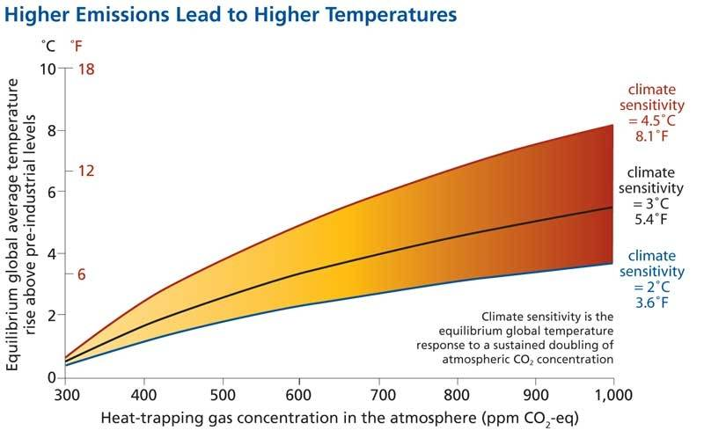
The content of OCCEI courses is effectively summarized by a graphic presented in The Intergovernmental Panel on Climate Change (IPCC) Fourth Assessment Report: Climate Change 2007 (see Fig. 1). The graphic describes the coupling between global average temperature and energy generation, illustrating the significant range of uncertainty (see Fig 1). The X-axis represents CO₂ concentration in the atmosphere, driven by the rate at which we burn fossil fuels. The Y-axis represents the modeled response of average global temperature under different assumptions of “climate sensitivity (the response of the atmosphere to a sustained doubling of CO₂ concentration). Without any feedback processes (e.g. clouds) that sensitivity is 2 C. However, models that incorporate various feedback mechanisms yield sensitivity as high as 4.5 C. The difference between these two scenarios is large in terms of overall impact on the Earth. Because annual CO₂ concentration increases have accelerated since 2003 from a historical rate of ~1.25 ppm/year to ~2.0 ppm/year (due to the emergence of China and India into the global economy and the corresponding increase in fossil fuel use), we are now faced with both serious global climate change, and substantial uncertainty in the magnitude of the long term change.
Figure 1: Higher Emissions Lead to Higher Temperatures.
Understanding the science underlying the above claims is central to OCCEI professional development and the attainment of climate literacy by the participants.
Classroom Pedagogy for Climate Change Literacy
Improving overall public climate literacy requires that teacher content knowledge be joined with effective, inquiry-based pedagogy emphasizing data analysis. Our past work in science teacher professional development indicates that many K-12 teachers equate inquiry-based pedagogy with teaching the “scientific method” (Carr, et al, 2009). This is especially true in middle and high school, where students often apply the steps of the scientific method in simplistic, artificially contrived contexts, usually disconnected from vital science concepts. It is therefore critical that innovative pedagogy be modeled, taught, and supported in content-focused professional development, coupling content knowledge with content pedagogy. To blend content and pedagogy in professional development, OCCEI incorporates research-based data-centered inquiry in its courses and activities, modeling pedagogy in which student learning is driven by the investigation and analysis of authentic observations and data (Bothun, 2003). Data-centered inquiry differs from the “scientific method” in that the student will articulate, test, and reconstruct their flawed conceptual models using real data and observations. NASA provides a wealth of ON line data for this purpose; other agencies such as NOAA provide rich data as well.
OCCEI uses data-driven inquiry to target central yet difficult concepts necessary for understanding climate change. For example, many novice students (and teachers) think of the atmosphere as a simple “blanket,” and they apply this model when considering the effect of greenhouse gases. The “blanket” model, while somewhat useful, is insufficient to properly understand the physical interaction of solar radiation, atmospheric constituents, and terrestrial albedo in driving global temperatures. An instructor using a data-centered pedagogical approach to teaching novices a more complex and useful model of the atmosphere would first prompt novice students to articulate their understanding of the atmosphere and the greenhouse effect. Explanations typically include the “blanket” model, as well as other misconceptions. Students would then be prompted (through discussion or other activity) to consider how their model(s) might predict the energy transmission/absorption properties of the atmosphere. A typical student response might be, “The CO₂ in the atmosphere reflects back heat emitted by the ground, like a blanket reflects back heat from my body.” Student ideas or hypotheses are then “tested” by examining data, in this case, wavelength-dependent transmission data of atmospheric gases such as N₂ CO₂, and CH₄. Students are supplied raw data that they then represent using graphical software. As students notice the different transmission characteristics of atmospheric gases at different wavelengths, it becomes apparent that the “blanket” model, while somewhat useful, requires modification in order to explain the data. The teacher facilitates the re-construction of a modified model to compare with the pre-existing model. By testing initial conceptions against data, students learn not only an improved model for understanding the underlying science of the atmosphere, but gain critical experience in analyzing real data.
Approach and Methodology
OCCEI will offer a comprehensive, interdisciplinary, professional development program consisting of an intensive one-week summer institute, school year mini-institutes delivered in a hybrid format, and classroom co-teaching partnerships, an innovative strategy in which scientists and teachers work side-by-side in the classroom. The institute coursework links fossil fuel energy, alternative energy sources and global climate change into one seamless educational package that demonstrates the overall connectivity between the human activity of energy generation and the subsequent impact of that activity on climate change. Classroom co-teaching partnerships promise to transform classroom practice and ensure that increased teacher content knowledge powerfully impacts student experience.
OCCEI Professional Development Model
OCCEI builds on North Coast Teachers Touching the Sky (NCTTS), a successful three-year ESEA Title IIB Math/Science Partnership project delivered by the PI and Co-I to six rural, high-poverty Oregon coast school districts from 2005-2008 (Carr, et al, 2009). NCTTS trained school-based teams of K-12 teachers to better utilize inquiry-based science instruction models within a comprehensive earth and space science curriculum. NCTTS activities included two week-long summer fieldwork institutes, a series of on-site Friday-Saturday mini-institutes during the school year, and hands-on mentoring and observation of participant teachers in their classrooms. NCTTS enabled the development of a robust and abiding partnership between PI Bothun and Co-PI Carr, their respective institutions, and the teaching and administrative staff of a number of rural, high-needs, partner school districts. The communication and trust built over several years in comprehensive partnership serves as a strong foundation for OCCEI.
Like NCTTS, OCCEI seeks to enhance critical teacher content knowledge, build the capacity for inquiry-based science teaching, and develop teacher leadership for sustainable and meaningful action in schools. This articulated approach between content knowledge, content pedagogy, and a focus on teacher leadership leads to powerful and coherent teacher professional development (Penuel, et al, 2007). OCCEI will extend and build on what has been learned in previous work, with content focus on earth systems science and climate change, and modeling data-driven classroom inquiry using NASA and other earth observation data resources. Critically, OCCEI will rethink the way teachers are supported in their classrooms, engaging scientists, master teachers, novice teachers, pre-service teachers, science educators, administrators, and others, in classroom co-teaching partnerships.
Partner School Districts: Nowhere in Oregon is the need for professional development (PD) in science teaching more acute than in high-poverty, rural school districts. OCCEI is partnering with with five small, rural districts of the Oregon North Coast, including Tillamook SD 9, Nestucca Valley SD and Neahkanie SD in Tillamook county, Seaside SD and Astoria SD in Clatsop county. These districts were selected based on a combination of higher than average community poverty, the presence of diverse, underserved student populations, and a student underachievement in science based on 2008 Oregon Department of Education achievement test data. Oregon’s North Coast is largely agricultural, with many families involved directly in agribusinesses such as farming, milk production, fisheries, and forestry, industries directly impacted by climate change. Past experience has shown that teachers in the rural districts we serve our prefer intensive, face-to-face summer PD, followed during the busy school year by a more flexible, hybrid delivery format blending face-to-face and online activities. OCCEI delivers an interlocking set of PD activities designed to sustain learning through a full school year and provide hand-on support in classrooms (see Fig. 2)

Classroom Co-Teaching Partnerships: The ultimate goal of PD is to increase student learning. In the past, such development for science teachers often consisted of short, “one-shot” workshops without post-activity support; this approach to transmitting educational innovation was largely ineffective (Desimone, Smith & Ueno, 2006). More recently, researchers have emphasized the “sustained” PD, in which support continues in schools and classrooms for at least 100 hours throughout the school year (Meyer & Barufaldi, 2003). NCTTS sustained its summer institute work with periodic short workshops during the school year, classroom observation visits by staff scientists, and the support of release planning time for teachers. However, even with these sustained efforts, the measured impact on teacher practices in NCTTS classrooms varied widely between individual teachers and schools. While the PD “transmitted” by NCTTS resulted in clear gains in teacher content and pedagogical knowledge, too many teachers and their students experienced little discernable impact in the classroom (Carr, et al, 2009). This provided us strong evidence that we can and need to do better. Those lessons learned from NCTTS have empowered us to adopt an additional strategy for OCCEI.
Classroom Co-Teaching Partnerships
On-Site Mini-Institutes and Online Coursework Courses
PROGRAM EVALUATION
NASA Mission Data and Resources
Teacher Climate Change Literacy

Data-Driven Inquiry

Student Learning

Teacher Leadership
NASA Oregon Climate Change Education Summit
(Summer
Institute)
Figure 2: OCCEI Professional Development Model
OCCEI seeks to transform the “transmission” model of PD by creating classroom co-teaching partnerships, an approach to diffusing innovative practice in which scientists and researchers work alongside classroom teachers in situ (Henderson, Beach & Famaino, 2006). OCCEI will facilitate a co-teaching partnership in each OCCEI school, engaging staff scientists and science educators, master, novice, and preservice teachers, and school administrators in the joint task of working with students in real time, “learning at each others elbows” (Roth & Tobin, 2002). Through a variety of co-teaching situations, all stakeholders will learn first hand how professional development must be adapted, modified, or even radically rethought in order to be successfully carried out in unique school and classroom contexts. Significantly, OCCEI will include in classroom co-teaching partnerships pre-service teachers from Pacific University’s National Science Foundation Robert Noyce Scholar program, further broadening OCCEI impact to include approximately 25 preservice teachers.
OCCEI Climate Change Education Model
OCCEI uses earth systems science as the foundation for understanding climate change (see below). In addition, we emphasize energy production as part of the climate change process, leading to a more comprehensive content package than similar efforts, which focus just on climate change. OCCEI strongly integrates energy and climate change in order to demonstrate a) the scale at which conventional fossil fuel facilities need to be replaced by non-greenhouse gas emitting sources of energy production, b) the kinds of technologies that need to be developed and deployed, and c) the timescale over which real implementation of significant sources of alternative energy can be brought on line. Both recent studies (Carnegie IAS Commission on Mathematics and Science Education, 2009) and our own experience teaching at the undergraduate level indicate that students are becoming increasingly concerned, interested and passionate about climate change and alternative energy, but their passion is not well informed. As climate literacy begins to emerge as a pre-requisite to being an educated citizen, science teachers need to be well trained on how to deliver this complex subject in an understandable and physically truthful manner.
OCCEI will create a multifaceted web-based suite of climate visualization and data analysis tools that will enable a data-driven learning approach to better engage teachers and students the issue of climate change as it relates to our choices of energy production. The study of energy production (and use) encompasses a broad range of interconnected themes, providing an excellent opportunity to integrate not only math/science/technology subjects but also social, political, economic and environmental aspects. Effective science and environmental education may be particularly important in light of strong evidence suggesting that American students – in fact, the U.S. public in general – are lacking in awareness of environmental and energy-related issues (BAMS, 2005; NEETF, 2002). Education programs that promote scientific literacy will help prepare students to interpret scientific, environmental, and energy-related issues and make sound choices and actions as voters, consumers, and professionals. Thus, the overarching goal and motivation of our proposed effort lies in the hope that introducing global climate change in the middle and high school curriculum will ultimately produce better consumption choices by individuals.
Earth Systems Science: Gateway Knowledge for Climate Change Literacy: One important finding of NCTTS that strongly informs OCCEI was the identification of considerable deficiency in teacher knowledge in the general area of Earth Systems Science (ESS). This is hardly a surprise; much of the necessary foundational material in ESS didn’t even exist in college 10 years ago when most participant teachers were trained. As ESS becomes increasingly important as a conduit for understanding global climate change, it becomes imperative that teachers be well trained in ESS and be well exposed to the wealth of data resources that are now available (mostly online) and are currently contributing to our understanding of ESS.
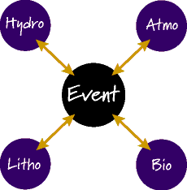
Knowledge of the various pathways in which the Earth systems are all connected is critical to understanding climate change. The existence of feedback channels (positive and negative) within the overall climate system are some of climate change’s most important physical drivers, but teacher knowledge of the role of these feedback systems has proved to be virtually non-existent. The lack of recognition of the connectivity of ESS processes became evident during the previous NCTTS project when teacher teams were assigned an earth systems analysis project. The purpose of the analysis is to sketch some of the ways “events” both natural (e.g. forest fire, flood, windstorm, volcanic activity, tsunamis, etc) or man made (e.g. Columbia River Dredging; construction of LNG import facilities, etc) have upon the various earth system spheres (e.g. atmosphere, lithosphere, hydrosphere, biosphere). The analyses done by teachers tended to show only the simple, direct causal connections between the given event and the four spheres, treating earth systems in isolation from each other (see Fig 3).
Figure 3: Simple Event-System Interactions
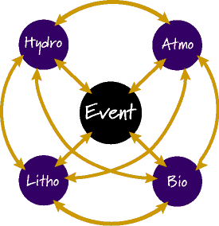
Clearly, in a complex system such as the Earth, multiple pathways exist. Figure 4 represents a more complete set of connections that the event ultimately triggers. Our experience, however, is that K-12 teachers have great difficulty conceptualizing these pathways, let alone identifying the physical drivers behind the pathways. In a similar way, the linkage between industrial processes and global climate change also follows many routes; a central goal of our approach to this subject is to reveal some of this routes. In particular, it becomes important to discuss the role of methane in global climate change in terms of these various routes and feedback channels. Increased literacy in climate change, therefore, can be represented by helping teachers transition their concept of linkage away from Figure 3 and towards Figure 4.
Figure 4: Complex interactions between and among systems

Climate Change Curriculum Framework
Much of OCCEI course content originates with the wealth of undergraduate curriculum material on both global climate change and global energy production that the PI has produced over the last 5 years. OCCEI course content is consistent with the Climate Literacy Framework set out by the National Oceanic and Atmospheric Administration and the National Science Foundation. It is also intended to introduce the science that underlies much of the policy recommendations of the fourth assessment of the Intergovernmental Panel on Climate Change (IPCC, 2007).
Essential Questions: OCCEI courses are anchored in four essential questions of climate change:
- What are the physical drivers of the climate system and the dynamics by which they are maintained or altered? Teachers will learn about jet streams, ocean currents and the various known interaction mechanisms. Short-term fluctuations such as El Nino and La Nina will play a major role in this discussion, as they are well-documented agents of change in altering major climate patterns (most educators are unaware of how their local climate changes with respect to the El Nino/La Nina cycle).
- How is data used to measure regional climate and to detect regional climate variations? Teachers will learn how to retrieve extant climate data, how to visualize it, and how to use it to define a given climate in a physically defensible manner. Presently, most teachers (and other policy makers) simply teach the “fact” that climate change is occurring. In order to make physical sense of climate change, teachers will learn to define a regional climate, and use extant NASA and other data resources to show that the defined climate has actually changed. Since climate data is generally noisy, it is ultimately ambiguous and the same data set may be used to support multiple points of view. One of the main indicators of climate change literacy is the ability to recognize what conclusions the relevant data can and cannot support. The intrinsic nature of climate data offers an excellent opportunity to improve teacher’s understanding of science as an uncertain process.
- How are climate and climate shifts often driven by processes that operate for decades? Decadal changes (e.g. the PDO or the AMO – see below) are now well defined by data, but their origins remain a significant puzzle. However, the existence of these climate cycles is very important in terms of choosing a baseline climate if one wishes to assess whether or not climate change has occurred.
- What are the exchange processes between the atmosphere and the ocean, the ocean and the land, and the land and the atmosphere? The rates of exchange of these processes are determined by planetary energy balance considerations. The basic effect of human activities on climate is to alter these rates of exchange thus taking the system out of a state of equilibrium to a more unstable state or volatile state. A fair argument can be made that this leads to increasing climate and weather volatility. The amplitude of our exchange rate alterations is directly correlated with the rate at which we use fossil fuels as our primary energy source relative to the rate that natural processes mix them out of the atmosphere.
Historical Evolution of Climate Models: Our historical understanding of atmospheric processes and climate progressed from the simple to the complex, creating a natural pedagogical pathway around which to orient OCCEI curricula. Teachers will first be introduced to the recent evolution of the IPCC climate modeling process, becoming familiar with the overall complexity of the climate system and the components by which it is commonly described.
Some major themes teachers will examine along this historical pathway are:
- In the mid 1970’s climate models were very crude and consisted of incoming solar radiation, the principal driver of climate, coupled with precipitation patterns. Direct CO₂ injection into the atmosphere from fossil fuel burning was the only feedback channel considered.
- By the mid 1980’s the role of clouds was introduced to the model, either as high altitude highly reflective ice crystal clouds that serve as cooling agents (negative feedback), or as low altitude water vapor clouds that provide additional warming (positive feedback). In addition, the changing albedo (reflective properties) of the Earth were being considered due to a) changing land use patterns (e.g. paving over green space) and b) changing character of ice masses (either through melting or becoming dirtier due to particulate pollutants settling out at the poles).
- At the time of the IPCC First Assessment Report (FAR) in 1990, climate models had grown to also consider the effects of the oceans as a simple “swamp” for CO₂ storage. The FAR issued presented this overall consensus statement:
The unequivocal detection of the enhanced greenhouse gas effect from observations is not likely for a decade or more.
- By 1995, the Second Assessment Report (SAR) climate model had become considerably more sophisticated than the earlier models by incorporating two new features, a) sulphate particles in the atmosphere either from volcanic events or from industrial processes (mostly coal burning), and b) the recognition that the ocean is a transport and storage system for CO₂ through the action of deep ocean current transport mechanisms. Not surprisingly, The SAR reached a somewhat different consensus:
The balance of the evidence suggests a discernible human influence on the behavior of the global climate.
The findings of SAR in 1995 represent a crucial “pedagogical moment” in climate change education. On one hand, sufficient data existed in 1995 to support the case for anthropogenic climate change. On the other hand, the intrinsic ambiguity and uncertainty of climate data challenged the public and policy makers to make a scientifically literate assessment of the facts. Lacking such literacy, the public expected instead unambiguous “smoking guns” to establish sound public policy. A central pedagogical goal in OCCEI courses is to train teachers to effectively understand how to manage the inherent ambiguity and uncertainty in climate data in order to reach a trustworthy scientific conclusion.
- The third assessment report (TAR) issued in 2001 used essentially the same climate model parameters as the SAR with just small refinements in how atmospheric aerosols were incorporated into the models. That TAR consensus statement was a bit stronger than the SAR statement:
There is new and stronger evidence that most of the warming observed over the last 50 years is attributable to human activities.
- The fourth assessment (AT4) was released in February 2007. Additional refinements in AT4 model a) changing vegetation patterns that alter the overall exchange rates within the carbon and sulphur cycles between the land and the atmosphere and b) the recognition that atmospheric chemistry (particularly the 12 year cycle associated with the breakdown of methane) can produce decadal changes in the overall microchemistry of the atmosphere. AT4 included the strongest consensus statement to date:
Most of the observed increase in globally averaged temperature since the mid 20th century is very likely due to the increase in anthropogenic greenhouse gas concentrations.
This statement became much more visible to the public because a) AT4 asserts the global average temperature has indeed increased and b) the likely reason is human activities. Yet, as noted earlier, a significant portion of the public remains convinced that there is “no real evidence for anthropogenic climate change” (Pew Research, 2009).
Data-Driven, Project-Based Pedagogy: Participant teachers will learn how climate change models have evolved by engaging in a series of data-driven projects and activities. Studies have suggested or directly shown that data-driven learning is an effective pedagogy that requires the application of scientific thinking to authentic, ambiguous data (Blumenfield, Krajcik, & Tal, 2006; Baker & White, 2003; Bednarz, 2000). Such exercises also lend themselves readily to collaborative, active work and a high perceived relevance of content, improving the learning and retention of science concepts (Kucharski, et al, 2005).
OCCEI’s data-driven pedagogical approach is consistent with recent developments in curriculum reform, aimed at the integration of science, technology, and mathematics as they relate to the real world (Yager, 2004). The issues of climate change and energy generation is highly relevant and thus allows for an effective teaching of scientific methods within a societal context that is meaningful to today’s student. Environmental and energy-related issues provide a convenient platform for problem or project assignments in an integrated math/science/technology project-based curriculum; OCCEI courses will expose the participant teachers to range of possible projects that, in turn, they can co-teach alongside project staff to their own students.
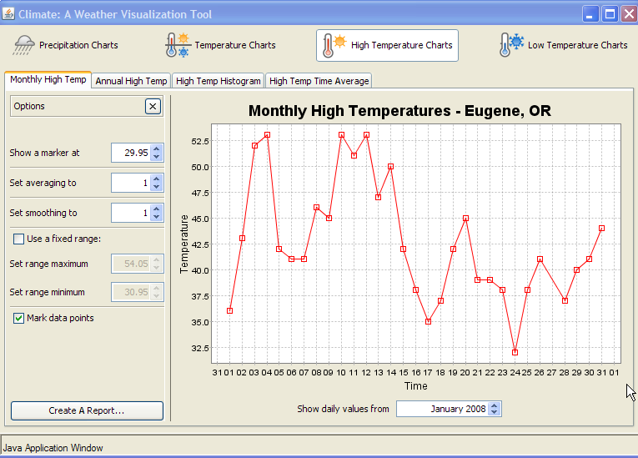
Data Visualization Tools and Climate Data Sets: OCCEI teachers will learn to access and implement in their classrooms the rich climate data sets available from NASA missions and other sources. In addition, teachers will be provided a suite of climate data visualization tools. We already have constructed some of these tools and have successfully used them in past projects. For example, we have developed a “Monthly Climate Visualizer” (see Fig 5), which incorporates a data set that contains the high/low temperature and precipitation data for every day in Eugene Oregon from 1940-2008. This interface allows students to interrogate the data either on a monthly or annual basis. Smoothing and averaging algorithms are built in so that students can construct smooth decadal averages to search for signatures of climate change. Virtually any climate data set can be used as input to this tool, and a very wide range of data driven exercises can be performed.
Figure 5: Monthly Climate Visualizer
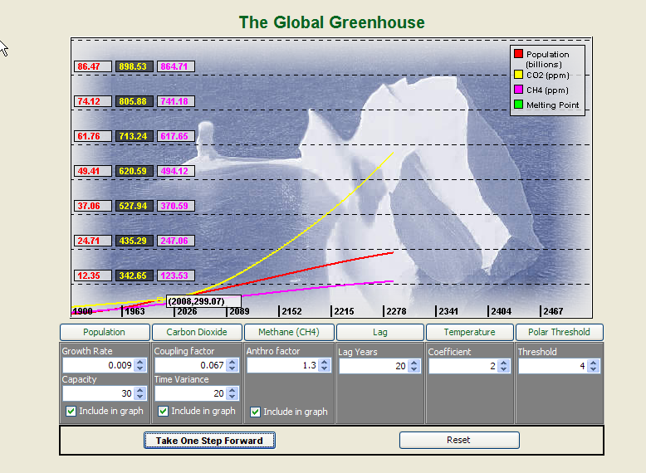
A second tool we have designed and implemented is “The Global Greenhouse,” a climate change simulator, allowing the manipulation of a very comprehensive set of adjustable parameters that fully define, in an operational way, the potential behavior of the Earth’s climate system to human activities and involves a metaphorical melting of the polar caps (see Fig 6). This climate change simulation begins in 1900 with initial conditions of 1.5 billion human population, 280 ppm of atmospheric CO₂, and 20 ppm of atmospheric methane equivalent. The graphs show the behavior of these three outputs as a function of time based a set of adjustable input parameters (see Table 1).
Figure 6: The Global Greenhouse
Table 1: Adjustable Parameters in The Global Greenhouse
Human Driven Rates |  | Climate Model Factors
Name | Definition | Name | Definition
Capacity | This factor adjusts the rate of growth of the human population | Lag | The time it will take for the atmosphere to initially respond in terms of having a temperature change with respect to CO₂ buildup.
CO2 | This factor is treated as a percentage of the total worlds population that uses Fossil Fuels. | Temp | This is the climate sensitivity parameter discussed earlier in relation to a sustained doubling of CO₂.
CO2V | This controls the future fraction of the world population that uses fossil fuels. It can be set to a fossil intensive nature (India/China continue to use fossils) or to a renewable future (less and less of the world’s population depends on fossil fuels). | Polar | The temperature threshold at which the polar caps melt. We are currently very uncertain of this parameter. The parameter can be varied from 2 to 8 degrees.
Anthro | This is the anthropogenic methane factor. In general, it will remain at 1. However, if we can find ways to grow rice without producing methane, have co-energy generation at sewage treatment plants, or eat less beef the factor can be less than 1. On the reverse side values greater than 1 represent methane release from now unfrozen permafrost; the worst potential form of positive feedback that greatly amplifies the rate of global climate change.

Within The Global Greenhouse, users can run many different combinations of models and test various scenarios against favorable and unfavorable climate models. One standard exercise is to given different teams different climate models and then run the simulation to compose a press release on the potential impacts of global climate change. In this way teachers and students can begin to understand and appreciate the strong relation between predicted societal impact and climate model uncertainty. In addition to the above data visualization and modeling tools, OCCEI courses will draw heavily on NASA resources and analysis of NASA imagery as they relate to aspects of global climate change. Course material and exercises will also make heavy use of Google Earth as well as the rich image data sets such as those available at NASA’s Earth Observatory. As a capstone project for the institutes, teachers will create and present concept maps that effectively link our current understanding of climate drivers with climate data and with energy use.
OCCEI Work Plan and Timeline
The timeline below assumes a funding cycle beginning 1 April 2010; work will begin as soon as project is approved, giving ample time to plan and deliver the initial summer institute, the NASA Oregon Global Climate Change Education Summit. We will use a generative process in developing further project components, informed by continual ongoing analysis of formative assessment data collected at all OCCEI activities (see Table 2).
Table 2: OCCEI Work Plan and Timeline
Timeframe | Activities
Jan-June 2010 | - Hold planning meeting and finalize institute design structure and content  - Hold information meetings at district sites  - Recruit initial cohort of 24 participants in school-based teams including a minimum of 3 teachers and 1 building or district-level administrator.
Aug 2010 | - Hold NASA Global Climate Change Education Summit at Pacific University Campus in Forest Grove, OR. 40 hour face-to-face course held in intensive 5-day format.  - Collect and analyze pre-assessment data.
Oct-Dec 2010 | - Deliver second 3 quarter-hour hybrid course (online plus two Friday/Saturday mini-institutes) focusing on energy generation and the integration of climate science and energy production.  - Initiate classroom co-teaching teams in participant schools.
Jan-Mar 2011 | - Deliver third 3 quarter-hour hybrid course (online plus two Friday/Saturday mini-institutes) focusing on the analysis and representation of climate data, computer related data analysis and the construction of data sets and exercises for students  - Continue to develop classroom co-teaching teams in participant schools.
Apr – May 2011 | - Classroom co-teaching teams implement climate change lessons in schools  - Presentation of concept map capstone projects  - Summative assessment  - Analysis of assessment data reflection, revision of practices  - Submit annual report to NSPIRES
June 2011 | - Select/recruit master teachers from OCCEI program completers for participation in new yearly cycle.  - Start next cycle with similar calendar as above

OCCEI Activities: The OCCEI program will begin with the NASA Oregon Global Climate Change Education Summit (GCCES) a five-day intense summer institute held at Pacific University in Forest Grove, OR, located 1-2 hours drive from partner districts. GCCES and NASA will be publicized as a significant campus event including local media and public demonstrations and talks related to climate change aimed at preservice teachers and undergraduate students present on campus during the institute. Each day will consist of a morning and afternoon session of instruction and activities using university classroom, lab, and computer resources. Participants will be provided food and refreshments, and will have the option of lodging on campus or returning to their homes each evening.
Activity will continue during the school year in a series of four Climate Change Mini-Institutes, held as Friday evening dinner meetings/Saturday workshops in school district facilities. The mini-institutes will be publicized locally and the work of teachers featured in local press outlets (which always improves morale). Learning will be sustained flexibly with online activities and exercises between the mini-institutes.
Classroom impact will be ensured by creating at each school site a Co-Teaching Partnership, consisting of participant teachers, the building principal, an OCCEI scientist (PI and/or co-PI), and a NSF Pacific Noyce Scholar pre-service science teacher. The partnerships will develop and co-teach in a variety of configurations OCCEI lessons and units. The goal is that all partners will be significantly involved in “live” teaching of climate change curriculum and in post-lesson dialogue and analysis of student learning. OCCEI scientists will engage in a minimum of three co-teaching sessions at participant schools. Co-teaching teams will be provided with modest funds to support class release time for planning and dialogue.
Participant Teacher Compensation: Teachers respond positively to being treated as professionals, and adequate compensation for out-of-contract time spent in PD. Our prior experience in NCTTS revealed how the critical role of this compenstation. OCCEI will compensate participant teachers $1500, divided into three $500 payments tied to completion of program requirements. This sum compares well with other high-quality professional development programs in our state, some of which compensate teachers at up to $3000 per year. Participants will also earn UO graduate level credit, for each completed workshop through the UO’s continuing education program.
Partnership Experience & Sustainability
OCCEI partners have substantial experience delivering sustained, collaborative professional development over the past several years, sustaining work between funded projects. Examples of prior professional development projects involving OCCEI partners include North Coast Highly Qualified Science Teacher Initiative (NHQSTI) an ESEA Title IIB MSP Grant, serving 48 K-12 teachers along Oregon’s North Coast from Nestucca to Astoria. During the three-year project, NCHQSTI developed a robust and valid evaluation model for assessing teacher content knowledge, classroom implementation of inquiry-based teaching, and student learning outcomes. NCHQSTI was noted by external evaluators for its high coherency and impact on participating teachers (Northwest Regional Education Lab, 2008).
Management Team: Dr. Greg Bothun (PI) will assume lead responsibility for developing and delivering OCCEI climate change curricula and digital tools. Dr. Bothun has been involved in K-12 teacher professional development since 1990. He is the director of the Pine Mountain Observatory and oversees a large in-state K12 visitation program that is done in conjunction with the Friends of Pine Mountain Observatory – a group of local amateurs that help to support the educational outreach mission of the observatory. Dr. Bothun has also developed an extensive series of physics/astronomy/earth system science JAVA/FLASH based visualizations, simulations and virtual experiments to serve as important aids in both data- and inquiry-driven curriculum (see http://homework.uoregon.edu/demo/). Dr. Bothun recently chaired a national conference on how improving computing infrastructure can lead to breakthroughs in various forms of renewable energy – (see http://www.sc.doe.gov/ascr/WorkshopsConferences/CRNARE.html).
Dr. Kevin Carr (Co-PI) will assume lead responsibility for developing delivering curriculum in data-driven pedagogy and in developing co-teaching partnerships. Dr. Carr has been actively involved since 1998 in professional development of both pre-service and in-service science teachers. He is an expert on educational action research, collaborative and inquiry-based learning and program evaluation and assessment. He was Co-PI with Dr. Bothun of North Coast Highly Qualified Science Teacher Initiative, NCLB Title IIB Grant, Oregon Department of Education, 2005-2008 ($554,000) and in 2003 was awarded a NASA IDEAS grant, in conjunction with Dr. Bothun, to better train Oregon high school teachers in astronomy. He currently serves as PI for a NSF Noyce Scholarship Grant for supporting new STEM teachers serving in high-needs schools.
Sustainability: Our past projects have been sustained by adhering to two specific principles: First, we include district superintendents as active partners, assisting in teacher selection and support. Second, we select school-based teacher teams who will mutually support each another in enacting innovative content, tools, and pedagogy into their own curriculum. OCCEI will create co-teaching partnerships, which will bring OCCEI scientists and researchers into the classroom with participants, working together for student learning. We anticipate that the relationships formed during the development of co-teaching partnerships will result in deep and transformative change for all partners.
Dissemination: The Oregon Department of Education will be provided with much-needed teacher-developed and field-tested models of climate change curricula, place-based projects, assessments. Presentations will be made at the Oregon Science Teacher Association (OSTA) meeting beginning in fall 2010, along with publication of articles in The Oregon Science Teacher (TOST), and other national science education and practitioner journals.
Evaluation
OCCEI will carry out a rigorous and comprehensive program evaluation with assistance from project partner Northwest Regional Education Laboratories (NWREL). NWREL provides research and development assistance to education, government, business, and labor as part of a national network of 10 educational laboratories funded by the U.S. Department of Education, Institute of Education Sciences (IES). NWREL Evaluation Specialist Edith Gummer has participated in all phases of project design as a member of the OCCEI writing team.
Instruments and Design
OCCEI will perform a rigorous analysis of project impact on teacher content knowledge, classroom practices and student learning. OCCEI has selected instruments and analysis procedures appropriate to a mixed-methods experimental design (see Table 3). OCCEI will implement a pre- post-test design to evaluate changes in teacher climate change literacy, and to better understand participant knowledge and misconceptions on the general topic the greenhouse effect, global climate change, and world energy use. Impact on classroom practice will be assessed during the project using the Reformed Teaching Observation Protocol (Piburn et al, 2000). The RTOP details for each participant a composite measure of multiple aspects of lesson design and implementation, content taught and classroom culture. Careful training of evaluators is required for effective implementation of RTOP. OCCEI partners have used the RTOP for several years and have established staff inter-rater reliability.
Table 3: OCCEI Evaluation Plan Maps to NASA and Project Goals
NASA Education Outcome Objective | OCCEI Goal | Instrument(s) | Analysis Method
2.2 Provide long duration and/or sustained professional development opportunities to educators that results in in deeper content understanding and/or confidence in teaching STEM disciplines | 1(a). Increase teacher climate change and earth systems science literacy | Climate Change Literacy Instrument (OCCEI-developed) | Pre-Post Comparison
 | 1(b). Improve teacher access to NASA climate change and NASA earth systems science resources | Fieldnotes  Interviews | Open-coded for category access to resources
2.4 Provide K-12 students with authentic first-hand opportunities to participate in NASA mission activities, thus inspiring interest in STEM disciplines and careers. | 1(c). Encourage pedagogical innovation and (d) transform classroom practice | Fieldnotes  Interviews  RTOP  Video Taping | Formative comparisons as project progresses
 | 2. Increase the number of middle and high school students using NASA Earth observation data/NASA Earth system models to investigate and analyze global climate change issues | Fieldnotes  Interviews  RTOP | Formative comparisons as project progresses

