Scientific Justification

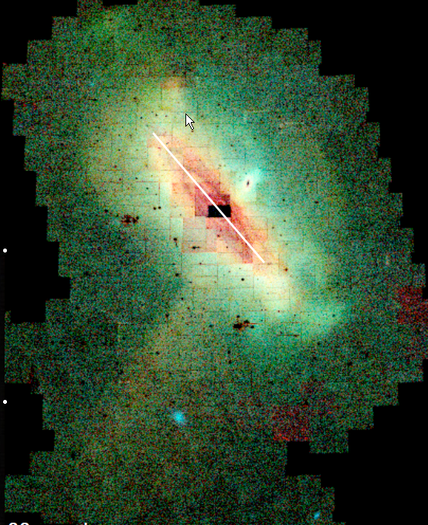
Over the last few years, new observations have provided increasing evidence for the presence of stars that are no longer associated with galaxies (e.g. the intergalactic stellar population). These intergalactic stars were first discovered in the Virgo cluster (Ferguson etal 1998; Durrell etal 2000) and there presence was attributed to tidal stripping processes. This discovery is important as it shows that, as the Universe evolves, it’s possible that certain dynamical processes can work to remove stars from their host potential wells. Current unknowns in this process are a) the efficacy of this removal process in different environments and b) the total potential these removal processes have in establishing a relatively large amount of intergalactic baryons (which may or may not infall back into extant potential wells). The existence of very extended and diffuse intergalactic populations of baryons has been made more clear by a) the discovery of very extended but diffuse filaments of stars and gas (e.g. Yagi etal 2007) and the now well known occurrence of XUV disks as discovered in previous GALEX imaging cycles. In addition, there is also the well known occurrence of both young and old stars at extremely large galactocentric distances in M31 and M33 (Ferguson et al 2007) as well as the phenomenal 10 scale length extent of NGC 300 (Bland-Hawthorne etal 2005). Using U-band surface brightness fluctuations as measured with the 1-meter telescope at the University of Oregon’s Pine Mountain observatory we have also verified the likely presence of greatly extended stellar populations around M31 and M33. Figure 1 shows a representation of this data (a “tidal” filament can clearly be seen) where it can be seen that there appears to be a greatly extended population of stars around M31 proper (diameter indicated by the white line). Such a greatly extended population of stars would seem to be easily subject to disruption thus producing a likely population of intergalactic stars in the Local Group. Intriguingly, the most thorough study of the Extragalactic background light done to date by Bernstein etal (2002) is consistent, in a model dependent manner, with the idea that 30-50% of all stars are in fact, no longer in galaxies. If this is indeed the case, then is it possible to find any local environment which shows this large population of lost stars? As will be explicitly shown in the next paragraph the answer appears to be categorically no, except for the amazing and intriguing system of Hickson Compact Group (HCG) 90 (e.g. White etal 2003) which we therefore propose to observe with GALEX to better characterize the nature of its outstanding diffuse light component (see Figure 2).
Fig 1. M31 stellar extent

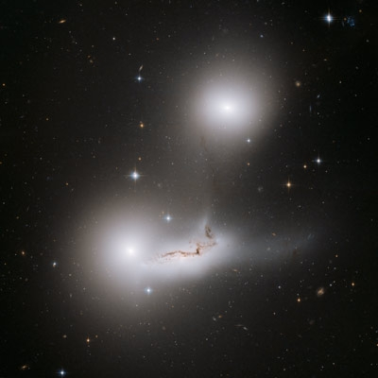
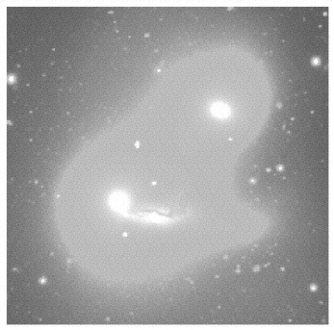
The study of diffuse light in extragalactic systems has a very long observational history. In general, the surface brightness of diffuse light is sufficiently low that its detection is often ambiguous and/or stretches the limits of detector capabilities. An early indication of this observational challenge can be found in Roach et al. (1972). In clusters and/or groups of galaxies, some amount of diffuse light (hereafter referred to as the ICL) should be present as a result of the combined actions of grazing tidal encounters, mergers, and galactic cannibalism. Robust quantitative measurements of the ICL could, in principle, help constrain the dynamical history of galaxy groups and clusters. . An early heroic photographic effort on the Coma Cluster by Thuan & Kormendy (1977) suggested that approximately 30% of the total cluster light was in the ICL component which was bluer than the composite stellar population of the member galaxies. Updated observations by Adami etal (2005) show that this diffuse emission is clumped in distinct concentrations associated with the brighter central galaxies. The blue nature of the diffuse light is suggested to be the result of star formation which is still occurring in the debris of these disrupted galaxies. In contrast, Krick etal 2006 find evidence in Abell 3888 for an ICL component that is redder than the member galaxies. The characterization of the ICL in groups of galaxies also shows large variability; for instance Mendes etal 2003 find a range of 0-18% fractional contribution of the ICL with near constant color of B-R = 1.45 in 4 Hickson compact groups (HCGs). In a study of 13 compact groups, Pildis etal 1995 found only one (HCG 94) that revealed a significant diffuse light component. In addition, Mulchaey & Zabludoff (1998) found that, although groups of galaxies are often sources of diffuse X-ray emission, there is generally little diffuse optical light that can be detected (see also Tran et al. 2001). In general, the lack of a substantial ICL component in groups is somewhat surprising as groups of galaxies, particularly compact groups of galaxies, represent an environment where tidal interactions should be very pronounced as most encounters will be slow. While one possible resolution is that the observed groups are all too dynamically young to show a significant ICL (see simulations by Rudick etal 2006) this conclusion is consistent with other features of groups that suggest they are several dynamical timescales old. Hence, based on the above, it would appear that Nature has not provided us a nearby environment that shows a large ICL from which a large population of intergalactic baryons would emerge. Ah ha, enter HCG 90- an environment strikingly different from that seen before; an environment in which the diffuse ICL dominates the total light.
Fig 2: Left: HCG 90 from HST Right: Composite Image from White etal 2003 showing galaxies + ICL; FOV approximately 6 x 6 arcminutes

HCG 90 is shown in Figure 2. There are 19 confirmed members within a 1.5x1.5 degree area. However, HCG 90 is mostly defined by its 6’x6’ core consisting of two elliptical galaxies and a much distorted disk like galaxy all of which are in the midst of some mutual interaction. The extraordinary properties of HCG 90, as measured by White etal 2003, including the following:

- The ICL comprises approximately 50% of the total V-band light. This is an order of magnitude larger than seen in a typical group and is truly unprecedented in scope.

- The mean color of the ICL is V-R =0.67 +/- 0.03. Although a spiral galaxy is heavily involved in this interaction, an associated blue component in the ICL is not clearly seen. This seems odd.

- Chandra Observations show only a weak amount of X-ray emission originating at the interface between the interacting spiral and elliptical. This emission is very cool (kT ~ 0.7 keV). The ratio of luminosity between the X-ray emitting gas and the diffuse optical light is 10⁻³ indicating perhaps that much of the gas has cooled and the system is dynamically old.

We therefore propose to observe this extraordinary system with GALEX for the following reasons.

- The optical data of White etal 2003 did not extend enough to clearly detect the edge/end of the ICL. The much larger field of view of GALEX and its low angular resolution (which is perfect for detecting diffuse light against the low NUV background of the night sky) will allow for much better definition of the ICL and the strange “kink feature” seen in the right hand side of the ICL.

- The lack of any blue population is mysterious. Possibly it is overwhelmed by the amount of old stars present in the ICL (we don’t at all dynamically understand how it’s possible to remove such a large amount of stars) that any young component can not be seen without UV observations. Identifying regions of current star formation in the interaction sphere of the core would help in understanding the overall system dynamics.

- The lack of significant X-ray emission (or really any emission) in this system was a total surprise and raises the enticing proposition that the gas has cooled significantly. If there is a significant mass of gas at 10⁵ K, then it’s possible that diffuse component might have sufficient flux in the FUV filter for detection. Admittedly, this is a stretch but if detected, this would be unprecedented and virtually everything about HCG 90 is, in fact, unprecedented.

In sum, HCG 90 is a very impressive system with extensive optical and X-ray observations. GALEX observations would nicely complement extant data and may very well reveal new features in this extraordinary ICL system. In an approved Cycle 4 program we have successfully detected more extended XUV disks who’s weakly bound nature make them natural candidates for producing eventual intergalactic stars. In this proposal we seek to explore another likely production mechanism that can occur in some strongly interacting compact groups of galaxies.

References:

Adami etal 2005 A&A 429, 39
Bernstein etal 2002 ApJ 571,107
Bland-Hawthorne etal 2005 ApJ 629,239
Durell etal 2000 AAS Bulletin 197,106
Ferguson etal 1998 Nature 391, 461
Mendes etal 2003 Extragalactic Globular Cluster Systems: ESO Workshop page 191
Ferguson etal 2007 Astrophysics and Space Sciences Proceedings: Structure and Evolution of Disk Galaxies pp 239-244
Hoopes etal 2005 ApJ 619, L99
Krick etal 2006 AJ 131, 168
Mulchaey and Zabludoff 1998 496, 73
Pildis etal 1995 AJ 110, 1498
Roach etal 1972 AJ 173, 343
Rudick etal 2006 ApJ 648 936
Thuan and Kormendy 1977, PASP 89, 466
Tran etal 2001 ApJ 549,172
White etal 2003 ApJ 585,739
Yagi etal 2007 ApJ 660, 1209

Description and Feasibility of the Observations

This proposal concerns only 1 target: Hickson Compact Group 90 as observed through the NUV and FUV filters. Most of the science goals can be meet with just the NUV observations to a) better determine the extant and structure of the previously documented ICL and b) to identify any NUV hotspots that would clearly represent interaction induced star formation (which surely should be there), but which are not evident in just the optical data alone. We desire the FUV channel as well as a high-risk (but only a 3 ksec risk) high-reward observation under the oft chance that a cool 10⁵ K diffuse component exists which contains a substantial mass of the tidally liberated gas that should be there, but is not detectable in the Chandra X-ray data. The detection of this gas, should it exist, would be unprecedented, but would also support a long suspected notion that a substantial amount of baryons might be out there hiding in a 10⁵ K gas.

GALEX has proven its unique capability to detect extended diffuse light whether it’s in the halos of starburst galaxies (e.g. the filamentary UV halo of M82 –Hoopes etal 2005) or in the XUV phenomena. Its large field, good sensitivity and the dark NUV background all combine to facilitate this king of detection. Exposure time calculators are never sufficient to return expected exposure times as a function of the surface brightness of the object. Moreover, the ability to reliably detect low surface brightness features depends more on how well the data can be flat fielded and how high the background is than the actual counts per pixel. To serve as an exposure guide, we therefore simply take the cases of the detection of the diffuse halo in M83 by Hoopes etal (2005) as well as our Cycle 4 exposures to detect diffuse XUV disks as a guide. These cases show that exposure times of 3 ksecs are sufficient to readily detect extended diffuse light against the dark background and to characterize its overall structure. Thus, we adopt 3 KSEC as the necessary exposure time for both the NUV and FUV observations.

