OSGC Earth Sciences Course Development Award Program

Proposed Course: The Physics and Politics of Global Climate Change

PI: Prof. G. Bothun, Dept of Physics, University of Oregon

Course Offered: Spring Term 2010 in the UO Honors College

Total Amount Requested: $5000

Signatures: signed cover page to come on Monday January 4

Course Description (246 words):

An immersive course in global climate change is also a course in data ambiguity – while one can build a very scientifically plausible case, one can not yet scientifically prove that climate change is human induced. Therefore, a course in climate change also serves as an excellent vehicle for improving student’s science literacy. Extant undergraduate climate change courses are generally taught a) assuming that it’s already happening, b) that regional climate change responds linearly to changing global conditions and c) that offering a physical explanation of climate change mechanism(s) is unnecessary because climate change is no longer just theoretical. While the preponderance of evidence is consistent with a, the use of climate data alone to prove a does not pass any scientific test of significance. This result is fundamental to the current policy debate. Point b can only be established empirically and without a discussion of point c students can not attain climate literacy. This course will focus on points a,b, and c. The students will be immersed in the noisy world of climate data (from various NASA sources). From those data sources, students will address two fundamental issues:

- From available historical climate data, what is the quantitative definition of a regional climate?

- Given that quantitative definition, does recent climate data show that the regional climate is indeed changing?

A secure detection of climate change requires that point 2 above pass various tests of scientific significance which the students will conduct on various data sets.

Introduction/Course Overview:

The potential for significant Global Climate Change (GCC) is likely the most severe and economically costly problem of this century. Effective solutions to mitigate its effects will require an unusually high level in international cooperation and thus this topic necessarily brings with it different cultural perspectives. For instance, China keeps posing the fairly logical argument that until they reach the same level of per capita energy consumption as the US, they are not going to cooperate much on reducing their carbon footprint. Unfortunately, the climate system can not withstand this potential perturbation by China. As awareness of this issue increases, so does the amount of miss-information, myth propagation and political agenda. It thus becomes important to focus on this issue in an objective, scientific manner so that the ambiguities and noise in the climate science data are clearly revealed. However, GCC also has significant economic, political and social dimension and the operational intent of this course is to integrate all of this together. Indeed, the recent “climategate” scandal involving the external hacking of emails at the University of East Anglia Climate center and the subsequent web spinning of those hacked emails in terms of climate scientists “making up the data to falsify the global warming signal” now becomes a very teachable moment, with a particular emphasis on the mere fact that temperature data alone may be the worst way to define and characterize GCC. The graphic below (from the 2007 IPCC report) is a good visualization of the intersection between the scientific and social dimension of this issue:

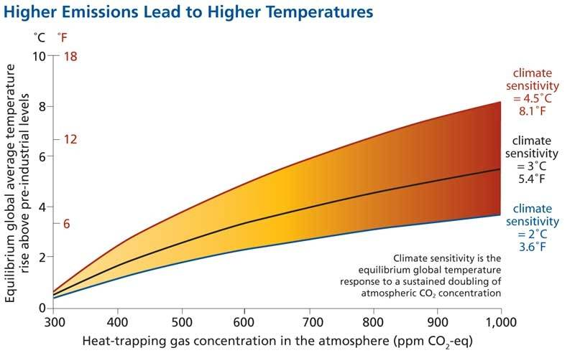

- The X-axis represents CO₂ concentration or the energy production axis of global climate change: This is driven by the rate at which we use fossil fuels. Over the period 1950-2000, the historical annual increase of CO₂ concentration was 1.25 +/- 0.2 ppm. However, starting in 2003 that rate rapidly increased to near 2 ppm due to emergence of China and India into the global economy. This is the political dimension

- The Y-axis represents the modeled response to the average global temperature under different assumptions of “climate sensitivity”. Climate sensitivity represents the response of the atmosphere to a sustained doubling of CO₂ concentration. Without any feedback processes (e.g. clouds) that sensitivity is 2 C. However, models that incorporate various feedback mechanisms yield a sensitivity of 4.5 C and the difference between these two scenarios is large. This is the scientific dimension.

Our purpose, therefore, is to fully students on a) the rates and choices that determine the evolution of the X-axis and b) the science that determines the projections of the Y-axis.

Our overall course content is consistent with the Climate Literacy Framework set out by the National Oceanic and Atmospheric Administration and the National Science Foundation. It is also intended to introduce the science that underlies much of the policy recommendations of the Intergovernmental Panel on Climate Change (IPCC) as their fourth assessment was released in February 2007. More specifically, project content will center around four principal themes:

- The physical drivers and the dynamics which maintain or alter those drivers of the climate system. Particular attention will be paid to jet streams and ocean currents and the various known interaction mechanisms. Short term fluctuations such as El Nino and La Nina will play a major role in this discuss as they are well documented agents of change in altering major climate patterns. Indeed most are not even aware of how their local climate changes with respect to the El Nino/La Nina cycle.

- How data is used to measure regional climate and to detect regional climate variations. Much of this project will be about how to retrieve various climate data, how to visualize it and how to use it to define a climate in a physically defensible manner. Presently most teachers (and other policy makers) simply assume that climate change is occurring. While, in fact that may be true, the notion of climate change makes little physical sense unless a) one can define a regional climate to being with and b) one can also use extant data to show that the climate, defined in that manner, has actually changed. Since climate data is generally noisy then it is ultimately ambiguous and the same data set may be used to support multiple points of view. But this is exactly one of the main indicators of science literacy is to the ability to recognize what data can and can not support. The intrinsic nature of climate data as a) noisy and b) an incomplete time series offers an excellent opportunity to improve teacher’s appreciation of the basic necessity that science is an uncertain process.

- The growing understanding that climate and climate shifts are often driven by processes that operate for decades. These decadal changes (e.g. the Pacific Decadal Oscillation or the Atlantic mean Oscillation –see more below) are now well defined by NASA satellite data, but their origins remain a large puzzle. However, the existence of these climate cycles is very important in terms of choosing a baseline climate if one wishes to assess whether or not climate change has occurred.

- The exchange processes between the atmosphere and the ocean, the ocean and the land, and the land and the atmosphere. The rates of exchange of these processes are determined by planetary energy balance considerations. The basic effect of human activities on climate is to alter these rates of exchange thus taking the system out of a state of equilibrium to a more unstable state or volatile state. A fair argument can be made that this leads to increasing climate and weather volatility. The amplitude of our exchange rate alterations is directly correlated with the rate at which we use fossil fuels as our primary energy source relative to the rate that natural processes mix them out of the atmosphere.

Finally, this course will also involve analysis of any possible regional climate change within the Pacific Northwest. On a more colloquial level, all in the Pacific Northwest would be aware of climate change if it suddenly started to rain a lot in the summer and not in the winter. That would be a total climate shift, obvious to even the most inane policy makers. Yet true climate shift is subtle and difficult to define and measure. This is because the intrinsic nature of the data that is used to characterize a climate is a) noisy and b) incomplete in time. Furthermore, it is now generally understood that climate in the PNW is modulated by multi-decadal cycles associated with oscillations in Northern Pacific sea surface temperatures (SST) (this is known as the Pacific Decadal Oscillation or PDO) that are punctuated with varying amplitude El Nino and La Nina events. For instance, the winter of 2007/2008 had high regional snowfall because we had entered a strong La Nina pattern (which has now ended). The oscillatory nature of the baseline climate in the PNW (and the western US) can be shown visually using many proxies, but perhaps the best proxy comes from the 500 year historical stream flow data of the Colorado River (Piechota etal 2004 EOS, American Geophysical Union, 85, 32)
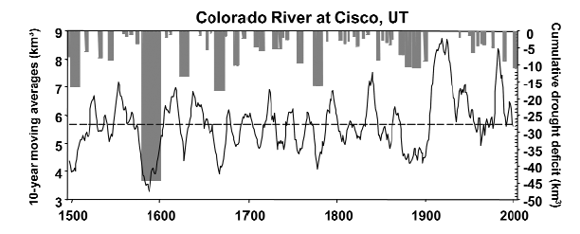
It is precisely because of the large multi-decadal volatility of the climate baseline that renders climate data ultimately ambiguous and hence the same data set may be used to support multiple points of view. As a result, policy is being made or proposed on the general assumption that climate change in the PNW must be happening since it also must be happening on the global scale. While there is likely little doubt that climate change is occurring, the rates and amplitude of that change have yet to be reliably measured. Most of the data driven aspects of this course will involve exercises that drive this fundamental point home – regional climate baselines are noisy and subject to multi-decadal variability.

Course Objectives:

This course has four principal objectives:
1. to introduce students to the science of climate change and the latest research that leads to the current grid models of climate change.
2. To emphasize the difficulty of accurately characterizing the nature of climate and therefore to determine a baseline from which climate change can be reliably measured.
3. To analyze potential social and political consequences of global climate change and the various efforts currently underway to lessen its overall impact.

4. To critically discuss why international efforts such as the IPCC, the Kyoto Conference and the recent Copenhagen summit have such difficulty incorporating the results of climate science into their policy discussions.

Deliverables:

This ten week course modular based and can be broken down as follows;
- Week 1: Economic Growth and Greenhouse Gas Emissions: growth of industrial output in the 20th century; emergence of BRIC in the 21st century; per capita emissions and GDP

- Week 2-3: The Climate Machine I: Dynamics of Atmospheres and Oceans: standard greenhouse effect; structure of the atmosphere; radiative transfer properties of the atmosphere; deep ocean currents; El Nino/La Nina; Carbon Cycle;

- Week 4-5: The Climate Machine II: Regional Effects of Climate Change: analysis of data to detect regional climate change; is it getting cloudier, snowier, rainier, windier, stronger hurricanes, more tornadoes, severe forest fires, prolonged droughts?

- Week 6-7: Climate Models and Predicative Value: How grid models are constructed; how are models constrained by data; the role of clouds and aerosols; uncertainty in the models; visualization techniques to present climate predictions

- Week 8-9: Climate Policy Choice under Uncertainty: parameter space in public policy; role of the United Nations; economic trade disruptions; policy/science forums and organizations

- Week 10: What to do about BRIC? Country profiles; current production and energy consumption trajectories;

Each module contains various data sets and various data tools that are used to analyze/visualize the data. All of these materials will be universally available via the opencourse.uoregon.edu web site – maintained by the PI.

Relevance to NASA Earth Science Focus Areas:

According to http://nasascience.nasa.gov/earth-science/focus_area_list the proposed course incorporates there of the six focus areas. In order of decreasing incorporation these areas are:

1. Climate Variability and Change – this course will make extensive use of the NASA data sets related to sea surface temperature (SST) and Arctic Sea Ice Loss measurements.

2. Weather – this course will make heavy use of the regional climate data sets available from GISS (Goddard Institute for Space Studies)

3. Carbon Cycle & Ecosystems – of particular importance to long term atmospheric effects is the role and accumulation of methane in the atmosphere. Once again this is a topic left out of most global climate change courses leaving the students thinking that only carbon dioxide matters. In fact, with its significantly higher cross section for the absorption of IR radiation, one methane molecule is equivalent in global warming potential to about 20 carbon dioxide molecules. If methane continues to rise, we will have serious IR retention problems in our atmosphere (50 years from now) even if we turn off all sources of carbon dioxide emission today! NASA is about the only agency that is systematically tracking methane emission and accumulation in the atmosphere.

Overall, our proposed course is well aligned with these Focus Areas.

Key Personnel:

- Prof. G. Bothun – Course Instructor
- Mr. Josh Rogers – Visualization Programmer
- Ms. Stephanie Ostrander – research assistant (and former OSGC undergraduate scholarship awardee)

Estimates of Student Participation:

Honors college classes at the UO are limited to 24 students. However, out of each HC class that I have taught in recent years, there have been 2-3 students that have gone on to produce Senior theses with me (see list in attached CV) and a bonus feature of these courses is that they effectively serve as a gateway for serious undergraduate research on the part of a few students that become strongly engaged with the material. I think this is a very important aspect of these courses.

Budget/Budget Explanation:

Personnel | Project Duties | Amount Requested | Institutional Match
G. Bothun | Course Instructor  Course Webmaster | $0 | About what the institution thinks of him
S. Ostrander | To acquire and format in EXCEL various regional climate data sets – she is currently working on an independent research project involving Pacific Northwest data | $2500 | UO Internal Grant to PI
J. Rogers | Programming FLASH/Java climate visualization tools - see for example  http://homework.uoregon.edu/demo/climate.jnlp | $2500 | UO internal Grant to PI

Current/Pending Support:

For the first time in his academic career, the PI currently has no external Federal support (although both NSF and NASA grants are pending). The PI has approximately 100K aggregated together through various internal University of Oregon Funding sources and grants which are being tapped to currently cover the salaries of J. Rogers and S. Ostrander. That resource can be used to match the 5K requested here.

Resume of G. Bothun

Education:
- B.S. Astronomy, University of Washington, Seattle WA, June 1976
- Ph.D. Astronomy, University of Washington, Seattle WA, August 1981

Thesis Title: A Multiwavelength Investigation of Spiral Galaxies in Clusters of Galaxies

Professional Employment
- Scientific Programmer: The Very Large Array Radio Telescope NRAO 1977
- The University of Washington, Astronomy Instructor 1980-1981
- Harvard-Smithsonian Center for Astrophysics, Center Research Fellow 1981--83
- California Institute of Technology, Bantrell Research Fellow 1983--86
- The University of Michigan, Assistant Professor in Astronomy (1986--1989)
- The University of Michigan, Associate Professor in Astronomy (1989--1990)
- The University of Oregon, Associate Professor in Physics (1990--1995)
- The University of Oregon, Professor in Physics (1995--present)
- The University of Oregon, Professor in Environmental Studies (2000—present)

Other Professional:
- UNIX System Administrator for Physics Department
- Webmaster for various educational technology curriculum projects
- Director, University of Oregon Pine Mountain Observatory (1990 – present)
- Scientific Editor, The Astrophysical Journal (1996---2002)
- National Academy of Sciences Decadal Panel (1997—2000)
- Phi Beta Kappa Visiting Scholar 2000---2001

Professional Societies
- American Astronomical Society
- Association for Environmental Studies and Sciences

Professional Experience:

Research Productivity
- 191 Papers in Peer Reviewed Journals (1980-2009)
- Original Member: ISI Highly Cited Researcher in Space Sciences (1980-2000 period)
- One Graduate Level Textbook: Modern Cosmological Observations and Problems
- One Undergraduate Textbook: Cosmology: Mankind's Grand Investigation
- Approximately 25 Popular Articles (Newspapers/Popular Magazines/Professional Blogs)
- Over $3.0 million in grant funding from NASA and NSF since 1986
- Chair of Numerous NASA Peer Reviews
- Approximately 2000 nights of Observing since 1980 on most of the major radio and optical telescopes in the world
- Extensive experience with Space Based instrumentation - including the Hubble Space Telescope

Research Interests:
- Galaxy formation and evolution
- Dwarf Galaxies
- Galaxies of Low Surface Brightness
- Large Scale Structure
- Clusters of Galaxies
- Observational Cosmology
- Applications of Instructional Technology
- Regional Climate Change Indicators
- Sustainable Energy Implementation and Policy

Honors College Thesis Student Supervision:

Harvey Rogers – Pacific Northwest Climate Change – 2004

Jesse Jenkins – Well to Wheels Analysis of 2020 Light Vehicle Fleet - 2005

Jessica Bliss – Oil Exploration in Ecuador and Indigenous Rights - 2005

Alexandra Luftig – Properties of Watershed Invertebrates – 2006

Joseph Sneed – Carbon Taxation in China – 2008

Heather Buxton - A Biological Analysis of the Impact of Oil Drilling Platforms and Pipeline Delivery in the Ecuadorian Amazon - 2009

Tommy Bairstow - The Feasibility of Cellulosic Ethanol Production in the Willamette Valley - 2009

Emily Chi -Are Atlantic Basin Hurricane Properties Changing over Time? -2009

Adrienne Wilkie - Regional Climate Change in the American Northeast -2010

Sibyl Geiselman: The Wind-Hydrogen Connection and the Smart Power Grid – 2010

Katherine Phillipson: Can a Market Based Approach to Reduced Carbon Emissions enable Environmental Justice? -2010

Ravi Parkih: The efficacy of the Energy Tax Credits and the implementation of renewable energy -2010

