Overview of Extant Program

Over the last 10 years the Astronomy Education Outreach Program, run by the University of Oregon’s Pine Mountain Observatory, has impacted thousands of visitors as well as teachers and students in K12 classrooms all around the state of Oregon. This outreach effort is certainly the largest in Oregon (in any science) and is one of the largest Astronomy outreach programs on the West Coast. The components of the outreach program include Informal Science education to the lay public, structured K12 classroom visits where the principles of digital astronomy are taught to students in a data driven manner, and summer institutes held on the grounds of the observatory which serve as Professional Development workshops for K12 science teachers. The outreach program is overseen by the Director of Pine Mountain and is implemented by a trained group of amateur astronomers known as the Friends of the Pine Mountain Observatory. Results from this program have been presented in (Kang and Gulino 2000; Bothun and Kang 2000; Kang and Bothun 2002; Kang 2004) and overall, the program continues to be oversubscribed in the state. There are simply many more requests for K12 classroom visits and well as professional development summer workshops than we are able to provide. In addition, to these activities, the PI has long been involved in the development of JAVA based data analysis and reduction appliance and simulations that provide teachers and students with the means to use authentic data as a critical part of their astronomy curriculum. It is this use consistent and central use of authentic data to frame the astronomical issue, and providing students and teachers a means of interrogating or analyzing that authentic data, that makes our overall outreach and education program distinctive.

Over the last 5 years we have consistently polled K12 teachers on the kinds of services or lessons they want our program to offer. One important result is that 40% of the polled teachers are highly interested in professional development mini workshops. While we typically hold 2 to 3 of these in a summer at the Observatory, in now way can we meet actual demand (see below for raw data). In terms of curriculum areas that K12 teachers want to see brought to their classrooms, the break down is as follows:

- 30% are interested in Astrobiology and Life in Extreme Environments as it relates to the possibility that Mars once hosted (or still does) primitive life.

- 25% want basic lessons about distances, sizes, motions and other characteristics of objects in space. Elementary school teachers specifically want information about objects in the Solar System.

- 20% want to investigate apparent sky motions using out very wide angle digital images of the sky (see Kang 2006)

- 20% want the ‘How We Know What We Know” part of our curriculum which centers around techniques that astronomers employ to essentially measure “photons”. This curriculum centers around issue of apparent flux, spectroscopy, distances from parallax measurements, and stellar temperatures as determined by filter fluxes. This entire curriculum is supported by JAVA simulations which we will explicitly discuss below

NASA resources also factor in heavily in our outreach K12 curriculum in two principle ways:

- Planets and the properties of planets and the discovery of Exoplanets are, by far, the number one topic of interest among both K12 students and teachers. Even the issue of Pluto being demoted as a planet (which is not a scientific issue) is engaging to this audience. Hence much of our classroom presentation now involves a full discussion and exploration of the various NASA planetary missions over the last few years (e.g. Galielo, Cassini, Dawn, Deep Impact, Mars Express, etc)

- In all high school or university classes the outreach program also discusses, in detail, potential NASA related careers in aerospace sciences as well as earth system sciences as NASA plays an increasing larger role in that discipline. This part of the outreach program is also done in collaboration with Oregon NASA Space Grant, headquartered at Oregon State University.

The following table breaks the program down to raw numbers of individual participants over the last 5 years. These numbers should effectively convey that our program is relatively large in scope:
The way to read this table is as follows. For the 2008-9 outreach season (essentially Sept 1 through June 14) the program visited 83 individual schools, conducted 331 separate classes at those 83 schools and those classes involved 385 teachers and 5941 students. In addition, for 2008-9, there were 25 other outreach events (these usually are weekend activities, sometimes involving teacher professional development workshops) and the total outreach scope involved 801 hours (and the outreach was often conducted by a team of individuals).

Year | Schools | Classes | Teachers | Students | Other | Hours
2008-9 | 82 | 331 | 385 | 5941 | 25 | 801
2007-8 | 66 | 288 | 310 | 4618 | 26 | 652
2006-7 | 78 | 342 | 318 | 6172 | 22 | 821
2005-6 | 76 | 335 | 324 | 5423 | 28 | 789
2004-5* | 96 | 425 | 639 | 7767 | 34 | 1064
Totals | 400 | 1728 | 1970 | 30670 | 135 | 4159

Since the schools/school districts are asked to cost-share on this program, there are some natural fluctuations in these numbers. In particular, the school year 2007-8 in Oregon was heavily fiscally constrained and correspondingly the numbers of classroom visits dropped. Note also that overall activity has been reduced by about 20% from the high year of 2004-5; that year saw a particular large number of professional development workshops as the outreach program that year was able to partner (as a subcontractor) with a Title IIb MSP program which thus effectively doubled the number of teachers that the program could reach relative to a normal year.

In sum, we have initiated a highly successful and highly penetrating Astronomy public education and outreach program within the State of Oregon. The program makes extensive use of authentic data as a means of establishing doing science by inquiry and now heavily makes use of NASA resources in terms of a) solar system exploration and b) informing students at the high school and university level about STEM career activities. The demand for the program is high, especially in the area of teacher professional development and teacher exposure to NASA resources and we are currently strongly budget limited in our ability to accommodate the need and interest in Astronomy within the state of Oregon. It is this limitation that provides the motivation for seeking additional funding and support of this program. Indeed, if this proposal is successful, it is highly likely that it can be leveraged against both the University of Oregon (who claims to be committed to public outreach) and Oregon NASA Space Grant to obtain additional funding of this worthy outreach effort.

Pine Mountain Observatory Physical Infrastructure:

The Pine Mountain Observatory (PMO) is located at an elevation of 6500 feet approximately 165 road miles due east of the University of Oregon campus. The Physics Department at the University of Oregon operates the facility but leases the land from the US Forest Service. The nearest large city is Bend (population 75,000 and growing very fast) which is 27 driving miles. The last 9 miles of this drive is on an unimproved road, irregularly "maintained" by the US Forest Service. The Observatory is located 50 linear miles from the Cascade crest and therefore is located in the prevailing dry climate of Eastern Oregon. Clear weather can occur throughout the year but is most prevalent in the period May 1 through Nov 15. Access to the observatory from Jan 1 – April 15 usually requires a robust 4 Wheel drive vehicle or snowmobile.

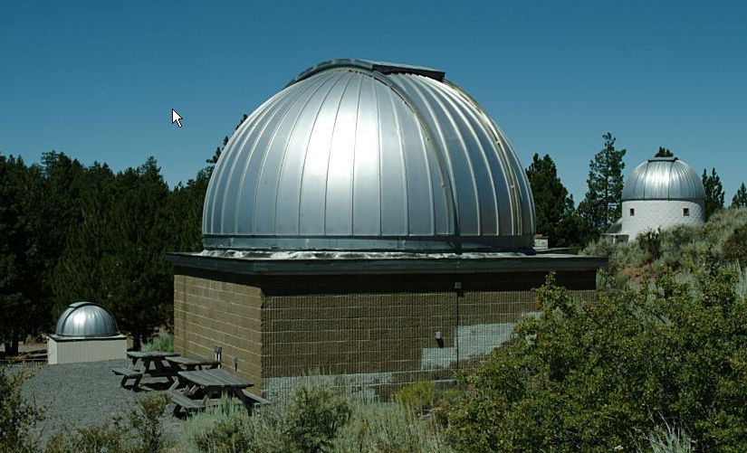
PMO was founded by E. Ebbighausen, I. Nolt and R. Donnelly. PMO had first light in 1967 with the commissioning of the 15 inch reflector (see Ebbighausen and Donelly 1968) . Shortly thereafter a 24-inch Boller and Chivens was constructed. The largest telescope, constructed by Sigma Research (long out of business), is the 32-inch telescope which was completed in 1977. Each of the three domes can be seen in this image of the observatory grounds. The primary research instrument at the observatory is a wide field Prime Focus CCD imaging system on the 32-inch telescope. This research camera is also made available for remote observing for some outreach exercises. Although there is a research component to the Observatory, its’ primary mission has been public outreach and education together with K12 classroom activities and K12 science teacher professional development.

The summer visitor season (May 15 – Oct 15) typically attracts 2-3000 visitors to participate in Friday/Saturday evening viewing sessions which are run by expertly trained amateur volunteers.
Internet connectivity to the site was established in 1997 and mountain top wireless was added in 2004. As a result of network access, dark skies, and electrical power, the Observatory has become a haven for amateur astronomers and their scopes and on a typical moonless summer night there may be as many as 20 amateur astronomers camped out on the mountain with scopes as large as
20 -30 inches. Many of these amateur astronomers are very knowledgeable about the night sky and make very effective astronomy mentors for the visiting public that evening.

Public Outreach and Informal Science Education:

The observatory is open for public viewing on Friday/Saturday evenings. At times there can be as many as 200-300 members of the public that show up. At the latitude of the observatory, astronomical darkness will not occur until 9:30-10 pm during most of the summer months and the visitors usually show up around 8 pm. The following outlines the basic sequence of events that define our nightly visitor program as implemented by volunteer amateur astronomers.

- There is an initial collection point of visitors inside a large “Circus Tent”. An approximate 1 hour “powerpoint” show on highlights in Astronomy, including many NASA resources, is presented to the public.

- After the tent experience, the public wanders around at sunset and starts to observe the naked eye sky. During moonless nights one often hears “what’s that” as someone points overhead, never really having seen the Milky Way before. This dark sky, naked eye experience often has a “spiritual” element to it that is all too easily discounted by the calculated world of science. Indeed, in my view, offering PMO as an open access site to see the dark night sky, is probably the single most important component of its outreach mission and should never be undervalued.

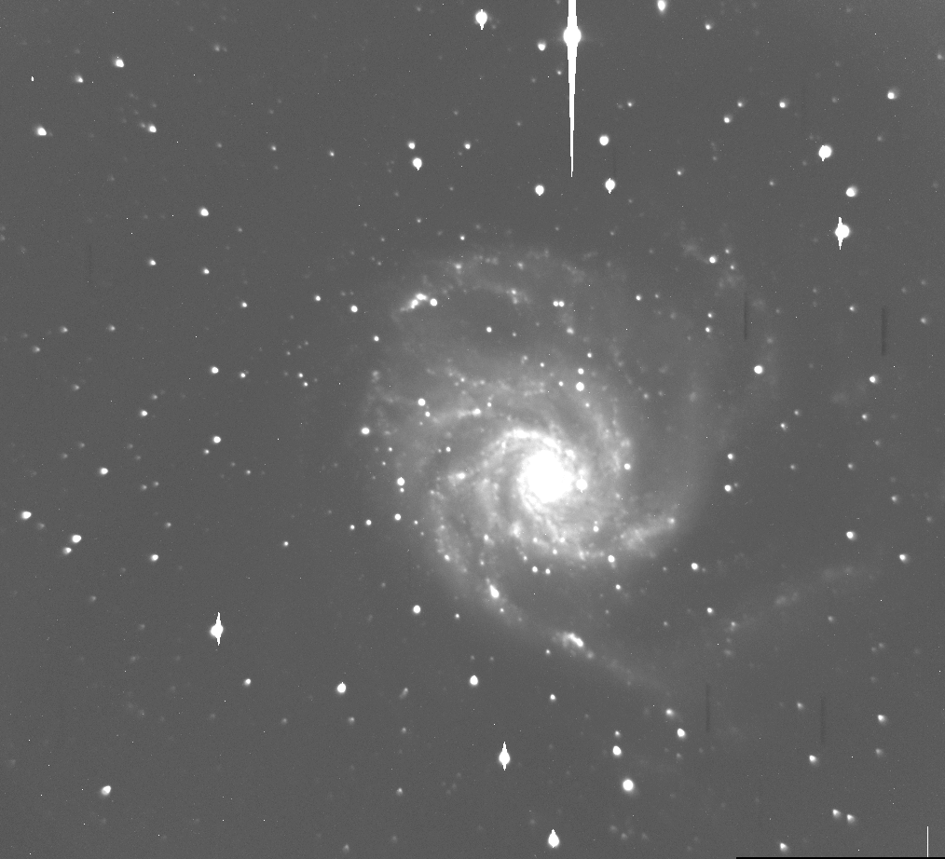
- When actual darkness sets in, public viewing occurs through the available scopes. The 24-inch telescope offers the best eyepiece viewing experience of certain objects in a narrow field (e.g. the moon, the planets, some star clusters and nebula). Wider field viewing experiences are offered through many of the amateurs scopes. Digital imaging is introduced to the visitors when they visit the 32-inch telescope + dome. The mountain also has wireless coverage making it possible for a digital image just obtained with the 32-inch telescope to be broadcast to a tour guides laptop screen somewhere else on the mountain. Most visitors think this is pretty “cool”.
The above sequence adequately describes the typical visiting experience to the mountain. The public starts out with an initial naked eye observing of the sky, seeing objects in the sky that many of them have never seen before due to local light pollution. Amateur astronomers acting as night sky guides help the public make out constellations, star clusters and other features. The public ends the visiting experience by a thorough exposure to modern astronomy and the power of digital imaging. This summer visitor program remains the core of PMO’s informal science education program and PMO is a highly valued asset as a result. The number of summer visitors remains strong and the only external factor that seems to matter in the number of visitors is the price of gas.

The K12 Connection: Emphasizing Science by Inquiry:

Overview:

The primary mission of the outreach program is to encourage students and teachers to perform science as an inquiry based activity. Astronomy naturally lends itself to this approach. We encourage students to perform scientific inquiry: To make observations, analyze data, note levels of uncertainty, draw rational conclusions, and to design questions and further investigations. An additional gain of this program is that it allows students to work with modern technologies and investigative techniques such as telescopes and digital cameras so as to become more technically literate. Success is evident when we hear at least one student per class state "I want to be a[n] astronaut [astronomer] [scientist]". Another common student reaction consistently noted by teachers is that poorly performing students are often inspired to participate, take interest, and improve their grade for the day when they see the technologies and get to work hands on with the equipment. We also collaborate with local Planetariums and Science Museums to hold classes and workshops at these facilities and to encourage classes to visit. We work with local amateur astronomers to set up sky viewing sessions at schools, solar viewing and/or evening sessions. During evening sessions we offer digital imaging first hand outdoors with one of our small portable CCD cameras. We have active contact with the Oregon Science Teachers Association (OSTA) and with the Oregon Department of Education (ODE). We provide several staff development workshops annually at OSTA and ODE functions and conferences, and attend ODE workshops to keep current on changes in State standards. We present a paper or conduct a session at a National Science Teachers Association, American Astronomical Society, or Astronomical Society of the Pacific event usually annually. We view these outreach activities and formal ties to educators in our state as an integral part of the observatory’s general mission.

K12 Teacher Training: Authentic Data Driven Inquiry Examples

For many consecutive years, PMO has been offering K12 science teacher workshops. These workshops are taught mostly by Rick Kang, the education officer for FOPMO, with supplemental help/teaching being provided by G. Bothun. In the past, these workshops have been supported by a) a NASA Ideas grant, b) State of Oregon Title IIb funding, c) Oregon NASA Space Grant and d) individual school districts (although this is becoming increasingly rare). Our training programs are unique and intensive and center around the delivery of real CCD pixel data to K12 science teachers. The intent of this training program is to provide the teachers a set of tools that they can employ in order to develop an interactive astronomy curriculum for their students. The overriding teaching strategy of this project is to get real data and analysis tools into the hands of students. Hopefully, this will kindle the excitement and spirit of discovery that is the very core of scientific research but which is rarely, if ever, communicated to students. Specific exercises and tools have been developed that will allow the students to effectively duplicate the steps of the professional scientist and much of the focus of our teacher training workshops is for them to develop content knowledge through the use of interactive tools. To provide the proper context and framework of this unique, interactive, digital astronomy experience it is useful to describe and show some of the commonly used tools employed in these professional development workshops. Once the teachers have been certified in the use of some of these tools, they become qualified to put in requests for PMO’s research camera to take specific imaging data to support certain kinds of teacher designed astronomy projects that, in turn, they can give to their students.

Five Example Interactive Astronomy Tools:

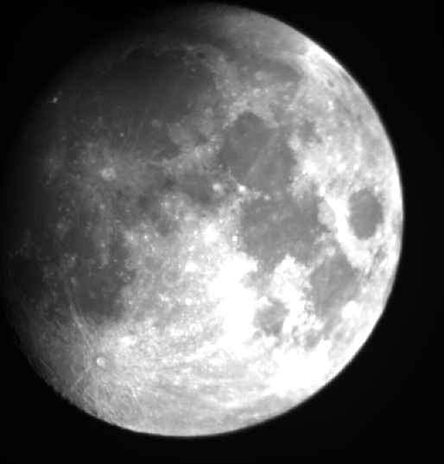
1. Image Analysis:

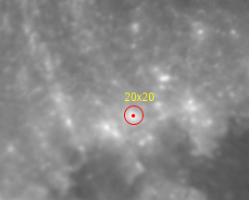
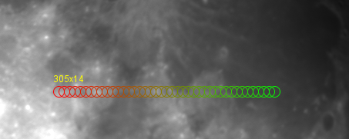
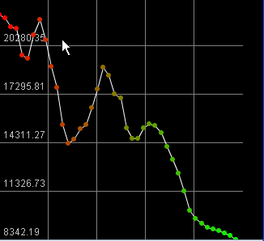
The field of view of the research camera on the PMO 32-inch is just slightly larger than that of the full moon. The fast shutter speed of the camera combined with an appropriate choice of filter can allow for a full digital image of the moon to be acquired without saturation effects. The figure at the right shows a 10 millisecond exposure of the moon. Since this image is fully digital it can be easily zoomed to show various details of the lunar topography. But we are interested in more than just viewing lunar topography – rather we wish to provide a set of tools that one can use to actually measure topography (e.g. crater size, crater density in some areas, size of lunar Maria and the like). The inset in the picture to the right reveals a small region of the lunar terrain in which a circular aperture diameter 20 pixels (about 75 km) is overlaid. The teacher/student can use this circular (which is adjustable in size) to measure the radius of circular features (e.g. craters). Of course, this measuring tool will work with any image so it’s not restricted to just lunar surface measurements. The second tool involves measure differences in surface reflectivity. To first order, the surface reflectivity contains information about what the surface is made of in that region (e.g. basalt has low reflectivity, impact debris has high reflectivity). Here the user defines a cross section in which to measure the reflectivity profile by averaging the surface intensity within a given circular radius. This cross section shown above is 305 pixels (about 1100 km) long and 14 pixels (50 km) wide. The resultant reflectivity profile is shown to the left where large scale reflectivity changes can clearly be measured. Hence we are not merely providing the user with just a digital image of an astronomical object, we are instead providing a whole analysis tool kit, all of which runs in the WEB browser environment, there is no special software to download and install, to quantitatively measure various aspects of the image that are relevant to some investigation or query. It is this dimension of the use of authentic data and appropriate data analysis tools that define out interactive astronomy curriculum as we introduce it to K12 teachers.

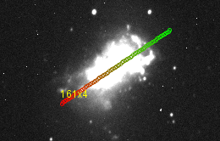
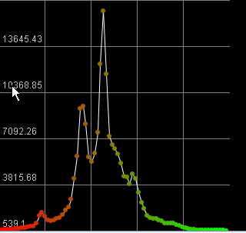
The image analysis tools can handle many different kinds of objects. For instance, galaxies have different kinds of structures and appearances when you image them in different filters (blue versus red, for example). The image to the right shows the galaxy NGC 4449 imaged with the PMO research camera in the light of the blue filter. A cross sectional measurement through this galaxy (roughly along its major axis) reveals a strongly peaked light distribution (which is indicative of central star formation) in this galaxy. In this way students can be given a library of galaxy images (including many imaged with the Hubble Space Telescope) to construct luminosity profiles and see how different kinds of galaxies have different kinds of properties. While we acknowledge this is a higher order application measuring features on the lunar surface, we illustrate it here as another example of the nature of our tool kit which we provide the teachers. The final example of this image analysis tool and probably the most powerful in terms of the reduction of real astronomical data is the automatic image finder. Below is an image of a nearby star cluster taken through a blue filter with such a short exposure that none of the fainter, background stars even register on the detector. The automatic star finder is run and each detected star, above a user specified threshold, is identified and marked within a standard aperture. The background subtracted flux of that star is then automatically determined as well as its pixel position. The program then generates a list of stellar position and flux through that filter. Imaging this star cluster through another filter, like a red filter, then allows the student/teacher to construct a color-magnitude diagram for that stellar cluster which is based on the real data from that real stellar cluster. The construction of color-magnitude diagrams in stellar astronomy is historically one of the fundamental ways that astronomers learned about stellar evolution and this authentic data exercise gives students an opportunity to construct that very same diagram using exactly the same methodology as professional astronomers. Thus we have built an interactive exercise that allows the students to duplicate the same process as the professional scientist.
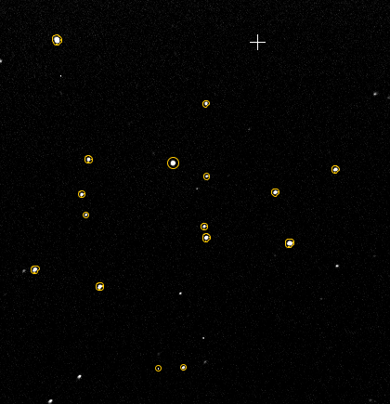
- The CCD Simulator: Training for Remote Data Acquisition

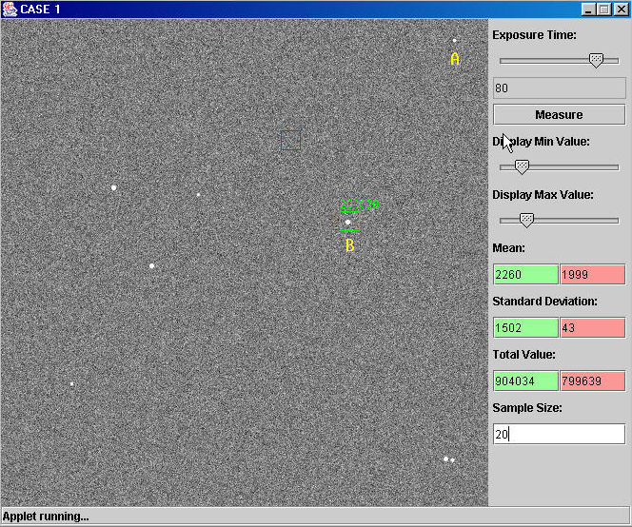
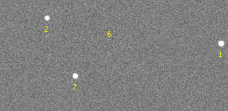
Another unique aspect of our long standing K12 program is the introduction of digital imaging to students. Long before the era where every student actually had their own digital camera, our outreach program brought small CCD cameras to K12 classrooms. Using a makeshift optical system we were able to produce a tabletop digital camera in which the students could take pictures of themselves. At the time (early 1990’s) this was, indeed, novel and helped educate the students about various aspects of the digital imager. Now that digital cameras are widespread, the process of producing images on a computer has transformed from amazing to mundane. However, this doesn’t mean that students are literate in how digital imagery works and how it is used in astronomy to measure the fluxes of astronomical objects. Before teachers or students can analyze the digital imaging data obtainable from the PMO research camera, we introduce them to the simulator shown below. This simulator allows students to a) control the exposure time b) manipulate how the image is displayed and c) measure fluxes of objects inside square aperture. One immediate learning goal of this exercise is for the teachers/students to understand that the pixels between the stars are not black (i.e. zero counts) because the night sky is not infinitely dark but has a residual background brightness due to terrestrial scattered lights, any scattered moonlight that is present and the extragalactic background light. Years of using this simulator has demonstrated the basic concept that most all teachers/students are unaware of this residual background flux which must be subtracted from the object flux to obtain to true real flux. The interface shown to the right shows 8 individual stars and two of them are labeled A and B. The flux of star B is determined within the 20x20 box aperture (box size is adjustable) by subtracting the mean counts in the green box (which represent object+sky) from the mean counts in the red box (which is placed on pure sky background): (Object+sky) – (sky) = true object flux. In addition, the observing properties of the simulator can be changed by an instructor controlled parameter file. For instance, the 8 stars in the above image represent objects imaged at high angular resolution against a very dark background – this simulates imaging from space. Larger image size (due to atmospheric seeing) and higher background light simulates images taken from the ground. In some cases the fainter stars detected above, can not be detected in the ground based simulation. So this tool has a secondary purpose of showing why imaging and detection of faint objects from space is so much more effective than from the ground. This serves to correct a common misperception in that its not the darker background that matters so much from space, it’s the fact that the light from stars is confined to a much smaller number of pixels, so the per pixel count is significantly higher and the stars are much more easy to detect. This effect is shown in the inset view above; the Star labeled B is now denoted as 1 in the simulated ground based view – star 6 in the inset is clearly not detected in the ground based simulator (see black arrow) but does appear as a faint detection in the space based simulated image. Our experience with this particular tool has been very positive and we find that after about 1 hour of usage, the user’s content knowledge of digital imaging and the measurement of astronomical fluxes has increased considerably. This exercise is then following up by the one described below which emphasizes the importance of imaging objects through different filters (e.g. blue, red, etc).

3. The Importance of Filter Imaging:
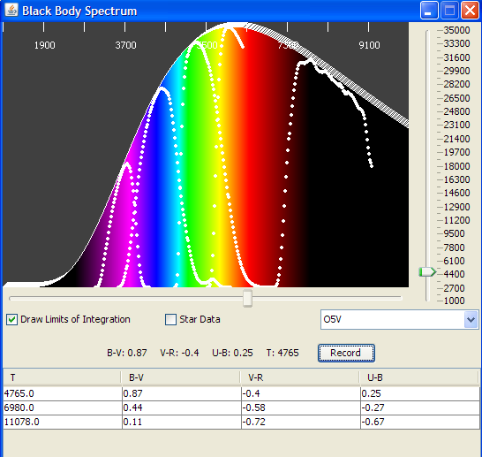
The image to the right shows our filter/blackbody simulation. In this simulation the user adjusts the temperature and the emission spectrum shifts accordingly in compliance with the Planck radiation formula. The white dotted lines indicate the UBVRI astronomical filter set and the table readout at the bottom records the B-V, V-R and U-B color indices as the user adjusts the temperature. In this way the user can empirically understand the relation between index color (say B-V) and temperature. This, of course, is why astronomical imaging is done through different filters. The button labeled star data, will bring up the real spectra of stars of different temperatures (we also use this library in the exercise described below) so that the students can measure the B-V color of different types of stars from the real data.

4. Measuring the Intensity of Spectra Lines: The Equivalent Width

From a library of real stellar data (e.g .Silva and Cornell 1992) we have developed a tool that allows the user to measure the spectral intensity of features and to compare one feature from one element (say Hydrogen) against the strength of a feature from another element (Calcium, Sodium, Magnesium) to determine the spectral type of the star. Of all the tools we have developed and deployed this is the most data intensive tool but it does allow students another authentic data experience. The image below shows the spectrum of a star and spectral features are clearly present.

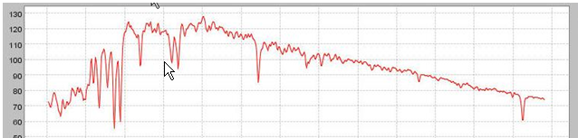

Following a step by step procedure, the end result produced by the user is shown below. The numbers I the two upper boxes represent the wavelength limits of the identified feature and the number in the lower box is the “answer” or the equivalent width of the feature. Again, using this data analysis interface on real stellar spectra is allowing the user to quantitatively measure the strength of a spectral feature using the same methodology of the real scientist.
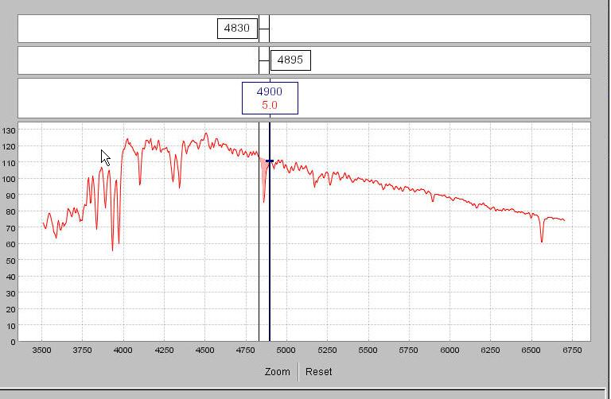

5. The Doppler Wobble Simulator: The Detection of Extrasolar planets.

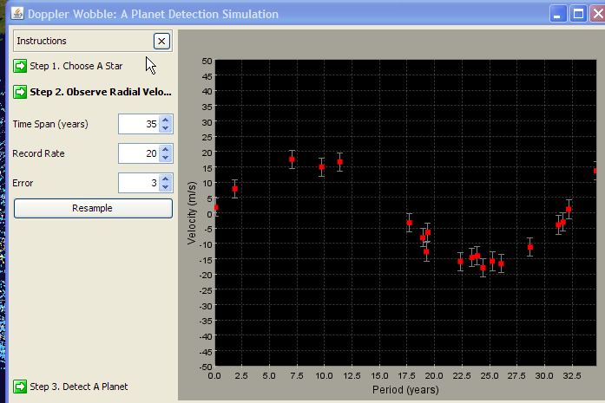
This is another relatively new astronomical topic now of great interest to teachers and students. This topic is also an excellent platform from which to launch a discussion of the various missions (e.g. TPF) designed to detect earth like planets. But before launching into such a curriculum, it is useful to get students to understand how the basic method of periodic radial velocity shifts in an observed star are used to detect a planetary mass and a distance of that mass from the star. The image above represents simulated data for a star that has been observed 20 times, over a 35 year period with a radial velocity accuracy of +/- 3 km/s user employs the fitter and adjusts the mass and distance of Jupiter (for comparison the Jupiter-Sun system is shown). Adjusting the mass and distance yields a solution of a 1.8 Jupiter mass planet located at a distance of 10 AU from this star. All kinds of observing configurations (e.g. radial velocity error, length of observing period, number of observations, planetary mass, planetary distance) can be given to the students so that they gain a better understanding of the kinds of planetary configurations that can and can not be detected with past, current and future instrumentation. Again, this tool allows for a direct user analysis and manipulation of data (in this case artificial but it could also be the real radial velocity data for some system) to see how instrumental configurations play directly into the ability to detect some phenomenon.
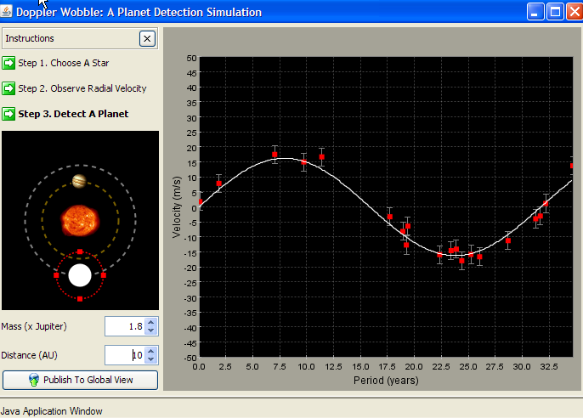

Proposed Program:

To date, the overall structure of our informal science education and outreach program has had high impact on the participants. We have been historically limited in the scale of the program (and the scale is already large) by either budget or trained manpower issues – nonetheless, we are proud of all that has been accomplished to date on a meager budget and low manpower. As explained in detail above, by way of the many examples, the central component of our K12 teacher and student outreach mission is to provide the teachers with the ability to construct authentic data exercises as a mechanism for teaching certain aspects of astronomy in their classroom. Using some of the tools described above, the students are able to analyze data and raise questions using the same methodology that the professional astronomer employs. We strongly feel that this direct data driven approach contributes more to STEM literacy than the traditional show and tell teaching methodology. In addition, an important component of the science literacy part of our curriculum is the use of data and tools (e.g. CCD simulator, Wobble simulator) to get students to understand issues associated with Signal-to-Noise and what it actually means to detect and record a phenomena. All too often we find another misconception that students (and teachers) think that scientific instrumentation is perfect and that measurements haven no errors. Astronomy is an ideal vehicle for demonstrating the important of instrumental limitations in detecting the kinds of objects that may inhabit the Universe.

Therefore this proposal seeks sustainability funding to continue with our current mode of operation. In particular we seek to support the following four activities:

- Continued informal science education and dark sky viewing via the PMO summer visitors program.

- Continued ability for qualified teachers to be able to remotely acquire digital imaging data, through various filters, with the aid of a remote data technician, as a means of building their own data driven astronomy curriculum.

- Continued support for K12 site/classroom visitation to educate teachers and students about various current aspects of solar system exploration and space science. In essence, historically, we are exposing approximately 6000 K12 students per year to NASA resources and NASA opportunities in the STEM workforce.

- Continued support to offer a few teacher professional development workshops each year. As documented above: a) there is large teacher interest in such workshops and b) we are highly limited in our ability to sustain these workshops. If this proposal is successful, we plan to use this funding to leverage further funding to maintain or increase the number of these workshops beyond that which can be supported by the budget item in this proposal.

The budget for this project requests specific funds to support each of these activities:

- We request a small amount of money to be used to compensate tour guides (e.g. amateur astronomers) for their help with the public visitors during the summer season. While most of these volunteers are happy to contribute their services free of charge, some compensation would help with motivation and gas money.

- We request partial support for the remote data technician (Allan Chambers). Mr. Chambers’s expertise on using the scope and the CCD camera is absolutely required for process of teacher generated remote imaging and data acquisition to occur. At the moment, and for the foreseeable future, there are two limitations to remote operations: 1) the filters must be changed manually – each filter is 3x3 inches and there simply is no room at the prime focus of the 32 inch to construct a filter well; 2) the mechanical drive system of the 32-inch was never intended from computer control. Although we have such an interface now, someone in the dome needs to be present to monitor the scope position to avoid contact with dome floor should the telescope be instructed to slew a long way across the sky. Therefore, the research camera is not a fully robotic instrument and retrofitting the telescope to make it so would be far more costly than simply supporting a remote data technician position.

- The bulk of the budget is to support the highly successful and very popular K12 classroom visitation. The principle instructor for this mission is Rick Kang who is an enthusiastic and knowledgeable presenter with at least 15 years of educational outreach experience. In addition to partial salary support for Mr. Kang, we request support for one undergraduate student to be trained in outreach and who can assist Mr. Kang on some of the classroom visits.

- We request $5K for participant support costs for to sustain teacher professional development mini-workshops. These funds are requested to support small stipends for the participant teachers as well as possible tuition waivers. Through the Continuing Education Program at the University of Oregon, participants in these workshops often earn 1-2 credits of graduate level work which greatly enhances the overall value of these workshops to the participants and contributes significantly to their professional development portfolio.

Current funding for the observatory is limited and comes via the following components:

- Basic funding for maintenance of the grounds and buildings and electricity to the site is provided for by Facilities Services at the University of Oregon. This budget provides for an on site caretaker who does assist with public tours at the site but its otherwise not engaged with the K12 outreach effort.

- Revenue generated by sales of Tee shirts and cups as well as visitors donations during the summer visitor season helps to sustain that activity, partially compensate tour guides and pay for some of the mileage associated with the K12 outreach program.

- A small endowment for research in astronomy (about $20K per year is used to pay for a part time remote observing/data technician as well as internet connectivity (although some of the latter has now been picked up via University cost-share)

- One time allocations made by the UO Research office, The College of Arts and Sciences and/or the Physics department are used to perform needed repairs on the telescope or domes.

- Approximately 10-12 K per year comes from NASA space grant to support our K12 classroom activities program and we anticipate that continuing. This overall amount, however, is quite insufficient to sustain the K12 outreach program which is why we seek additional funding here.

- PI generated research money has been used to acquire some parts of the CCD camera, the focusing mount, the current filter system and data analysis machines.

We also add one final, but important, comment about our outreach effort: The Electronic Universe Project (http://zebu.uoregon.edu) started up on Feb 9, 1994. This is likely the very *first* Web server that was devoted to the delivery of digital astronomical images and scientific explanations to the public (and this web presence may, in fact, predate NASA’s first home page). Initial funding for that project was secured with State of Oregon development funds – we mention it here to demonstrate the PI’s long term commitment to public education in science.

Summary:

The informal science education program, as manifested by the summer visiting season at PMO, as well as the K12 outreach program, carried out under the umbrella of the University of Oregon and PMO, has been long time fixtures in the state of Oregon. Over the years it has become clear that PMO is an important part of the fabric of people’s lives in the dark skies of central Oregon. In turn, changes in K12 curriculum combined with renewed and revitalized science standards at the state level, and the increasingly obvious need for an improved STEM workforce. Given the very low level of astronomical infrastructure and education programs (there are no Astronomy degree programs at any University in Oregon), PMO is really the only organization that is qualified to give professional based outreach. Thus, we have a large area to serve. The outreach program started off at modest level in the early 1990’s once digital imaging in astronomy became the normal mode of data acquisition. Small scale CCD cameras were brought to K12 classrooms to a completely uninitiated audience – this was real cutting edge stuff at the time. As a result of that, the requests for our outreach services begin to increase leading to the creation of professional development mini workshops for K12 science teachers with an effort to introduce them to astronomy via the pathway of authentic data investigations. To support that mission, a suite of electronic data analysis and simulation tools were developed and widely employed. By now we have built a well-established program, still principled on authentic data exercises as the means to build and deliver the curriculum and offer a truly unique experience for our participants. The program works, its highly valued, its highly needed and we request support for sustaining our current momentum and for meeting current demand.

References:

Bothun and Kang 2000 AAS 197.12005 The Pine Mountain Observatory Outreach Program
Ebbighausen and Donnelly 1968 PASP 80, 203 The Pine Mountain Observatory of the University of Oregon
Kang 2006 AAS 209.21813 Using Authentic Sky Data to Investigate Earth’s Motion
Kang 2004 AAS 205.8701 Astrophysics for Elementary Students and Teachers
Kang and Bothun 2002 AAS 201.5305 Measuring Authentic Digital Data in K-12 Classrooms
Kang and Gulino 2000 ASPC 220 306 University of Oregon’s Electronic Universe – a Professional-Amateur Collaboration for Public Science Education
Silva and Cornell 1992 Ap.J. Supplements 81, 865 A New Library of Stellar Optical Spectra

Budget Justification

Summary of Proposed Work Effort and Funding:

- Professor Gregory D. Bothun, University of Oregon is the PI. No salary is requested.

- Web programmer Josh Rogers will work on the various simulations and data exercises needed to support the ON line component of this project. We request 1 month of salary support for this effort.

- R. Kang will conduct K12 classroom visitations at various locations in the state throughout the school year. He will be assisted in some cases by volunteers and/or a trained undergraduate. We request partial stipend support for Mr. Kang’s effort which we estimate to be 800 hours per year.

- We also request money in year 1 to purchase a dedicated laptop plus modern data projector to be used in the K12 classroom visits.

Participant Support Costs:

- By prior arrangement with the Continuing Education Program at the University of Oregon, we have negotiated a rate of $50 per credit for teacher participants. We plan to hold 4 mini-workshops each involving 5 teachers for 2 credits. Hence we request $2000 per year to cover this cost
- We also plan to provide teachers with a $150 per stipend for participation in the mini-workshop. Hence we request $3000 per year to cover this cost.

Salaries:

- No salary is requested for the PI. Salary/stipend support is requested for R. Kang, the outreach educator as well as for undergraduate assistance and amateur astronomer volunteer assistance.

Travel:

- We request $2000 per year to support the in state travel costs

Indirect Costs:

- This project qualifies for the University’s 29% overhead rate that is a flat rate charged to Public Service grants. Direct costs charged as such are for everything except Participant Support Costs as described above.

Current and Pending Support

Current Support for PI:

- Do Galaxy Disks Ever End: NASA GALLEX Mission 33K August 1,2008 – July 31, 2009

- Research and Education at the Pine Mountain Observatory: NASA Spacegrant 81K January 1, 2008 – July 15, 2009

Pending Support for PI:

- K12 Professional Development Course: Evolution of Planetary Surfaces and Their Ability to Sustain Life: NASA AESP Mini-Grant Program. 23K requested

- A Simulation and Data Driven Approach for K12 Global Climate Change Education: Achieving Climate Literacy NASA 300K requested for 3 years starting January 1, 2010

- The PI and will be putting in for another one of the Title IIb partnership grants when those funds become available to the State of Oregon. We consider the current proposal as complimentary to that future one and if both are granted we will be able to accommodate more teacher participants.

- Cycle 6 GALEX Mission: GALXES Imaging of the Diffuse Light in HCG 92

Resume of G. Bothun

Education:

B.S. Astronomy, University of Washington, Seattle WA, June 1976

Ph.D. Astronomy, University of Washington, Seattle WA, August 1981

Thesis Title: A Multiwavelength Investigation of Spiral Galaxies in Clusters of Galaxies

Professional Employment

Scientific Programmer: The Very Large Array Radio Telescope NRAO 1977

The University of Washington, Astronomy Instructor 1980-1981

Harvard-Smithsonian Center for Astrophysics, Center Research Fellow 1981--83

California Institute of Technology, Bantrell Research Fellow 1983--86

The University of Michigan, Assistant Professor in Astronomy (1986--1989)

The University of Michigan, Associate Professor in Astronomy (1989--1990)

The University of Oregon, Associate Professor in Physics (1990--1995)

The University of Oregon, Professor in Physics (1995--present)

The University of Oregon, Professor in Environmental Studies (2000—present)

Other Professional:

UNIX System Administrator for Physics Department

Webmaster for various educational technology curriculum projects

Director, University of Oregon Pine Mountain Observatory (1990 – present)

Scientific Editor, The Astrophysical Journal (1996---2002)

National Academy of Sciences Decadal Panel (1997—2000)

Phi Beta Kappa Visiting Scholar 2000---2001

Professional Societies

American Astronomical Society

American Association for the Advancement of Science

Professional Experience:

Research Productivity

188 Papers in Peer Reviewed Journals (1980-2008)

Original Member: ISI Highly Cited Researcher in Space Sciences (1980-2000 period)

One Graduate Level Textbook: Modern Cosmological Observations and Problems

One Undergraduate Textbook: Cosmology: Mankind's Grand Investigation

Approximately 25 Popular Articles (Newspapers/Popular Magazines)

Over $3.0 million in grant funding from NASA and NSF since 1986

Chair of Numerous NASA Peer Reviews

Approximately 2000 nights of Observing since 1980 on most of the major radio and optical telescopes in the world

Extensive experience with Space Based instrumentation - including the Hubble Space Telescope

Research Interests:

Galaxy formation and evolution

Dwarf Galaxies

Galaxies of Low Surface Brightness

Large Scale Structure

Clusters of Galaxies

Observational Cosmology

Applications of Instructional Technology

Climate Change Indicators

Sustainable Energy Implementation and Policy

Miscellaneous:

Initiated the Electronic Universe Project - a Web server dedicated to public outreach and education by delivering real data, explanation and analysis to the lay public. This has been on the air since Feb 9, 1994 - making it one of the first such servers in the entire world. Server has seen close to 40 million hits since operation commenced.

Developed suite of Java based simulation tools for introductory classes in physics, astronomy, and environmental studies; widely used Nationwide.

Have given over 100 public lectures since 1984 to various groups

Helped developed the new Environmental Studies/Sciences program at the University of Oregon

Supervise the Friends of Pine Mountain Observatory Educational outreach program which visits 200+ K12 classrooms a year in the State of Oregon and which accommodates approximately 2500 visitors per year during the summer to the observatory.

Have lead numerous K12 teacher development workshops.

