December 2007

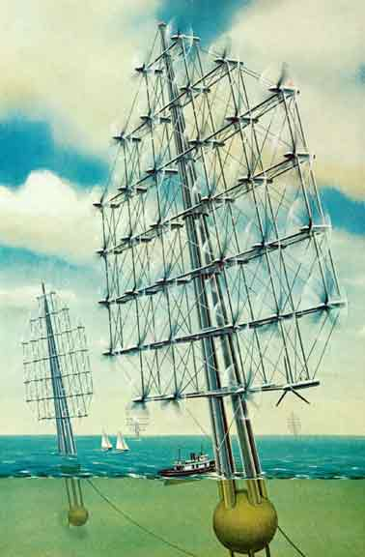
To me, every hour of the light and dark is a miracle,
Every cubic inch of space is a miracle,
Every square yard of the surface of the earth is spread with the same,
Every foot of the interior swarms with the same;
Every spear of grass-the frames, limbs, organs, of men and women, and all that concerns them,
All these to me are unspeakably perfect miracles.

--Walt Whitman

Electrical Grid

Background: The Clear Need for a New and Smarter Electrical Grid

Future demand projections suggest that, by the year 2050, the world demand for electric power will be somewhere between 30 and 60 TerraWatts (TW). If current scaling continues, the US will use 1/3 of that power (10-20 TW). In 2006 our total grid capacity was estimated to be 0.91 TW (with a peak summer time demand of 0.79 TW). There is very little excess capacity in the current grid and given the large cost of installing additional transmission lines (1.5 -2 million dollars per mile) capacity additions to our existing highly centralized distribution system are unlikely to occur at a pace which will keep up with escalating demand. Inevitably this condition will over-stress the current grid resulting in unreliable performance. To prevent loss of service or regional blackouts, robust real-time power management of the grid must occur, and that capability does not yet exist. Due to our long term disinvestment in additional transmission capacity, the US now is in a critical stage of grid vulnerability. Without a complete modernization of the grid and its control systems we will not be able to easily integrate new sources of generation. Thus it is mandatory that the development of new sources of generation that utilize alternative and renewable energy occurs in parallel with a wholesale upgrade and re-design of the current centralized grid.
The New Green Smart Grid

Will manage and deliver approximately 10 Terra watts of electrical energy through a highly distributed system of 100 million nodes each capable, at any given time, of producing, using, or storing electrical energy. Transactions on this network will be dictated by real time signal pricing and net metering. The overall nature of the system will be defined by the number and capacity of green nodes that employ various forms of renewable electricity generation.

Much of the current grid’s vulnerability occurs as a result of its physical behavior. This system of electricity generation, transmission, and distribution is essentially a single, highly interconnected machine. This single network is physically and administratively subdivided into three “interconnects”— the Eastern, covering the eastern two-thirds of the United States and Canada; the Western, encompassing most of the rest of the two countries; and the Electric Reliability Council of Texas (ERCOT), covering most of Texas (Figure 1). Within each interconnect, power flows through ac lines, so all generators are tightly synchronized to the same 60-Hz cycle. The interconnects are joined to each other by dc links, so the coupling is much looser among the interconnects than within them. (The capacity of the transmission lines between the interconnects is also far less than the capacity of the links within them.) One result of this system is that electric power does not necessarily travel just by the shortest route from source to sink, but also by parallel flow paths through the various parts of the system. For instance, where the network jogs around large geographical obstacles (e.g. Rocky Mountains, Great Lakes), s loop flows around these obstacles are set up that can drive as much as 1 GW of power in a circle, taking up vital transmission line capacity without actually delivering power to consumers. Thus, our current system is not well optimized toward actual power delivery but instead is more optimized toward power routing. As a result, significant loss in the entire system can occur as a result of failure in only a small number of its nodes.

The 2004 report titled "Structural Vulnerability of the North American Power Grid," (Albert etal) produced results based on a model of the entire transmission grid as consisting of 14,000 nodes (generating facilities, transmission substations, and distribution substations and 19,000 edges which correspond to the transmission lines that transport power between the nodes. In this model, the value of each substation in the network is based on its time-averaged load as defined by the number of shortest path routes between other nodes that pass through that one specific node. Their analysis clearly identifies our critical vulnerability. Approximately 40% of the nodes operate at relatively low load level (less than one thousand paths through that node) but approximately 1% have a load factor that is higher than one million. Should any one of those extreme load points (and there are 140 of them) fail, then major disruption of the entire system occurs. That is, catastrophic failure potential occurs from the loss of as little as 1-2% of the individual nodes of the system. In particular, the grid quickly becomes disconnected when the high-load transmission substations are selectively removed from the system--if the nodes that have the highest load are removed first, followed progressively by the nodes with successively lower loads. According to the model, a loss of only 4 percent of the 10,287 transmission substations results in a 60 percent loss of connectivity. During a cascading failure, in which the high-load substations fail in sequence, the model shows that the loss of only 2 percent of the nodes causes a catastrophic failure of the entire system.
Grid Reliability

We must keep the lights on independent of natural or unnatural circumstances.

Evidence for this kind of failure is provided via the August 2003 blackout. The timeline of events thought to have triggered that cascade failure are enumerated below and reveal the sensitivity of the overall system to failure at a few critical nodes:

- 1:58 p.m. The Eastlake, Ohio, generating plant, owned and operated by First Energy, shuts down.
- 3:06 p.m. A First Energy 345-kV transmission line fails south of Cleveland, Ohio.
- 3:17 p.m. Voltage dips temporarily on the Ohio portion of the grid. Human controllers take no action, but power shifted by the first failure onto another power line causes it to sag into a tree at 3:32 p.m., bringing it offline. While the Mid West ISO and First Energy controllers try to understand the failures, they critically fail to inform other system controllers in nearby states.
- 3:41 and 3:46 p.m. Two breakers connecting First Energy’s grid with American Electric Power are tripped.
- 4:05 p.m. A sustained power surge on some Ohio lines occurs.
- 4:09 p.m. Voltage sags deeply as Ohio draws 2 GW of power from Michigan.
- 4:10 p.m. Many transmission lines trip out, first in Michigan and then in Ohio, blocking the eastward flow of power. Generators go down, creating a huge power deficit. In seconds, power surges out of the East, tripping East coast generators to protect them, and the blackout commences.

The entire event took a little over an hour for the initial transmission power line failure to propagate throughout a very large region. More to the point, the occurrence of this event has not resulted in any significant new capacity in the grid or any significant new manner in which the grid is being managed. Thus, a similar occurrence seems likely.

Moreover, new technology is rapidly appearing that makes power management issues even more critical. A recent DOE study suggests that the current “idle” capacity in the grid (0.1-0.2 TW) could be enough to recharge approximately 180 million plug-in hybrid vehicles (PHEVs) during off peak hours. Yet, as just discussed, the current grid is not ready to handle this new kind of power management and distribution that would occur from the wide spread adoption of this technology. This is a downright silly position for the US to currently be in, as we strive for improved energy efficiency and independence as well as a reduced reliance on fossil fuels.

Hence we argue that the transformation of the grid may be the most important step in achieving energy independence as the grid must be able to accept new technology sources of generation and storage. Our current centralized grid is not very adaptable. Existing components of a typical system include the generation source, routing via transmission and distribution network and the customer or sink:

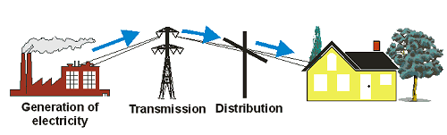

The new grid will be much more highly distributed and will have many more pathway connections than the simple diagram shown above. Schematically, it might look like this:

Features and/or components of this grid would include the following:

- 100 million nodes each capability of generating or storing electricity

- Generating technologies potentially, include rooftop PV power, small scale wind farms, rooftop micro wind turbines, small biomass burners, and small scale hydro facilities.

- Storage technologies would include batteries, flywheels, hydrogen fuel cells, etc.

- Local command and control over whether or not to buy, sell, or store electricity through the adoption of real time price signaling and net-metering.

- Real time operational management and real time awareness of the status of the overall grid as well as each individual (of the now 100 million nodes) node’s status and operational capability.

- Direct high capacity transmission (either HVDC or HTS) from large renewable farms (e.g. wind farms in western North Dakota; CSP facilities in American Southwest) to the grid.

In short, this is the challenge ahead of us. In terms of computational needs, the goal is straightforward and that is to develop new computing and algorithmic resources to expand the current model from its 14,000 node state, to the potential case of 100 million distinct nodes in a highly distributed system. It is within this context that the panel was convened to identify the necessary Priority Research Directions in the area of improving the grid.

OVERALL SUMMARY OF COLLECTIVE PRDs:

The Energy Distribution – Grid Futures and Reliability Panel convened to discuss the necessary evolution of the current grid to a future, smarter grid that can effectively and pragmatically incorporate new sources of electricity generation and distribution to maximally leverage our investment in renewable energy generation technologies, which to a large extent, includes distributed load management technologies.. The addition of renewable energy sources to the overall energy mix produces challenges to the management of the current grid infrastructure. Four fundamental challenges have been identified:

- Dramatic movement toward further decentralization of the grid management, toward a larger, more complex system of distributed energy resources dramatically changes the way that the grid is operated and distributed and places extreme emphasis on management techniques that must insure the overall reliability of the power grid. The degree of this decentralization will likely be strongly affected by policy.

- Many high yield renewable sources are located in regions without sufficient transmission and ancillary infrastructure that would facilitate integration with the grid. As a result, such sources are not part of our energy generation matrix even though one overriding goal is to “de-carbonize” the grid.
Grid Evolution

The grid must evolve away from its current centralized nature to a high distributed system where each household can also be a power plant.

- The use of price-signaling, net metering and other market strategies produces a very large and time variable customer response function. A highly adaptive transactional network needs to be developed to effectively manage these emerging market strategies in a manner that promotes reliability, efficient operation, and effective integration of new technologies.

- Grid reliability remains important. As we move towards a more distributed system issues such as intermittency (from sources of generation) and the overall ability to accurately predict generation and load become paramount. A substantial penetration of renewable sources of generation also incurs issues of stability of that generation.

The overarching goal of each of the identified PRDs is to apply advance computational resource to increase grid robustness and diversity of resources while managing increasing levels of renewable and alternative energy resources. In other words, the future grid must keep the lights on independent of any possible disruption (natural or unnatural) in one part of its infrastructure. As the world transitions from traditional fossil-fuel technologies toward more environmentally friendly clean energy alternatives, industries and decision makers will need better scenario-based planning capability, control/response and integration tools (i.e. models, sensors, new reliability metrics, high-resolution data) befitting emerging technologies. Likewise, for clean distributed energy resources (DER – includes distributed generation and demand response), further research and development to improve technology, communication and controls to inform industry planners, and help decision makers transform markets and policies will need to be needed. Ultimately, however, all of these decisions, plans, and generating technologies come together to form the critical need for a SmartGrid method of better managing the distribution and use of electricity will insuring the overall reliability of grid operations.

We emphasize that effective and reliable management of the grid is critically important to achieve the benefits provided by our new sources of renewable and efficient energy Simply put, the large-scale introduction of non-traditional renewable resources will have a different impact on the grid than have been historically observed. Moreover, this next generation electrical grid will be far removed from the operational characteristics of the current grid. This grid will be a large, complex, multi-scale network with time variable dynamic feedback on a far greater scale than currently exists. Thus there is a strong need to develop new algorithms to characterize the system and to predict future behavior (near term and long term). There is also a strong need to develop better software and data visualization packages that will move the management of the grid to a real time state. Finally, there needs to be continued research into the properties of advance materials so that the overall energy storage capacity of the grid can be improved.

Deregulation of electricity markets, more so with the introduction of renewables into grid, is akin to a decentralized environment in which each of the suppliers (including individual suppliers such as those with solar panel roof tops) are focused on maximizing their respective profits instead of system-wide cost minimization. The electricity markets in such a scenario become balanced markets in the sense that agents who did not make an accurate forecast of their (regional or home) demand enter this market to sell/buy their surplus/deficit. Each of these agents maximizes their daily profits by trading electricity hourly to balance his/her individual needs. At the end of the day, they become net sellers or net buyers in a balancing market. The key is to maintaining or balancing these future grid electricity transactions in real time and operating these future grid electricity markets smoothly. This scenario is similar to that of trading securities on the Wall Street in real time yet preventing the markets from collapsing. One significant dissimilarity that exists between electricity markets and securities market, however, is that electricity needs to be physically delivered to a designated location through transmission lines. The analog to Internet operations, in this regard, remains a useful one. Specifically, the NSF funded University's Route Views project (http://www.routeviews.org <http://www.routeviews.org/> ) was designed originally as a tool for Internet operators to obtain real-time information about the global routing system from the perspectives of several different backbones and locations around the Internet. The question however is how to build and implement such a system for the future grid with renewables?

Finally the analog between the next generation electrical grid and the large transactional nature of the Internet is clear. In the fully distributed system (as envisioned by Roy Smalley and often referred to as
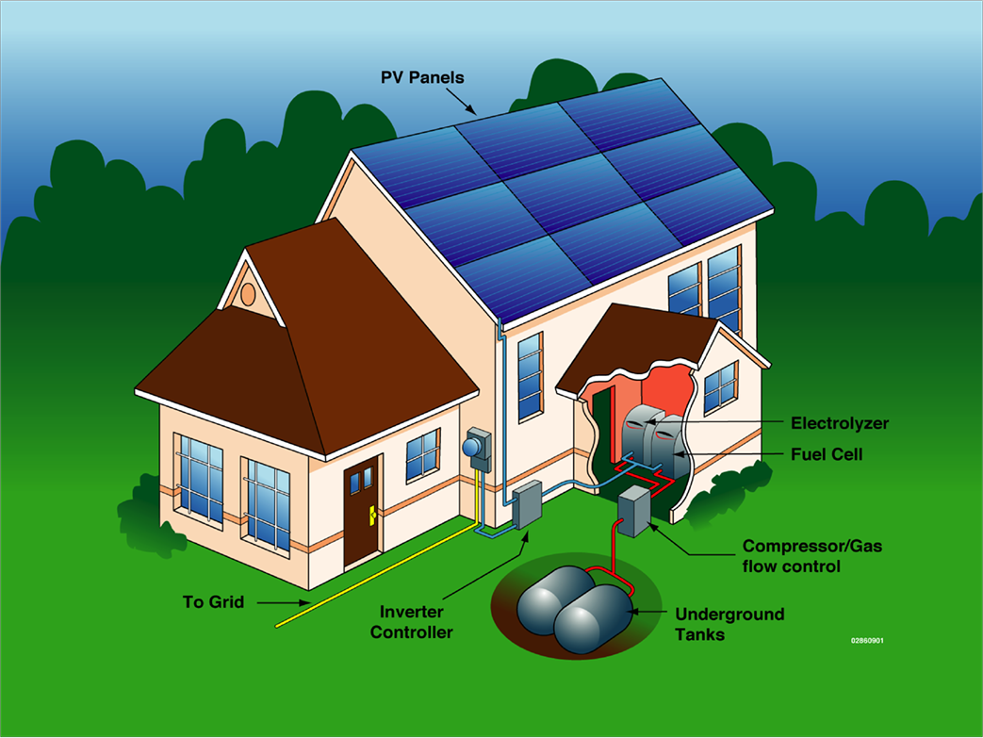
http://peakenergy.blogspot.com/2005/10/richard-smalley-and-smart-grids.html the Smalley grid) each individual household is capable of generating, storing, or selling electricity. Thus the individual household needs to be in real time contact with the smart electrical grid at all times. Furthermore, each individual household may contain up to 10 smart appliances which need to respond to the current price of electricity and make a decision about whether to use grid electricity or perhaps the stored electricity of the individual household node on the grid (or perhaps buy electricity at a reduced rate from your neighbors). These conditions then set the bit transmission scale of this smart electrical grid, and we will see that it is quite large, thus requiring and Internet like structure to mange its daily operations.

To wit, there are 100 million households in the US which could be on the node each with 10 major appliances. Thus the number of smart electrical grid clients is 1 billion. Suppose that each appliance is probed with an SMS (255 byte) message every hour (or as often as the price of electricity changes) and returns a similar response to the probe. The data rate for such transactions would then be 2x 1 billion x 2040 bits per hour = 1 gigabit per second, nationwide, continuous. It thus seems essential that the next generation electrical grid be operated with Internet protocols so the fully distributed system of storing, generation and selling electricity can be realized and so that the state of this complex system can be known in real time. It’s a daunting challenge but its completely required if we are to effectively integrate renewable energy from either large scale production sites or distributed homes.

One innovative suggestion that emerged is that this situation may lend itself to a large scale application of game theory. Game theory is a branch of applied mathematics that deals with the strategies adopted by the decision makers during decision making situations. The basic assumption is that players pursue some well defined objectives while taking into account their knowledge of other decision makers' behavior and possible states. At a preliminary level, game theory dictates that balancing of markets is achieved at Nash equilibrium, where each of the players (electricity traders) achieves his/her maximum profit. Evaluation of individual player's optimal strategies involves optimization of large-scale, multi-variable, profit functions with inequality (generation capacity) constraints and stochastic demands. From a computational point of view, modeling electricity markets using game theory based models becomes computationally intensive due to the sheer number of players (traders in an electricity market with renewables) involved in the game, their respective cost structures, generation capacity constraints, stochastic demand inputs, and bid (supply) functions. Furthermore, presence of multiple equilibriums poses additional complexity to the solution.

IMPACT ON RENEWABLES

Implementation of the system described in this PRD is also essential if the future grid is going to be able to successfully accommodate very local sources of generation (e.g. PV powered roof tops; small scale wind farms on the back acre, etc). Without a system that can adequately account for individual buildings (homes, schools, businesses) as potential power plants, the highly distributed nature and potential of renewable sources of electricity generation is defeated.

PRD 3: Establish interoperability between the legacy grid and the future grid.

ABSTRACT

The current grid has no capability for part of it to go down for an extended maintenance period that would be required to upgrade some of its components. Thus as we change out grid components and grid management techniques, this must be done in a way that ensures uninterrupted operations so as to maintain reliable service. Interoperability issues become of extreme importance when pragmatically planning to phase in construction of the new grid over a timescale of 20-30 years if we are to avoid discontinuities and new vulnerabilities while adapting to a new grid infrastructure.

EXECUTIVE SUMMARY

A reliable bridge needs to be built from extant legacy systems to these new systems. More specifically, one must carefully plan which part of the physical grid, the myriad of control schemes, and which particular control center can be updated or replace in what time period and how long that transition will occur. There is very little excess capacity to allow for taking part of the grid out of service but still keeping the whole network up. The capacity of the current grid is at its limit, yet demand continues to grow faster than infrastructure is added. The “smoothness” of this transition depends critically on the interoperability of data taxonomies. New control systems must be able to function, initially, using the previous data formats else the lights will go out. Additionally, new components must allow for the future integration of new control strategies

SUMMARY OF RESEARCH DIRECTIONS

There is a strong need to find the ability to port old control algorithms to new platforms while simultaneously creating or evolving new control algorithms to accept greater complexity and feedback adaptive control. Most importantly, this development effort must occur without ever brining the gird down. From the generic system design point of view, this requires the development and implementation of new data protocols so that future upgrades to network control systems become backwards compatible. One such industry entity that exists solely to address this grand challenge is the GridWise Architecture Council http://www.gridwise.com. Their mission, as they defined by their vision statement is to:

“weave together the most productive elements of our traditional infrastructure with new, seamless plug-and-play technologies. Using advanced telecommunications, information and control methods, we can create a "society" of devices that functions as an integrated, transactive system”

Embodied in this statement is the essence of the research challenge. The future grid must be envisioned as a large system of transactional elements each of which communicates with each other via well defined protocols – again, the analogy to the Internet should be clear. The current grid system is probably more strongly defined by physical protocols (knobs, levers, and phone conversations) than by any kind of networking protocol. So the key research challenge, which ultimately should involve members of a broad and diverse community, is to design and operate the future grid as an advanced telecommunications network. This research direction is quite similar in spirit to that previously established in the Grid 2030 white paper (http://www.energetics.com/pdfs/electric_power/electric_vision.pdf) which strongly argues the absolute necessity of the smart power grid.

PRD 4: Identify and evaluate emergent behavior in the future grid:

ABSTRACT

Systems are classified as complex when either their overall state is difficult to characterize or when the state of a system rapidly changes. The future grid has both of these features and thus may represent a new kind of complex network. Emergent behavior, by definition, cannot be detected at the component level, or even the subsystem level. This presents a very unique challenge within the power grid community - determining what will happen when a large population starts to use a new technology. If such emergent behavior is not rapidly identified then cascading effects could occur.

EXECUTIVE SUMMARY

In the future grid a variety of different behaviors will emerge from the end-users and these emergent behaviors will interact with the entire grid. The non-linear nature of these events raises the strong possibility that small perturbations on some local scale will trigger a larger event on a larger scale in the grid. This is undesirable behavior. In order to predict emergent behaviors (whether benign, beneficial, or detrimental), one must utilize a full-order model or the real time state of the grid in order to detect anomalies that might represent emergent behavior. However, unlike emergent behavior in other complex networks (e.g. the stock market), the electrical grid must stay up regardless of conditions.
This requires mixing discrete and continuous networks with expected emergent behavior while ensuring connectivity to complex grid topologies

SUMMARY OF RESEARCH DIRECTIONS

There are a lot of potential drivers for emergent behavior (e.g. sunrise on a PV farm, wind picking up on a wind farm, overall customer response function) that can radically alter the flow of power to different regions of the country. Identifying the full suite of potential perturbations is a major research challenge. The overall behavior of the grid in response to these smaller scale perturbations needs to be clearly understood, under a variety of “what if” scenarios so that various potential forms of emergent behavior can be identified. Furthermore, any form of negative emergent behavior should be controlled and thus early indicators of emergent behavior need to be formulated. This requires identifying and assembling the relevant data that might serve as critical indicators of any impending problem and then having the ability to rapidly communicate this to various aspects of grid operations. The need for visual or graphical representation of this multi-agent model is key and this may well require new computational and information architectures that will enable efficient execution of hybrid multi-agent models as opposed to compiling and relaying information as just simple graphical data.

The future grid network can best be characterized and consisting of two components: a) mixed discrete nodes which are embedded in b) a continuous complex network– with expected emergent behavior. This is not an easy modeling problem and there are few analogs to this situation in the real world. There is likely an interesting (theoretical) applied math component to the proper characterization of this mixed mode network. Traditional approaches such as maximum likelihood or simulated annealing may fail to converge on optimized solutions in such a network. Significant challenges exist in the proper mathematical description of the model, designing new algorithms for simulating the model, designing tools to extract useful information and knowledge from the simulations.

COMPUTATIONAL NEEDS

Assuming that the proper mathematical characterization of this mixed mode network can occur and the proper set of algorithms can be developed to achieve convergence or minimization, the computational cost of analyzing this network is large. For example, a brute force approach might make use of extensive Monte Carlo simulations of the various grid components that each are nudged with small perturbations. The strongly non-linear nature of the couplings in the grid, together with the sheer number of couplings, places this problem in the domain of very high computational resource. Indeed, what we have just described is similar to requirements for calculations and simulations of the global climate system.

The computational challenges associated with this PRD include:

- Identifying an algorithmically efficient mechanism to properly characterizer strongly non-linear behavior. In principle, this is similar to traffic modeling but requiring greater complexity to capture unique grid topologies, interactions and feedback
- Proper numerical modeling or mathematical representation of the more complex system and techniques that deal specifically with a mixed mode network.
- Designing new algorithms for simulating models – developing scenarios-based testing capability
- Designing tools to extract useful information and knowledge from simulations (finding unexpected behavior, determine areas of stability, instability and chaos, dependence on feedback controls and topology)
- Provide options for transformation, while ensuring smooth transitions and informed decision making

PRD 5: Enable the development and integration of innovative components for renewable and efficient energy into the future grid.

ABSTRACT

Currently, some physical components of the grid are more than 100 years old and are far beyond the end of their lifecycle. The development and use of advanced materials as energy storage devices is another crucial component to the future grid. Such materials will allow the individual nodes on the grid (e.g. buildings) to potentially store significant amounts of electricity that can be later pumped into grid during times of peak demand. The deployment and use of storage is critical because it will allow the temporary storage of low cost energy, lowering overall energy costs, and dramatically increasing effective grid capacity.

EXECUTIVE SUMMARY

The deployment of potentially large amounts of storage, enabled by the development of new materials, will require significant management if these devices are to be robustly integrated into the future grid. This is a second area in which development of scalable game theory algorithms will play a significant role, as each device needs to determine when to buy and sell power based on its individual profile. Enabling this complex market, where devices may be polled every 1-10 seconds and every buy and sell decision must be accurately recorded, is clearly a distributed peta-scale data management and processing challenge.

SUMMARY OF RESEARCH DIRECTIONS

Advances in materials research now offer the possibility of using superconducting material for transmission and storage. There is a critical need for significant advances in materials research to create effective, low cost solutions to the energy storage problem (e.g. better batteries, hydrogen storage). Thus significant research into electrical storage properties of new materials (which can be operated safely) is crucial in our overall ability to an efficiently operating energy infrastructureCOMPUTATIONAL NEEDS

IMPACT ON RENEWABLES

By far the biggest promise to the end user of renewables lies in their potential ability to become a power plant. As illustrated, a typical house could have many forms of energy generation (rooftop PV) and storage (Hydrogen fuel cells) and thus serve the grid as a power generating node. It is precisely this potential that leads to the expected highly distributed nature of the future electrical grid. Enabling energy storage technologies (e.g. flywheels, batteries, fuel cells, SMES, etc) are a key component for the end user to meet this realization.

.

