Wayne Morse Center for Law and Politics

Resident Scholar Program for 2009-10

Application Cover Sheet

Please type answers in the fields provided. Click on gray boxes to enter information, they will expand to fit the information you provide.

Name: Greg Bothun

Rank/Department: Professor of Physics

UO ID: 950461997 Phone: 6-2569

E-mail address: dkmatter@uoregon.edu

Tenured? Yes X No If not, tenure review year:

Title of Proposed Resident Scholar Project: A Secure Detection of PNW Climate Change
Abstract (not to exceed 100 words)

Previous analysis of Pacific Northwest climate data up to the year 2003 has verified the existence of multi-decadal periods of PNW climate that oscillate between wet/cool states and warm/dry states. That preliminary effort lead to a functional representation of PNW climate that could be used to predict future patterns and showed that changes in snowfall are the best indicator of regional climate change. We seek to finish this project by analysis of the 2004-2009 climate data to solidify our main prediction that the PNW has entered a prolonged warm/dry period with significantly reduced snowpack which has important policy implications.

Have you applied for other support for this project? Yes No X

If yes, please indicate sources and estimated notification dates:

- Source: Date: mm/dd/yy

- Source: Date: mm/dd/yy

Have you received support or anticipate receiving support for this project or a closely related project? Yes No X

If yes, please describe the sources, amounts, and timing:

- Source: Amount: Dates:

- Source: Amount: Dates:

Narrative Description (1483 words)

Project Definition:

A secure detection of climate change requires an answer to the following baseline questions:

- What is the quantitative definition of what constitutes a regional climate?

- Within the boundary condition of that definition, how does climate data show that the regional climate is indeed changing?

This is a difficult research question to answer and the problem has not been satisfactorily examined in a scientifically rigorous manner. Moreover, until the science is done more rigorously, you can’t implement effective policy. While global climate change is no doubt occurring, a true regional climate shift is subtle and difficult to detect. On a purely colloquial level, can any long time resident of the PNW really discern that the local climate here is different than it was 30 years ago? A secure and objective detection of climate change is made difficult precisely because climate data is noisy and incomplete in time.

Furthermore, the climate in the PNW is modulated by multi-decadal cycles associated with oscillations in Northern Pacific sea surface temperatures that are punctuated with varying amplitude El Nino and La Nina events. For instance, the winter of 2007/2008 had high regional snowfall because we had entered a strong La Nina pattern (which has now ended). The oscillatory nature of the baseline climate in the PNW (and the entire western US) can be shown visually using many proxies, but perhaps the best proxy comes from the 500 year historical stream flow data of the Colorado River (Piechota etal 2004):

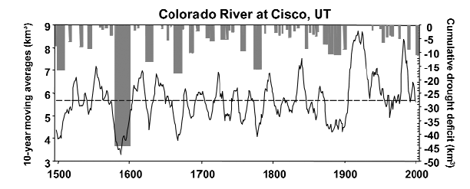

It is precisely because of the large multi-decadal volatility of the climate baseline that renders climate data ultimately ambiguous and hence the same data set may be used to support multiple points of view. As a result, policy is being made or proposed on the general assumption that climate change in the PNW must be happening since it also must be happening on the global scale. While there is likely little doubt that climate change is occurring, the rates and amplitude of that change have yet to be reliably measured. Making this required reliable measurement is the goal of this research project.
Significance of the Project:

The main reason there is debate/skepticism about the nature of climate change is simply that there is no “smoking gun”. Extant data is sufficiently ambiguous that multiple points of view can be supported. In legal world terms, extant data does allow room for “reasonable doubt” when it comes to the case of climate change. Indeed, while one can build a very plausible and compelling scientific argument for climate change by including all indicators (especially the rate of Arctic Sea Ice loss) one can not scientifically prove the case from only temperature data – the signal is just too noisy and fails tests of scientific significance. On the other hand, the methodology of climate indexing (see below), lends itself to a consistent way to establish and measure a climate and detect changes in that index over time which may be significant. In this case, one now has a reliable methodology to apply to any regional climate data set and the policy debate can move away from the perception that regional climate change is occurring to address the specific rate and manner in which the climate is changing as revealed by the actual climate data.

Plan of Work/Expected Results:

The analysis will be performed using a new statistical technique of climate indexing. Climate indexing is akin to the Dow Jones index - one identifies fundamental components of the climate system, accesses the data that exists for those components, and then combines these components in some statistically weighted manner to produce a numerical value for a particular year. This methodology produces an internally consistent way to characterize the climate and allows for a more quantitative assessment of its long term behavior.

In the mid 1990’s, the Pacific Northwest Index (PNI), was developed by Ebbesmeyer and Strickland (1995), as a terrestrial climate index useful for studying climate effects on salmon productivity trends. The PNI is a composite index that combines measurements of air temperature, annual precipitation and snowfall to produce an annual index. Measurements are

- air temperature at Olga in the San Juan Islands,
- total precipitation at Cedar Lake (located near Snoqualmie Falls)
- Snowpack depth at Paradise on Mount Rainier on March 15 of each year.

Each annual measurement has a value of x standard deviations away from its long term average.
The individual deviations are then averaged to produce an annual number. Years with positive values of the PNI are warmer and drier (coded in red below) than average and those with negative values are cooler and wetter than average (coded with blue below). The smoothed waveform that highlights the red and blue regions represents a 5 year running average over the data. The resulting conclusion, from developing such an index, is that the PNW is clearly subject to multi-decadal periods of wet and cool weather with abundant mountain snowfall or periods of warmer/drier weather with less snowfall.
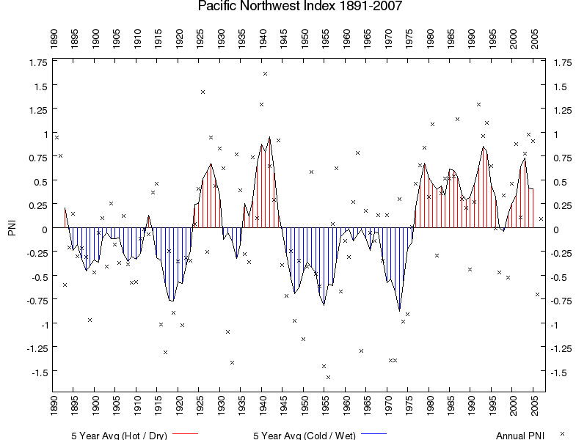

The PNI shown above, is based on only 3 recording sites – since dozens of recording sites are available then if the above waveform is a correct characterization of last century’s climate then this basic waveform should be recoverable from these other sites In other words, what would happen if you used air temperature as measured in Kelso WA, annual rainfall as measured in Astoria OR and snowfall as measured in Bend OR to construct the PNI? This was the subject of an Honors College thesis completed in 2003 which focused on three major research questions:

- Is the PNI a fluke or can it be broadly reproduced?
- Does the PNI have a primary driver or are rain, snow and temperature equally weighted?
- Can one deconvolve the PNI time series into harmonic components so as to predict the future climate pattern?

Initial results are:

- The PNI, in fact, is robust. We assembled thousands of random combinations of 3 sites and got very similar waveform behavior directly verifying the reality of multi-decadal climate cycles.

- The PNI is most sensitive to snowfall - systematic changes in snowfall/snowpack may be the best indicator of regional climate change.

- Our initial harmonic model is shown below:

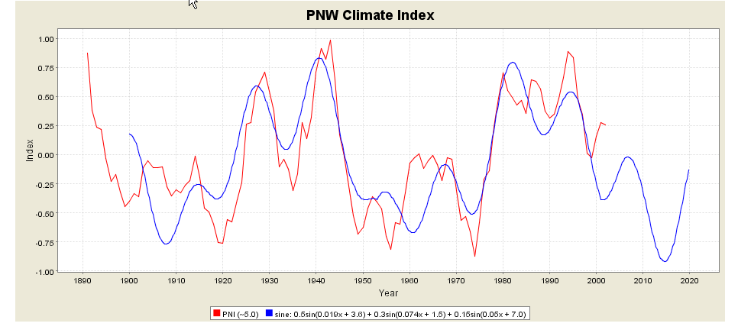

The blue line (extrapolated out to 2020) is our harmonic model, with principle timescales of 52, 20 and 14 years. The red line represents our composite PNW index that uses many more different climate sites than used by the PNI.

In terms of policy our result suggests that the PNW should have returned to another cold/wet period (or large amplitude) starting in 1999. With the exception of the La Nina event previously discussed, the post 1999 observed climate data are in strong disagreement with this prediction and this may indicate the secure detection of change in the PNW climate to sustained warm/dry conditions (which affects power generation, ski resorts, and forest fires). What is needed to solidify this preliminary result into a publishable peer reviewed paper is an analysis of the last 6 years of climate data as the red line above stops in 2003. Hence we request support for a research project to add the last 6 years of PNW climate data into the master database. Initial data inspection reveals that post 2003 data does strongly deviate from the model indicating that this century’s climate is going to be different. With the rigorous addition the 2004-2009 data, this method will have produced a secure detection of climate change in the PNW – a climate change that is driven much more strongly by changes in precipitation patterns than by temperature alone.

Contribution to the Wayne Morse Center:

I have a fair amount of experience at the science/policy interface. A couple of years ago I chaired an important national workshop on the issue of Renewable Energies (see CV) and I routinely teach classes in the Honors College or the Environmental Studies program on global energy policy and global climate change policy. I am a frequent speaker on campus about Energy issues and am well known to have an excellent command of the scale of the energy problem (or the scale of the climate problem) which others find of value. Indeed, probably my best scholarly contribution in 2009 was an article in the Huffington post about Energy Literacy and the impact of the Obama stimulus package on the energy issue – see http://www.huffingtonpost.com/jesse-jenkins/economic-stimulus-clean-e_b_168325.html.
In general, I interact well with other disciplines, have a lively personality and bring a useful scientific perspective (based on real data) to most discussions. I believe my research and methodology on climate change has significant scientific merit and brings with it new scientific insight into what it means for climate change to occur. Too much of the debate currently is anecdotal or biased in nature. I bring a balanced perspective which can be defended by real climate data and that voice is important in any policy discussion.

References:
Ebbesmeyer, C.C. and R.M. Strickland. 1995. Oyster Condition and Climate: Evidence from Willapa Bay. Publication WSG-MR 95-02, Washington Sea Grant Program, University of Washington, Seattle, WA. 11p.

Piechota etal 2004 EOS, American Geophysical Union, 85, 32

Resume of G. Bothun

Education:
- B.S. Astronomy, University of Washington, Seattle WA, June 1976
- Ph.D. Astronomy, University of Washington, Seattle WA, August 1981

Thesis Title: A Multiwavelength Investigation of Spiral Galaxies in Clusters of Galaxies

Professional Employment
- Scientific Programmer: The Very Large Array Radio Telescope NRAO 1977
- The University of Washington, Astronomy Instructor 1980-1981
- Harvard-Smithsonian Center for Astrophysics, Center Research Fellow 1981--83
- California Institute of Technology, Bantrell Research Fellow 1983--86
- The University of Michigan, Assistant Professor in Astronomy (1986--1989)
- The University of Michigan, Associate Professor in Astronomy (1989--1990)
- The University of Oregon, Associate Professor in Physics (1990--1995)
- The University of Oregon, Professor in Physics (1995--present)
- The University of Oregon, Professor in Environmental Studies (2000—present)

Other Professional:
- UNIX System Administrator for Physics Department
- Webmaster for various educational technology curriculum projects
- Director, University of Oregon Pine Mountain Observatory (1990 – present)
- Scientific Editor, The Astrophysical Journal (1996---2002)
- National Academy of Sciences Decadal Panel (1997—2000)
- Phi Beta Kappa Visiting Scholar 2000---2001

Professional Societies
- American Astronomical Society
- Association for Environmental Studies and Sciences

Professional Experience:

Research Productivity
- 191 Papers in Peer Reviewed Journals (1980-2009)
- Original Member: ISI Highly Cited Researcher in Space Sciences (1980-2000 period)
- One Graduate Level Textbook: Modern Cosmological Observations and Problems
- One Undergraduate Textbook: Cosmology: Mankind's Grand Investigation
- Approximately 25 Popular Articles (Newspapers/Popular Magazines/Professional Blogs)
- Over $3.0 million in grant funding from NASA and NSF since 1986
- Chair of Numerous NASA Peer Reviews
- Approximately 2000 nights of Observing since 1980 on most of the major radio and optical telescopes in the world
- Extensive experience with Space Based instrumentation - including the Hubble Space Telescope

Research Interests:
- Galaxy formation and evolution
- Dwarf Galaxies
- Galaxies of Low Surface Brightness
- Large Scale Structure
- Clusters of Galaxies
- Observational Cosmology
- Applications of Instructional Technology
- Regional Climate Change Indicators
- Sustainable Energy Implementation and Policy

Miscellaneous:
- Initiated the Electronic Universe Project - a Web server dedicated to public outreach and education by delivering real data, explanation and analysis to the lay public. This has been on the air since Feb 9, 1994 - making it one of the first such servers in the entire world. Server has seen close to 25 million hits since operation commenced.
- Developed suite of Java based simulation tools for introductory classes in physics, astronomy, and environmental studies. Widely used Nationwide.
- Have given over 100 public lectures since 1984 to various groups
- Helped developed the new Environmental Studies/Sciences program at the University of Oregon
- Supervise the Friends of Pine Mountain Observatory Educational outreach program which visits 200+ K12 classrooms a year in the State of Oregon and which accommodates approximately 2500 visitors per year during the summer to the observatory.
- Have lead numerous K12 teacher development workshops.

Honors College Thesis Student Supervision:

Harvey Rogers – Pacific Northwest Climate Change – 2004

Jesse Jenkins – Well to Wheels Analysis of 2020 Light Vehicle Fleet - 2005

Jessica Bliss – Oil Exploration in Ecuador and Indigenous Rights - 2005

Alexandra Luftig – Properties of Watershed Invertebrates – 2006

Joseph Sneed – Carbon Taxation in China – 2008

Heather Buxton - A Biological Analysis of the Impact of Oil Drilling Platforms and Pipeline Delivery in the Ecuadorian Amazon - 2009

Tommy Bairstow - The Feasibility of Cellulosic Ethanol Production in the Willamette Valley - 2009

Emily Chi -Are Atlantic Basin Hurricane Properties Changing over Time? -2009

Adrienne Wilkie - Regional Climate Change in the American Northeast -2010

Sibyl Geiselman: The Wind-Hydrogen Connection and the Smart Power Grid – 2010

Katherine Phillipson: Can a Market Based Approach to Reduced Carbon Emissions enable Environmental Justice? -2010

Ravi Parkih: The efficacy of the Energy Tax Credits and the implementation of renewable energy -2010

