**Background:**

Ever since they were first discovered in 1963 Quasars (QSOs) represent distant point sources of light that shine through material that can probe structures at various redshifts via the detection of chemical absorption features along the line of sight. However, without independently measuring the redshift of the structure which is causing the absorption, it is impossible do precisely determine the chemical species that is producing the absorption feature. If the feature is spatially near an obvious galaxy, then measuring the redshift of the galaxy often leads to the interpretation that the observed absorption lines are associated with some kind of extended debris about that galaxy, likely liberated through previous tidal interactions with other galaxies [2,3]. This region of extended debris has come to be known as the Circumgalactic Medium or CGM – see Tumlinson etal 2017 and has only recently come to be recognized as an important part of the overall galaxy environment. In many cases, the contents of the CGM or known to be infalling into the host galaxy and income cases possibly might serve as fuel to drive an AGN. The origin of the contents of the CGM are not well known. Certainly, some of the material is accumulated from several interactions between galaxies that are constantly interaction in a group or cluster environment. Sometimes this interaction can be extreme such as the case for HCG90 (White and Bothun 2003) in which more than 50% of the stellar light from all the galaxies is in the form of an extended CGM. One important clue about the nature of the CGM is the presence of metals in the QSO absorption line spectrum. This indicates the material has been processed and therefore was likely liberated from a galaxy undergoing chemical evolution via star formation. Simple expectations suggest that the strength of the CFM is highly environment dependent and, as discussed below, our current investigation of the Coma environment shows many examples of CFM like features.

High resolution spectroscopy of QSOs reveals chemical absorption features along the line of sight at redshifts similar to various foregrounds galaxies and other structures [3]. The higher the resolution of the spectra the more one can detect very weak QSO absorption lines. Our analysis of the, The Hubble Telescope Spectroscopic Legacy Archive QSO data allow for the detection of lines with equivalent width (EW) as low as 0.05 angstroms. The overall geometric scenario associated with QSO absorption lines an intervening structure is shown in Figure 1 where some distant QSO is shining through structure. A high-resolution spectrum of the QSO reveals absorption lines in the foreground material, thus showing that baryonic matter exists there. In this particular case, there could be multiple systems involved along one line of sight as it passes through a structure with a velocity dispersion of ~300 km/s. Thus, high resolution helps to resolve individual structures within a galaxy group or cluster potential that might have redshift difference of a few 100 km/s.

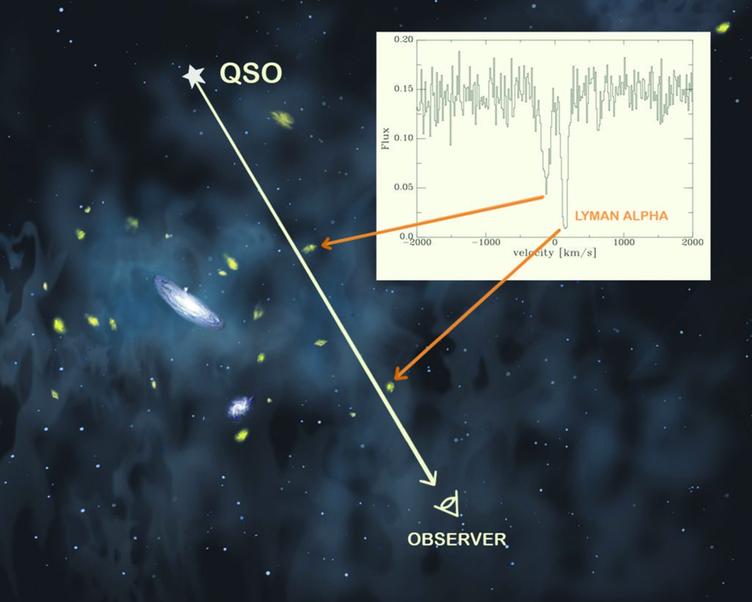

The existence of intracluster light, intergalactic stars, cold diffuse baryonic clouds in clusters of galaxies has long been a potential source for unaccounted baryonic matter than could contribute to the long standing missing baryon problem (e.g. Cen and Ostriker 1999, more REFS Crain et al). This component is extremely difficult to detect. For instance, suppose that the Coma cluster inner 1 degree radius were to contain 1014 stars. The surface brightness of that component would be XXX making it extremely difficult to detect, although there is some evidence for its existence. (REF). Most simulations (REFS) involving standard cold dark matter coupled with some hydrodynamic means of galaxy formation reveal that left over gas will be heated by various processes forming a somewhat smooth background of warm baryonic gas with temperatures in the range of 10^5-7 K. Detection of this baryonic component is difficult. At the high temperature end, which might be expected in some clusters, a soft X-ray signature might be available. Evidence for this gas, either in the Milky Way halo or elsewhere, has long come from various QSO absorption lines, usually of O VI. But without a strong understanding of the temperatures of these clouds that produce these features, determining masses of such structures has historically been difficult. Most evidence to data, while confirming that this warm phase IGM does exist, suggest that it is not sufficient to account for the full missing baryon problem (REFS). The case of the Coma cluster, when our QSO absorption line systems in the Coma supercluster can be correlated against various X-ray studies (mostly Chandra) in that area we may well find examples of baryonic clouds in the intracluster medium that also show a soft X-ray presence.

As discussed below, our data analysis to date shows a number of absorption lines that have been statistically identified with various ionized metals. This directly indicates that the absorbing material has been processed likely when that material was in some host galaxy participation in star formation and was later removed. For the case of the Coma supercluster, tidal interactions would likely be the main source of this removal, but blow by stellar winds or supernova shocks is also a possibility. Donahue et al argue that collisionally excited metal ions dominate the soft x-ray emissivity of clouds, and in fact are required to produce any X-ray emission, at an expected temperate of ~ 0.1 Kev. In addition to seeding by some host galaxy through supernova-driven winds, accretion from the IGM into these cloud structure is also a possibility, particularly in the Coma supercluster. In addition, because the mass of these potential clouds is very much smaller than any L* host galaxy, over time, the dynamics of the cluster environment while serve so separate the clouds from the original host galaxy. A few billion years later, this might produce some kind of smoot distribution of warm baryonic clouds in the cluster.

Some results from the COS/Halos project (REFS) are relevant here to the cluster environment if one imagines thousands of Milky Way like objects that populate the Coma supercluster. Each of these objects is presumably embedded within some 100-200 kpc dark matter halo. Observations (REFS) around Milky Way size galaxies indicate the detection of OVI features with relatively high column density out to a radius of ~150 kpc. Some of these clouds have line widths consistent with velocity broadening in a small bound dynamic structure. In addition, some of these clouds exhibit velocity offsets from the host galaxy of 100-250 km/s. If such a network of extended clouds that defines the CGM around these kinds of galaxies is formed as a result of the suspected galactic feedback process associated with their initial formation, then immersion of all of these extended structures around individual galaxies in a robust cluster potential would likely lead to a large redistribution of those individual halo clouds into a warm, intracluster medium. Relevant to this scenario Amiolleta etal 2017 discovered ~50 equal-mass galaxies either in the process of merging or strongly interaction that exhibited extended diffuse X-ray emission, presumably as a result of the interaction of their own extended CGMS. Thus we are left with a reasonable expectation: clusters of galaxies, as they begin to form after individual L* galaxies have mostly collapsed and produced their own individual CGM primarily due to feedback associated with the initial formation, should contain the redistribution baryonic content of all thse individual CGMs now well removed from their host galaxy. Hence a sufficiently large number of QSO sightlines in the cluster region, may well detect these population of redistributed clouds. We show below that we have detected such a population in Coma and now wish to a) extended this analysis to other nearby superclusters (e.g Perseus-Pisces, Hercules – A2151, A2634) and b) for the case of the Coma cluster, use the Chandra archive to search for diffuse X-ray emission at the locations were we have detected QSO absorption lines.

II. Detected QSO absorption lines in the Coma Supercluster

This region contains about 20,000 L* galaxies that are grouped into various kinds of structures [4]. A portion of that data centered on the Coma cluster proper [5] (radius denoted by yellow dashed line in Figure 2) where the X’s and colored circles represent background QSOs for which spectra exist.

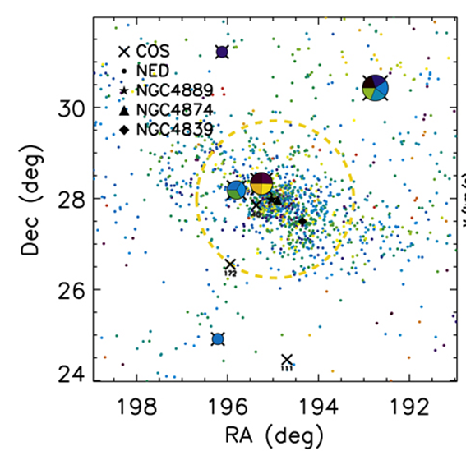

One of the unique features of this particular environment is that local galaxy density various by over 4 orders of magnitude [6]. Hence, if absorption lines are detected we might expect detections to correlate with local galaxy density if the baryon removal processes are local to individual galaxies and have relatively recently occurred (but this seems unlikely) On the other hand, this environment is subject to much dynamical mixing and therefore any local baryonic gas removal from any particular galaxy may eventually mix within the overall structure consistent with the scenario previously outlined. Figure 3 shows the positions of our detected QSO absorption line systems where the Coma supercluster is essentially between 160 and 200vin RA and 20-40 in Dec. There are a number of available systems that sample the relevant region as well as available “comparison” areas.

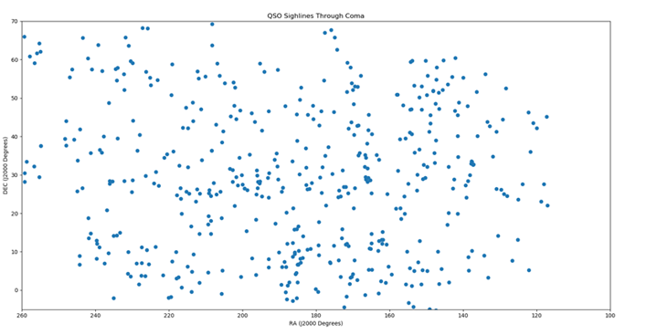

In figure 4, we superimpose the distribution of galaxies in these region which have velocities indicating physical membership within the Coma Supercluster as defined by the redshift ranges seen in the studies of Bothun etal and D’antinoi etal.

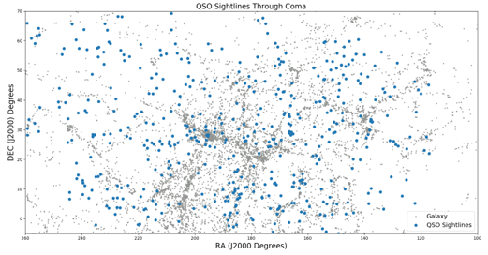

Figure 4 better shows the associations between the QSO absorbers and the rich structure in this region. Many of these QSO absorption line systems have sightlines through voids while others have sightlines through the various wall features. Since we have only plotted galaxies that share the same redshift space the total size of this connected kinematic structure is now observed to be considerably larger than the original detection of the Great Wall (dallaparent). In the tables below we give the overall statistical nature of our sample in which it is immediately obvious that there are many absorption lines associated with various metallic ions. Our line identifications are still being refined at this point as this is a difficult process as there are thousands of lines that appear in the integrated detections; “near coma” is defined between RA = [100, 260], Dec [0, 70], and z = [0.0215, 0.0245]. In addition, also have a few hundred more QSOs detected that define a background that we use for detected line is the range z=0 to 0.2. This background can serve as a reference sample to Coma to see if the Coma like structure produce an enhancement of QSO absorption line systems to this this suspected distributed collection of baryonic clouds stripped from the CGM of individual galaxies,

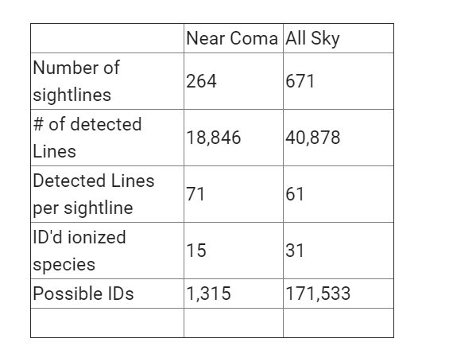

The high-resolution nature of the COS observations limits the overall ability to detect certain kinds of absorption features. In general, the workable spectra have a wavelength range of 1250 -1800 angstroms and the average redshift is about z =0.023. The distribution of all the wavelengths of all 18,000 absorption lines in the Coma sample is shown below in Figure XX. The regions around 1200 angstroms are strongly contaminated by Geo Coronal Ly alpha.

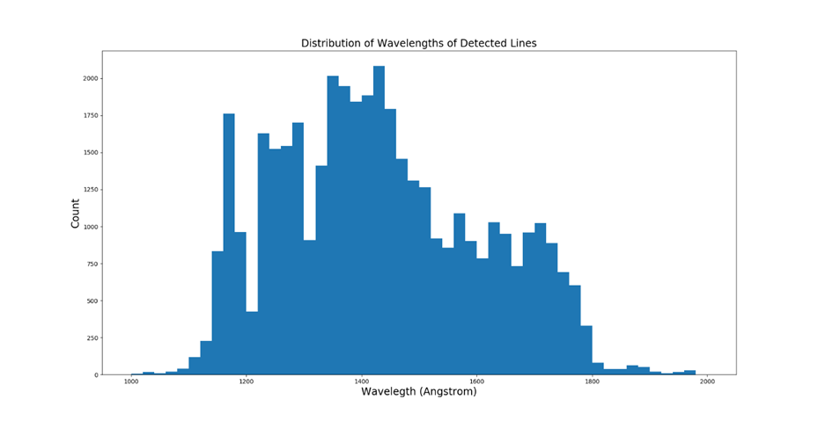

The following table contains the tentative line identification corresponding to various ionized metals that would are associated with the Coma supercluster redshift range. Most of the features in the spectra, have not yet been reliably identified.

|  |  |  |  |
| --- | --- | --- | --- |
| Species | Number of lines | Species | Number of lines |
| AL II | 1 | O III | 1 |
| C II | 190 | P II | 102 |
| C IV | 22 | Si IV | 27 |
| Fe II | 79 | Si II | 102 |
| Mn II | 24 | Ti III | 55 |
| N III | 2 | V II | 13 |

The identifications listed above have absorption features with EW of 0.1 angstrom or higher, so most of them are quite weak but the S/N of the COS spectra is sufficiently high that they can be extracted. Since the physical conditions of these clouds are unknown we do not yet know if there are lines that we should have detected but have not. The empirical fact that ionized Carbon is the most common line, is perhaps reassuring that we have most of the lines correctly identified. In any event, it is clear that the absorbing clouds are full of processed material – consistent with the notion that these clouds originally come from removed CGMs of individual galaxies.

In terms of column density associated with Carbon lines, Figure 5 presents a selection of some of the better measured systems and plots their column density as a function of distance from either the Coma cluster or the Leo cluster (which can now be considered as part of the Coma supercluster). The bulk of these systems have column densities below 10^17 with a likely detection threshold of 10^14.5, below which the line really become too weak to accurately measure. In this sample, however, there are 4 systems with column density greater than 10^18 and we are particularly interested in possible X-ray emission associated with those positions. In general, as seen more strikingly in Figure 6, there is no dependence of column density on distance from a particular cluster center.

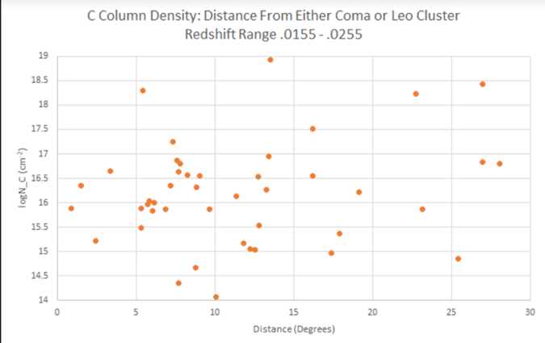

Figure 6 plots the raw EW of the absorption line features (which correlates with column density) as a function of redshift “distance” from Coma. Values in excess of 0.002 in redshift space correspond to galaxies in the extended supercluster and in some of the infalling regions (see D’antionio etal). Clearly at all “distances”, the same range of EWs occurs indicating a likely well-mixed collection of clouds. Since, the X-axis is a proxy for local galaxy density and the data clearly shows there is no correlation, indicating very well mixed release of baryons.

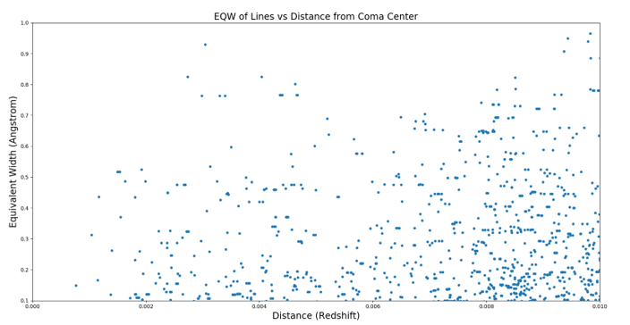

**Remaining Work:**

Given the successful detection of many element absorption lines in the Coma Cluster/Supercluster environment, we propose to continue to these measurements to two low redshift, extensive highly clustered environments – Pesueus-Pisces (coordinates) and the Hercules supercluster (coordinates). Both of these regions are dominated by disk galaxies, many of them gas rich, and are environments that are producing many tidal interactions. We thus expect the same kind of liberate individual galaxy CGMs to become a baryonic component to their respective intracluster baryonic populations, but probably not to the same degree as seen in Coma. Nonetheless, the addition of these two structures will allow for an even better comparison between the low redshift cluster environment and the low redshift background environment that we are obtaining as a byproduct of doing this work. In addition to extended our QSO absorption line work we also wish to correlated the various sightlines observed in Coma, Persues-Pices, and Hercules to the Chandra archive in order to possibly detect (or set limits) on any diffuse emission associated with these absorption line systems in the supercluster environment. We of course realize that it would not be possible to separate out this X-ray emission in the region of the clusters that contain the hot ICM (central degree of Coma, very weak in Hercules (A2151), non existent in Pereius Pisces) but we have very few sightlines that are superimposed on this core. So we are concerned only with the detection of diffuse X-ray emission in the vast amount of sightlines that are not contained in the virialized regions of these superclusters.

The key scientific objectives of this now extended study are

1. To constrain the IGM gas density and covering fraction of Carbon clouds as a function of local galaxy density (this has never been done before on a large scale)
2. To attempt to detect diffuse X-ray emission around some of these QSO absorption line systems. A detection will help better establish the temperature of the absorption cloud and the expected kinds of ionic species that might exist given an approximate measure of the density. This soft X-ray emission would also provide another means of photoionization beyond that provided by the MetaGalactic UV flux.
3. To better compare the ionic abundances and ionization states within various filaments and voids in this structure. This in turns helps to constrain the amount of gravitational heating that can occur in these structures due to the presence of surrounding galaxies.
4. To map our detection of IGM densities into a general simulation-based model on the mechanisms and timescales needed to liberate this many baryons from the individual galaxies. Our preliminary analysis to data suggests that we would have not detected as many absorption line systems as we have if at least 1/3 of the baryons have already been liberated from the individual galaxies in this region

In sum, we have a promising new data sample to thoroughly investigate a vexing problem in cosmology, namely, where are all the suspected baryons created in the Big Bang? Preliminary analysis of the sample has clearly showed the presences of a robust IGM in this region, indicating that baryons are well present outside individual galaxies. In addition, we have detected several different ionic species which can in turn better probe the physical nature of the IGM in this region. The proposed combination of the COS archive with the Chandra archive in order to better probe the physical nature of presumably well-mixed baryonic clouds that have been previously stripped from the CGM of individual galaxies in the environments of nearby superclusters represents a relatively unique probe into the continuing mystery of the missing baryons.

IGNORE EVERYTHING BELOW:

References:

1. Tanimura, H. et al. 2017, A Search for Warm/Hot Gas Filaments between Paris of SDSS Luminous Red Galaxies, https://arxiv.org/abs/1709.05024

2. Mo, J. and Escude, J. 1996, Gaseous Galactic Halos and QSO Absorption line Systems, The Astrophysical Journal 469, 589

3. Burchett, J. et al. 2016, A Deep Search for Faint Galaxies Associated with Very Low Redshift C IV Absorbers. III. The Mass- and Environment-dependent Circum-galactic Medium, The Astrophysical Journal 832, 124

4. Bothun, G. and Dressler, A. 1986, Blue disk galaxies in the Coma Cluster – Analogs to Z = 0.5 cluster members?, The Astrophysical Journal 301, 57

5. Yoon, J. and Putnam, M. 2017, Ly Absorbers and the Coma Cluster, The Astrophysical Journal, 839, 2

6. dell’Antonio, I., Geller, M., and Bothun, G. 1996, Peculiar Velocities for Galaxes in the Great Wall. II: Analysis, The Astronomical Journal, 112, 1780

7. Morrison, S. et al. 2016, Element Abundances in a Gas-rich Galaxy at Z=0.5: Clues to the Early Chemical Enrichment of Galaxies, The Astrophysical Journal 830,158

8. D’Odorico, V. et al. 2010, The rise of C IV mass density at z <2.5, MNRAS 401, 2715

