Improving Undergraduate Physics Majors Experience in Systems Thinking

Introduction and Motivation

We propose to develop an intensive summer REU experience for a population of physics majors that will better train them to a) view science as a discovery process, b) develop tools to use physics as way to investigate how real-world systems actually work (e.g. systems thinking) and c) deal with data to obtain, calibrate, analyze, present and then use that data to characterize how a system works. This proposal is motivated by the following basic observations that the PIs have made over a combined 40+ years of teaching in undergraduate physics major programs.

1. The Physics major curriculum is generally strongly guided by the chosen textbook for that area. These textbooks generally provide a linear evolution withing the sub-field and the narrative of this evolution is strongly driven by the use of the appropriate math (student call appropriate math as “formulae), that allows a proper derivation of the necessary physics to understand the phenomena.
2. Homework assignments are generally based on cookbook problems which have specific solutions that are achieved by using specific “formulae”. In general students spend far more of their time trying to determine the correct formulae to just in their plug-and-chug mindset approach to problem solving. This leads them wholesale to believe that “physics” is only a process of using applied math to solve a particular set or questions and not as a process for investigating how systems work. In essence physics as taught to them as if the “=” sign as the only thing that matters and that, somehow, nature pays for intention to the “=” sign than it does to how its systems operate. Nothing, of course, could be farther from the truth.
3. In general, physics majors have poor collaboration skills when it comes to problem solving and system thinking. Often times this deficiency is spun as being not an issue because it is claimed that physics students do well at working on their homework together. According to point 2 above, this collaboration really involves a hunt for the right equation, nowadays usually using the Internet, to solve the textbook problem at hand.
4. In general, physics majors have poor communication and writing skills. This is mostly because they are never actually needed to solve textbook problems and so there is no ability to develop these skills within the overall physics undergraduate program. Indeed, it may also be that a) there is no incentive for faculty to devote time to do this given the overall number of textbook topics that must be discussed during the term and b) the department itself does not really value the development of these skills.
5. In general, physics majors have poor scientific programming skills compared to many of their undergraduate peers. Most traditional physics courses don’t involve any data reduction, analysis and presentation and programming skills are certainly not required to solve any of the formulae-based homework problems. While the development of these skills may be relegated to various required Physics “lab courses” – the curriculum in those courses is generally based on various closed end, time-tested material.

Many of the deficiencies in the 5 points just described come together when one tries to teach physics majors about real systems in nature and how they operate. Here we briefly discuss a course in astrophysics designed for students who have taken the first two years of the physics course sequence and a course in atmosphere dynamics for students who have taken these first two years as well as having been slightly exposed to fluid dynamics and/or partial derivatives. The first hint of problems to come, is when the students are exposed, in the very first lecture, to the basic notion that a) most of what we know about these systems comes from observations and data and b) to deal with these systems one has to make some basic assumptions in order to apply known physics to them. At that point it becomes clear that his population of students struggles to think about how one can characterize a system. These points can be further illuminated by their responses to a few basic, general questions. Examples are:

1. Can we assume a star to be a uniform density sphere?
2. Can we assume the Earth’s atmosphere is isothermal?
3. How do we know that our atmosphere is thin?
4. Why does it rain?
5. Estimate the difference in heat capacity between the Earth’s atmospheres and oceans.
6. Why might quantum mechanics be important in determining the total amount of energy emitted by the Sun?

In addition, homework assignments in these classes are largely based on data and modelling and never involve anything cookbook or anything required finding the right formulae. Initially, students are quite frustrated (which then disengages them from the content) and complain that the homework problems “can’t be solved”. An example problem: using a dark matter halo gravitational potential, use this rotation curve data to fit a dark matter model. While this is not a hard problem, it apparently was the first time the idea of fitting data to a model was introduced to these students. In the end, both of these courses worked out well and the student’s felt that they learned many new things but the course was strongly constrained by a) the generally poor programming skill of the students and b) there large difficulty in thinking about how systems work via the combination of various sub-components.

Hence, it has become clear to us that current physics major, while perhaps gaining a good understanding of how to use Calculus to solve 19-th century physics problems, simple do not have a very broad skill set that can help them with other possible career choices. Indeed, the results of project Spin-UP (Hilborn 2003) become quite relevant as we discuss immediately below. For now, we note that study determined that only 35% of physics undergraduate majors go on to physics Graduate school (20% of majors go to other fields in Graduate school). Thus, at best the traditional formula drive undergraduate major physics curriculum designed to send students on to graduate school in Physics serves only about 1/3 of those majors. It seems now high time to experiment with teaching undergraduate physics in a different way, a way that is more engaging to a more diverse pool of student and a way that is more relevant to the skill these majors are likely to need in their future lives.

The declining relevancy of the physics majors to undergraduates clearly starts around 1990 as shown in Figure 1. By the year 2000 only 0.3 % of all undergraduate degrees were given in physics, despite the relatively large faculty N that exists for most Physics departments. The SPIN-UP project was designed as a mechanism to cope with this decline and to basically ascertain “why physics is not interesting”.

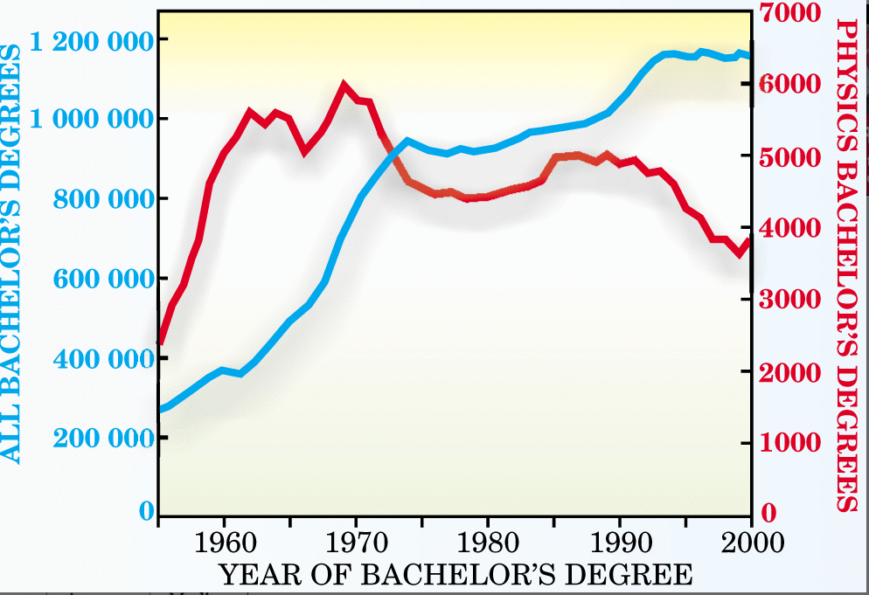

While the main focus of this project was on individual departments that did not exhibit this kind of national level decline, to determine what aspects of those problems made physics more attractive. Although this study is data, at now being 17 years old, most of the trends noted in that study remain relatively the same, indicating almost no evolution in the general physics curriculum. While this study uncovered a number of keys for increasing participation in the physics major, there were two outstanding, and of course, unspringing factors.

* Improvements in student mentoring and faculty-student interactions usually in the form of informal small groups of faculty and students.
* The introduction of undergraduate research as a **key** component of the undergraduate physics majors. Often times it is precisely this research component that indirectly leads to better mentoring and more informal faculty-student interactions.

Hence, there seems to be a clear path here: get undergraduate students more involved in research early ON, and sustain that involvement throughout their undergraduate experience. Undoubtedly, most Physics departments will claim the indeed they are doing this but this “research” is generally not “integrated” into the whole pathway to degree. Certainly, that is the case for us, at the University of Oregon, and there are 3 basic reasons that we are unable to perform the necessary integration.

1. Many faculty feel that students have very poor research skills and hence it would be a waste of faculty time to involve them in undergraduate research. While we emphasize that we feel that involving undergraduate students in research is most definitely a large portion of your responsibility as a faculty member, we agree that students must first be trained in what research is, how to do research, and to develop resiliency to failure in doing research. Indeed, that is what is intended as the training for our proposed REU project.
2. Integration really means the substitution of research credits for some course credits. It is completely unreasonable to treat undergraduate research as some kind of “add-on” to the already heavy load of physics and math classes**. Real curriculum reform in physics undergraduate education will only occur when such integration is actually done.**
3. Resources**:** This generally comes down to infrastructure in terms of space and equipment and these can be strong logistical obstacle to the desired integration. Based on our previous experience with undergraduate research projects (described more below), we have found that team based small projects a) really work, b) demonstrate to the students that the can flourish as a group and experience meaningful success in that way and c) offers an environment that is more receptive and encouraging for students from diverse backgrounds. Hence, a main goal of our proposed REU experience, is the development of small-scale research experiences that can be more broadly developed to give other departments working examples of project success that can be experience without needing a large investment in infrastructure.

Pedagogical Strategy

For this REU we are proposing to develop, implement and test, various kids of research-based problem learning that requires student team collaboration. We hope to produce successful modules that can be used by other Universities to introduce these activities as a substitute for the traditional homework based on textbook problems These activities could serve as a capstone to a course or could be used to develop various student projects that could make up a substantial component of their grade. At the very least, this would give alternatives to those physics students that are particular stressed by traditional exams. We anticipate that such an integration will have the following positive effects:

1. Students will be more broadly trained and given a better foundation for migrating their physics experience into other discipline areas.
2. Retention of female students within the first two years will be higher.
3. Students will gain a much better set of data skills than they currently receive.
4. Students will gain a much better set of communication and scientific writing skills than they currently receive.
5. Students will gain better collaborative skills.
6. Most importantly, students will be exposed to the experimental investigation of nature in which there are no “right-answers” to be obtained, but rather that knowledge arises via discovery and exploration so that students a lead by good data to better understand how a system works.

These developed collaborative learning exercises can expose the physics students to different learning modalities that can facilitate their understanding of systems thinking and to improve their overall data science skills. This directly has the result of improving the quantitative foundation of their critical thinking skills that will serve their emergence into other disciplines. Instead of learning in these first two years that physics is basically applied math (or more crudely, “what formula am I supposed to use to solve this problem”), instead they will use physics as the essence of building predictive models of the world, verifying them, and using them to model reality (e.g. Greca and Moreira 2002). Although many physicists see their discipline as a fun-filled, curiosity-driven endeavor, college physics courses are sometimes characterized as unwelcoming (Rojstaczer and March, 2010) and that factor may partially account for female underrepresentation in physics. In a large-sample, multiyear study conducted at Cornell University, researchers examined the effect of peer interactions on students’ persistence in science and observed that the form of these interactions strongly influenced female students’ persistence in physical science majors (Ost, 2010). Beilock and Ramirez (2011) concluded that the introduction of inclusive styles to teaching in physics was conducive to better retention. Inclusiveness generally occurs when a learning community forms between professors and student groups working together on some project. In this way, a learning community of motivated students can be formed around a particular research project and its analysis. Rather than our traditional teaching, where students often see textbook material as disparate entities, reintroducing these topics in the context of a common theme provides a conceptual framework that ties these disparate subjects together and promotes better student engagement while simultaneously better developing research-based collaborative skills.

As argued above, while the traditional method of learning can be effective, many students are unable to see the common principles at play across all of these subjects, or cannot appreciate the insight that data can provide to illuminate how the system works and the various relationships that might be present among the sub components. A good example is the climate system in which various feedbacks (positive or negative) are at work that serve to change how the system functions as this continual feedback is part of systems evolution. While no doubt these physics majors could take a course on perturbation theory and recognize that feedbacks can be treated via a series of often non-linear partial derivatives, they would be given little or no context on why any of this matters and therefore could successfully complete that course without ever knowing why it’s a bad idea to raise temperatures in Siberia to increasingly melt the methane-containing permafrost. While that may be a trivial example, it serves to reinforce our general position that undergraduate physics majors are continually exposed to a variety of mathematical approaches without really ever being exposed to the physical context of the problem. Another example is this: the study of E&M (usually at the junior level) is often mostly an exercise in multivariate calculus. Our position is that a better approach, and possibly better understanding, would be to teach E&M in the context of how the Arecibo radio telescope works. (see for example Finklestein 2003). However, some have argued, from a legacy point of view, that teaching physics in context is essentially engineering and/or applied physics and that we should strive to teach physics at a deeper level. Well, in the context of training undergraduate physics majors to be successful in physics Graduate school, that approach may make some sense. The given on-the-ground reality that only 30% of said physics majors go on to physics Graduate school means that not focusing on the applied nature of physics is likely doing a disservice to the other 70% of majors who after acquiring their BS have learned only how to apply math to physics problems.

Furthermore, this method of learning can exacerbate a false idea that is particularly endemic to physics: that some kind of innate intelligence (dominance?) is needed in order to succeed in physics. In this case, dominance is best defined as mathematical dexterity. If students identify with a group that is underrepresented in the field, this thought can have devastating effects on their learning and persistence in the subject. Getting the wrong answer is too-often taken as evidence that they are not suited for physics, which negatively affects their motivation and ability to practice on their own. In turn, we strongly evaluate for problem solving via the “right answer” approach and rarely evaluate on the basis of process or how to even think about the problem. Indeed, when is the last time you have seen a problem on a Physics MidTerm exam that starts out, *“draw the system and identify what qualitative behavior the various systems might exhibit”.*Instead the problem relates to identifying the correct equation to use. Furthermore, this approach trains students to falsely believe that physics is about solving clearly stated problems that always have one correct answer. Science and engineering are not about arriving at one answer, but in developing and testing models. Our experience shows that physics majors are among the worst at making models (compared to students in environmental science, biophysics, or atmospheric science). Our goal is to overturn this training via various exercises in the proposed REU program (see more below) via a set of open-ended experimental journeys. Our experience is that an experimental projects collaborative focus corrects successfully overcomes the “getting the right answer” phobia.

The development of this REU proposal is strongly guided by two recent successes we have experienced involving undergraduate physics majors (first 2year students only) in introducing them to research and collaboration. In the Summer of 2019 we experimented, using a small number of students, with a physics “lab” class that consisted entirely of hands-on building of novel devices in which to make various kinds of measurements (one being building and flying a small drone around the large open Atrium in the Physics Building with sensors to collect temperature and humidity data). The point of that exercise was for them to gain experience in the **design, build, test, fail, re-design, test again, calibrate cycle**. For those physics’ students inclined to believe that using the right equations is the means to solve a problem, this approach was eye-opening and, of course, was met with some initial resistance. Some students didn’t even think this was what physics could be about, but emphasized that applied physics/engineering/systems thinking would be tools that can be added to their resume to enhance their career prospects. Most important, however, is the following observation. In general, not matter what the project was, all the student teams would initially fail. When all these teams observed each other failing, this largely broke down the dominance barrier discussed earlier. Almost immediately their desire for collaboration took off and much of the conversation around the large student group working table specifically designed to support this kind of learning modality was mostly “hey, what happens to this thing if you do that”; upon saying that repeatedly, the students were totally launched into the experimental mode of learning about something. Ultimately the data acquired by the various devices that were made, using mostly Arduino sensors, was used to segments on data analysis and data visualization. Interestingly, the class was 50% male and 50% female and the continual engagement with these projects as the exclusive class pedagogy seemed to completely eliminate the gender barrier.

The success of the summer 2019 course experiment resulted in the awarding of a small grant from NASA to form a student team research grant focused on designing a component for Oregon’s first CubSat. The “Oresat” (see: oresat.org) is scheduled to be deployed from the International Space Station in 2021. Our team at UO is tasked with designing an electromagnet that can be used to orient the Oresat in Earth’s magnetic field, a device called a magnetorquer. As part of the project, we are working with a team of upper-division undergraduates with majors in physics (core population from the Summer 2019 course), computer science, and chemistry to design and build the magnetorquer. This multidisciplinary team of undergraduate researchers represents the kind of engagement with an open-ended, data-driven, and fairly original research project that we are promoting as the essential feature of the proposed REU.

BEN M. – MORE WORDS NEEDEd here on cubesat stuff.

SPECIFIC MODULES FOR THIS REU

One of the most important things to establish early on is a framework for knowledge. As alluded to above, physics students often confuse knowledge with their ability to get the right answer. For example, a physics student may be able to successful predict, from some simple thermodynamics approach, that the current temperature of the Microwave Background is 2.7 K but have no knowledge of why there even is a MWB to begin with. Again, through experience we have identified two basic strategies for dealing with this.

* Expose students to real physics mysteries in a historical context to demonstrate the process of how the mystery can eventually be solved. The story of the understanding of combustion, first explained via the phlogiston mechanism, before being experimental resolved is good for this. The development of the transistor and the development of radio communications are also good. Basically, the idea is to show that, historically, it is often the accidental discovery of something convolved with the open mind, that leads to real progress. Indeed, this approach to science was predicted by Newton

*In experimental philosophy, we are to look upon propositions inferred by general induction from phenomena as accurately or very nearly true, notwithstanding any contrary hypotheses that may be imagined, till such time as other phenomena occur by which they may either be made more accurate or liable to exceptions.*

The truth is malleable and evolving and experimentation is the mechanism that drives this evolution.

* Ground the students in objective observation. A successful effort can work as follows (depending on location) – first ask the students how many different kinds of trees or plants exist within a one block radius from your current location. Then send them out in groups with cell phones for them to take a picture of what they think is a unique plant within that radius. The results are generally eye-opening for the students and helps them to realize the vital role that accurate observations play (indeed allowing Kepler to prove that planetary orbits have to be ellipses based on Tyco’s accurate observation of Mars).

Arduino stuff, programming, etc to go here

In sum, the proposed development of a series of projects-based experiments via the proposed REU are designed to augment, complement and extend traditional homework problems which we will allow students to appreciate a broader context in physics is embedded. Rather than such problems being viewed as isolated and designed to primarily increase student literacy with the vocabulary and basic operational principles of physics textbook problem solving, fully integrating them in a broader experimental context will mostly like increase the physics intuition of the students and help move them away from the notion that physics problems are only solved using math. The reality is that physics is an open-ended process of investigating phenomena and our physics undergraduate curriculum in the first two years should emphasize this instead of suppressing it. The impact of this proposed shift in how students are exposed to introductory physics at the university level could well be profound. Students will be far more exposed to experimental and research-based approaches that have been traditionally used to demonstrate the voracity of physics “theory” as well as the applied research domains for these discoveries in physics. Students will also receive better collaborative training and be exposed to real research at a much earlier stage. In turn, faculty teaching these courses will be less bound by textbook constraints and previous instructional inertia and will now be able to exercise the opportunity to teach courses in a more open-ended and discovery-based way. Our hope would be that this new teaching approach would produce better student engagement, and, frankly, make the material more interesting and to better connect that material with other emerging disciplines that requires an improved student tool kit for research and data analysis.

Practical Matters, what we need funding for:

There are three essential areas that require funding in order to move forward and the proposed budget serves to address these primary needs.

Funding to hire a coordinator (Chris Dudley or maybe Ian Ellis) to oversee the student projects, assess their progress, solve some of their technical issues, help discover new resources that can be used to refine their projects. A lot of these projects involve the use of Arduino devices and programming such devices to do various tasks using various sensors. This coordinator could also be a Graduate Student that has substantial experimental experience. In turn, this gives the graduate student valuable real-world managerial experience.

Funding to support faculty mentorship over the summer. This will allow faculty participants to work directly with the students to build various learning communities centered around various open-ended projects.

Equipment and Space: The space problem is always significant. We anticipate project group size of 4-6 students and this program would need a dedicated space where various materials are available. Essentially this program needs a fabrication and data analysis space. With some care and planning and resources we can convert existence space in Willamette Hall to serve this need (for example Willamette 317 and/or 417 better connecting the current scattered spaces in the basement of Willamette). However, purchasing equipment will be an essential recurring need that is best illustrated in the following examples: In the summer class there was a 3D programming and print part of that curriculum. However, the existing supply of 3D printers to the students was extremely limited to those in the Science library. Those printers turned out to either lack some needed features for the projects or were not easily available for student use on a drop-in basis. Thus, Bothun’s 3D printer in his lab had to be used exclusively for the various print jobs. In addition, at one point we had a soldering iron issue where there weren’t enough available in real time for the students to do the precision soldering needed for some Arduino board connections. Hence, the available research infrastructure for student led research projects proved to be somewhat inadequate and this situation has to be improved in order for our approach to scale up at the level of the REU (including drone wars in the atrium as a capstone experience).

Other Sections needed and to come:

Project Schedule

Project capstone experience

Project Management

Student recruitment and selection

Project evaluation (Kevin Carr)

Also words about McDevitt etal