**The Carbon Cycle Kinematic Skit**

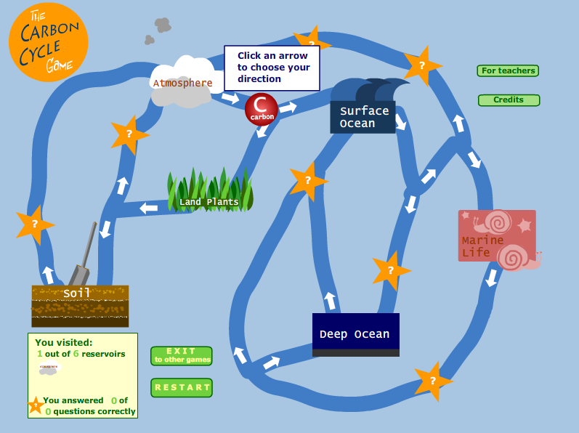

Telling the story of how Carbon Atoms travel through the system.

Material needed: Humans, dice, different colored hats (just paper to hold up)

Hats:

* Brown if you are in the Earth repository
* Blue if you are in the surface ocean repository
* Dark Green if you are in the plant repository
* Red if you’re an evil fossil fuel carbon atom (don’t worry there is some probability of changing your hat color).
* Yellow if you in the Deep Ocean repository
* Grey if you are in the Atmosphere
* Light Green if you are now Marine Life

Storage Reservoirs and Decision Pathways:

Note: This won’t work right the very first time – this is an iterative process – we might not have enough bodies and will have to improvise.

Instructions:

We will need 5 teachers at 5 different, well separated desks:

We will need one Supervisor that keeps track of the Moves and the Carbon atom accounting via hat colors - this is the most important job.

All other participants are carbon atoms. Each carbon atom collects a card for every new repository they reach. End of the game occurs when all carbon atoms have at least 1 card.

**Move 1**: Earth station

The Earth Surface station emits 7 carbon atoms with brown hats and 2 carbon atom with a red hat. (the rest of the atoms don’t yet get emitted).

Earth Station Dice Roll protocol (starts on Move 4)

* 1 or 2: carbon atom gets a red hat and goes to atmospheric station
* 3,4: stay in the soil
* 5; go back to the plant station
* 6: carbon atom gets a gray hat and goes to atmospheric station

**Move 2**: Atmosphere station

Atmospheric Station Dice Roll Protocol:

* 1 – remain in the atmosphere
* 3, 3 or 4: Dark green hat; go to Plant Desk
* 5 or 6: Blue hat, go to Surface Ocean station.

**Move 3:** Atmosphere Station previous protocol; Surface Ocean Station

Surface Ocean Station Dice roll protocol:

* 1,2 : stay in the surface ocean
* 3,4 : got back to the atmosphere
* 5: go to deep ocean as carbon atom (yellow hat)
* 6: go to deep ocean as marine life (light green hat)

**Move 4:** Earth station protocol; Atmospheric Station Protocol; Plant Station

Plant Station Dice roll protocol:

* 1,2 go back to the atmosphere - you ended up in an animal and were respired out
* 3 or 4 stay in plant
* 5 or 6: Go back into the soil (brown hat) at Earth Station thanks to bacteria

**Move 5:** Atmospheric Station Protocol; Plant Station; Surface Ocean Protocol; Deep Ocean

Deep Ocean Protocol:

* 1,2 or 3 – go to surface ocean
* 4 or 5 – stay in deep ocean as yellow hat
* 6 – be incorporated into an animal in the deep ocean (light green hat)

**After the first 5 moves – we need to do an accounting of how all the reservoirs are populated and notice certain things. Each of you should then write down a prediction of what reservoir you will be in, at what move number**

Subsequent moves starting with move 6.

* Earth station action on Moves 7, 10, 13, 16
* Atmosphere station – all moves
* Plant station – all moves
* Surface ocean station – every odd move now
* Deep ocean station – every 4th move – 9,13,17,etc

For all individual atoms pay attention the following:

a) On what move did you reach a new repository

b) are there some places that seem hard to get to

c) where are you spending the bulk of your time?

d) how many times did you have to wear the evil red hat

e) how many cycles does it take for the Red Hats to remain in the atmosphere (we might not have enough bodies to do this)